CX Banking

OptiCash 10.1

User Reference Guide

Version 10.1.0

Build Number 1322

April 2023

Copyright and Trademark Information

If this guide is distributed with software that includes an end-user agreement, this guide, as well as the software described in it, is furnished under license, and may be used or copied only in accordance with the terms of such license. Except as permitted by any such license, no part of this guide may be reproduced, stored in a retrieval system, or transmitted, in any form or by any means, electronic, mechanical, recording, or otherwise, without the prior written permission of NCR Corporation. Please note that the content in this guide is protected under copyright law even if it is not distributed with software that includes an end-user license agreement.

The content of this guide is furnished for informational use only, is subject to change without notice, and should not be construed as a commitment by NCR Corporation. NCR Corporation assumes no responsibility or liability for any errors or inaccuracies that may appear in the informational content contained in this guide.

OptiCash, OptiNet, OptiVault, OptiCashMI, OptiVLM, OptimizeCF, OptiSuite, OptiRecon, and OptiBridge are trademarks of NCR Corporation.

Adobe Acrobat Reader is a registered trademark of Adobe Systems Incorporated. Microsoft, Windows, and Windows Vista, Internet Explorer (IE) are either registered trademarks or trademarks of Microsoft Corporation in the United States and/or other countries. Solaris is a Trademark or registered trademark of Sun Microsystems, Inc. in the United States, and other countries. Oracle is a trademark of Oracle in the United States and other countries. Websphere is a trademark of IBM in the United States and other countries. UNIX is a trademark in the United States and other countries, licensed exclusively through X/Open Company, Ltd. All other trademarks are the property of their respective owners.

© 2020 NCR Corporation  
Atlanta  
Georgia  
USA  
[www.ncr.com](https://www.ncr.com/)  
All Rights Reserved

.

Revision Record

|  |  |  |
| --- | --- | --- |
| Date | Page No. | Description of Change |
| April 2023 | All | Initial Draft |
|  |  |  |
|  |  |  |

Table of contents

CX Banking 1

OptiCash 1

User Reference Guide 1

Copyright and Trademark Information 1

Revision Record 2

Table of contents 3

Introduction to OptiCash 11

Conventions Used in this Help Documentation 12

1. Getting Started 12

1.1. Screen Resolution 12

1.2. Navigation Tips 12

1.3. Accessing OptiCash 12

1.4. Logging into OptiCash 12

1.5. Logging Out of OptiCash 14

2. Introduction to the Interface 15

2.1. General OptiCash Pages 16

2.1.1. Main Menu Tabs 16

2.1.2. Common OptiCash Icons 17

2.1.3. Common OptiCash Buttons 18

2.1.4. Date Selector 19

2.1.5. Cashpoint Search 20

2.1.6. Cashpoint Selector 22

2.1.7. Language Selector 25

3. Cashpoint Window 26

3.1. Cashpoint Parameters 27

3.1.1. Cashpoint General Definitions 28

3.1.2. Cashpoint Currencies and Denominations 32

3.1.3. Cashpoint Parameters 35

3.1.4. Cashpoint Business and Service Days 41

3.1.5. Cashpoint Service Costs 47

3.2. Cashpoint→Main→Overview 51

3.3. Cashpoint→Main→Balance Entry Page 59

3.4. Cashpoint→Main→Current Balances 62

3.5. Cashpoint→Basic→Cashpoint Definition 63

3.6. Cashpoint→Basic→Parameters 64

3.7. Cashpoint→Basic→Service Days 66

3.8. Cashpoint→Basic→Denominations 69

3.9. Cashpoint→Basic→Denominations (Special Consideration for Advanced Devices) 70

3.10. Cashpoint→Basic→Non-Cash Media 73

3.11. Cashpoint→Basic→Linkage 74

3.12. Cashpoint→Advanced→Costs 77

3.13. Cashpoint→Advanced→Parameters 79

3.14. Cashpoint→Advanced→Foreign Currency Service Days 81

3.15. Cashpoint→Advanced→Linkage 83

3.16. Cashpoint→Advanced→Linkage→Add New 84

3.17. Cashpoint→Advanced→Linkage→Funding Partners 84

3.18. Cashpoint→Orders→Order Overview 85

3.18.1. Order Details Page 87

3.18.2. Create New Order Page 90

3.18.3. Manual Order Entry (Except Return Cash) 91

3.18.4. Manual Order Entry (Advanced Device Return Cash) 93

3.18.5. Branch Return Recommendation Review & Manual Order Entry (Branch Return Cash) 95

3.18.6. Order Confirmation 96

3.18.7. Create New Transfer 98

3.18.8. Foreign Currency Order 100

3.18.9. Order Custom Fields 102

3.18.10. Order Workflow 104

3.18.11. Order Blog & Blog History 106

3.18.12. Order Tracking ID 107

3.18.13. Order details page (with claim management configured) 109

3.19. Cashpoint→Forecast→View Forecast 110

3.20. Cashpoint→Forecast→Generate Forecast 114

3.21. Cashpoint→Forecast→Analysis 114

3.22. Cashpoint→Reports 115

4. Today Tab 116

4.1. Today→Dashboard Page 117

4.2. Today→Current Balance Levels 119

4.3. Today→Last Load Snapshot Page 121

4.3.1. Dashboard→To Do List 123

4.3.2. Today→Data Alerts Page 126

4.3.3. Today→Forecast Health Summary Report 128

4.3.4. Today→Check Dynamic Forecast Results Report 129

4.4. Today→Orders Page 130

4.5. Today→Orders Workflow Page 135

4.6. Today→Pre-Emptive Alerts 137

4.6.1. Pre-Emptive Alert Report 138

4.7. Today→Data Health 141

4.7.1. Data Health Summary 141

4.7.2. Run Data Health Check 142

4.7.3. Data Health Indicator Status Details 144

5. Processing Tab 145

5.1. Processing→Process Status 146

5.2. Processing→Results 147

5.2.1. Result Details→Forecast Snapshot Report 149

5.2.2. Result Details→Recommendation Snapshot Report 151

5.3. Processing→Load→Load Balances Page 152

5.4. Processing→Load→Load Orders 154

5.5. Processing→Load→Load Downtime 156

5.6. Processing→Load→Load Validation Settings Page 158

5.7. Processing→Recommendations 162

5.7.1. Processing→Recommendations→Run Recommendations Page 162

5.7.2. Run Recommendations→Recommendation Validation Report 163

5.7.3. Processing→Recommendations→Settings Page 168

5.7.4. Processing→Recommendations→Institution Settings Page 172

5.7.5. Processing→Recommendations→Recommendation Output 174

5.7.6. Processing→Recommendations→Network Contraints Optimization 175

5.8. Processing→Forecast 177

5.8.1. Forecast→Forecast Institutional Settings 179

5.9. Processing→Orders Output Page 180

5.10. Processing→Orders Output→Settings 182

5.11. Processing→Cost Calculation 185

5.11.1. Cost Calculation→Actual Costs/Projected Costs/Model Costs 185

5.11.2. Cost Calculation→Cost Options Page 188

5.11.3. Cost Calculation→Cost Calculation Details Report 190

5.12. Processing→Custom Jobs 191

6. Network Tab 192

6.1. Network→Cashpoints Page 192

6.1.1. Network→Cashpoints→Create Cashpoint Wizard 195

6.2. Network→Defaults Page 195

6.3. Network→Defaults→Administer Default Settings 196

6.3.1. Network→Defaults→Parameters 197

6.3.2. Network→Defaults→Costs 197

6.3.3. Network→Defaults→Denominations 198

6.3.4. Network→Defaults→Advanced Parameters 198

6.3.5. Network→Defaults→Service Exceptions 199

6.3.6. Network→Defaults→Forecast Adjustments 200

6.3.7. Mass Assigning 200

6.3.8. Network→Defaults→Assign Foreign Currency Settings Page 200

6.4. Network→Carriers Page 203

6.4.1. Carriers→Centers 204

6.4.2. Carriers→Servicers 205

6.4.3. Carriers→Depots 207

6.4.3.1. Depots→Depot Add/Edit Page 208

6.4.3.2. Depots→Assign Service Costs 211

6.4.3.3. Depots→Assign Service Days 212

6.4.3.4. Depots→Assign Cashpoints 214

6.4.3.5. Depots→Assign as Secondary Depot 214

6.4.4. Carriers→SLA Profile 215

6.4.5. Carriers→Route Definitions 217

6.4.5.1. Carriers→Route Definitions→Add 218

6.5. Network→Regions Page 219

6.6. Network→Groups page 220

6.7. Network→Clusters page 222

6.8. Network→Balance Types 224

6.9. Network→Commercials 225

6.9.1. Commercials→Corporate Page 226

6.9.2. Commercials→Client Page 227

6.9.3. Commercials→Commercial Definitions Page 229

6.9.4. Commercials→Commercial Parameters Page 231

6.9.5. Commercials→Assign Clients to Branch Page 233

6.10. Network→Network Monitoring 234

6.10.1. Network Monitoring→New Rule 236

7. Events Tab 239

7.1. Events→Calendar Page 239

7.1.1. Calendars→Cashpoints 241

7.2. Events→Events Page 243

7.2.1. Events→Add/Edit Event 244

7.3. Events→Year Type Page 246

8. System Tab 248

8.1. System→Institution Page 248

8.2. System→Privileges Page 249

8.2.1. Privileges→Users 250

8.2.2. Privileges→Business Units 253

8.2.3. Privileges→Business Units (Restricted and Global Privileges) 257

8.2.4. Privileges→OptiNet Workflow Profiles 259

8.3. System→Currencies/Denominations Page 260

8.3.1. Currencies/Denominations→Currencies Page 260

8.3.2. Currencies/Denominations→Denominations Page 262

8.3.3. Currencies/Denominations→Cash Qualities Page 264

8.3.4. Currencies/Denominations→Foreign Currency Denominations Page 266

8.3.5. Currencies/Denominations→Non-Cash Media Page 268

8.3.6. Currencies/Denominations→Exchange Rate Page 270

8.3.7. Currencies/Denominations→Interest Rates 271

8.3.8. Currencies/Denominations→Inner Wallet Types 272

8.4. System→Order Settings Page 274

8.4.1. Order Settings→Override Reasons 275

8.4.2. Order Settings→Order Workflow 275

8.4.3. Order Workflow Editing 278

8.4.4. Order Settings→Order Custom Field Definitions 281

8.4.5. Order Settings→Custom Field to Order Linkage 283

9. System→Maintenance Page 285

9.1. System→Maintenance→Cashpoint Maintenance 285

9.1.1.1. Cashpoint Maintenance→Copy Cashpoint 286

9.1.1.2. Cashpoint Maintenance→Rename Cashpoint 286

9.1.1.3. Cashpoint Maintenance→Delete Cashpoint 287

9.1.1.4. Cashpoint Maintenance→Activate/Deactivate Cashpoints 288

9.1.1.5. System→Maintenance→Copy History 289

9.2. System→Maintenance→Purge Data 290

9.2.1. System→Maintenance→Include/Exclude History 294

9.3. System→Maintenance→JDBC→Table Cleaning 296

9.4. System→Maintenance→ATM Side-by-Side Cluster Aggregation 296

9.5. System→Maintenance→Update Pre-service Amount 296

9.6. System→Maintenance→Export Cashpoints 297

9.7. System→View Logs 297

9.8. System→Audit Log Browser 299

9.9. System→About Page 302

10. Virtual Analyst Tab 303

10.1. Virtual Analyst→Settings 303

10.2. Virtual Analyst→Reports 306

10.2.1. Auto History Selection Results 306

11. Reports Tab 308

11.1. Reports Overview 308

11.2. Report Basics 313

11.3. System Settings Reports 315

11.3.1. Cashpoint Contacts 315

11.3.2. Cashpoint Details 316

11.3.3. Cashpoint Parameters 317

11.3.4. Cashpoint Denominations 318

11.3.5. Advanced Device Components 319

11.3.6. Recycler and Recommendation Enhancement 320

11.3.7. Cashpoint Service Costs 323

11.3.8. Cashpoint Service Days 324

11.3.9. Cashpoint Service Exceptions 324

11.3.10. Cashpoint Service Schedules 325

11.3.11. Cashpoint Event Collisions 327

11.3.12. Cashpoint Events 328

11.3.13. Cashpoint Clusters 329

11.3.14. Cashpoint Groups 330

11.3.15. Commercial Cashpoint Groups 330

11.3.16. Cashpoint Linkage 331

11.3.17. Institution Details 332

11.3.18. Network Contacts 333

11.3.19. BUSINESS UNITS 333

12. Historical Reports 334

12.1. History 334

12.2. Linked History 337

12.3. History By Denomination 338

12.4. Enhanced ATM History 340

12.5. Intraday History 341

12.6. Downtime 342

12.7. Orders 343

12.8. Ordered Denominations 344

12.9. Commercial Orders 345

12.10. Order Custom Fields 346

12.11. Bag Reference Numbers 347

12.12. Special Orders 348

12.13. ATM Residuals 348

12.14. Linked Orders 349

12.15. Recommendations 350

12.16. Special Requirements 351

12.17. Target vs. Historical Balance 352

12.18. Target Balance vs. Historical Recommendation 352

12.19. Order Notification Report 353

12.20. Cash Levels Report 354

12.21. Order Blog History Report 355

13. Planning Reports 356

13.1. Forecast Average Cycle Discrepancy 356

13.2. Forecast Comparison 358

13.3. Forecast Details 358

13.4. Forecast Definition 359

13.5. Expired Forecasts 360

13.6. Forecast Health 361

13.7. Forecast Health (Calculated) 362

13.8. Horizons 363

13.9. Linked Horizon 364

13.10. Advanced Device Horizon 365

13.11. Emergency Recommendation Analysis 366

13.12. Downtime Order Impact Analysis 367

13.13. Downtime Recommendation Impact Analysis 368

13.14. Linked Recommendations 369

13.14.1.1. Routes Trips 370

13.15. Transportation Details 371

13.16. Driving Directions 371

14. Metrics & MI Reports 373

14.1. Cash Position 373

14.2. Cash Utilization 374

14.3. Costs (Actual) 380

14.4. Costs (Charted Actual) 382

14.5. Costs (Actual vs. Projected) 382

14.6. Order Override Reasons 382

14.7. Order Status 383

14.8. Order Disputes 384

14.9. Orders Compliance 384

14.10. Recommendation Compliance 386

14.11. Target Balance Lost Opportunity 387

14.12. Target Balance Lost Opportunity with Linked ATMs 388

14.13. Target Balance Branch Cash Lost Opportunity Summary 390

14.14. Horizon Comparison 391

14.15. Carriers SLA Compliance Report 393

15. Models Tab 395

15.1. Model Overview 395

15.2. Modelling Requirements 396

15.3. Model Types 397

15.4. General Modelling Rules 400

15.4.1. Why it is necessary to have all cashpoints forecasted prior to Simulations 400

15.4.2. Would the Model be created with the current cashpoint settings 400

15.4.3. Emergencies in the beginning of generated horizons 400

15.5. Getting Started 401

15.6. Creating a New Model 402

15.7. Models→Overview 403

15.8. Models→PROCESSING 407

15.9. Models→Results 408

15.10. Models→Simulations 408

15.10.1. Models→Simulations→Settings 409

15.11. Model Cost Calculations 410

15.12. Models→Network Settings 411

15.12.1. Costs 413

15.12.2. Advanced Parameters 414

15.12.3. Carriers 414

15.12.4. Currencies 415

16. Reports 416

16.1. Charted Model Costs 417

16.2. Savings (Cost Comparison) Report 418

16.3. Cash Utilization Comparison 419

16.4. Delivery Day Utilization 421

16.5. Horizon Comparison 421

16.5.1.1. Parameters 424

16.6. Service Costs 425

16.7. Service Days 425

16.8. Cashpoint Service Schedule 425

17. Glossary 427

18. Table of Figures 434

19. Table of Descriptions 439

Introduction to OptiCash

OptiCash is the solution for lowering costs through more effective currency management. OptiCash is a comprehensive system designed to optimize currency ordering and clearing for financial institutions with branches, branch ATMs, and standalone ATMs. Based on historical cash-demand data, OptiCash will forecast currency requirements considering important factors such as seasonality, holidays, special events, and trends.

Additionally, forecasted currency requirements are evaluated against various cost components associated with ordering, holding, and delivering currency to a Cashpoint. The overriding objective: calculate the optimal amount of cash required for Cashpoints and reduce operating costs.

|  |  |
| --- | --- |
|  | * **Caution:** OptiCash is a live application. Changes that are made in the application are permanent and can affect the operation of the system. There are limited undo capabilities for the users; therefore, be sure to consult this manual before deleting or changing system parameters. |

Conventions Used in this Help Documentation

The conventions used in this help documentation are shown in the table below.

* + 1. Conventions

| Convention | Use |
| --- | --- |
| Green Text | Indicates a link to the top of the current section. These links can be clicked to quickly navigate through this document. (In some cases, you may need to hold the CTRL key to click the link) |
| Blue Text | Indicates a link to a different topic or section. These links can be clicked to quickly navigate through this document. (In some cases, you may need to hold the CTRL key to click the link) |
| → | The “arrow” sign indicates a menu choice. For example, “**Choose File → Open**” means “click the File menu, and then click Open.” |
|  | Used to warn users of potential problems or to take caution when making changes to settings and parameters. |
|  | Tips or information that may help use the functionality. |

# Getting Started

OptiCash is a web-based application operating in a multi-user environment and producing daily recommendations for the amount and frequency of currency orders. The recommendations are distributed from a central location. For branches, a host-based application typically passes these recommendations to the branches for their review, acceptance or update, and return. Resulting updates are then re-imported into the system as actual orders that can then be printed or passed electronically to the cash provider. NCR Cash Management will assist in getting the application properly configured.

## Screen Resolution

Because OptiCash runs in a browser, the user may choose any valid desktop resolution, and OptiCash will resize automatically. 1024x768 resolution and larger is recommended to minimize scrolling on some of the screens containing large amounts of information.

## Navigation Tips

When using OptiCash, avoid using the Back and Forward buttons  in the browser. All navigation should occur within the application via the menu or icons thereby insuring the successful processing of the OptiCash system.

## Accessing OptiCash

To begin using the application, enter the required EPSS Application URL in the Browser.

|  |  |
| --- | --- |
|  | **Suggestion:** save the EPSS Application URL in the Favorites folder for easier future access. |

## Logging into OptiCash

Once EPSS Application has been launched, the login screen will appear as shown below. To log in, enter your Username and Password and click Login.

|  |  |
| --- | --- |
|  | **Note:**  For external authentication, the Login prompt will not be displayed. Login will be automatic based on network authentication. |

Figure 1: OptiCash Login Screen

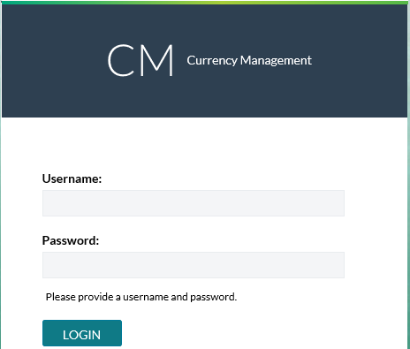

Starting 10.0 version, User should login to EPSS portal

**Note:** The above login screen is not visible. If external IDP is configured, then the IDP login form is displayed.

EPSS login screen is shown as below

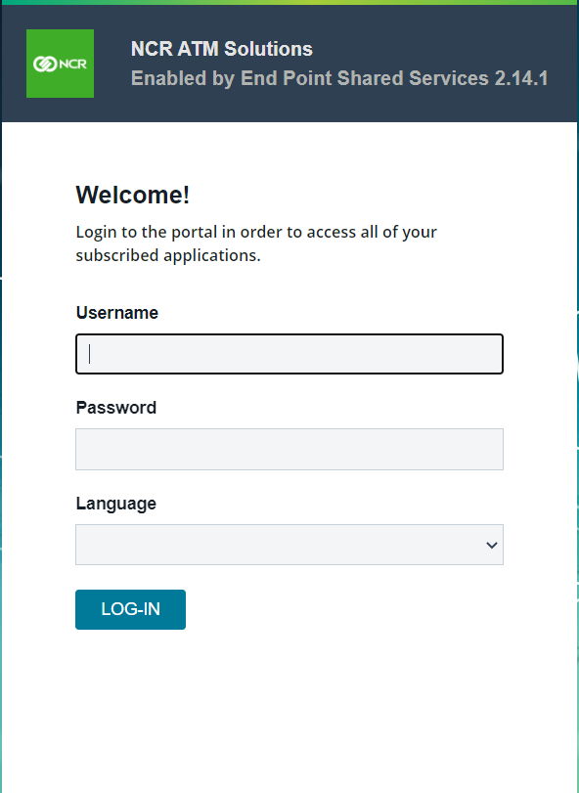

If **Keycloak IDP** is integrated with EPSS, the login screen will be as shown below

Figure 2: KEYCloak IDP

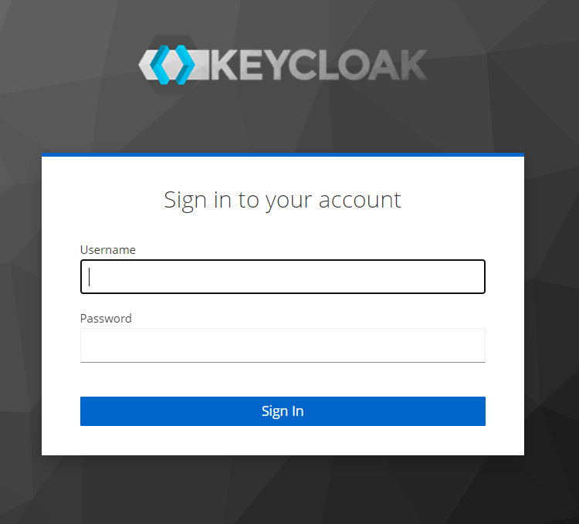

One might have different setup if you have configured Azure AD as IDP (Identity Provider)  
  
  
Once Login is Successful Cash Management Dashboard Screen will appear as shown below. To access OptiCash Open App Launcher, and click on ‘OC’ button

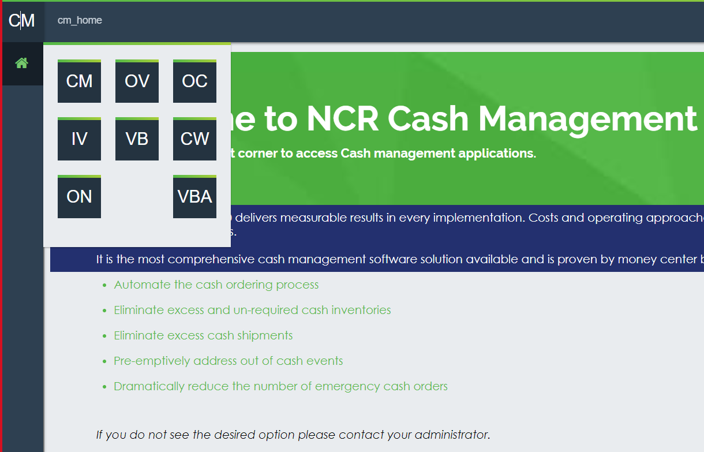

## Logging Out of OptiCash

To log out, click the Logout button from User Menu Item Icon which is located in the bottom left-side menu options of the screen.   
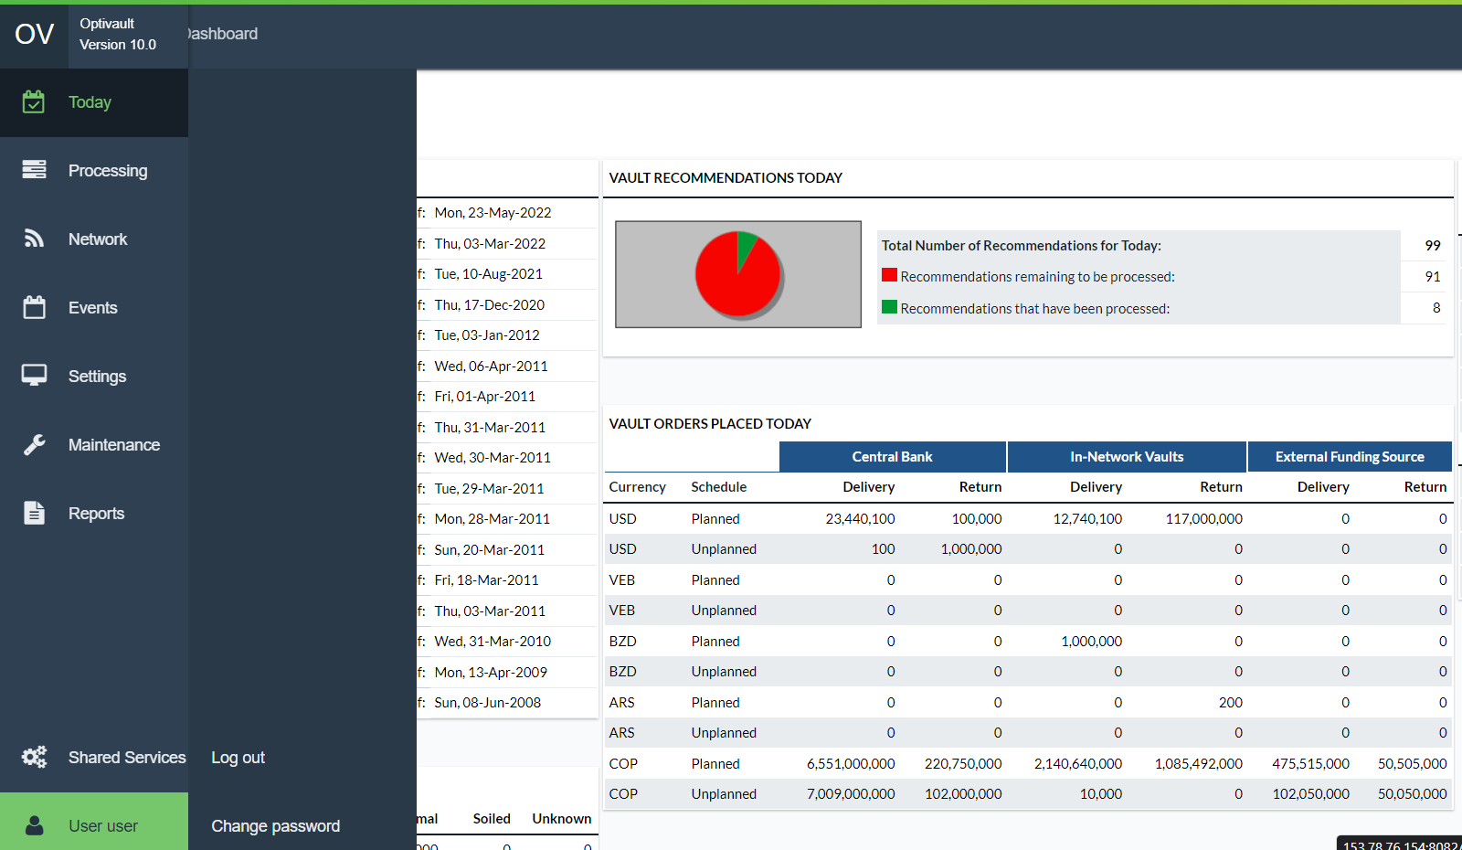

|  |  |
| --- | --- |
|  | **Note:**  To ensure the successful processing of the OptiCash system, do not use the **Close** button in the browser; always use the Application Logout icon instead. |

1. Introduction to the Interface

The following section will show examples of most of the OptiCash interface pages and explains the functionality, purpose, or use of each page. This section is to be used as a reference when working with the application daily.

To keep this manual as succinct as possible, the user interface is described in detail in this section. Other chapters throughout the manual will then refer to the appropriate section of the user interface to avoid having duplicate screen images and text.

This chapter has been broken out into different sections to make it easier for readers to find the information they are seeking. The General topics are broken out by the main Tabs or functions with all associated information contained beneath those sections. The following is a summary of the information that will be covered along with hyperlinks to each topic.

* General OptiCash Pages
* Cashpoint
* Today Tab
* Processing Tab
* Network Tab
* Events Tab
* System Tab
* Virtual Analyst Tab
* Reports Tab
* Models Tab

## General OptiCash Pages

Users of OptiCash will encounter several pages that are common throughout the application. The user should become familiar with these pages as they are used quite frequently when working in OptiCash.

The following is a summary of the information that will be covered along with hyperlinks to each topic.

* General OptiCash Pages
* Common OptiCash Icons
* Common OptiCash Buttons
* Date Selector
* Cashpoint Search
* Cashpoint Selector
* Language Selector
* Return To: Introduction to the Interface

### Main Menu Tabs

The user can control the OptiCash operations through the main menu tabs displayed in the picture below. After selecting the menu items, additional options are displayed, until a final menu option is reached, allowing full access to all functions of OptiCash.

Figure 3: Navigation Tabs

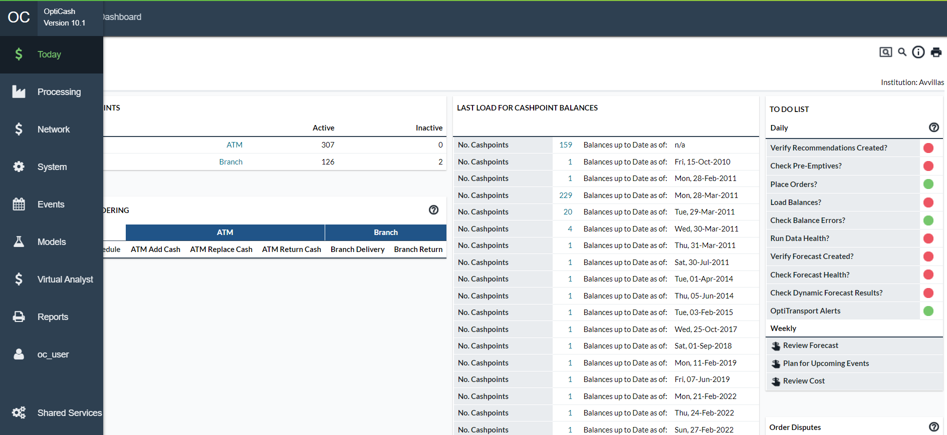

Table 2: Main Menu Tabs

| **TABS** | **DESCRIPTION** |
| --- | --- |
| **Today** | Shows daily Cashpoint and order status and lists the processes or tasks to be executed daily by users. |
| **Processing** | Contains main OptiCash processes: balance load, recommendations, forecast, etc. |
| **Network** | Organizing Cashpoints. |
| **Events** | Calendars and event definition. |
| **System** | System maintenance and institutional setup. |
| **Models** | OptiCash simulation models. |
| **Virtual Analyst** | Features to automate fine-tuning of forecast process. |
| **Reports** | OptiCash reports. |

Return To: Introduction to the Interface

### Common OptiCash Icons

Some common icons are used throughout the application with which the user should become familiar. Table 3: OptiCash Icons gives an overview of these icons and their functions.

Table 3: OptiCash Icons

| **ICON** | **DESCRIPTION** |
| --- | --- |
|  | **Search Icon:** provides access to search for Cashpoints by ID, Name, and type. |
|  | **Help Icon**: Displays OptiVault Online help. |
|  | **Print Icon:** Print from any of the screens. This function will only print what is currently displayed in the browser. Any text that is not visible will not be printed. |
|  | . |
|  | **Home Icon:** Return to the main OptiVault screen. |
|  | **Download icon:** Allows the user to download the file to the local system. |
|  | **View icon:** Allows the user to view a file that is hosted on the server. |
|  | **Exit icon:** Closes the Cashpoint window. |
|  | **Edit:** Allows the analyst to edit the parameters or settings. |
|  | **Purple Ball:** Holiday Indicator to denote days that have holiday events |
|  | **Orange Ball:** Event indicator to denote days that have normal events |
|  | **Red Ball:** Indicator that the process or action is incomplete |
|  | **Green Ball:** Indicator that the process or action is complete |
|  | **Yellow Ball:** Indicator that the process has been completed but there still may be actions that need to be completed |
|  | **Alert Indicator:** Informs the user that there is a possible problem with the action or process |
|  | **Question Mark Icon**: Help tips and information for each field in the application (to close it, click on the top right corner of the note). |
|  | **Radio button:** Used for selecting items. |
|  | **Check box:** Used for selecting items. |
|  | **Link:** Identifies a Cashpoint as being linked to another Cashpoint(s) |
|  | **Single Arrow Icon:** Move to the next page of the list. |
|  | **Double Arrow Icon:** Move to the first or last page of the list. |
|  | **Date Selector Icon:** Used to select a date from a calendar box. This option will allow you to enter the date in “YYYY-MM-DD” format. |
|  | **Calculator Icon: A**utomatically calculates certain values using the history data. |

Return To: Introduction to the Interface

### Common OptiCash Buttons

The buttons in the following table will appear in most of the windows when executing daily or weekly tasks:

Table 4: OptiCash Buttons

| **BUTTON** | **DESCRIPTION** |
| --- | --- |
|  | Exit the window. |
|  | Save the changes made in the fields. |
|  | Exit without saving changes. |
|  | Update the changes made in the fields. |
|  | Select all the items listed on the screen. |
|  | Display the default values in the fields. |
|  | Submits the request for the function on the current screen to be processed |
|  | Finalizes the selection of Cashpoints or functions to allow the user to move to the next step in the process |

Return To: Introduction to the Interface

### Date Selector

In several areas of the application, it may be necessary to select or change a date for reports, orders, etc. Date fields can only be changed by accessing a Date Selector by clicking the Date Selector icon 

Figure 4: Date Selector

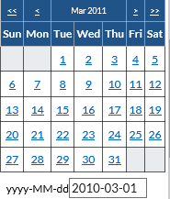

Table 5: Date Selector Description

| **FIELD** | **DESCRIPTION** |
| --- | --- |
| **<<** | Moves the Calendar 1 Year in the past |
| **>>** | Moves the Calendar 1 Year Forward |
| **<** | Moves the Calendar 1 Month in the past |
| **>** | Moves the Calendar 1 Month forward |
| **Dates** | Hyperlinks will denote which dates can be selected. In some cases, dates will not be available (i.e., The date being selected is for a delivery day and Sunday is a non-delivery day; Sunday would not be available for selection) |
| **yyyy-MM-dd** | Specifies the currently selected date. If the user would like to type in the date, then it is possible to do so in this field, but it must conform to the format of Year(yyyy)-Month(MM)-Day(dd). |
| **Clear** | Clears the date completely from the field that was originally selected |
| **Cancel** | Cancels the date selection without changing any values. |

Return To: Introduction to the Interface

### Cashpoint Search

Many times, a user will want to find a particular Cashpoint for a variety of different reasons. An easy way to search for Cashpoints is by using the Cashpoint Search Function. The Search window can be accessed by clicking on the Search Icon  on most OptiCash screens.

Figure 5: Cashpoint Search Page

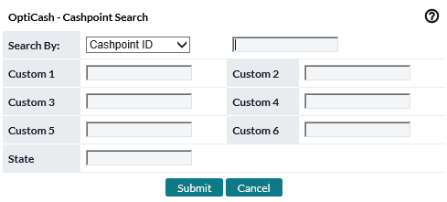

Table 6: Cashpoint Search Description

| **FIELD NAME** | **DESCRIPTION** |
| --- | --- |
| **Search By:** | Allows the user to select how OptiCash will search for the Cashpoint. The options available are:  **Cashpoint ID (Default) –** With this option, the user can search for Cashpoint using its unique identifier. Type the Cashpoint ID in the field to the right of the Search by Box.  **Cashpoint Name –** With this option, the user can search for Cashpoint using the name that is defined at the Cashpoint level. Type the Cashpoint name in the field to the right of the Search by Box.  **Type –** Allows the user to select only ATMs or only Branches in the search. Note: You are not able to search by custom or state fields when using this search parameter. |
| **Custom 1 – 6** | OptiCash users can store a variety of information at the Cashpoint level using custom fields. These fields can hold data such as internal account numbers, classification information, etc. Using the custom fields, the user can search for a particular value in a custom field.  **Example**, if Custom 1 was the color of the Cashpoint and you were searching for blue Cashpoints, you could enter ‘Blue’ in the Custom 1 field to find all blue Cashpoints |
| **State** | OptiCash users are also able to search by State if the State Field is being used at the Cashpoint level.  **Example**, if the customer was looking for all Cashpoints in California, they could simply type in CA to bring up California Cashpoints. |
| **Submit** | Submits the request to search for the Cashpoint. If nothing was entered in the search criteria field, then all Cashpoints will be returned. |
| **Cancel** | Closes this window without processing any information. |

Return To: Introduction to the Interface

### Cashpoint Selector

Frequently the user is asked to select one or a number of Cashpoints for reports, Mass assignments of parameters, etc. For these processes, the Cashpoint Selector is used. This window gives the user several different ways to search for Cashpoints by allowing the user to filter the selection results using different criteria.

Figure 6: Cashpoint Selector Window

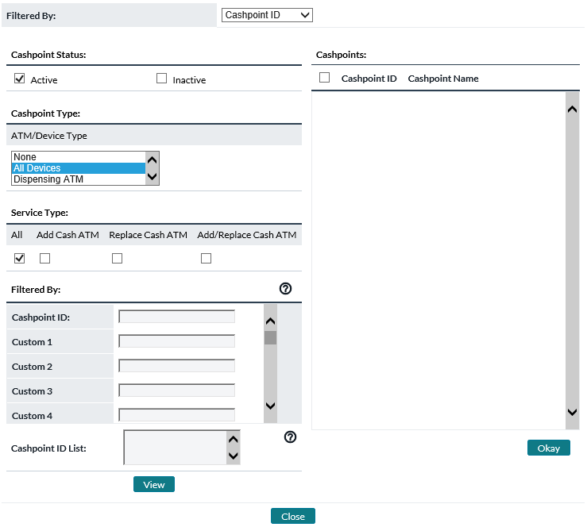

Table 7: Cashpoint Selector Description

| Field Name | Description |
| --- | --- |
| **Filtered By:** | Allows the user to select how OptiCash will search for the Cashpoint. When a new selection is made, OptiCash will change the area in the bottom-left corner to allow the user to select or input criteria specific to that input type. The options available are:   * **Cashpoint ID (Default) –** With this option, the user can search for Cashpoint using its unique identifier. Type the Cashpoint ID in the field marked ‘Cashpoint ID’. Optionally, the user can search for custom fields or state values as well. * **Cashpoint Name –** With this option, the user can search for Cashpoint using the name that is defined at the Cashpoint level. Type the Cashpoint name in the field marked ‘Cashpoint Name’. Optionally, the user can search for custom fields or state values as well. * **Type –** Allows the user to select only ATMs (by type if necessary) or only Branches in the search. * **Center –** Allows the user to select Cashpoints that belong to one or a group of Centers. For more information about Centers, See: Network→Carriers Page * **User Groups –** Allows the user to select Cashpoints that belong to one or a group of User Groups. For more information about User Groups, See: Network→Groups page * **Carrier –** Allows the user to select Cashpoints that belong to one or a group of Carriers or Depots. For more information about Carriers, See: Network→Carriers Page |
| **Cashpoint Status** | Allows the user to choose Active/Inactive/All Cashpoint statuses when searching for Cashpoints. |
| **Cashpoint Type** | Allows the user to select one or several types of Cashpoints including;   * All * Branch * ATM which can be limited to None, All, Dispensing ATM, Recycling ATM, Deposit Machines, Teller Cash Machine, Self-Checkout Machine, Smart Safe, and Other Recycle Capable Devices |
| **Cashpoints** | List the Cashpoints that the user can select from. The user needs to check the box on the Cashpoint(s) they would like to choose for their selection. Pressing the **Okay** button will finalize the selection and return it to the page requesting the information. |
| **Custom 1 – 6** | OptiCash users can store a variety of information at the Cashpoint level using custom fields. These fields can hold data such as internal account numbers, classification information, etc. Using the custom fields, the user can search for a particular value in a custom field.  **Example**, if Custom 1 was the color of the Cashpoint and you were searching for blue Cashpoints, you could enter ‘Blue’ in the Custom 1 field to find all blue Cashpoints  **Note**: The user is only able to search by these fields when using the Filtered by Cashpoint ID or Cashpoint Name options. |
| **State** | OptiCash users are also able to search by State if the State Field is being used at the Cashpoint level.  **Example,** if the customer was looking for all Cashpoints in California, they could simply type in CA to bring up California Cashpoints.  **Note**: The user is only able to search by these fields when using the Filtered by Cashpoint ID or Cashpoint Name options. |
| **Cashpoint ID List** | Filter by pasting a comma or tab delimited list of Cashpoint IDs. Useful when you have a predefined list. |
| **View** | Submits the request to search for the Cashpoint. If nothing was entered in the search criteria field, then all Cashpoints will be returned. The results of the search are shown in the Cashpoints box which the user can then select Cashpoints by clicking on the checkboxes and ‘Okay’ to finalize the selection and return the information to the page requesting the Cashpoints. |
| **Close** | Closes this window without processing any information. |
| **Page** | Shows how many pages of Cashpoints have been returned. Each page contains 25 Cashpoints, and the user can navigate between pages to select particular Cashpoints |
| **<< < > >> Buttons** | These buttons allow the user to navigate between pages. The double arrows take the user to the beginning or end of the list, whereas the single arrows take the user to the next or previous pages respectively. |
| **Select All Button** | This button will select all Cashpoints that are in the Cashpoint list. If the list was filtered, then only those Cashpoints will be selected. |
| **Okay Button** | This button finalizes the transaction and returns the selected Cashpoints to the page requesting the Cashpoint selection. |

Return To: Introduction to the Interface

### Language Selector

The Language Selector is located at the footer line of every page. This allows each user to select their own language choice. Please note that in OptiCash this causes the Dashboard to open.

Figure 7: Language selector

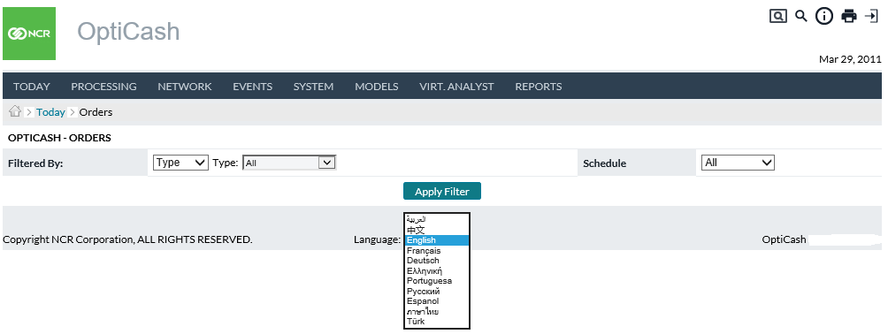

Return To: Introduction to the Interface

1. Cashpoint Window

The Cashpoint is the heart of OptiCash. Each one holds a piece of a large puzzle, which is the Cash Network. The Cashpoint holds all the History and Parameters that allows the system to create Forecasts and Recommendations at a granular level. The Cashpoint window contains all the information, parameters, reports, and functions that allow the user to define, manage, and execute processes for Cashpoint.

The following is a summary of the information that will be covered along with hyperlinks to each topic.

* Cashpoint Parameters
* Cashpoint→Main→Overview
* Cashpoint→Main→Balance Entry Page
* Cashpoint→Basic→Cashpoint Definition
* Cashpoint→Basic→Parameters
* CashpointàBasicàService Days

Figure 22: View Service Days

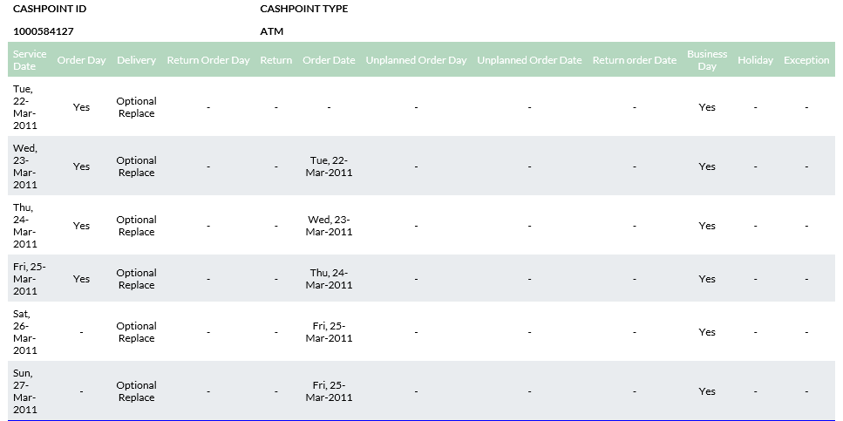

* Cashpoint→Basic→Denominations
* Cashpoint→Basic→Non-Cash Media
* Cashpoint→Basic→Linkage
* Cashpoint→Advanced→Costs
* Cashpoint→Advanced→Parameters
* Cashpoint→Advanced→Foreign Currency Service Days
* Cashpoint→Forecast→View Forecast
* Cashpoint→Forecast→Generate Forecast
* Cashpoint→Forecast→Analysis
* Cashpoint→Reports

Return To: Introduction to the Interface

## Cashpoint Parameters

This section will detail each of the parameters and settings that are related to or assigned to a Cashpoint. This section will be the central reference point for all the Cashpoint parameters.

A Cashpoint is made up of many different parameters that define how it works, what it does, whom it belongs to, and who manages it. The elements that will be discussed in this section are illustrated in the chart below:

Figure 8: Cashpoint Elements

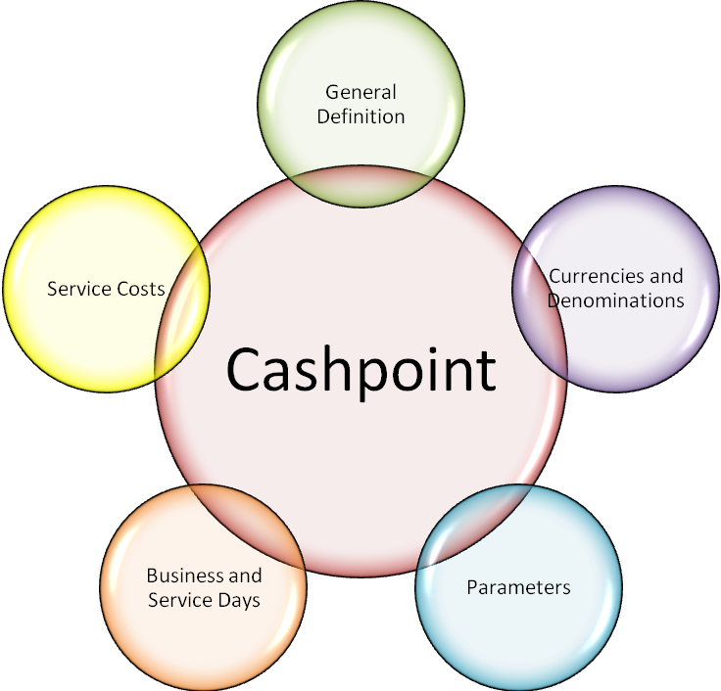

Return To: Cashpoint Window

### Cashpoint General Definitions

Each Cashpoint needs a general definition or description of what the Cashpoint is and where it fits into the network. Not all the information in this section is required for the Cashpoint to operate properly; those that are required will be marked. This section applies to all Cashpoints.

Table 8: Cashpoint General Definitions

| Cashpoint Element | Description |
| --- | --- |
| **Cashpoint ID**  **(Required)** | Unique alphanumeric code that identifies the Cashpoint.  The Cashpoint ID can be a maximum of 12 digits. It must not contain any spaces between the characters, nor should it contain special characters (‘{[]}|~`!@#$%^&*)”.The software will give an error message if the user tries to enter an invalid character. |
| **Cashpoint Name**  **(Required)** | An alphanumeric name can be given to the Cashpoint to help identify it from other Cashpoints.  The Cashpoint Name can be a maximum of 80 Characters. Certain special characters will be rejected (i.e., single, or double quotes), but spaces are acceptable for this field. The software will give an error message if the user tries to enter an invalid character. |
| **Cashpoint Type**  **(Required)** | Determines both how the Cashpoint works as well as how it is replenished. Different Cashpoints have different functions, replenishment styles, and parameters. The user must choose between one of the following Cashpoint types.  All Cashpoints allow customers to withdraw funds and receive replenishments from a carrier. The main difference between Cashpoint types has to do with the method of replenishment and whether customer deposits are available to be withdrawn.  **Branches** are unique in that they give and receive cash from customers and their Carriers.  **Dispensing ATMs**   * **Add Cash ATMs** – Cash is only withdrawn, and the Carrier only fills the ATM (no money returns with the Carrier). * **Replace Cash ATMs** – Cash is only withdrawn and the Carrier swaps old ATM cassettes with newly filled cassettes. The old cassettes are returned with the Carrier with any residual cash. * **Add/Replace Cash ATMs** – Cash is only withdrawn but the replenishment is different. This is a special scenario where in some instances the Carrier Adds Cash and in others, it performs a Replace Cash. * **Advanced Devices** * **Recycler ATM** – Cash can be Deposited into this machine and then be made available for withdrawal. May have multiple components split between deposit-only, withdrawal-only, and recycling functionality. * **Depositor ATM –** Cash can only be deposited into this machine. Servicing can be either completely emptying the machine, or the user can designate what amount is to be extracted. * **Teller Cash Machine** – Allows branch personnel to insert large denomination notes and receive smaller denominations in return. * **Self-Checkout Machines** – Used in retail environments where customers insert notes/coins and receive change back from the machine. * **Smart Safe –** Smart safes are utilized by branch personnel usually. The machine receives, accurately counts, and secures inserted currency. * **Other Recycle Capable Device** – This is designated for any machine that does not fit any of the more specific descriptions. |
| **Region**  **(Required)** | The region to which the cashpoint belongs. A cashpoint can only be a member of one region. |
| **Primary Depot**  **(Required)** | The Primary Depot services the main optimized currencies to the Cashpoint. Optimized currencies are those that are forecasted and recommended for Cashpoint. A Cashpoint can only be a member of one Primary Depot.  For more information about Depots, see: the Network→Carriers Page |
| **Secondary Depot**  **(Required for Branches only)** | The Secondary Depot services the Non-Optimized (Foreign) currencies to Cashpoint. A Cashpoint can only be a member of one Secondary Depot.  For more information about Depots, see: the Network→Carriers Page  **Note:** The Secondary Depot does not apply to ATMs |
| **SLA Profile** | SLA Profile indicates the Service Level Definition is utilized by the servicer of each cashpoint. |
| **Class ID** | The Class ID is used to identify and classify certain Cashpoints.   * N/A * Standard * Speciality   This parameter does not affect any processes.  **Note**: Class ID is used in the DEL4 (4.2.2) Orders Output file. |
| **Time Zone** | The Time Zone where the Cashpoint is located.  This is for informational purposes only currently. It does not affect any other processes. |
| **Contact Name** | Contact person’s name for this Cashpoint. The Contact Name can be a maximum of 80 characters.  This is for informational purposes only currently. It does not affect any other processes. |
| **Address Line 1** | Address information for this Cashpoint. Address Line 1 can be a maximum of 80 characters  This is for informational purposes only currently. It does not affect any other processes. |
| **Address Line 2** | Additional address information for this Cashpoint. Address Line 2 can be a maximum of 80 characters.  This is for informational purposes only currently. It does not affect any other processes. |
| **City** | City where this Cashpoint is located. The city can be a maximum of 30 characters.  This is for informational purposes only currently. It does not affect any other processes. |
| **State** | State where this Cashpoint is located. The State can be a maximum of 15 characters.  This is for informational purposes only currently. It does not affect any other processes.  **Note:** The user can search for Cashpoints based on this field, therefore it may be a good idea to store information which can help users locate this Cashpoint. Custom fields can also be used for this purpose. |
| **Zip Code** | The postal code of Cashpoint. The Zip Code can be a maximum of 10 characters.  This is for informational purposes only currently. It does not affect any other processes. |
| **Phone Number** | The phone number for the contact person of this Cashpoint. The Phone Number can be a maximum of 15 characters  This is for informational purposes only currently. It does not affect any other processes. |
| **Fax Number** | The fax number for this Cashpoint. The Fax Number can be a maximum of 15 characters.  This is for informational purposes only currently. It does not affect any other processes. |
| **Email Address** | Email address for the contact person for this Cashpoint. The Email Address can be a maximum of 80 characters.  This is for informational purposes only currently. It does not affect any other processes. |
| **Cluster ID** | If this cashpoint is a member of a cluster, that cluster will be listed here. |
| **Route ID** | If this cashpoint is associated with a route, that route will be listed here. |
| **OptiNet Order Cut-off Times (Branches only)** | Beyond this time of day, order updates of the specified type will not be allowed. These cut-off times are only enforced in OptiNet for the specific branch (OptiCash and CarrierWeb ignore them). |
| **Custom 1 – 20** | OptiCash users can store a variety of information at the Cashpoint level using custom fields. These fields can hold data such as internal account numbers, classification information, etc. Using the custom fields, the user can search for a particular value in a custom field.  **For example**, if Custom 1 was the color of the Cashpoint and you were searching for blue Cashpoints, you could enter ‘Blue’ in the Custom 1 field to find all blue Cashpoints  Custom Fields can be a maximum of 50 characters each.  **Note**: The user is only able to search by these fields when using the Filtered by Cashpoint ID or Cashpoint Name options. |
| **Comments** | Free form field for putting internally visible comments on a particular cashpoint. |

Return To: Cashpoint Window

### Cashpoint Currencies and Denominations

Currencies are not directly assigned to a Cashpoint; Denominations are assigned to a Currency and then associated with a Cashpoint. Currencies and Denominations serve two functions for a Cashpoint. The primary is that they serve as an identifier for Cashpoint’s history. They are also referenced when creating recommendations and orders to ensure the correct mix.

Only Denominations that will have history loaded should be assigned to a Cashpoint. If other Denominations are assigned, it could cause problems with the Forecasting and Recommendation processes.

Advanced Devices require the setup of components (cassettes or other individual containers) along with denominations. Because of this, the interface is very different. See the 2nd table of the following.

Table 9: Branch and Dispensing ATM Denomination Fields

| Fields | Description |
| --- | --- |
| **Denomination ID** | Unique alphanumeric code that identifies the Denomination. |
| **Denomination Name** | A name given to the denomination that is generally more readable than the Denomination ID. |
| **Description** | A description of the denomination |
| **Denomination Type** | Specifies whether the denomination is a Note or a Coin. |
| **Order Unit** | For most institutions, orders for any denomination must be in increments of a certain number of notes (1000 note bundles). OptiCash allows for two types of order units that are pre-defined at the Denomination level, Large or Small.  At the Cashpoint level, the user has the option of choosing   * **Large** – Must order in increments of the Large bundle size defined for the Denomination. * **Small** – Must order in increments of the Small bundle size defined for the Denomination. * **Any** – The user can order any amount if it is in line with the denomination value (i.e., you could not order $140 of $50 bills). |
| **Denomination Value** | The value of one note or coin of that denomination. |
| **Order Percent** | The percentage of each order that will be this denomination.  When recommendations are created, the recommendation is normally split up between the different denominations based on the percentage stored at the Cashpoint level. (i.e., 20’s = 20%, 50’s=40%, and 100%=40%). In this way, the user is presented with a recommended Order split out by denomination.  **Note:** The sum of all Split Percentages must equal 100%. |
| **Preferred Balance Percentage** | Similar to the Order Percentage, the Preferred Balance Percentage is used to divide the recommended Order by the pre-defined percentages. The difference is that the split percentages define what percentage of the balance will be held and the recommended Order will be split to maintain that balance. (i.e., If 20’s was set to 50%, then the order would split to maintain balances for 20’s at 50%).  **Note:** The sum of all Split Percentages must equal 100%. |
| **Preferred Balance Option** | A checkbox is available at the Cashpoint level to turn on or off the Preferred Balance Split. If the option is checked, then the recommended Orders will be split using the Preferred Balance Percentages; otherwise, the Order Percentages will be used. |
| **Maximum Capacity**  **(ATMs Only)** | Specifies the Maximum amount of each Denomination the Cashpoint will hold. |

Table 10: Advanced Device Components

| Fields | Description |
| --- | --- |
| **Component Type** | What function this component will serve   * **Withdrawals Only** – This component will dispense contents to customers. It will not receive cash from ATM customers. * **Deposit Only** – This component will receive input from customers. It will not dispense contents to ATM customers. * **Recycler** – This component both receives from and dispenses cash to ATM customers. |
| **Denomination ID** | Unique alphanumeric code that identifies the Denomination. |
| **Denomination Name** | A name given to the denomination that is generally more readable than the Denomination ID. |
| **Denomination Type** | Specifies whether the denomination is a Note or a Coin. |
| **Order Unit** | For most institutions, orders for any denomination must be in increments of a certain number of notes (1000 note bundles). OptiCash allows for two types of order units that are pre-defined at the Denomination level, Large or Small.  At the Cashpoint level, the user has the option of choosing   * **Large** – Must order in increments of the Large bundle size defined for the Denomination. * **Small** – Must order in increments of the Small bundle size defined for the Denomination. * **Any** – The user can order any amount if it is in line with the denomination value (i.e., you could not order $140 of $50 bills). |
| **Capacity (in Pieces)** | The maximum number of items (notes or coins) that the component can physically contain. |

Return To: Cashpoint Window

### Cashpoint Parameters

Cashpoint parameters are used to tell the recommendation process how much cash to keep and deliver to a Cashpoint. Most parameters are common to all Cashpoints, however, there are exceptions where parameters are specific to a certain Cashpoint type.

See the following tables for descriptions of the different Cashpoint Parameters.

* Table 11: General Cashpoint Parameters
* Table 12: ATM-Specific Parameters
* Table 13: Branch-Specific Parameters

Table 11: General Cashpoint Parameters

| Fields | Description |
| --- | --- |
| **Safety Stock** | Safety Stock is a minimum balance that Cashpoint should always have on hand to operate. When a Cashpoint’s daily requirements fall below the Safety Stock, an order is placed to replenish the Cashpoint.  The Safety Stock is a buffer to ensure that Cashpoints do not run out of cash. |
| **Exception Amount** | The Exception Amount is used to allow some flexibility to the Required Balance.  When the Exception Amount is set, the recommendation will not trigger an emergency delivery until the Exception amount is exceeded.  **For example**, Tuesday’s Required balance is $100,000, and the opening balance for Tuesday is $98,000 meaning the Cashpoint will fall short $2,000. If the exception amount were set to $5,000, the opening balance for Tuesday could fall to $95,000 without generating an Emergency Delivery.  **Note:** The Exception Amount is an exception based on the Safety Stock. Therefore, the Exception Amount cannot exceed the Safety Stock value. |
| **Exception % of Holdings** | An alternative to the Exception Amount is the Exception % of Holdings. Similar in function to the Exception Amount, the Exception Percentage will allow the minimum balance to fall below the Safety Stock by the Percentage set.  **For example**, if the Safety Stock were set to $10,000 and the Exception Percent to 20%, then the opening balance could fall $2,000 below the requirements before generating an Emergency Delivery. |
| **Create Multiple Daily Recommendations/Orders When Daily Demands Exceeds Capacity** | Yes/No Radio box to select. Yes, indicates that the ATM's daily demand exceeds physical capacity or that the Branch daily demand exceeds allowable limits. Therefore, OptiCash will recognize that multiple single-day recommendations and orders are necessary.  **Note**: OptiCash will not recommend optimized delivery times in a single day, but it will recommend multiple single-day deliveries are necessary and recommend accordingly. |
| **Maximum Amount per Recommendation when Daily Demand Exceeds Capacity** | Users can indicate what the ceiling amount is for each delivery when multiple single-day delivery functionality is in use. |
| **Minimum Delivery** | The minimum amount of cash to be ordered. This amount is usually defined by the carrier as they have a minimum that must be ordered before they will make a trip to a Cashpoint.  **Note:** Do not keep this value too low as it may cause the system to create very small orders. |
| **Minimum Unplanned Delivery** | The minimum amount of cash to be ordered. This amount is usually defined by the carrier as they have a minimum that must be ordered before they will make a trip to a Cashpoint.  **Note:** Do not keep this value too low as it may cause the system to create very small orders. |
| **OptiNet Order Maximum Values** | Users can determine a Maximum Amount that can be ordered in OptiNet for the specific cashpoint. Users can also define a Maximum % Variance OptiNet users may deviate from the Recommended Amount. For example: if cashpoint has a Recommendation for 100,000 and the percent variance is set to 10%, OptiNet users may override the recommendation to as little as 90,000 or up to 110,000.  Users can define these settings for each Order type (ATM Add Cash, ATM Replace Cash, ATM Return, Branch Delivery, Branch Return, Branch Transfer, et al) Emergency Orders can also be defined separately.  **Note**: This setting applies to the cashpoint for all users. There is a separate Maximum Order Amount for individual users (See System > Privileges > Users). When an OptiNet user attempts to submit an order and both Maximum settings could apply, then the smaller one will be used. |

Table 12: ATM-Specific Parameters

| Fields | Description |
| --- | --- |
| **Pre-Replenishment Percentage** | Funds withdrawn from Cashpoint before delivery are expressed as a percentage of total daily demand.  This information is used to determine how much cash the Cashpoint needs to have to start the day.  For example, if a Cashpoint is always serviced in the morning and 10% of the day’s withdrawals happen before that delivery, then the Pre-Replenishment Percentage would be 10%.  **Note:** If the amount of the percent is unknown, a high number should be entered in this field. |
| **Denomination Level Safety Stock During Recommendation** | Denomination Level Safety Stock During Recommendation is a checkbox. If checked, the Recommendations process will look at the denomination-level last load balance (most recent balances) and create a recommendation if 1 or more of them will run too low on the first day of the horizon.  **Note**: Recommendations are otherwise made entirely on the currency level (i.e., not looking at 10s vs. 20s vs. 50s etc). This checkbox does not apply to Branches or Advanced Device ATMs. This is also visible in Network > Defaults mass assign and a report. |
| **Maximum Holding Type (includes Recyclers)** | The maximum holding type determines the maximum holding optimization method to be used by OptiCash in emergencies.  The Maximum Holding Type determines the maximum holding optimization method to be used by OptiCash. Certain criteria are taken into consideration when determining if delivery to an ATM is necessary, including:   * Opening balance * Forecast demand * Constraints   During the recommendation process, these three factors determine whether OptiCash will send a delivery. In unusual circumstances, an emergency order may be required as well. Such circumstances might include:   * Unusually high cash demand, falling out of the forecasted range * Unusually high cash demand when other ATM(s) are out of service * Previous delivery was completed, or the required amount changed   In situations where emergency deliveries are required, OptiCash provides 3 options on the ATM Default Setup screen for handling the situation. Refer to the drop-down field labelled “Maximum Holding Type” for the following options:   * **Optimized Emergencies** – OptiCash will optimize the cost of the emergency delivery to determine the best amount that minimizes the total cost of the period analysed. * **Shortfall Amounts** – OptiCash ignores the cost of the emergency and delivers the amount of cash needed to get to the next delivery. This scenario is recommended in an on-demand schedule if emergencies are ignored. * **Overfill Max Capacity** – OptiCash ignores the maximum capacity of the machine and allows orders to be created that would exceed the ATM’s Maximum Capacity. This is normally used when the Cashpoint has very high demand and is serviced more than once per day, or when additional funds are delivered to the Cashpoint but not loaded. |
| **Standard Order Amount** | A static replenishment/replacement amount that will override the recommendation amount calculated by the system. Available for situations where a carrier or operational restrictions require that the same amount of cash be delivered on every scheduled delivery.  **Note:** Standard Order Amounts should only be used for Replace type ATMs. Add Cash ATMs are currently not supported. Additionally, the Standard Order Amount should be set to equal Maximum Capacity. (Both values represent the largest amount of cash that will be present in the ATM) |
| **% Adj. To Recommendations** | Percentage adjustment to be applied to the system-generated recommendations. If zero, no adjustment will be applied.  This parameter is used to increase the amount of the Recommendation by a certain percentage. It is useful to protect the Cashpoint with extra cash without changing the forecasted withdrawals. |
| **Maximum Order Amount** | The maximum amount permitted for recommended order.  **Note:** This parameter may be applied to All Days, a specific Day of the Week, or individual dates. Also of note, this applies strictly to the recommendation process; users entering manual orders for this Cashpoint will be able to exceed the Maximum Order Amount after a warning message. |
| **% of Pre-Withdrawals (Recycler Only)** | The withdrawals forecasted on a service day are anticipated to occur before the service. |
| **% of Pre-Deposits (Recycler Only)** | The deposits forecasted on a service day are anticipated to occur before the service. |
| **Maximum Holding Amount or Maximum Capacity (Recycler only)** | The total value of cash holdings in the cashpoint should not exceed. Typically, an insurance limit, or other limits are different from the physical capacity limits (which are defined for individual components). |

Table 13: Branch-Specific Parameters

| Fields | Description |
| --- | --- |
| **Maximum Capacity** | The maximum amount of funds the branch may hold. This amount may be due to physical limitations, insurance limits or corporate policy.  **Note**: For ATMs, this is determined by the sum of the denomination maximum capacities. |
| **Minimum Return** | The minimum amount of cash to be ordered. This amount is usually defined by the carrier as they have a minimum that must be ordered before they will make a trip to a Cashpoint.  **Note**: Do not keep this value too low as it may cause the system to create very small orders. |
| **Maximum Deposit Bag Amount** | This field is used to set the Maximum Bag Amount that is used in OptiNet for producing Outer Bags and detailed Return information. This parameter does not affect the recommendation process, it is used to limit the amount that can be put in a single bag. |
| **EOD Target Balance** | Yes or No. EOD Target Balance refers to a certain branch profile wherein the Branch expects to close every day with a specified target balance. In this scenario, every business day must have both a Delivery and a Return occurring. For example, if the Branch receives a Delivery at beginning of the day enough to cover that day’s activity, then at end of the day Returns all remaining cash, to end the day with zero overnight balance. Note: When this is enabled, the % of Withdrawals to Cover must be 100%, and all Business Days must be required service days. |
| **EOD Target Balance Amount** | When EOD Target Balance (above) is enabled, this amount says what balance the Branch expects to close with every day. |
| **% Of Withdrawals To Cover** | The percentage of forecasted withdrawals that should be covered by cash balances in the branch at the start of the day. If 100% is input, the branch should have enough cash at the start of the day to satisfy 100% of the expected day’s withdrawals. |
| **% of Deposits Available for W/Ds** | The percentage of daily cash deposits used or recycled to cover cash withdrawals. |
| **% Adj. To Generate Returns** | Optional user adjustment is used to increase the returns generated during the recommendation process. Only positive values are permitted. This is used in the calculation of the recommended cash order. If zero, no adjustment occurs. |
| **% Adj. To Total Requirements** | Optional user adjustment that can increase the Required Balance in some cases. Only positive values are permitted. If zero, no adjustment occurs. Generally used at the start of system implementation to control the rate of cash-outs at Cashpoints.  The '% Adj. to Total Requirements' parameter is used to increase the amount of cash a branch is required to have in its opening balance on a given day. It is a percentage of the total of Other Requirements  **Example**: % Adj to Total Requirements = 50% % Withdrawals to Cover = 80% % Deposits Available for Withdrawal = 20% Safety Stock = 20,000 (total of) Other Requirements = 30,000 Forecasted Withdrawals for tomorrow = 100,000 Forecasted Deposits for tomorrow = 80,000 Required Balance for tomorrow = 129,000 which is 20,000 + 30,000 * (1 + 0.5) + (100,000 * 0.8) - (80,000 * 0.2) which is Safety Stock + Other Requirements*Adj% + % withdrawals - % deposits |
| **Other Requirements** | For Branches, there is an option to allow the user to input additional requirements for use by the branch. This can be beneficial to ensure a minimum balance is maintained at the Branch.  For instance, a branch may need to keep a certain amount of cash for tellers to use at the start of each day.  **Unit Amount** is an amount that a teller may require to have in his/her cash drawer at the start of the day.  **Units**: The number of teller drawers on a typical day.  **Total Amount** is the unit amount multiplied by the number of units. For example, six teller drawers with an amount of 10,000 would result in a Total Amount of 60,000. |

Return To: Cashpoint Window

### Cashpoint Business and Service Days

Both the Recommendation and Forecasts processes rely on the Business and Service days to determine when demand is expected to occur. Additionally, these processes need to be aware of changes in demand with Service Exceptions and special events. All these Parameters are covered in this section.

Table 14: Business and Service Days Description

| Fields | Description |
| --- | --- |
| **Calendar** | Events are used to tell OptiCash when a Cashpoint might experience a holiday or a special event that may change the demand or operation of a Cashpoint. Events are defined and assigned to a Calendar, which is in turn assigned to a Cashpoint.  A Cashpoint can have many Calendars assigned to it, but at least one is required for the Forecast Process to run.  For more information on Calendars and Events, see: Events Tab |
| **Open Holiday Flag** | Events that are marked as a ‘**Holiday’** on a calendar are indicators to the Forecast and Recommendation process that the Cashpoint will be closed on that day. In cases of ATMs and some Branches, they are still open and accessible even on holidays. Therefore, the Open Holiday Flag is used to tell the system that even though there is a holiday, Cashpoint is still open and available. |
| **Business Days** | Business days are defined for every Cashpoint to tell the Forecast and Recommendation process which days the Cashpoint will service customers. This should be the normal work schedule of Cashpoint. |
| **Processing Days** | Days which will be counted toward the Lead Time. For example, if Lead Time is 1 day and Processing Days are set to Mon-Fri, then a Recommendation for carrier service on Wednesday will be presented to a user on Tuesday, while a Recommendation for service on Monday will be presented to a user on the prior Friday (because Saturday & Sunday not counted). |
| **Transit Time** | The number of days that money is delivered to or returned by this cashpoint spends in transit. Transit Time is used by cost calculation to determine Dead Money Costs. Dead Money Cost is the number of days times the Overnight Earnings Rate. |
| **Required Service Days** | When selected for a given day, this option tells the Recommendation process that it is required to make a delivery on this day. As a result, OptiCash will attempt to maximize the required day to make the most of the delivery costs.  **Note:** Optional Days must also be checked when Required Service Days are specified. |
| **Optional Service Days** | When selected for a given day (without a Required Service Day), this option tells the Recommendation process that it is possible to deliver cash on this day, but not required. In this case, OptiCash has the choice of cash will be delivered. This allows the system to be flexible and order cash only when needed. This is also referred to as an On Demand Scenario.  **Note:** This option is overridden if Required Days are selected for the same day. |
| **Add Cash Days** | Refers to replenishment days for Add Cash ATMs. |
| **Replace Cash Days** | Refers to replenishment days for Replacement Cash ATMs. |
| **Add/Replace Cash Days** | Refers to replenishment days for Add/Replace ATMs. |
| **Delivery Days** | Refers to delivery replenishments for Branches |
| **Return Days** | Refers to cash returns to the centre by the carrier for Branches or Recycler ATMs. |
| **Cycle** | The frequency that the Cashpoint is normally serviced. It is not always the case that a Cashpoint is serviced every week; this is the purpose of this parameter. It allows the user to specify one of the following methods:   * **Weekly** – Service is done every week * **Bi-Weekly** – Service is done every 2 weeks * **Tri-Weekly** – Service is done every 3 weeks * **Fourth Week** – Service is done every 4 weeks * **Monthly Week 1** – Service is done only the first week of the month * **Monthly Week 2** – Service is done only the second week of the month * **Monthly Week 3** – Service is done only the third week of the month * **Split Week** – Service alternates on different schedules from one week to the next. |
| **Cycle Start Date** | When Cycles, other than Weekly or Monthly Week 1, 2 or 3 are specified, then the user must also define the start date for the cycle. This tells OptiCash where the starting point for the cycle is and bases future delivery dates accordingly. |
| **Lead Time**  **(Normal Branch Delivery, ATM Add, or ATM Replace)** | The Lead Time is the time required by the carrier, in advance of delivery, that an order must be placed.  **For example**, If an order placed today can be delivered tomorrow, then the Lead Time is defined as 1. |
| **Lead Time**  **(Normal Branch Returns)** | The Lead Time is the time required by the carrier, in advance of a return of cash, that a return order must be placed.  **For example**, if a Return Order is placed today and will be picked up tomorrow, then the Lead Time is 1. |
| **EOD Return Time**  **(Branches Only)** | Indicates that the branch generally has its cash picked up by the servicer at the end of the business day. Therefore, the demand on the day of return must be included in the calculation of the return recommendation. If not indicated, a beginning-of-day (BOD) return time is assumed. This includes one less day of demand in the calculation of the return recommendation. |
| **Lead Time**  **(Unplanned Orders)** | The Lead Time is the time required by the carrier, in advance of an emergency order of cash, that an emergency order must be placed.  **For example**, if an Emergency Order is placed today and will be delivered today, then the Lead Time is 0. |
| **Unplanned Service Days** | An Unplanned or Emergency delivery falls outside the Lead Time for normal deliveries.  An Unplanned Delivery is a movement of cash to a Cashpoint that can be initiated on short notice. As a result, these types of services are generally more expensive and are avoided at all costs. It is, however, the goal of OptiCash to keep Cashpoints running at all costs and therefore emergencies will be generated to protect a Cashpoint from falling short.  In some instances, institutions choose not to use emergencies or limit them to specific days.  If customers choose to leave all Unplanned Service Days unchecked, it is essential that users use pre-emptive alerts report to warn of any Cashpoints running low on cash.  Emergencies produced by OptiCash under Optimized Emergencies and Shortfall Amount models represent a powerful tool where there is a clear strategy in the daily procedures. The financial institutions are not always able to deliver emergency cash, and therefore OptiCash allows the user to unselect emergencies at the Cashpoint level.  Deciding to avoid emergencies in OptiCash may be a dangerous practice since the user disables the only way OptiCash can alert the user when Cashpoints are running low on cash.  **Note**: Emergencies in OptiCash are always indicated by pre-emptive alerts, which are triggered as soon as the opening balance on any given day is under the required balance defined by the user. |
| **Service Exceptions** | During certain times of the year, particularly around holidays, it is necessary to change the schedule to accommodate days on which the carrier and/or processing institution is not working. The service exception feature allows certain days to be marked as not following the normal service schedule. Service Exception entries modify the normal service schedule on specified dates – turning on or off services, rescheduling services, and altering the type of services allowed. Some Service Exceptions may also change the allowed dates for ordering (i.e., the processing days – used when applying Lead Time), as detailed below.  **No Services** - Any service that might have normally occurred during this time is cancelled with no rescheduling. Also, dates marked as ‘No Services’ are not counted as order processing days.  **Shift After –** Reschedule carrier service that would normally occur during this time to a later date. The amount of time later determined by the Shift Days entered by the user. Also, dates marked as ‘Shift After’ are not counted as order processing days.  **Shift Before -** Reschedule service that would normally occur during this time to an earlier date. Amount of time earlier determined by the Shift Days entered by the user. Also, dates marked as ‘Shift Before’ are not counted as order processing days.  **Ignore Holiday -** OptiCash assumes that the carrier will ignore the holiday and may provide service as scheduled on the exception date(s). Dates marked as ‘Ignore Holiday’ are not counted as order processing days.  **Optional Add Cash –** Exceptionday(s) become valid for Add Cash Service. (Available for ATM Cashpoints only)  **Required Add Cash –** Exceptionday(s) become mandatory for Add Cash Service. (Available for ATM Cashpoints only)  **Optional Replace Cash –** Exceptionday(s) become valid for Replace Cash Service. (Available for ATM Cashpoints only)  **Required Replace Cash –** Exceptionday(s) become mandatory for Replace Cash Service. (Available for ATM Cashpoints only)  **Optional Delivery –** Exceptionday(s) become valid for Delivery service. (Available for Branch Cashpoints only)  **Required Delivery –** Exceptionday(s) become mandatory for Delivery service. (Available for Branch Cashpoints only)  **Optional Return –** Exceptionday(s) become valid for Return service. (Available for Branch Cashpoints only)  **Required Return –** Exceptionday(s) become mandatory for Return service. (Available for Branch Cashpoints only)  **No Normal Delivery -** Normal delivery is not available on exception day(s). Emergency deliveries may still occur.  **No Return –** Return service is not available on exception day(s). (Available for Branch Cashpoints only)  **Emergency -** Emergency delivery becomes a valid option on the exception day(s).  **No Emergency -** Emergency delivery is no longer a valid option on the exception day(s). Normal delivery may still occur on exception day(s). |
| **View Service Days Button** | Shows a list of the upcoming service days as generated from Service Days settings and Service Exceptions. For details on this report, see Cashpoint Service Schedules |

Return To: Cashpoint Window

### Cashpoint Service Costs

Cost definitions are important in OptiCash because they are used to make decisions on the frequency and amount of cash to deliver to Cashpoints. The different cost elements are explained in the table below. For additional information on costs and cost calculations, see: Processing→Cost Calculation

Table 15: Service Costs Description

| Fields | | Description | |
| --- | --- | --- | --- |
| **Delivery Costs** | | Refers to the Transport cost to deliver cash to a Branch | |
| **Add Costs** | | Refers to the Transport cost to deliver cash to an Add Cash ATM  **Note:** Add/Replace Cash ATMs would require both Add and Replace Costs to be defined. | |
| **Replace Costs** | | Refers to the Transport cost to deliver replacement cassettes to a Replace Cash ATM  **Note:** Add/Replace Cash ATMs would require both Add and Replace Costs to be defined. | |
| **Return Costs** | | Refers to the Transport cost to return cash from a Branch to the Depot. | |
| **Combined Service Costs** | | Refers to the Transport cost to deliver cash to a Branch and Return cashback to the Depot on the same trip. In some cases, there may be a different cost defined for this type of service.  **Note:** If this cost is not set and a delivery and return occur on the same day, the calculation of the cost will add the Delivery and the Return costs together. | |
| **Unplanned Service Costs** | | Refers to the Transport cost to deliver Emergency or unplanned deliveries to a Branch or ATM. | |
| **Type: Fixed** | | Fixed cost per delivery regardless of the amount of cash being transported.  Total Delivery Cost = Fixed Cost per Delivery | |
| **Type: Per Defined Unit** | | In addition to the fixed cost defined above, some carriers may charge a fixed cost per defined unit of delivery (for example, a bag or box of money transported). In this case, set the unit size, and the cost per unit size.  The formula for total delivery cost:  Total Delivery Cost = Fixed Cost per Delivery + (Delivery Amount / Unit Size) x Fixed Cost per Defined Unit.  **Example**: Fixed delivery cost = 50, defined unit size = 5000, cost per defined unit = 20. When the delivery = 45000, the total cost of delivery will be:  50 + (45000 / 5000) * 20 = 230. | |
| **Type: Per Unit of Currency (Fixed)** | | Alternatively, carriers may also charge per unit of currency (the charge for a single unit of currency, for example, 0.003 EUR per 1 EUR transported). Set the cost per unit of currency.  The formula for total delivery cost:  Total Delivery Cost = Fixed Cost per Delivery + Delivery Amount x Fixed Cost per Currency,  **Example**: Fixed cost = 50, delivery amount= 45000, cost per 1 single currency transported = 0.003; the total cost will be:  50 + 45000 x 0.003 = 185. | |
| **Type: Per Unit of currency – Range (Variable)** | | In some instances, carriers may charge a variable fee per currency transported based on the amount of delivery. Click on the **Range** button to define the ranges used in this scenario. Set the cost per currency for each range (Amount) and define the minimal and maximum delivery amounts (From / To) within each range.  The formula for total delivery cost:  Total Delivery Cost = Fixed Cost per Delivery + Delivery Amount x Variable Cost per Currency*,  *where the cost per currency is a variable cost value based on the defined range of delivery amount.  **Cost** – The Cost for each unit of currency (i.e., if the order were $1000 the cost would be multiplied by 1000)  **Delivery Amount (From/To)** – The Range that applies to the cost (i.e., 1 to 1000)  **Discount** – The amount that is not charged (i.e., The first 1000 is not charged at all however after 1000 the amount is charged per unit of currency)  Figure 9: Cost Range Page    **Example**: With the range as defined above, and delivery of 45000, the total cost of delivery would be:  50 + 45,000 x 0.0025* = 162.50.  *Cost per currency = 0.0025, since the delivery amount of 45000 falls within the range of 40001 - 60000. | |
| **Type: Monthly (Fixed)** | | The monthly cost structure allows users to set a specific number of allowable trips for one flat monthly rate charged by their carrier service. Trips above the allowable number are then charged by the other cost factors such as Fixed, Per Defined Unit, Per Unit of Currency, et al.  **NOTE**: Currently, only ATMs with Add or Replace service are fully supported for monthly cost usage. Monthly costs for Branches and Add/Replace combination services are in an experimental stage and should be used with caution. | |
| **Go Green! Carbon Offset** | | Selecting this option forces the software to favour holding cash verses deliveries when costs are close between holding and delivery costs. This option helps reduce the number of deliveries and in reducing carbon emissions. | |
| **Currency Insurance rate** | | The currency insurance rate is the rate charged to insure funds kept in Cashpoints (0, 7, 15, etc.). This is an annual rate and is typically covered by the FDIC in the U.S. market. | |
| **Replenishment Handling Costs**  **(a.k.a. Delivery Handling Cost or Return Handling Cost)** | | Total internal costs associated with the processing/handling of cash add delivery for an ATM. This may include the value of employees’ time required during the delivery, and any other overhead or administrative costs. This is not the cost associated with the service depot. | |
|  | **Note**: Typically, there might be the following cost scenarios applied to the Cashpoint for the delivery service:  1. Fixed Cost per Delivery only.  2. Fixed Cost per Delivery + Fixed Cost per Defined Unit  3. Fixed Cost per Delivery + Fixed Cost per Unit of Currency  4. Fixed Cost per Delivery + Variable Cost per Unit of Currency  In some cases, the carrier services may not imply a fixed cost per delivery, instead, either Fixed Cost per Defined Unit, or Fixed Cost per Unit Currency, or Variable Cost per Unit of Currency will be applied. In such cases, enter ‘0’ in the fixed cost field. | |
|  | **Note**: For Cashpoints with multi-currency capability, only currency insurance rate and replenishment handling costs must be defined for each currency, while the carrier costs (fixed and variable cost per delivery) are only defined for the master currency. Fixed and variable delivery costs are always associated with the master currency, assuming that the delivery costs of a master and slave currency are the same and these costs are always reflected in the master currency for accounting/reporting purposes. | |

Return To: Cashpoint Window

## Cashpoint→Main→Overview

The Cashpoint overview page gives the OptiCash analyst a wealth of information that can be used to understand and improve Recommendations.

Figure 10: Cashpoint Overview Page

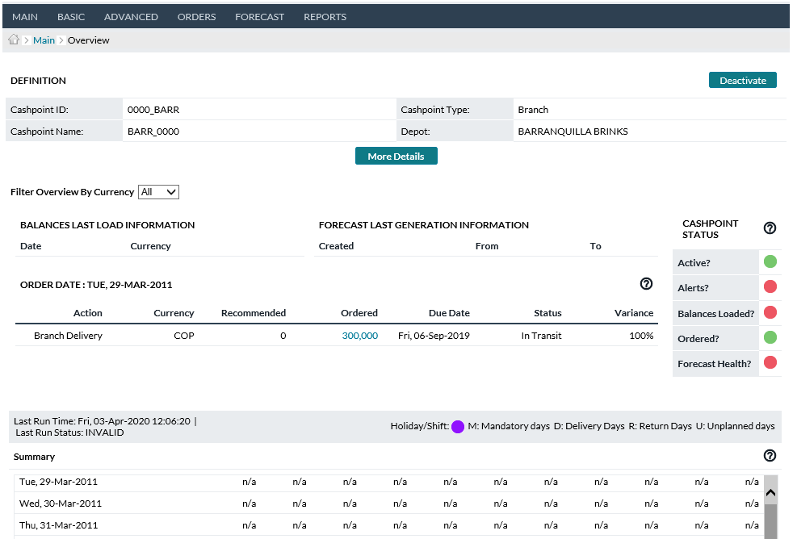

**Cashpoint Window**

Table 16: Cashpoint Overview Description

| Fields | Description |
| --- | --- |
| **Definition** | Shows an overview of the Cashpoint listing the name, Cashpoint ID, and Cashpoint Type. In this section, there is also a button that can be used to Activate or Deactivate the Cashpoint. |
| **Activate/Deactivate Button** | In the Definition section of this page, the user has a button that can be used to activate or deactivate the Cashpoint.  **Note**: Cashpoints can also be Activated from the Maintenance Page. See: Cashpoint Maintenance→Activate/Deactivate Cashpoints |
| **Delete Button** | In the Definition section of this page, the user has the option to Delete the Cashpoint from the system. Note: Only Cashpoints that are inactive can be deleted.  **Caution:** Deleting a Cashpoint is complete and permanent. There is no undo feature; therefore, deleting a Cashpoint removes the Cashpoint along with all parameters, settings, and history. |
| **More Details** | More Details allows the User to expand and show more defining fields from the Cashpoint Definition page. System Administrators can select which fields will be displayed under More Details in the OptiCash Settings portion of the secured Maintenance directory. |
| **Filter Overview by Currency** | Users can filter the History and Horizon displayed on the Overview page. Choices include All or any of the one or more currencies assigned to the cashpoint. |
| **Cashpoint Status** | This section shows status indicators similar to those on the To-Do List, but specific to the current Cashpoint. |
| **Active** | Shows an indicator if the Cashpoint is active/inactive.  **Red** – Inactive  **Green** – Active |
| **Alerts** | Shows an indicator if the Cashpoint has had any type of data alerts in the past 7 days.  **Red** – Data Alerts exist for this Cashpoint in the last 7 days  **Green** – No Data Alerts exist for this Cashpoint in the last 7 days.  Clicking on the indicator will launch the Data Alerts Report Page.  For information about the alerts, see:  Today→Data Alerts Page |
| **Balances Loaded** | Show an indicator to let the user know if balances have been loaded in the last 7 days.  **Red** – No new balances in the last 7 days  **Green** – Balances have been loaded in the last 7 days.  Clicking on the indicator will take the user to the Balance Entry page. For more information on this page, see: Cashpoint→Main→Balance Entry Page |
| **Ordered** | Shows an indicator to let the user know if there are Open Recommendations for this Cashpoint.  **Red** – There are Open Recommendations for this Cashpoint  **Green** – There are no Open Recommendations for this Cashpoint.  Clicking on the indicator takes the user to Cashpoint’s Ordering Page. |
| **Forecast Health** | This indicator is used both as a reminder to verify and improve forecast quality as well as to give a visual indicator as to the forecast quality for the Cashpoint.  **Red** – Indicates a poor forecast health for this Cashpoint.  **Yellow** – Indicates that forecast health is marginal for this Cashpoint.  **Green** – Indicates this Cashpoint has a good forecast quality.  Clicking on the indicator will take the user to the Cashpoint Forecast Analysis Page. See Cashpoint→Forecast→Analysis for more information. |
| **Balances Last Load Information** | Shows a status for each currency as to the last date that history was loaded. Clicking on the hyperlink for the date will take the user to the Cashpoint Balance Entry Page for the day specified. see Cashpoint→Main→Balance Entry Page for more information. |
| **Current Balance Levels (ATM Only)** | Redirects User to the Cashpoint>Main>Balance Entry page which includes the Current Balance Level dashboard report and graphs. For additional information on the Current Balance Level reports please refer to Today→Current Balance Levels  **NOTE**: At the individual ATM level, only the ATM Balances by Denomination, ATM Balances by Cassette Type, and ATM Actual Balance vs. Target are available. |
| **Forecast Last Generation Information** | Shows the user the last date that a Forecast was generated for this Cashpoint including the start and end dates of the Forecast period.  Clicking on the hyperlink for the date will take the user to the Cashpoint Generate Forecast page. For more information on this page, see: Cashpoint→Forecast→Generate Forecast |
| **Order Date:** | Shows the Recommendations and Orders for the current day for this Cashpoint. The following are the fields in this section:  **Action** – Type of service to be performed  **Currency** – The Currency ID for the Recommendation/Order  **Recommended** – The amount that was Recommended to Order (if no Recommendation a zero signifies a manual order)  **Ordered** – The amount that was Ordered (if still an Open Recommendation, the amount will be zero).  **Due Date** – The date that the service will be completed  **Variance** – The percentage difference between the Recommended and Ordered amounts.  Clicking on the hyperlink under the Action column takes the user to the Order Overview for this Cashpoint. For more information. |
| **Reports** | Shows hyperlinks to the Cashpoint reports for Orders, History, Horizon, and Forecast. Clicking on the respective hyperlink takes the user to the Cashpoint report. See: Cashpoint→Reports |
| **Summary** | The Summary section may seem like a simple report, but it is a very powerful tool with a lot of information that is useful to the OptiCash analyst. There are slight differences between the ATM and Branch pages which will be explained below.  The Summary gives information about the history, upcoming deliveries and activity, Delivery and holiday schedules, and predicted balances. The Summary Report is broken up into three sections:  **Gray** – Indicates History which was loaded into OptiCash. This is what happened on each day in terms of balances and activity.  **Yellow** – Indicates Gap History; meaning data was not loaded for those days and therefore OptiCash calculates the balances based on the forecast.  **White** – Indicates the Horizon; meaning the activity and balances that are projected to happen in the coming days. |
| **View By**  **(Advanced Devices only)** | Using the View By button at the top-right corner of the Summary portion, users can select to view the Summary/Horizon by either Values or Pieces. |
| **Gap Data** | Whenever there is missing Daily Load information between the Last Load date and the current day, OptiCash will fill in the data with Gap Data. The Gap Data calculations are essential to keeping OptiCash running if Daily Load data is unavailable for one or more days.  Gap Data is calculated by using the last known Load Balance Information and using the Forecasted daily activity as the ‘Actual’ data. The Gap data is then used as the Last Load Balance to make decisions and Recommendations. The Gap data is shown on the Summary page with a Yellow background. |
| **Date** | Shows the date of the Summary Report for this Cashpoint.  **Grey –** Historical Data loaded into OptiCash.  **Yellow** – Gap Data calculated for the missing days of history.  **White –** Horizon data calculated 45 days in the future based on current Recommendations and Orders.  Hyperlinks are available for the Actual and Gap History days. Clicking on a link takes the user to the Balance Entry page. See Cashpoint→Main→Balance Entry Page for more information.  For Horizon days, a code is shown after the date to indicate holidays and service days. (There is a key provided above the Summary pane.  **Purple Icon –I**ndicates the day is marked as a Holiday for this Cashpoint.  **M -**  Mandatory Delivery Day  **D –** Optional Delivery Day  **R –** Optional Return Day  **U –** Available Unplanned Delivery Day |
| **Currency** | The Currency ID for the entry. |
| **Open Balance** | Shows the Opening Balance for this entry  **Gray –** Historical Opening balance as loaded into OptiCash  **Yellow –** Calculated Opening Balance based on the last known Closing balance.  **White –** Horizon Opening Balance. The Horizon Opening Balance should always equal the prior day’s Closing Balance whether that balance was calculated or actual history. |
| **Pre-Withdrawals**  **(ATM Only)** | The number of withdrawals that will take place before the ATM replenishment.  **Gray** – Historical Pre-withdrawals as loaded into OptiCash  **Yellow** – Calculated Pre-withdrawal amount based on the Pre-Replenishment Percentage Parameter. This will be zero if no Deliveries were scheduled. See:  Table 12: ATM-Specific Parameters  **White** – Calculated Pre-withdrawal amount based on the Pre-Replenishment Percentage Parameter. This will be zero if no Deliveries were scheduled. See:  Table 12: ATM-Specific Parameters |
| **Deliveries** | Shows the Deliveries for this Cashpoint.  **Gray** – Historical Deliveries as loaded into OptiCash  **Yellow** – Committed Orders that were scheduled to be delivered during the gap days.  **White** – Actual committed Orders and/or Open Recommendations that are due to be delivered on that date. |
| **Returns** | Shows the Returns for this Cashpoint. (Branch, Replace Cash ATMs, and Recyclers)  **Gray** – Historical Returns as loaded into OptiCash  **Yellow** – Committed Return Orders that were scheduled to be delivered during the gap days. For Replace Cash ATMs, this number is calculated based on the Opening Balance-Pre-Service Withdrawals.  **White** – Actual committed Return Orders and/or Open Return Recommendations that are due to be completed on that date. For Replace Cash ATMs, this number is calculated based on the Opening Balance-Pre-Service Withdrawals. |
| **Unplanned Deliveries** | Shows the Unplanned Deliveries for this Cashpoint.  **Gray** – Historical Unplanned Deliveries as loaded into OptiCash  **Yellow** – Committed Unplanned Orders that were scheduled to be delivered during the gap days.  **White** – Actual committed Unplanned Orders and/or Open Unplanned Recommendations that are due to be delivered on that date. |
| **Unplanned Returns** | N/A - OptiCash no longer supports Unplanned Returns. |
| **Deposits**  **(Branches and Recycling ATMs only)** | Shows the Deposit summary for this Cashpoint.  **Gray** – Historical Deposits as loaded into OptiCash  **Yellow** – Forecasted Deposit amount for this date  **White** – Forecasted Deposit amount for this date |
| **Withdrawal** | Shows the Withdrawal summary for this Cashpoint.  **Gray** – Historical Withdrawals as loaded into OptiCash  **Yellow** – Forecasted Withdrawals amount for this date  **White** – Forecasted Withdrawals amount for this date |
| **Net Demand**  **(Branches and Recycling ATMs only)** | Shows the Net Demand summary for this Cashpoint.  **Gray** – Historical Net Demand based on Deposit and Withdrawal information as loaded into OptiCash  **Yellow** – Forecasted Net Demand amount for this date  **White** – Forecasted Net Demand amount for this date  **Note**: Forecasted Net Demand can be different depending on the Institutional Forecast Settings. If Net Demand is Calculated, the Forecasted Net Demand should be a product of the Deposits - Withdrawals. If Net Demand is Forecasted, then the Net Demand figure could be drastically different from the product of Deposits – Withdrawals. For more information about this setting, See:  Forecast→Forecast Institutional Settings |
| **Closing Balance** | Shows the Closing Balance for this Cashpoint.  **Gray –** Historical Closing Balance as loaded into OptiCash  **Yellow –** Calculated Closing Balance amount for this date based on Net Demand (Note: that the closing balances will change based on Calculated versus Forecasted Net Demand).  **White –** Calculated Closing Balance amount for this date based on Net Demand (Note: that the closing balances will change based on Calculated versus Forecasted Net Demand).  **Note:** Forecasted Net Demand can be different depending on the Institutional Forecast Settings. If Net Demand is Calculated, the Forecasted Net Demand should be a product of the Deposits - Withdrawals. If Net Demand is Forecasted, then the Net Demand figure could be drastically different from the product of Deposits – Withdrawals. For more information about this setting, See:  Forecast→Forecast Institutional Settings |
| **Required Balance** | Is the amount calculated as the minimum amount of cash that must be in the Opening balance at the start of the day. If the Required balance is higher than the Opening Balance on a given day, an Emergency Delivery may be generated to protect the Cashpoint (unless an exception amount or percentage waives the requirement… see: Table 11: General Cashpoint Parameters for more information)  The Required Balance is always zero for Historical data. For Gap and Horizon days, the calculation varies for ATMs and Branches.  **Branches** – The Required Balance = Safety Stock + Other Requirements + Amount of Withdrawals to Cover – Amount of Deposits Available for Withdrawal.  **Example:**  Safety Stock = 148,700  Other Requirements = 100,000  Withdrawals To Cover = 80%  Deposits Available for W/D = 20%  Forecasted Withdrawals = 467,380  Forecasted Deposits = 121,520  Therefore, the Required Balance =  ( 148,700 + 100,000 + (.80 * 467,380) – (.20 *121,520)) = **598,300**  **ATMs –** The Required Balance depends on whether or not a delivery is scheduled for the day.  **Delivery Days** – Required Balance = Safety Stock + Calculated Pre-Withdrawals  **Non-Delivery Days –** Required Balance = Safety Stock + Forecasted Withdrawals  **Example :** (Delivery Day)  Safety Stock = 10,000  Pre-Replenishment Percentage = 50%  Forecasted Withdrawals = 50,000  Therefore, the Required Balance =  (10,000 + (.50 * 50,000)) = **35,000**  **Example:** (Non-Delivery Day)  Safety Stock = 10,000  Pre-Replenishment Percentage = 50%  Forecasted Withdrawals = 50,000  Therefore, the Required Balance =  (10,000 + 50,000) = **60,000** |

Return To: Cashpoint Window

## Cashpoint→Main→Balance Entry Page

At the Cashpoint level, the user can add or change historical data from the Balance Entry Page. To access a particular date, the user must select a date and click on the **Submit** button. Additionally, Denomination balances can be accessed by selecting the Load Balance By Denomination and clicking on Submit.

Denomination-level balance entry also allows for entry by Cash Quality. OptiCash will only generate quality-defined Recommendations/Order for Branch Returns and Recycling-ATM returns, but balance tracking by quality is possible for all cashpoint types. For details on Cash Quality please see System→Currencies/Denominations→Cash Quality.

Figure 11: Currency Balance Entry Page

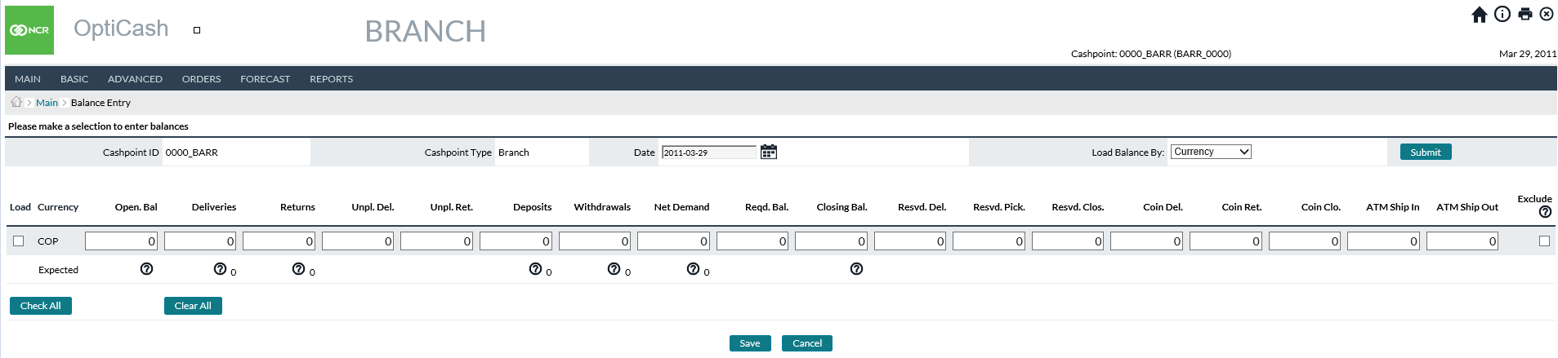

Figure 12: Denomination Balance Entry Page

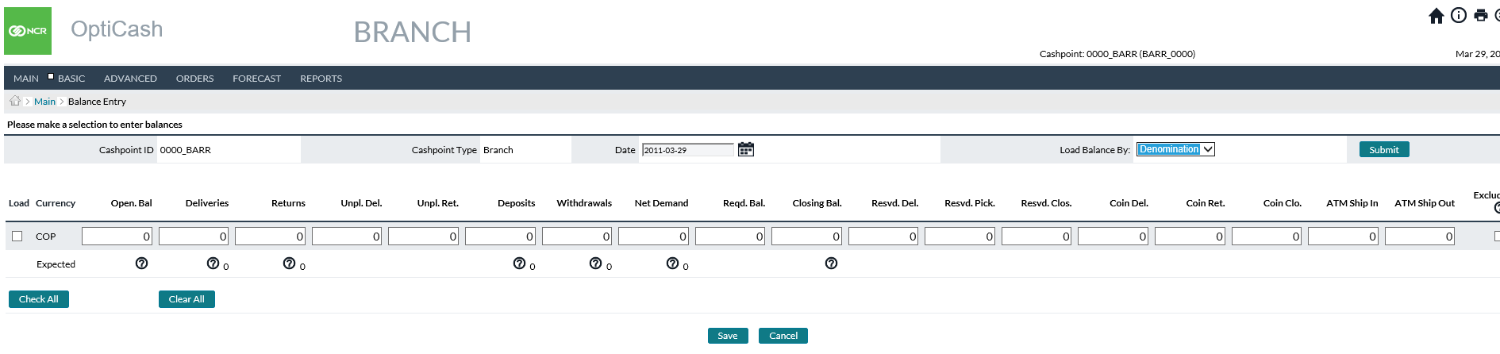

Table 17: Balance Entry Description

| Field | Description |
| --- | --- |
| **Cashpoint ID** | Unique alphanumeric code that identifies the Cashpoint. |
| **Cashpoint Type** | Branch or ATM. |
| **Date** | Choose a date from the calendar, for which the balance information will be displayed. |
| **Load Balance By** | Choose whether to load the balance by currency or denomination. |
| **Load** | Check the box when loading a balance for the selected currency. |
| **Currency** | Unique alphanumeric value for this currency. |
| **Opening Balance** | The initial balance represents the last load balance load during the load process. |
| **Deliveries** | Planned deliveries and committed orders. |
| **Returns** | For branches, replace or recycle ATMs represent the amount of cash returned. |
| **Unplanned Delivery** | Delivery is done without normal planning (triggers different cost values). |
| **Unplanned Returns** | Return done without the normal planning (triggers different cost values). |
| **Withdrawals** | The amount representing customer withdrawals. |
| **Pre-Withdrawals** | The withdrawal amount during a service day before the carrier arrives. |
| **Required Balance** | Required calculated inventory at the beginning of the day. |
| **Closing Balance** | Closing balance at the end of the day. |
| **Operational** | Check the box if the Cashpoint is operational. |
| **Exclude** | If the **Exclude** box is checked, the forecast will not include this record in its basis for predictions. |
| Branches only: | |
| **Deposits** | Represent customer deposits. |
| **Net Demand** | Total Deposits minus total withdrawals. |
| **Resvd. Del.** | This is an optional field for branch reserved cash delivery. |
| **Resvd. Pick.** | This is an optional field for branch reserved cash pick-up. |
| **Resvd. Clos.** | This is an optional field for the branch reserved closing balance. |
|  | **Reserved cash** is part of the cash holdings at end of the trading day but is reserved for special customers. Reserved cash is put aside for special customer collection and is not used to service other customer withdrawals.  **Note:** Reserved cash will not affect the opening and closing balance for the branch at the end of the day. When recommendations run, normal forecasted demand will be taken into consideration. However, recommendations will decide based on available cash to cover forecasted demand. Since reserved cash will affect available cash, the next day’s opening balance will equal the last day’s closing balance less the reserved cash balance. |
| **Coin Del.** | This is an optional field for branch coin delivery. |
| **Coin Ret.** | This is an optional field for branch coin return. |
| **Coin Clos.** | This is an optional field for branch coin closing balance. |
| **ATM Ship In** | For branches with onsite ATMs: total returns received into branch funds from linked Cashpoints (funds are not considered customer deposits). |
| **ATM Ship Out** | For branches with on-site ATMs: total replenishments from branch funds to linked Cashpoints (funds are not considered customer withdrawals). |
| Recycling ATMs only: | |
| **Deposits** | Represent customer deposits. |
| **Dispense** | The amount available in the cassette is configured to only dispense notes. |
| **Recycle** | The amount available in the cassette is configured to receive deposits and can dispense as withdrawals. |
| **Cash-In** | The amount available in the cassette is configured to receive deposited notes only and cannot be used by the machine to dispense as a withdrawal. |

|  |  |
| --- | --- |
|  | **Note**: If you choose today or a future date, gray columns will be displayed showing the expected amounts under the fields of Open Balance, Deliveries, Returns, Deposits, Withdrawals and Closing Balance. You can enter your amounts for this future date and click Save to save your entry. If you choose a past date, actual amounts will be displayed, which, if necessary (for instance, if there are errors in the balance load), can be edited by clicking on the button Edit. |

Return To: Cashpoint Window

## Cashpoint→Main→Current Balances

The Balance Entry page also contains the Current Balance Levels defined in Today→Current Balance Levels portion of the User Guide. At the individual ATM level, the reports show Balances by Denomination, ATM Balances by Cassette Type, and ATM Actual Balance vs. Target reports and graphs. For Branches, the page displays the last loaded balance, For more information, please refer to Today→Current Balance Levels.

Figure 13: ATM Current Cash Levels Page

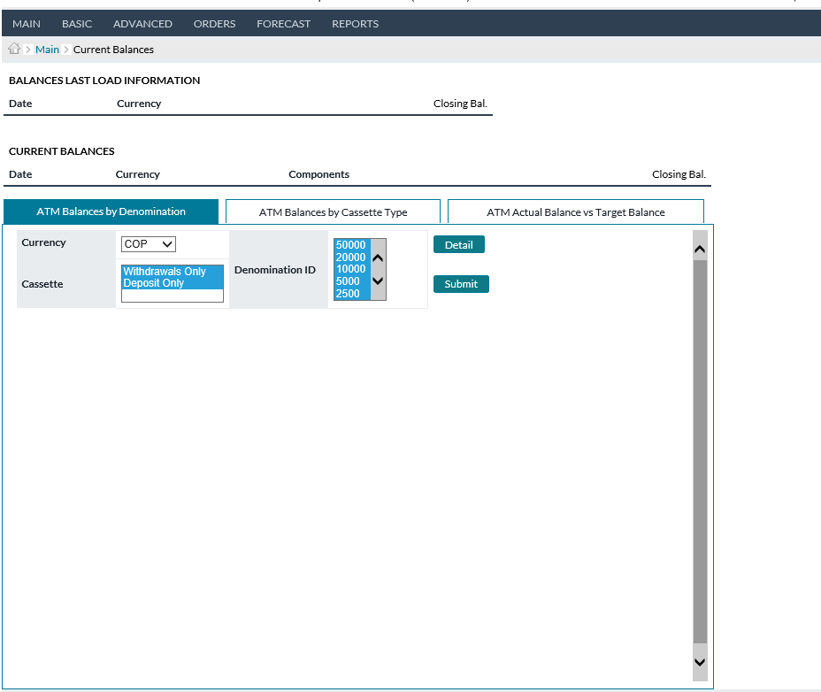

Figure 14: Branch Current Cash Levels Page

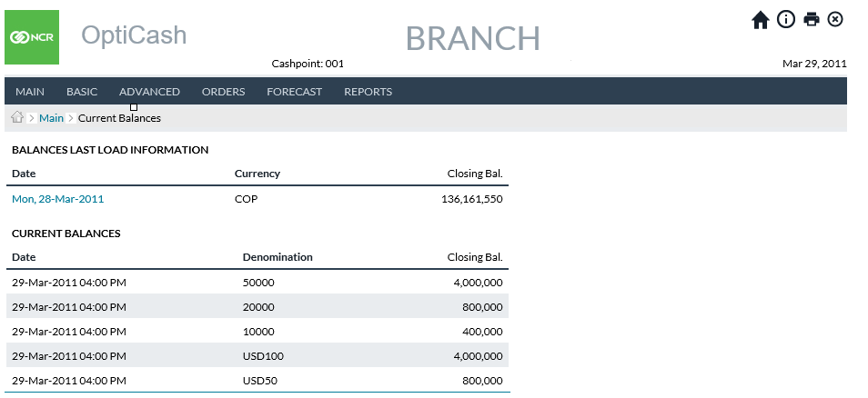

## Cashpoint→Basic→Cashpoint Definition

This page of the Cashpoint window shows the informational parameters about Cashpoint. It defines the Cashpoint ID and name, assigns the Depot and Region, and provides demographic data. For more information on individual fields, see: Table 8: Cashpoint General Definitions

Figure 15: Cashpoint Definition Page

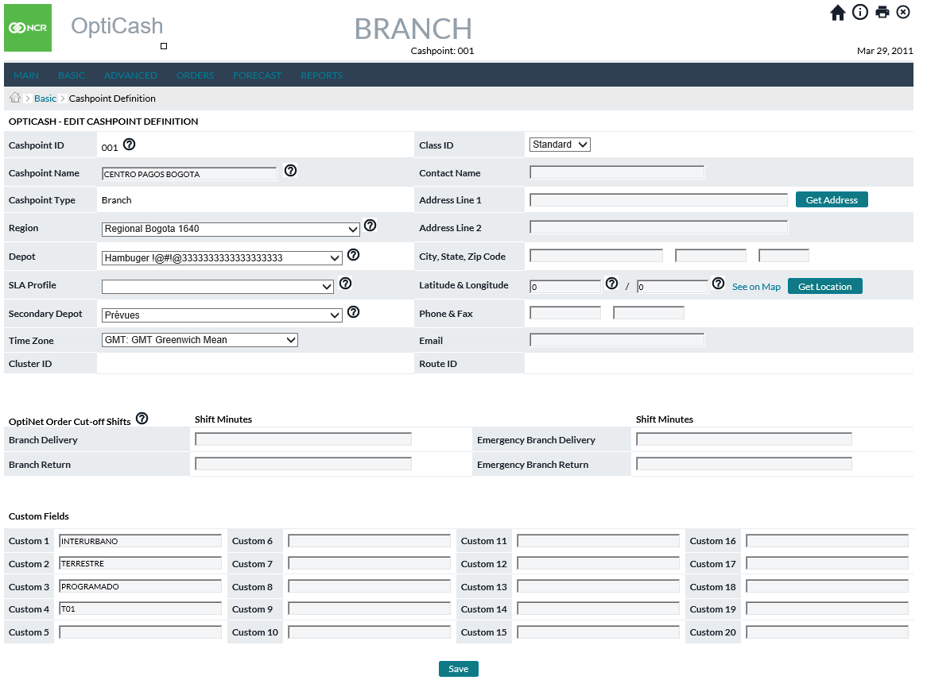

Return To: Cashpoint Window

## Cashpoint→Basic→Parameters

The Basic Parameters page allows the user to set parameters specific to the cashpoint. The user should ensure that the values on this page are correct based as they will Affect the quality of forecasts and recommendations. For additional information, see the following tables:

* Table 12: ATM-Specific Parameters
* Table 13: Branch-Specific Parameters

Figure 16: Branch Parameters Page

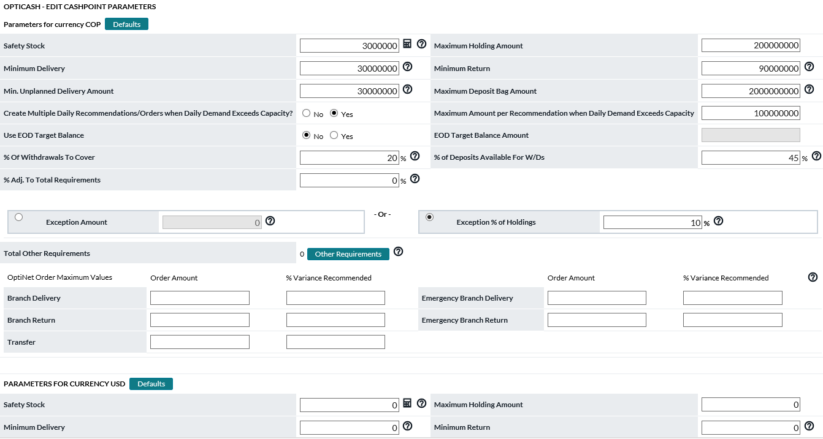

Return To: Cashpoint Window

Figure 17: ATM Parameters Page

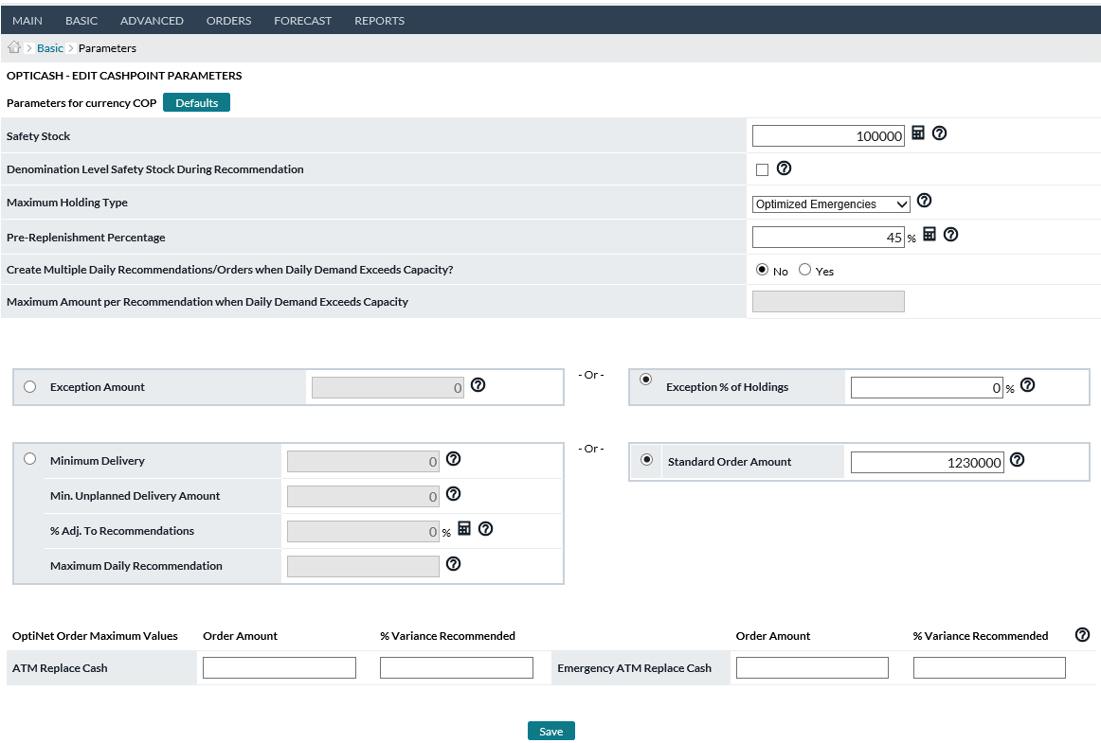

Return To: Cashpoint Window

Figure 18: Advanced Device Parameters Page

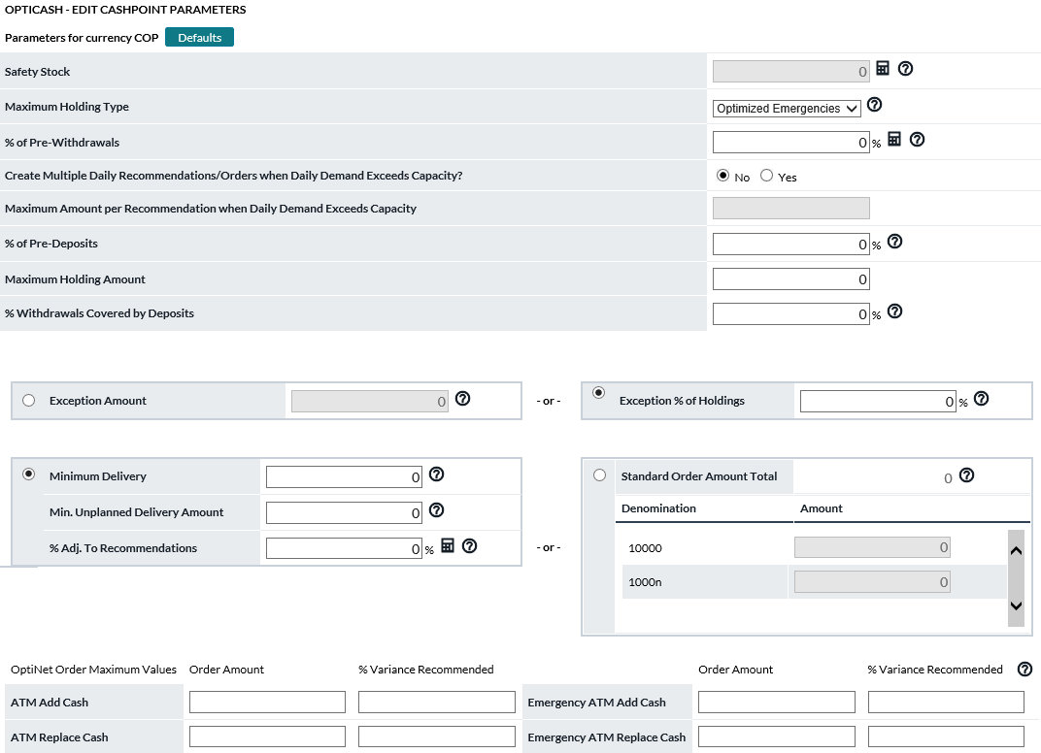

Return To: Cashpoint Window

## Cashpoint→Basic→Service Days

The Service Days page allows the user to control the business days and service days for a Cashpoint. For additional information on these parameters, see: Table 14: Business and Service Days Description

Figure 19: Branch Service Days Page

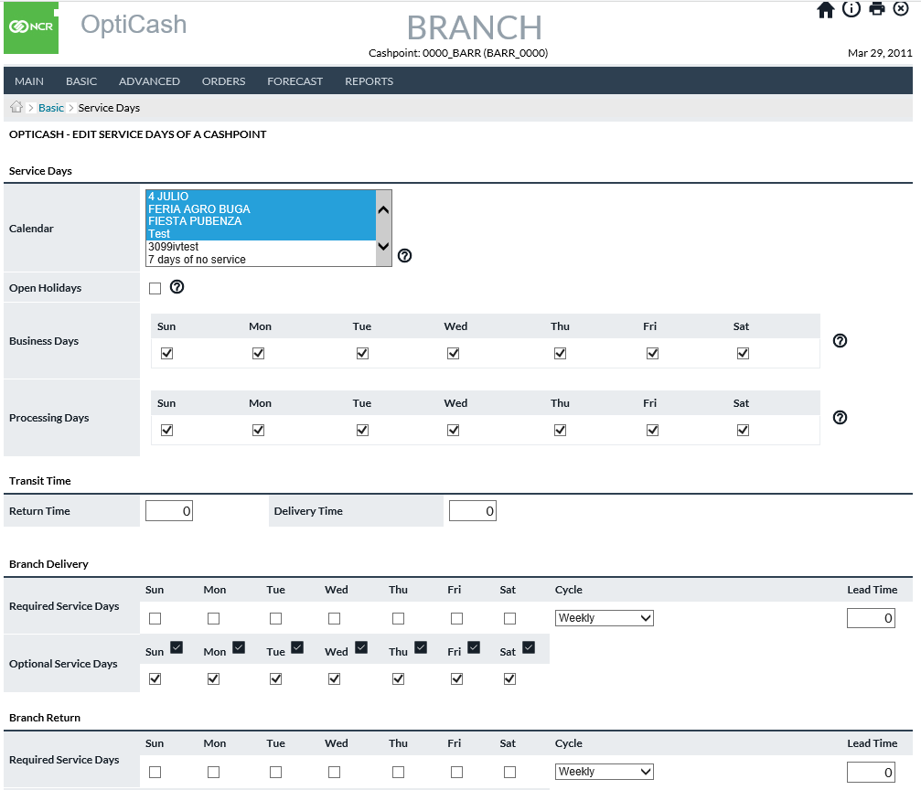

Return To: Cashpoint Window

Figure 20: ATM Service Days Page

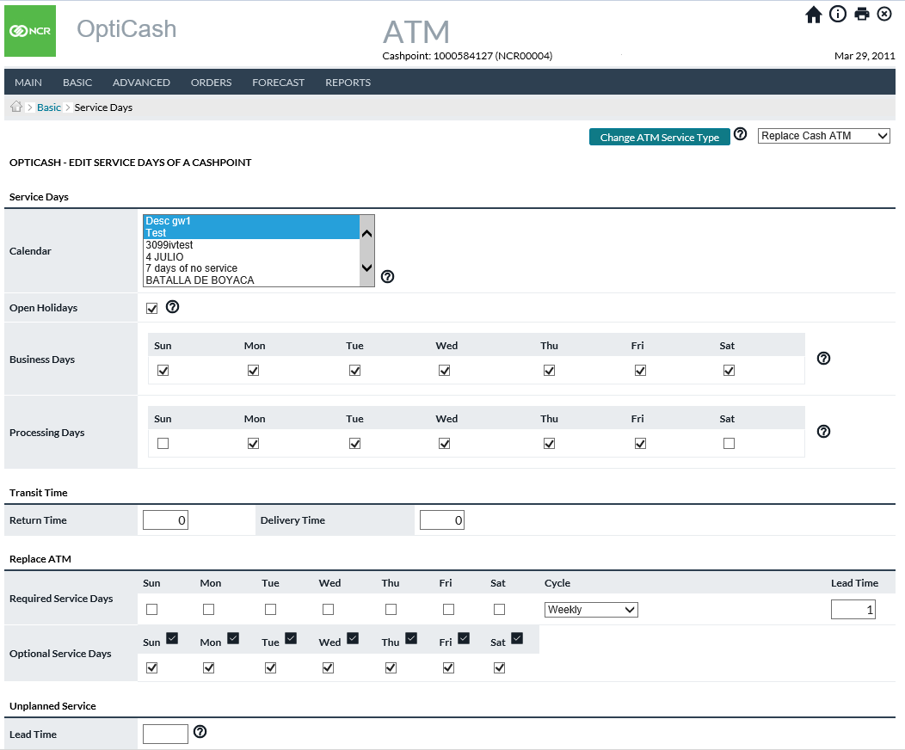

Return To: Cashpoint Window.

Figure 21: Advanced Device Service Days Page

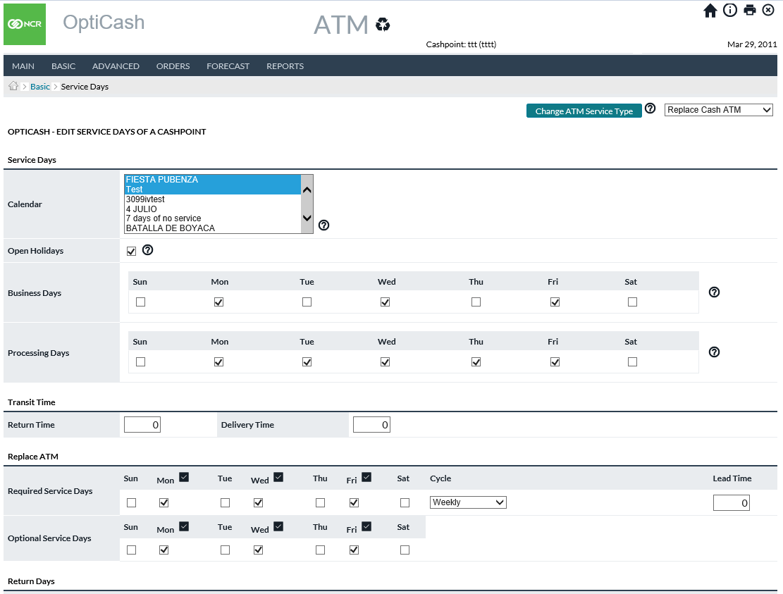

Return To: Cashpoint Window.

Figure 22: Service Exceptions

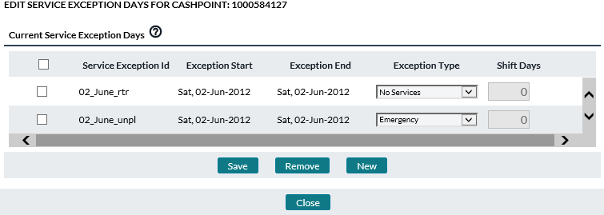

Figure 23: View Service Days



## Cashpoint→Basic→Denominations

The Denominations page allows users to assign denominations to a Cashpoint and set parameters specific to those denominations.

For more information on Denominations, see: Currencies/Denominations→Denominations Page

Figure 24: ATM Denomination Page

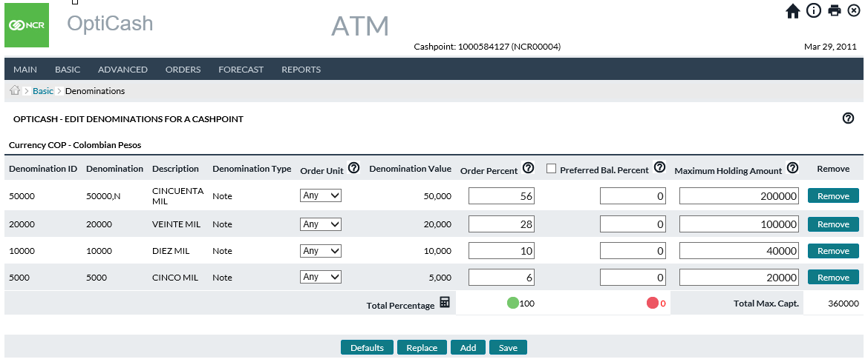

Figure 25: Branch Denomination Page

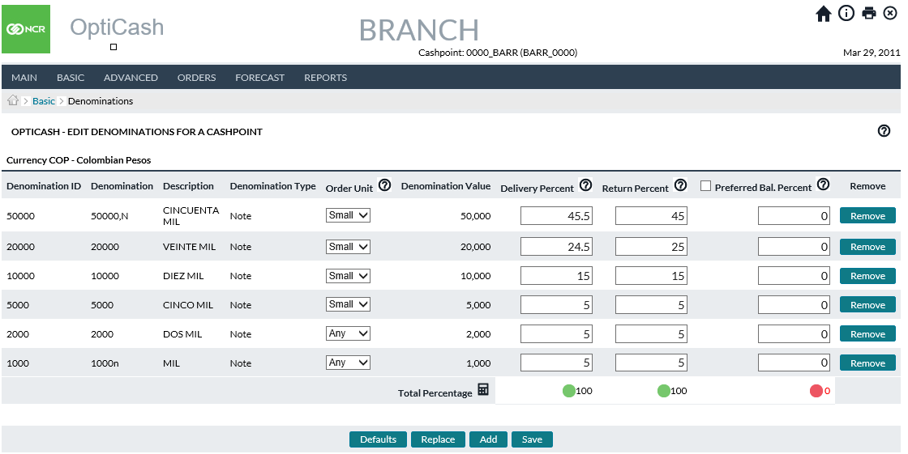

Return To: Cashpoint Window

## Cashpoint→Basic→Denominations (Special Consideration for Advanced Devices)

Figure 26: Advanced Device Denomination Page

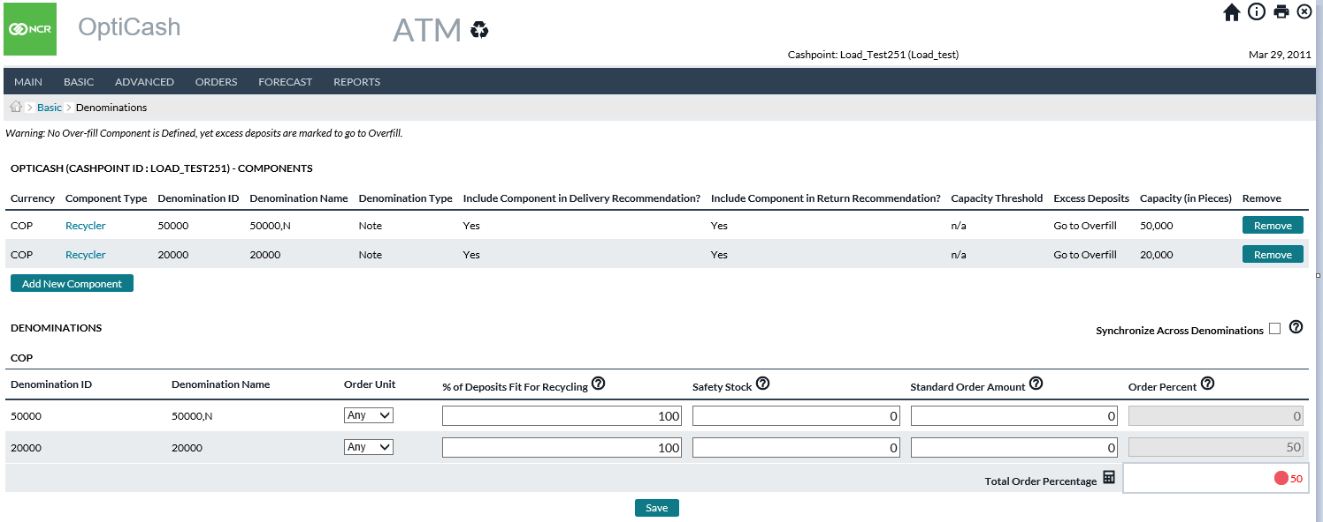

Return To: Cashpoint Window

Advanced Devices (Recyclers, Deposit ATMs, etc. – not Branches or Dispensing ATMs) in OptiCash look at “**components**” rather than denominations. Components are containers or cassettes. Each component can be Deposit only, Withdrawal only, or Recycling where it is configured to both receive and dispense. The capacity of the component is measured in physical (note count and coin count) terms rather than the standard value capacity.

Components can be assigned to contain specific denominations or notes or coins or they can be “**Mixed Note**” or “**Mixed Coin**” as are commonly used for Deposit-only machines where it is unknown what users will need to deposit.

When configuring a component, the OptiCash analyst will determine each of these settings as indicated in the table below.

Table 18: Advanced Device Components and Denominations Fields

| Field | Description | |
| --- | --- | --- |
| **Currency** | The currency to which the record applies. | |
| **Component Type** | Definition of the usage of the component (cassette).  **Withdrawal Only** – The component will only dispense currency  **Deposit Only** – The component will only receive currency  **Recycler** - The component will both dispense and receive | |
| **Denomination Name** | Defines the denomination handled by the component. Available options are any denomination defined as usable for ATMs or the **“Mixed Note”/”Mixed Coin”** options. The latter two are intended for usage in Deposit Only components where it is unknown what the users will be depositing. | |
| **Include Component in Delivery Recommendation** | Allows each unique component to be included/not included in the Recommendation process when determining Deliveries  Options are Yes/No | |
| **Include Component in Return Recommendation** | Allows each unique component to be included/not- included in the Recommendation process when determining Returns  Options are Yes/No | |
| **Capacity Threshold** | Percentage setting (0-100%) that creates an upper bound to trigger a Return recommendation. OptiCash will automatically trigger a Return Recommendation when full capacity is reached, but this setting will allow for a measure of safety against the risk of filling up and no longer being able to accept Deposits | |
| **Excess Deposits** | Tells the Recommendation process what to do in the Horizon when predicted Deposits will be more than the applicable component. Options available are:  **Go to Overfill –** will drive Excess Deposits to the Overfill component. This option would most likely apply to Recycler components and known-denomination deposit-only components  **Trigger Return** – This option works in conjunction with the “Capacity Threshold” setting. When the predicted balance gets within the threshold, a Return recommendation will be generated.  **Ignore** – This option tells the recommendation process to allow Excess Deposits to be ignored and not counted. This option would be applicable in situations where deposits above capacity are rejected. | |
| **Capacity (in pieces)** | Defines the physical capacity of the component in either coin or note count rather than value. This is the physical number of notes or coins that can be held by the component. | |
| **Delivery Unit**  (Denominations table) | Options are Large, Small, and Any as defined in the *Settings>Currencies/Denominations>Denominations page.* | |
| **% of Deposits Fit for Recycling**  (Denominations table) | Allows for Denomination-level definitions of what is suitable for recycling. (e.g., the USD 1 note is normally of poor quality and not suitable but other denominations often are) | |
| **Standard Order Amount**  **(**Denominations table) | | A static replenishment/replacement amount that will override the recommendation amount calculated by the system. Available for situations where the carrier or operational restrictions require that the same amount of cash be delivered on every scheduled delivery.  **Note**: Standard Order Amounts are applicable only for Replace type services (Add Cash services would not be used). Additionally, the Standard Order Amount should be set to equal Maximum Capacity. (Both values represent the largest amount of cash that will be present). This Standard Order Amount column is greyed out if the Standard Order Amount option in the *Basic > Parameters* page is disabled. |
| **Synchronize Across Denominations**  **(Denominations table)** | This option causes any Replace delivery recommendation that is created to include all denominations. Use this if there is an operational or physical constraint that prevents servicers from Replacing some components and not others. For example, if the ATM balance includes 100 notes sufficient to cover demand until the next service but 50 notes are not enough, then enabling this option will cause the current Recommendation to include Replace of both 100 and 50 notes. Disabling this option would mean instead Recommendation for 50 notes only.  **Note**: This option applies for Replace Cash, and not Add Cash service. | |

Figure 27: Advanced Device CompoNent Definition Page

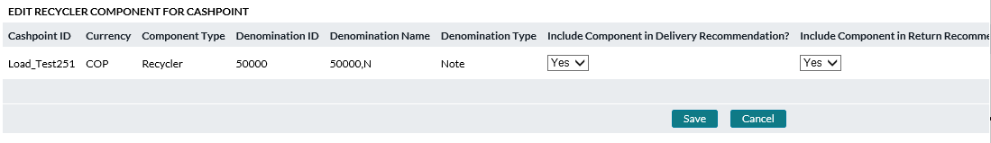

Return To: Cashpoint Window

## Cashpoint→Basic→Non-Cash Media

The Non-Cash Media Page allows the user to assign Non-Cash Media to the Cashpoint. These must be pre-defined before they can be assigned. For more information on setting up and assigning Non-Cash Media, see:   
Currencies/Denominations→Non-Cash Media Page

Figure 28: Non-Cash Media Page

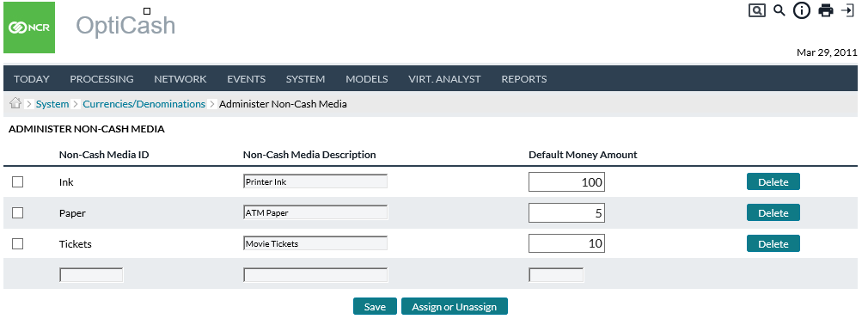

Table 19: Non-Cash Media Description

| Field | | Description | |
| --- | --- | --- | --- |
| **Non-Cash Media ID** | | Unique alphanumeric value for identification of this media. | |
| **Non-Cash Media Description** | | Description of non-cash media. | |
| **Default Money Amount** | | The amount which will be ordered along with each Normal Cash order. | |
| **Add Button** | | To add a new Non-Cash media, click **Add** and choose non-cash media from the list available and click the **Assign** button to assign the selected media to this Cashpoint. Note that the list for non-cash media is defined and managed on the network level under the *System tab → Currencies/Denominations → Non-Cash Media.* | |
| **Update Button** | | It is only possible to enter changes in the order amount. To save the changes, click the **Save** button. | |
|  | **Note**: When a non-cash media is defined for a Cashpoint, recommendations for that Cashpoint at the Cashpoint level and in OptiNet will also include the non-cash media order amount. | |

Return To: Cashpoint Window

## Cashpoint→Basic→Linkage

There are some instances when Cashpoints need to be linked to another Cashpoint for logistical purposes or the purpose of sharing costs, schedules, or vaults. ATMs can be Linked to other ATMs or Branches, and Branch-to-Branch linkage is possible. Note that an ATM cannot be the parent of a branch, and multi-level aggregation is not automatically supported. Users could manually create aggregation between parent and child branches by running their Optimization processes in sequence, but OptiCash does not automatically aggregate.

OptiCash also facilitates the tracking of different intra-branch accounts cashpoint linkage to those specific accounts via the Balance Account dropdown.

Figure 29: Cashpoint Linkage Page

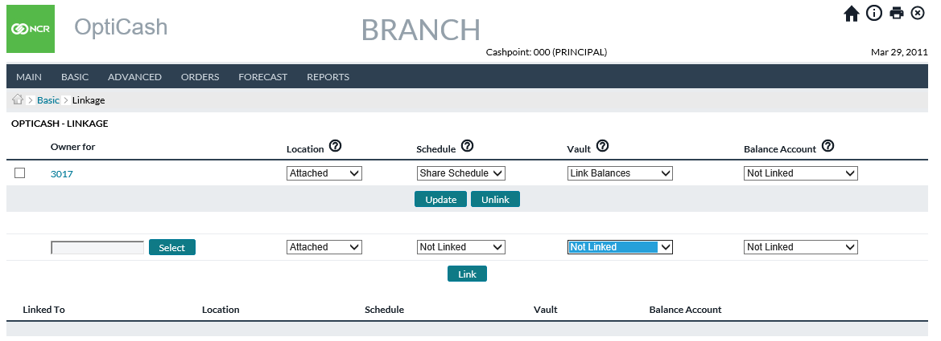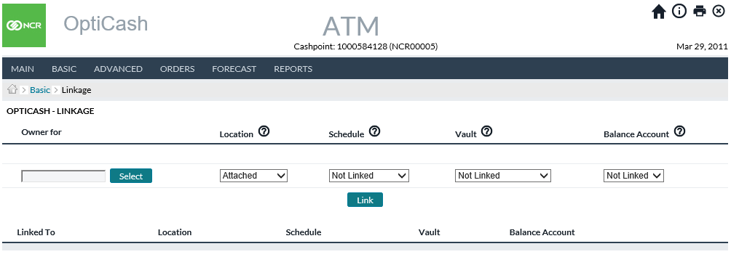

Table 20: Cashpoint Linkage Description

| Field | Description |
| --- | --- |
| **Select Button** | Used to select a Cashpoint ID to be linked. |
| **Owner For** | The unique ID of the ATM is to be linked with this Cashpoint. |
| **Location** | Indicates the physical relationship between the Cashpoint and the location it is linked to.  **Attached** - Indicates an ATM is physically located at the linked-branch location and is not serviced by the branch staff  **On-Site** - Indicates an ATM is physically located at the linked-branch location and is serviced by the branch staff.  **Off-Site** - Indicates an ATM is not physically located at the linked-branch location and is not serviced by the branch staff.  **Side-by-Side** - A group of ATMs located in the same area, general vicinity, or location (i.e., shopping malls, airports. City centres). Side-by-Side will be used for cluster ATMs described in section Clusters.  **Note:** When location selection is not used in conjunction with other linkage attributes (costs, schedule, or vault), then the linkage is limited to location information only and will not affect the optimization process. |
| **Schedule** | Indicates if the service schedule will be shared between these Cashpoints.  **Not Linked:** No linkage established  **Share Schedule** - The optimization process will use the delivery schedule as defined by the controlling Cashpoint (Branch or Parent ATM for clustering). |
| **Vault** | The accounting/general ledger relationship, if any, between the Cashpoints it is linked to.  **Not Linked -** No linkage established  **Linked Balances -** The optimization process will optimize each of the linked ATM’s consumer demand for cash, aggregate the results to the linked branch, and then optimize the branch horizon producing a single vault order.  **Linked Orders -** The optimization process will optimize each Cashpoint's consumer demand for cash independently, and then aggregate the results producing a single vault order.  **Aggregated Horizon** - This causes orders for the linked child cashpoints to be added to the delivery/return of the parent cashpoint. It is intended to be used in situations where a group of cashpoints is optimized together (history, forecast, recommendations, and all settings are in 1 parent cashpoint), but then ordering is separate for each cashpoint. Think of like 1 “nexus” branch that is over several smaller nearby branches: In OptiCash the entire group is represented by 1 cashpoint, but then users take that 1 recommendation for the entire group and place manual orders at all the cashpoints separately. If “Aggregated Horizon” was not used, then the Recommendations process at the parent would not know about the orders at child cashpoints and think that too much or too little cash would be coming in future, and thus bad recommendations. |
| **Balance Account** | This linkage permits users to link child cashpoints to separate account balances within the branch such as a linked onsite ATM balance, an Emergency Reserve balance, or any balance account setup by users in the Network/Balance Types screen.  There are 3 pre-configured balance types with the ability for users to create more. See NETWORK→BALANCE TYPES for instructions on creating and editing different balance types.  **Not Linked** - No linkage established  **Branch ATMs** – Funding account for ATMs serviced by branch employees using branch funds.  **Branch Deposit ATMs** – Funding for Deposit ATMs and/or Recyclers  **Branch Reserve** – Balance reserved for a “what-if” emergency situation.  See NETWORK→BALANCE TYPES for instructions on creating and editing different balance types. |

Return To: Cashpoint Window

## Cashpoint→Advanced→Costs

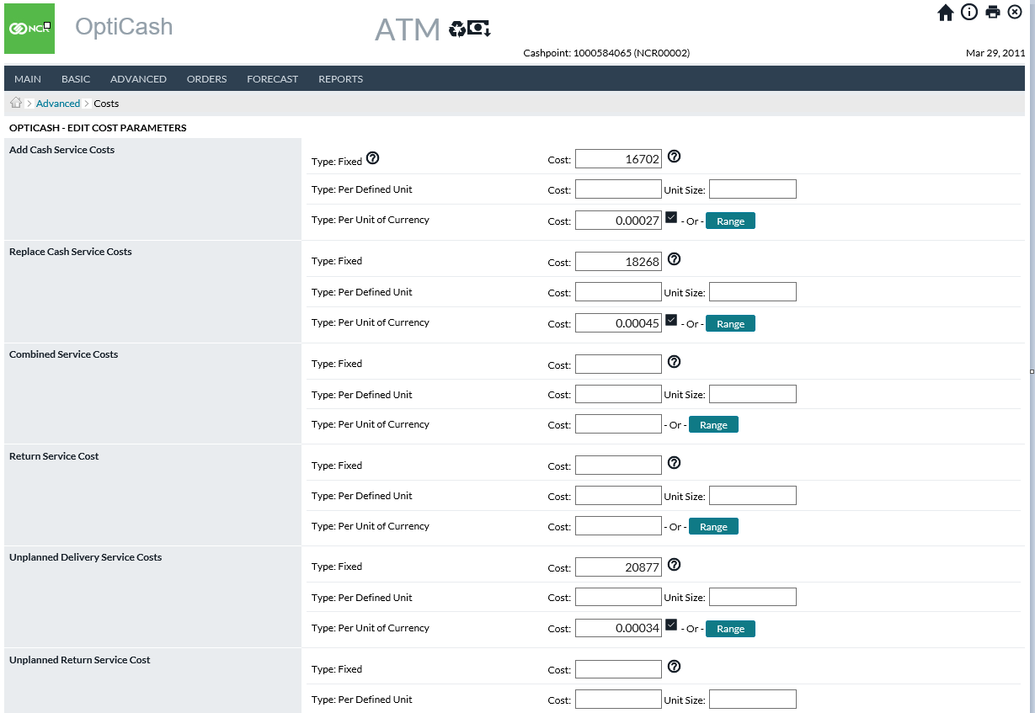

The *Advanced→Costs* page allows the user to set or change the cost options for the Cashpoint. See Cashpoint Service Costs for further details.

Figure 30: ATM Costs Page

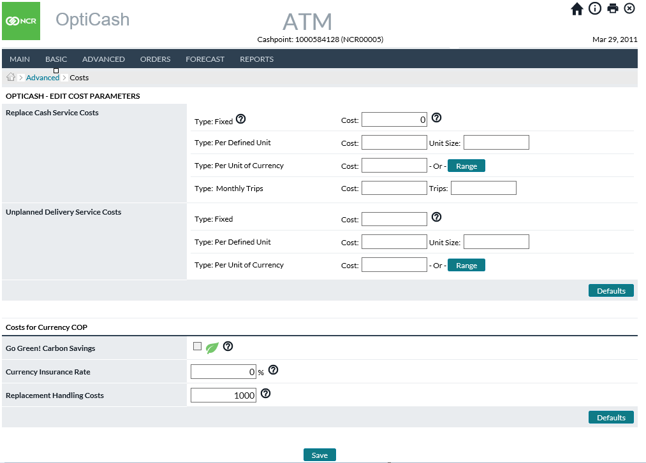

Return To: Cashpoint Window

Figure 31: Recycler ATM Costs Page

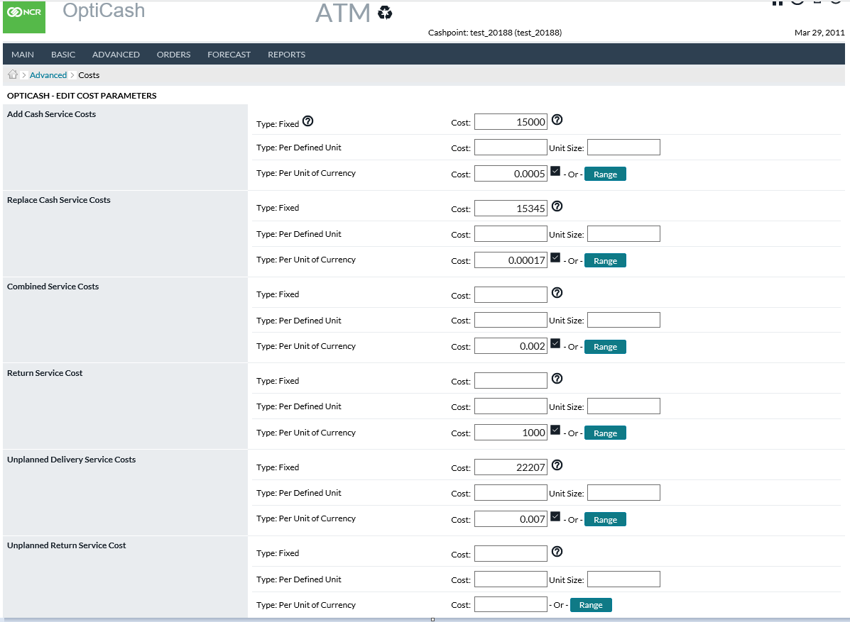

Figure 32: Branch Costs Page

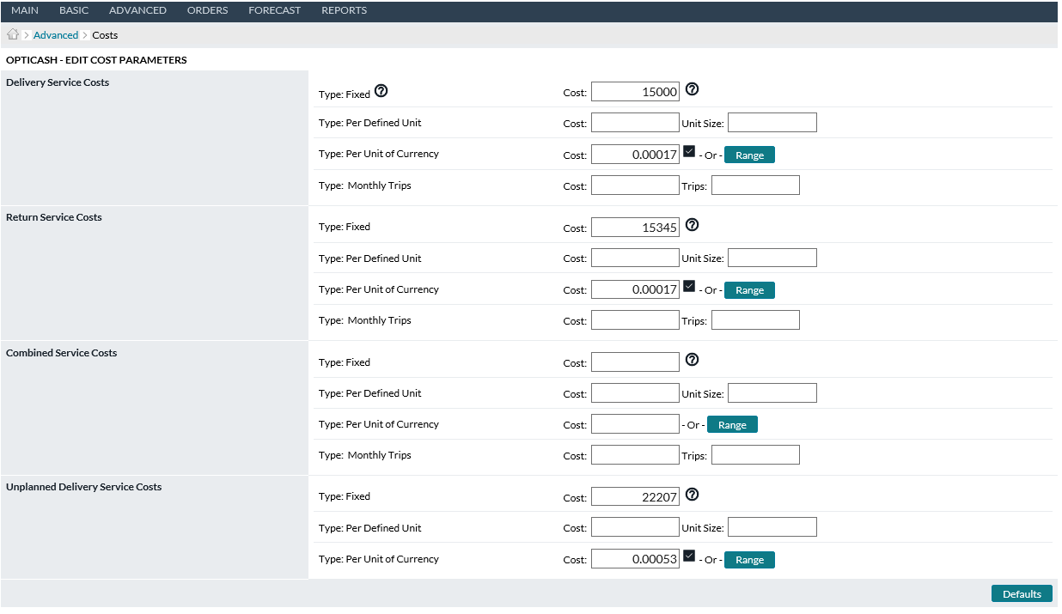

Return To: Cashpoint Window

## Cashpoint→Advanced→Parameters

The *Advanced→Parameters* page allows the user to set parameters specific to the Cashpoint for days of the week or a specific date. The parameters are the same as the default *Basic→Parameters* but simply temporarily override parameters depending on the option selected (Day of the Week or a Specific Date).

The user should ensure that the values on this page are correct based on the quality of the forecast and recommendations. For additional information on these parameters, see the following tables:

* Table 12: ATM-Specific Parameters
* Table 13: Branch-Specific Parameters
* Table 14: Business and Service Days Description

Figure 33: ATM Advanced Parameters Page

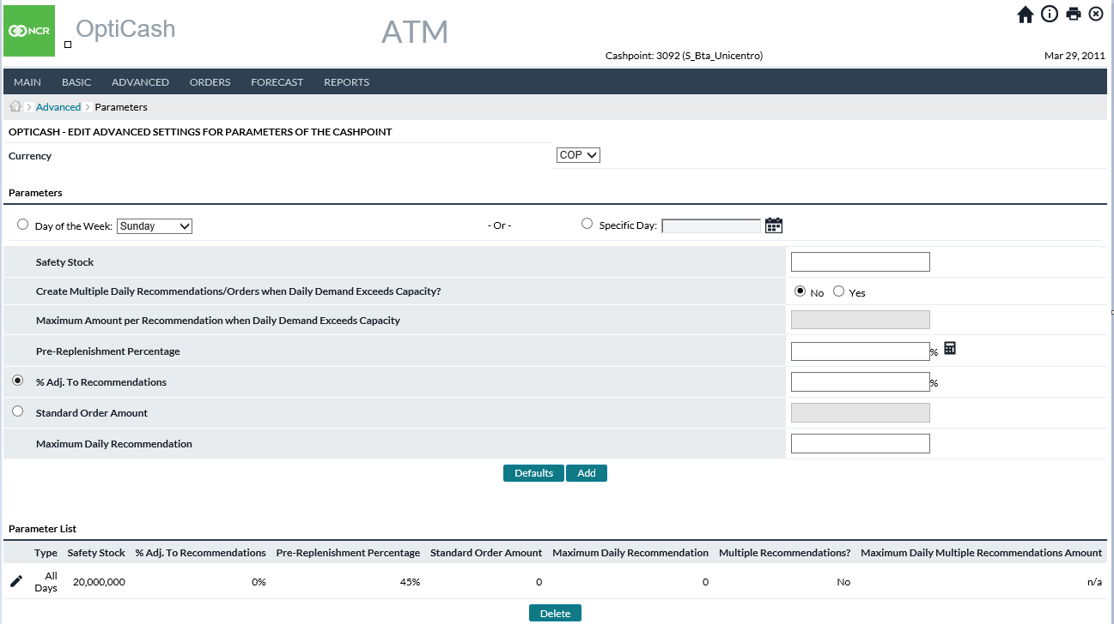

Figure 34: Branch Advanced Parameters Page

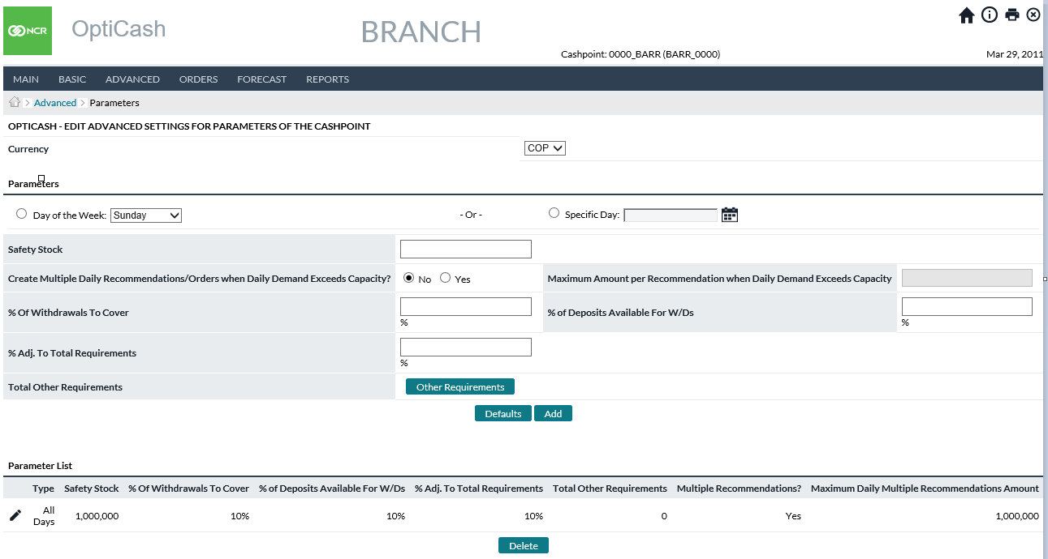

Figure 35: Advanced Device Advanced Parameters Page

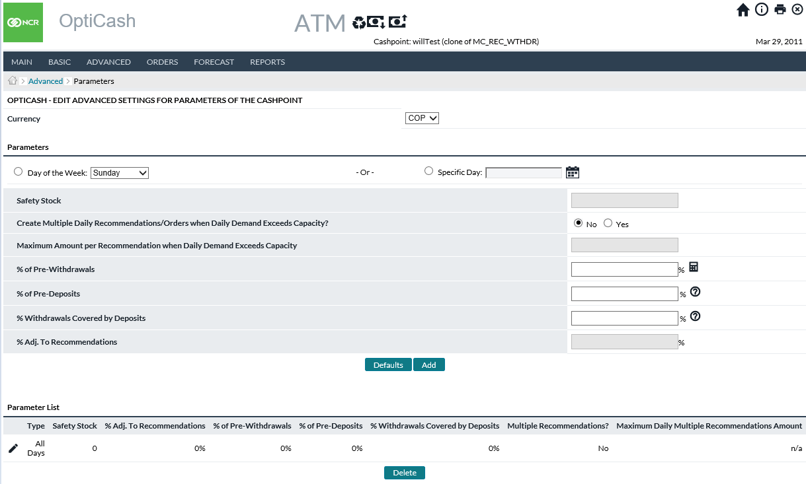

Return To: Cashpoint Window

## Cashpoint→Advanced→Foreign Currency Service Days

The Foreign Currency Service days are used to override the Service Days used for Optimized Currencies with delivery, return, and emergency days and lead times. The *Cashpoint→Advanced→Foreign Currency* Service Days page allows the user to add, remove, or edit Foreign Currency Service Days for a Cashpoint.

Foreign Currency Service Days can be assigned to one or more Cashpoints from the System page. This section will describe the elements specific to the Cashpoint level. For additional information on this page or to see how Foreign Currency Service Days are mass assigned, see Network→Defaults Page

Figure 36: Foreign Currency Service Days Page

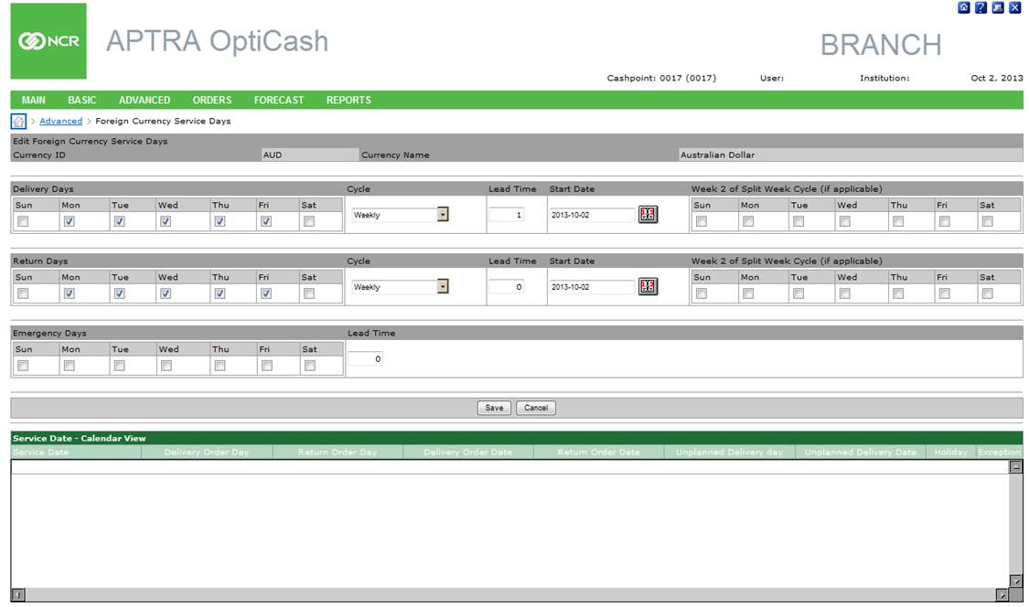

Table 21: Foreign Currency Service Days Description

| Field | Description |
| --- | --- |
| **Foreign Currencies With Custom Service Days list** | A list of currently assigned Foreign Currency Service Days is displayed on the main page of the Foreign Currency Service Day page. Clicking on the hyperlink for the Currency will display the current settings for the corresponding Foreign Currency for review or editing purposes |
| **Add Currency** | Displays a list of Foreign Currencies that has not yet been assigned to Cashpoint. The analyst can select a currency from the list and click the ‘**Submit’** button to define the parameters for the Foreign Currency |
| **Submit Button** | Submits the Foreign Currency selected in the adjacent field to be defined for the Cashpoint. |
| **Save Button** | Saves Changes made to the Foreign Currency Service Days for the selected Currency. |
| **Remove Settings Button** | Removes all Service Day Assignments for the selected Currency |
| **Calendar View** | A visual report is displayed with the available Delivery, Return, or Emergency Schedule for the selected currency. This calendar is populated after the ‘Save’ button has been clicked and represents the settings defined for the selected Currency. |

Return To: Cashpoint Window

## Cashpoint→Advanced→Linkage

Advanced Linkage provides control over the Safety Stock, Optimization, and inclusion in branch demand for branch accounts. See Cashpoint→Basic→Linkage for definitions of different branch accounts.

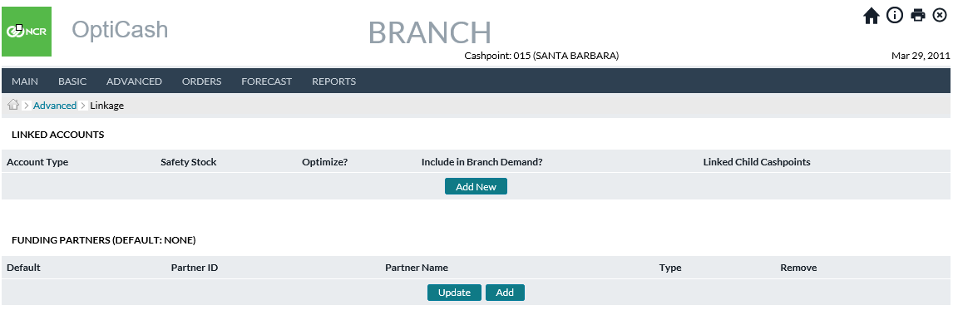

Table 22: Advanced LInkage Field Descriptions

| Field | Description |
| --- | --- |
| **Account Type** | Hyperlinked listing of all Balance Accounts utilized by that branch. By clicking on the hyperlinks, the user can edit the Safety Stock, Optimize, and Include in Branch Demand fields |
| **Safety Stock** | Sets a Safety Stock (minimum balance) in for the unique Balance Account. The absence of a value assumes a 0-Safety Stock |
| **Optimize** | A Yes/No setting to determine if that Balance Account will be optimized by the OptiCash engines |
| **Include in Branch Demand** | A Yes/No setting to determine if that Balance Account’s predicted deliveries and returns will be added to the parent branch deposits and withdrawals |
| **Linked Child Cashpoints** | A hyperlinked list of child cashpoints linked to /associated with the unique Balance Account |

Return To: Cashpoint Window

## Cashpoint→Advanced→Linkage→Add New

Users can add additional Balance Accounts by clicking the Add New button at the bottom of the Account Type column. Clicking will generate the Add New screen. The user will select the un-associated Balance Account and then define the Safety Stock, Optimize, and Include Branch Demand Fields per the requirements of the bank. See Table 22: Advanced Linkage Field Descriptions for definitions of the fields in question.

Figure 37: Custom Linkage Add New Screen

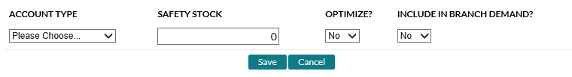

## Cashpoint→Advanced→Linkage→Funding Partners

Users can add additional Funding Sources by clicking the Add button at the bottom of the screen. Funding Partners can be removed by checking the associated Remove box and selecting Update. By clicking Default and then Update, Users, establish one Partner as the default which will be auto filled on the Create New Transfer screen. Other Partners can still be selected instead of the default whenever the User requires.

Figure 38: Funding Partner Linkage Screen



Table 23: Advanced Linkage Field Descriptions

| Field | Description |
| --- | --- |
| **Default** | The preferred Funding Partner will autofill in the Funding Partner dropdown located on the Create New Transfer screen. |
| **Partner ID** | Cashpoint ID of each Funding Partner |
| **Partner Name** | Cashpoint Name of each Funding Partner |
| **Type** | Cashpoint Type of each Funding Partner |
| **Remove** | Allows users to remove Funding Partners from the list. Users click the appropriate Remove box and select Update at the bottom of the screen |

Return To: Cashpoint Window

## Cashpoint→Orders→Order Overview

The Order Overview page gives detailed information about the status of the orders as well as the ability to view all information relating to orders. This section also reviews the following pages that are accessible from the Order Overview page:

* Order Details
* Create New Order
* Create New Transfer
* Foreign Currency Order
* Order Custom Fields
* Order Workflow
* Order Tracking ID

Figure 39: Order Overview Page

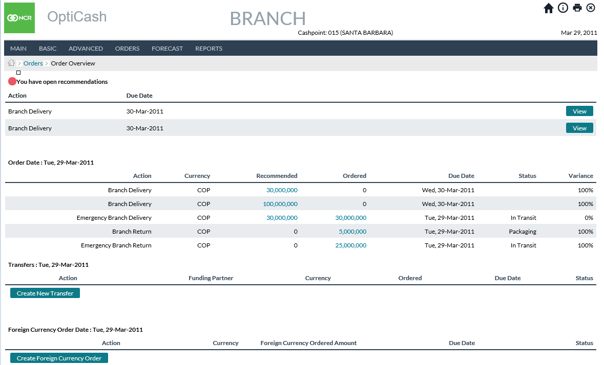

Table 24: Order Overview Description

| Field | Description |
| --- | --- |
| **Status** | Represented by a **Color** Icon:  **Green**: there are no open recommendations for this specific Cashpoint for today.  **Red**: there is an open recommendation for this specific Cashpoint for today. |
| **Action** | Indicates if this is a cash delivery or a return from a branch or ATM. |
| **Currency** | Unique identification of the currency. |
| **Recommended** | Amount of cash recommended by OptiCash. Note that this amount is hyperlinked, so the recommendation details can be viewed by clicking on it. |
| **Ordered** | If cash was already ordered by the Branch/ATM Staff or the OptiCash analyst, the amount will be displayed in this field. Order details can be viewed by clicking on the hyperlink. |
| **Due Date** | The due date indicates the date when the ordered cash will be delivered considering the lead time. |
| **Variance** | Variation between what has been recommended and what has been ordered (100% will be displayed if the order has not been placed yet). |
| **Create New Order** | Allows the user to create a Manual order. The order can only be created if there are no open recommendations. |
| **Create New Transfer** | Users can create cash transfers from a select list of other branches which are established on the *Cashpoint>Advanced>Linkage* page. This allows users to relocate cash excess from one branch to another needing additional funds without having to order new cash from the Central Bank or other external cash source. The branch receiving the cash is the only one that can initiate the transfer.  **Note:** This option is only available between two branches. It is not available for ATM to ATM, Branch to ATM, Depot to Branch, etc. |
| **Create Foreign Currency Order** | Available only to Branch Cashpoints. This Function (if licensed) allows the user to place orders for Non-Optimized currencies which are generally foreign currencies that are not assigned to the Cashpoint and don’t generally have high enough volume to optimize. Currencies must be defined at the system level before they can be ordered. |
| **Foreign Currency Action** | Indicates the type of service (Delivery or Return) |
| **Foreign Currency** | Unique ISO identifier for the currency that is being ordered |
| **Foreign Currency Ordered Amount** | The total amount of the Foreign Currency Order |
| **Foreign Currency Due Date** | The date that the service will be executed for the foreign currency. |

### Order Details Page

Figure 40: Order Detail Page

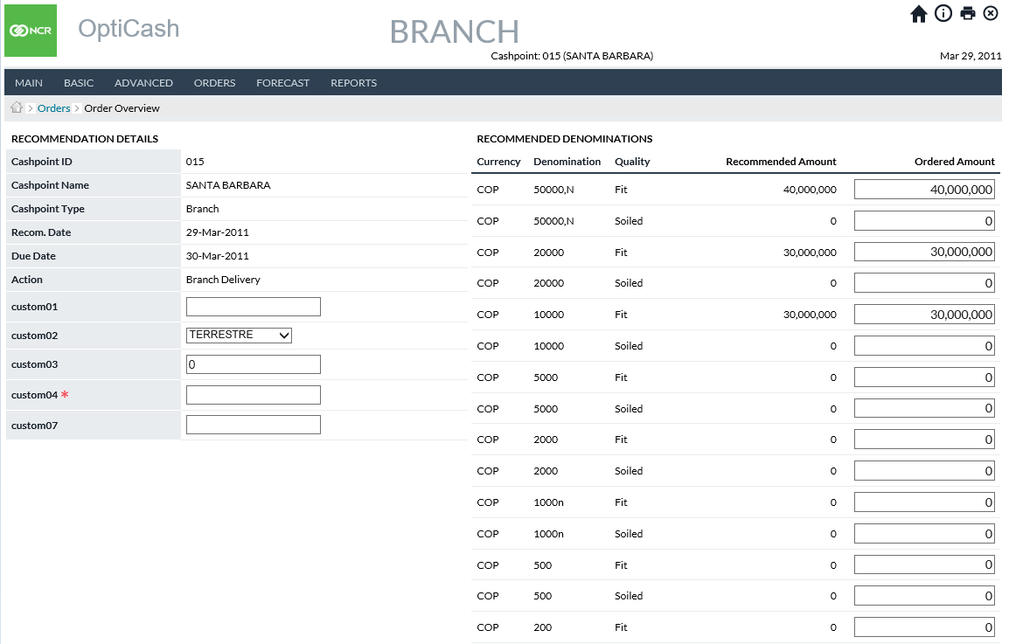

Table 25: Order Detail Description

| Field | Description |
| --- | --- |
| **Cashpoint ID** | Unique alphanumeric code that identifies the Cashpoint. |
| **Cashpoint Name** | The name of this Cashpoint. |
| **Cashpoint Type** | Branch or ATM. |
| **Order Date** | Typically represents today’s date or the date when the cash is being ordered. |
| **Due Date** | The due date indicates the date when the ordered cash will be available. Normally, the due date considers the lead-time of the Cashpoint, the service days available, the holiday and other constraints defined in the application. |
| **Action** | Shows the type of action for this order. For branches, it can be Delivery, Return, Emergency Delivery or Emergency Return. For ATMs, it can be: Add, Replace, Emergency Add, Emergency Replace, or ATM Return Cash. |
| **Bag Reference** | Bag Reference field will only be displayed for branch returns. In this field, a 12-character bag reference number can be entered for a branch return for tracking purposes. This feature can be turned on or off under the OptiCash / OptiNet settings in the /maint/ URL. |
| **Currency (Recommended Denominations panel on the right side of the window).** | Currency ID for which the amount is recommended. |
| **Denomination** | The denomination for which the amount is recommended. |
| **Recommended Amount** | The amount that is recommended by the system. |
| **Quality (Returns only)** | Designates the note quality for each denomination being returned. Corresponds to the OptiCash user-defined qualities. |
| **Ordered Amount** | The recommended amount is displayed in the Ordered Amount field (changes to this amount can be entered here if the user wants to override the recommendation). |
| **Capacity** | The maximum amount of cash that a Cashpoint will allow. This is often measured in terms of the cassettes servicing the denominations. |
| **Accept Button** | Click on **Accept** to accept the amounts recommended by OptiCash. In this case, the total recommended amount is equal to the total ordered amount and a variation reported in this case would be 0%. Note that the recommendation will still be considered accepted if branch staff decides for a different distribution than generated by OptiCash but totalling the same amount as recommended by OptiCash. |
| **Override Button** | If the recommendation is considered not viable, click on the **Override** button and a new window will be displayed. In this window, select the Override reason from the dropdown list, enter different order amounts in the field provided and click on the **Submit** button. |
| **Decline Button** | OptiCash allows the user to "Decline" a recommendation. By clicking on the **Decline** button, the order will not be created, but the recommendation will be marked as "declined". If a recommendation is declined, it will no longer show as an Open Recommendation in the *Today → Snapshot →Ordering* Status chart. It will also show as "declined" in the details of *Today → Orders→ Order Details* window.  The network level recommendation report will also reflect when a recommendation is declined.  To decline the recommendation, click on the **Decline** button. Please note that the user can go in and accept or override the recommendation later if so desired. |
| **Cancel Button** | Selecting the Cancel option exits the order without making any changes |

Return To: Cashpoint Window

### Create New Order Page

The Create New Order page follows from the Order Overview tab when the user selects the Create New Order button. On the initial Create New Order screen users are required to select what type of order they wish to enter; ATM Add Cash/Emergency Add, ATM Replace Cash/Emergency Replace, ATM Return Cash, Branch Delivery, Branch Return, Emergency Branch Delivery, and Emergency Branch Return.

Figure 41: Create A New Order Page

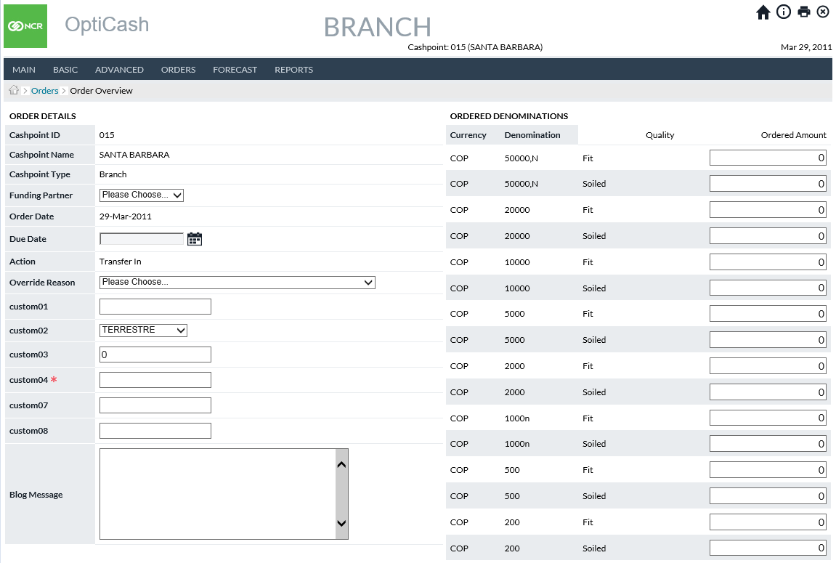

Table 26: Create A New Order Description

| Field | Description |
| --- | --- |
| **Cashpoint ID** | Unique alphanumeric code that identifies the Cashpoint. |
| **Cashpoint Name** | The name of this Cashpoint. |
| **Cashpoint Type** | Branch or ATM. |
| **Order Date** | Typically represents today’s date or the date when the cash is being ordered. |
| **Due Date** | This field will only be populated for usage in the following screens. It is blank on the initial Create New Order Screen |
| **Action** | Shows the type of action for this order. For branches, it can be Delivery, Return, Emergency Delivery or Emergency Return. For ATMs, it can be: Add, Replace, Emergency Add, Emergency Replace, or ATM Return Cash. |
| **Override Reason** | This field will only be populated for usage in the following screens. It is blank on the initial Create New Order Screen |
| **Blog Message** | This field will only be populated for usage in the following screens. It is blank on the initial Create New Order Screen |

Return To: Cashpoint Window

### Manual Order Entry (Except Return Cash)

Figure 42: Manual Order Page

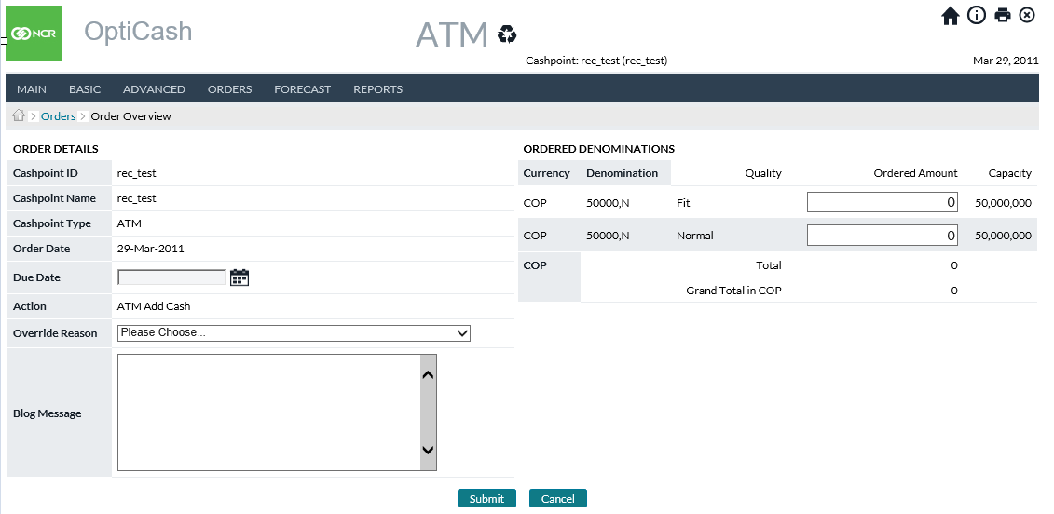

Table 27: Create New Order (Manual Entry) Description

| Field | Description |
| --- | --- |
| **Cashpoint ID** | Unique alphanumeric code that identifies the Cashpoint. |
| **Cashpoint Name** | The name of this Cashpoint. |
| **Cashpoint Type** | Branch or ATM. |
| **Order Date** | Typically represents today’s date or the date when the cash is being ordered. |
| **Due Date** | The due date indicates the date when the ordered cash will be available. Normally, the due date considers the lead-time of the Cashpoint, the service days available, the holiday and other constraints defined in the application.  OptiCash and OptiNet use the smart calendar to control the dates. Only those dates viable for delivery/return under the Cashpoint definition will be allowed. As an example, if a Cashpoint has a service lead time of 1 day, and the only available dates for delivery are Tuesday or Thursday, the order for this Cashpoint could only be made on Mondays or Wednesdays due to the lead time defined at the Cashpoint level. The picture below shows the calendar with the hyperlinked dates that are available for making an order. |
| **Action** | Shows the type of action for this order. For branches, it can be Delivery, Return, Emergency Delivery or Emergency Return. For ATMs, it can be: Add, Replace, Emergency Add, Emergency Replace, or ATM Return Cash. |
| **Override Reason** | This option is required when the order is new or overridden. The override reasons are created at the **Institution** level under the **System** tab or using OptiNet maintenance functionality. Please refer to the OptiNet step-by-step information. |
| **Bag Reference** | **Bag Reference** field will only be displayed for branch returns. In this field, a 12-character bag reference number can be entered for a branch return for tracking purposes. This feature can be turned on or off under the OptiCash / OptiNet settings in the /maint/ URL. |
| **Ordered Amount (Ordered Denominations Panel)** | This entry must be performed on the right side of the window, in the Ordered Denominations window.  Enter the amount of Cash by denomination and currency that need to be ordered. When amounts are entered the following validations are taken into consideration:  **Delivery Validation**:  Denomination Ordered Amount should not be less than Small or Large Order Unit Size for that denomination (Unit sizes are defined at System → Currencies/Denominations → Denominations; large or small order unit is assigned at the Cashpoint level Basic → Denominations).  The total ordered amount should not exceed the maximum capacity of the Cashpoint.  **Return Validation:**   * Denomination Ordered Amount should not be less than Small or Large Order Unit Size for that denomination (Unit sizes are defined at *System → Currencies/Denominations → Denominations*; large or small unit size is assigned at the *Cashpoint level Basic → Denominations*).   **Note:** In OptiNet, the Return Increment feature (defined in OptiNet by an Administrator) can be used to validate the Ordered Amount for each denomination instead of Unit Sizes. However, Return Increments will only apply to the OptiNet Branch Order screens for validation, while OptiCash will validate against unit sizes only.  **Note:** When the Display Order Notes/Bills Details on Order Screens is set to ‘True’ (Defined in the OptiCash/OptiNet Settings by an Administrator) the user will enter the number of Bills/Coins by denomination and currency to be ordered instead of the Amount. |
| **Submit Button** | Commits the order provided all information was entered correctly. If there are errors or missing information, the user will be prompted for the correct information before committing to the order. |
| **Cancel Button** | Cancels the transaction and no information is saved. |

Return To: Cashpoint Window

### Manual Order Entry (Advanced Device Return Cash)

Figure 43: Advanced Device Manual Order Page

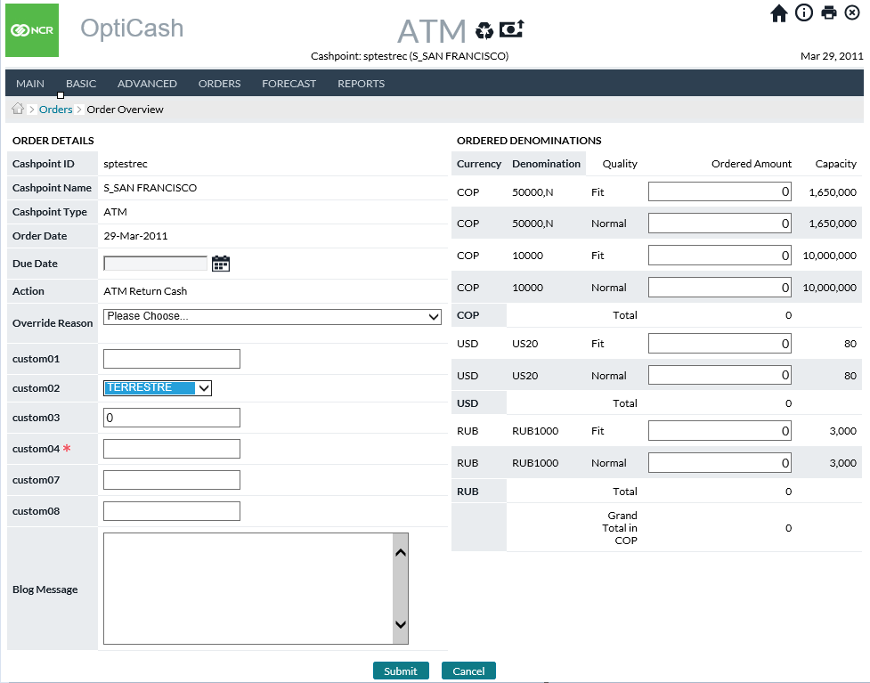

Table 28: Create A New Order Description (Advanced Device Return)

| Field | Description |
| --- | --- |
| **Cashpoint ID** | Unique alphanumeric code that identifies the Cashpoint. |
| **Cashpoint Name** | The name of this Cashpoint. |
| **Cashpoint Type** | Branch or ATM. |
| **Order Date** | Typically represents today’s date or the date when the cash is being ordered. |
| **Due Date** | The due date indicates the date when the ordered cash will be available. Normally, the due date considers the lead-time of the Cashpoint, the service days available, the holiday and other constraints defined in the application.  OptiCash and OptiNet use the smart calendar to control the dates. Only those dates viable for delivery/return under the Cashpoint definition will be allowed. As an example, if a Cashpoint has a service lead time of 1 day, and the only available dates for delivery are Tuesday or Thursday, the order for this Cashpoint could only be made on Mondays or Wednesdays due to the lead time defined at the Cashpoint level. The picture below shows the calendar with the hyperlinked dates that are available for making an order. |
| **Action** | Shows the type of action for this order. For branches, it can be Delivery, Return, Emergency Delivery or Emergency Return. For ATMs, it can be: Add, Replace, Emergency Add, Emergency Replace, or ATM Return Cash. |
| **Override Reason** | This option is required when the order is new or overridden. The override reasons are created at the Institution level under the System tab or using OptiNet maintenance functionality. Please refer to the OptiNet step-by-step information. |
| **Submit** | For ATM Recycler Returns, the Submit button automatically enters an order to return all the cash contained in the machine. No entry of the amounts is necessary. All currency will be returned. |
| **Specify Amount** | Will move the user to the next screen where an amount less than the full contents of the machine can be entered for return with denomination-level detail.  (see below for detail on the Specify Amount screen) |
| **Cancel** | Cancels the action |

Return To: Cashpoint Window

### Branch Return Recommendation Review & Manual Order Entry (Branch Return Cash)

If utilized, OptiCash allows the specification of cash quality for Branch Returns. When creating Manual Orders for Branch Returns, users can break down each returned denomination by Cash Quality. For more information on Quality see *System→Currencies/Denominations→Cash Qualities*.

Figure 44: Branch Return Create A New Order Page

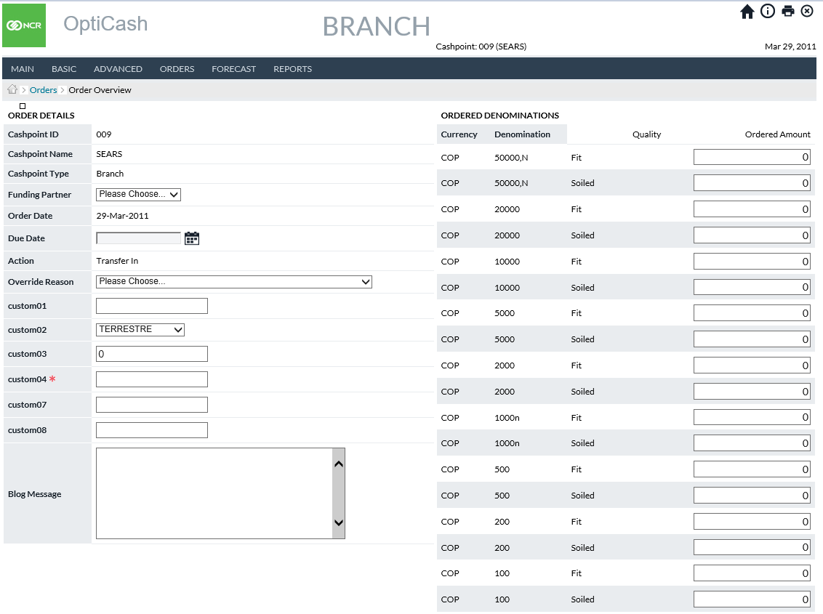

Return To: Cashpoint Window

Figure 45: Branch Return Recommendation Review Page

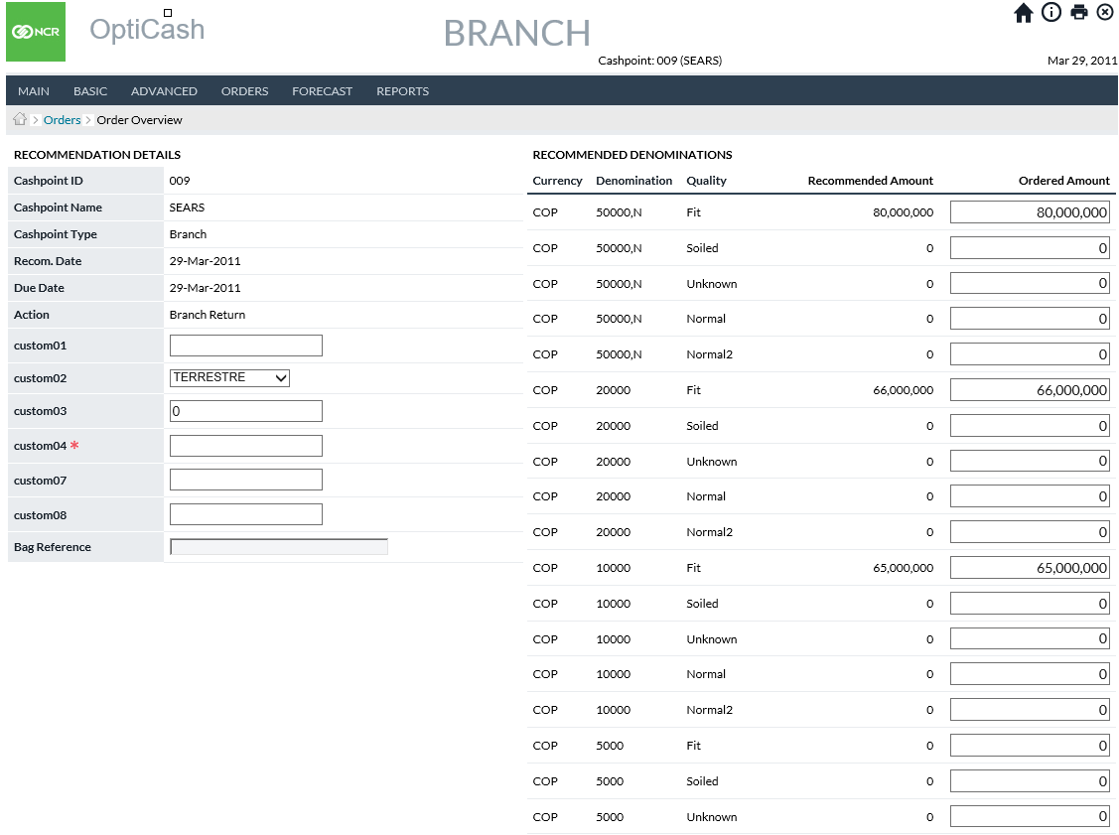

Return To: Cashpoint Window

### Order Confirmation

Figure 46: Order Confirmation Page

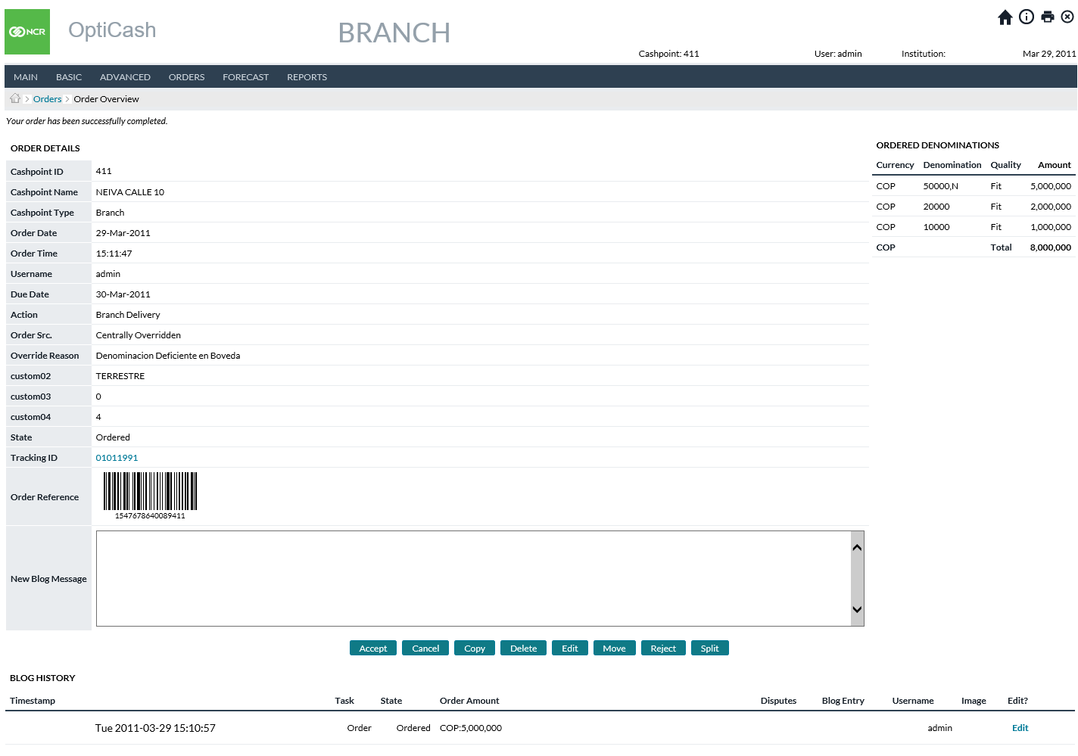

Table 29: Order Confirmation Description

| Field | Description |
| --- | --- |
| **Cashpoint ID** | Unique alphanumeric code that identifies the Cashpoint. |
| **Cashpoint Name** | The name of this Cashpoint. |
| **Cashpoint Type** | Branch or ATM. |
| **Order Date** | Typically represents today’s date or the date the cash is being ordered. |
| **Order Time** | Time at which the order was committed. |
| **Username** | Name of the user that committed the order. |
| **Due Date** | The due date indicates the date when the order will be completed. Normally, the due date considers the lead-time of the Cashpoint, the service days available, the holiday and other constraints defined in the application. |
| **Action** | Describes the type of service that will be performed (Delivery/Return/Add/Replace) |
| **Status** | The Type of Order Submitted. For more information about statuses, see Table 47: Order Status Description |
| **Override Reason** | This field is required when the order is a manual order or an overridden recommendation. The override reason is a status indicator that is used to describe the reason for changing a recommendation or creating a manual order. See Order Settings→Override Reasons |
| **Bag Reference**  **(if applicable)** | Bag Reference field will only be displayed for branch returns. In this field, a 12-character bag reference number can be entered for a branch return for tracking purposes. This option can be turned on or off based on the needs of the bank. Please consult the Administrators guide for more information about turning options on/off. |
| **Ordered Amount**  **(Ordered Denominations Panel)** | This entry must be performed on the right side of the window, in the Ordered Denominations window.  Enter the amount of Cash by denomination and currency that need to be ordered. When amounts are entered the following validations are taken into consideration:  **Delivery Validation:**  1. Denomination Ordered Amount should not be less than Small or Large Order Unit Size for that denomination (Unit sizes are defined at *System → Currencies/Denominations → Denominations*; large or small order unit is assigned at the Cashpoint level Basic → Denominations).  2. The total ordered amount should not exceed the maximum capacity of the Cashpoint.  **Return Validation:**  1. Denomination Ordered Amount should not be less than Small or Large Order Unit Size for that denomination (Unit sizes are defined at *System → Currencies/Denominations → Denominations*; large or small unit size is assigned at the Cashpoint level Basic → Denominations).  **Note:** In OptiNet, the Return Increment feature (defined in OptiNet by an Administrator) can be used to validate the Ordered Amount for each denomination instead of Unit Sizes. However, Return Increments will only apply to the OptiNet Branch Order screens for validation, while OptiCash will validate against unit sizes only. |
| **Submit Button** | Commits the order provided all information was entered correctly. If there are errors or missing information, the user will be prompted for the correct information before committing to the order. |
| **Cancel Button** | Cancels the transaction and no information is saved. |

### Create New Transfer

The Create New Transfer page follows from the Order Overview tab when the user selects the Create New Transfer button. Transfers can only occur between two branches and cannot be created between ATMs, ATMs and Branches, Branches and Depots, or other non-branch-to-branch combinations.

Users can only set Transfer from a pre-set group of other branches which are called “**Funding Partners**”. Funding Partners are established on the *Cashpoint>Advanced>Linkage page* On the initial New Transfer screen users is required to select the Funding Partner from which the cash is to be transferred.

Users are also required to select an Override Reason, Due Date, Denomination split, and any other Order Custom Field in use for Transfers. Transfers can only be set for “**Transfer In**” and must be placed by the branch receiving the cash. Branches cannot set outbound Transfers, and the branches sending cash out cannot set a Transfer.

Figure 47: Create A New Transfer Page

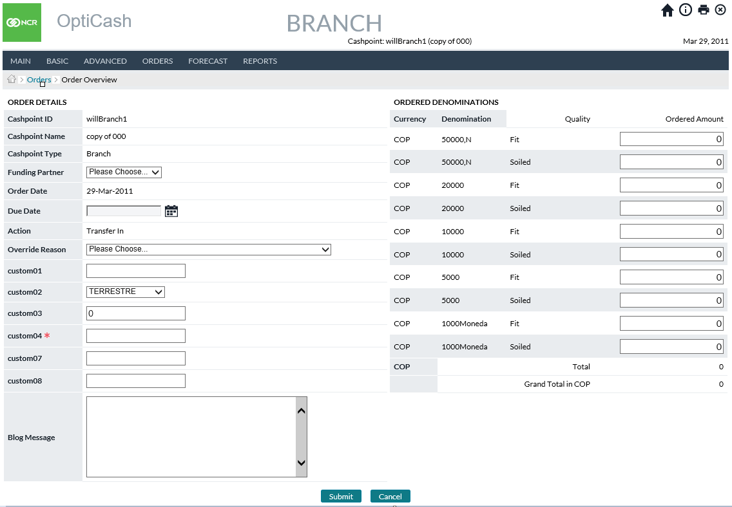

Return To: Cashpoint Window

Table 30: Create A New Order Description

| Field | Description |
| --- | --- |
| **Cashpoint ID** | Unique alphanumeric code that identifies the Cashpoint. |
| **Cashpoint Name** | The name of this Cashpoint. |
| **Cashpoint Type** | Autofill to *Branch* |
| **Funding Partner** | Branch ID which will Transfer the Cash Out. The Funding Partner list is a dropdown list setup on the *Cashpoint>Advanced>Linkage page*.  If a Branch has multiple Funding Partners, they can choose one as the Default value to be filled. The default Funding Partner can be edited and is not required. |
| **Order Date** | Typically represents today’s date or the date when the cash is being ordered. |
| **Due Date** | Date the cash is to be received on |
| **Action** | Auto filled to *Transfer In* |
| **Override Reason** | Preset Dropdown of common reasons for non-recommended orders or order edits. When displayed it is a required field. |
| **Blog Message** | *This field will only be populated for usage in the following screens. It is blank on the initial Create New Order Screen* |

Return To: Cashpoint Window

### Foreign Currency Order

Figure 48: Create A New Foreign Currency order Page

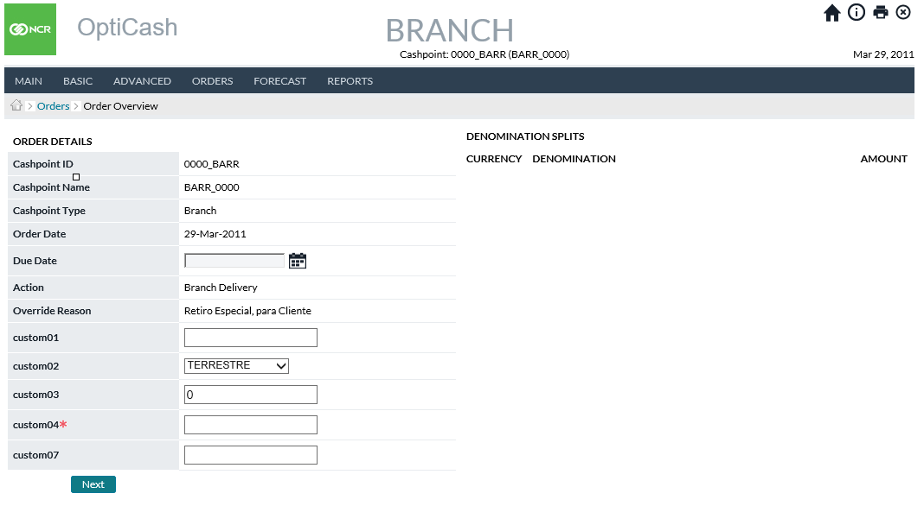

Table 31: Foreign Currency Order Description

| Field | Description |
| --- | --- |
| **Cashpoint ID** | Unique alphanumeric code that identifies the Cashpoint. |
| **Cashpoint Name** | The name of this Cashpoint. |
| **Cashpoint Type** | Branch or ATM. |
| **Order Date** | Typically represents today’s date or the date when the cash is being ordered. |
| **Due Date** | The due date indicates the date when the ordered cash will be available. Similar to the regular order screen for optimized currency, the due date considers the lead-time of the Cashpoint, the service days available, holidays, and other constraints defined in the application. |
| **Action** | Shows the action that has been selected in the previous window. |
| **Override Reason** | This option is required when the order is new or overridden. The override reasons are created at the **Institution** level under the **System** tab or using OptiNet maintenance functionality. |
| **Bag Reference** | **Bag Reference** field will only be displayed for branch returns. In this field, a 12-character bag reference number can be entered for a branch return for tracking purposes. This feature can be turned on or off under the OptiCash / OptiNet settings in the /maint/ URL. |
| **Blog Message** | If Blog and Trace is utilized, individualized notes relating to the order being placed can be entered by the users. |
| **Add** | Opens the currency selector screen |
| **Ordered Amount (Denomination Splits Panel)** | After entering currencies, denominations and amounts, all orders are displayed. Amounts will be hyperlinked so that if additional editing is necessary, it can easily be performed for the denomination in question. |

Return To: Cashpoint Window

Figure 49: Order Foreign Currency Page

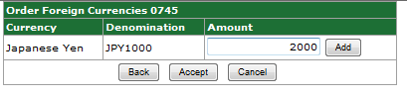

Table 32: Foreign Currency Order Amount Entry Description

| Field | Description |
| --- | --- |
| **Currency** | The user selects desired currency from the drop-down |
| **Denomination** | User selects desired denomination from drop-down |
| **Amount** | The user enters the amount required for the denomination.  **Delivery Validation**:  1. Denomination Ordered Amount should not be less than Small or Large Order Unit Size for that denomination (Unit sizes are defined at *System → Currencies/Denominations → Denominations*; large or small order unit is assigned at the Cashpoint level Basic → Denominations).  2. The total ordered amount should not exceed the maximum capacity of the Cashpoint.  **Return Validation**:  1. Denomination Ordered Amount should not be less than Small or Large Order Unit Size for that denomination (Unit sizes are defined at *System → Currencies/Denominations → Denominations*; large or small unit size is assigned at the *Cashpoint level Basic → Denominations*).  **Note:** In OptiNet, the Return Increment feature (defined in OptiNet by an Administrator) can be used to validate the Ordered Amount for each denomination instead of Unit Sizes. However, Return Increments will only apply to the OptiNet Branch Order screens for validation, while OptiCash will validate against unit sizes only |
| **Add** | Adds the denomination as an order. The process of adding additional denominations under one currency can be repeated from this screen for every assigned denomination. |
| **Back** | Take the user back one step in the process of editing needs to be done |
| **Accept** | Completes the denomination orders, enters them, and closes the screen. By going back to the Add button on the Create New Foreign Currency order page, this window can be reopened, another currency selected, and the process repeated as many times as are necessary |
| **Cancel** | Cancels the order and closes the screen |

### Order Custom Fields

Order Custom Fields allow users to enter additional information for the order that is not part of the normal ordering process (i.e., Department Number). These fields can be assigned at the system level to apply to any or all types of orders

Figure 50: Order Custom Fields on THE Orders Overview Page

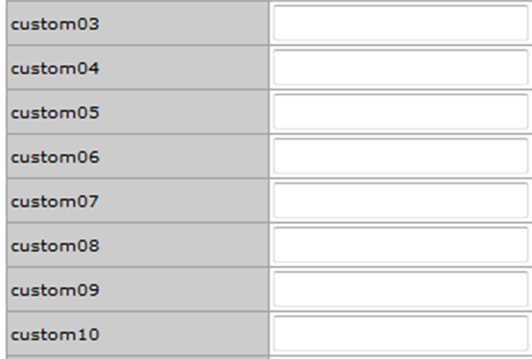

Table 33: Order Custom FieLD Description

| Fields | Description |
| --- | --- |
| **Custom01 – Custom10** | Custom Fields that can be used to collect data about the order that is not part of the normal ordering process. There are two types of fields that can be made available to the user for the custom fields:   * **Free Text** – a box to allow users to type in any information necessary that applies to the Custom field * **Custom List** – A list of items to choose from   In either case, information can be entered and then stored in the order for use in the output of the data. For more information on Order Custom Fields see: Order Settings→Order Custom Field Definitions or Order Settings→Custom Field to Order Linkage |
| **Custom01 * - Custom10 \*** | The Starred Items in the Custom fields indicate that the Entry is mandatory and an item must be selected or entered before the order can be processed. |

Return To: Cashpoint Window

### Order Workflow

Order Workflow is a separately licensed functionality that is used to help analysts manage the State of an order from the time it is created until the time it is delivered. Workflow rules can be set up by an administrator from the Order Settings→Order Workflow page to manage the different States of an order.

Order Workflow utilizes the fields Cashpoint ID, Order Date/Time, Due Date, Action, State, and Task. By performing particular tasks/functions, Users progress the order through different States as designed under System→ Order Settings→Order Workflow.

Figure 51: Order Page with Workflow

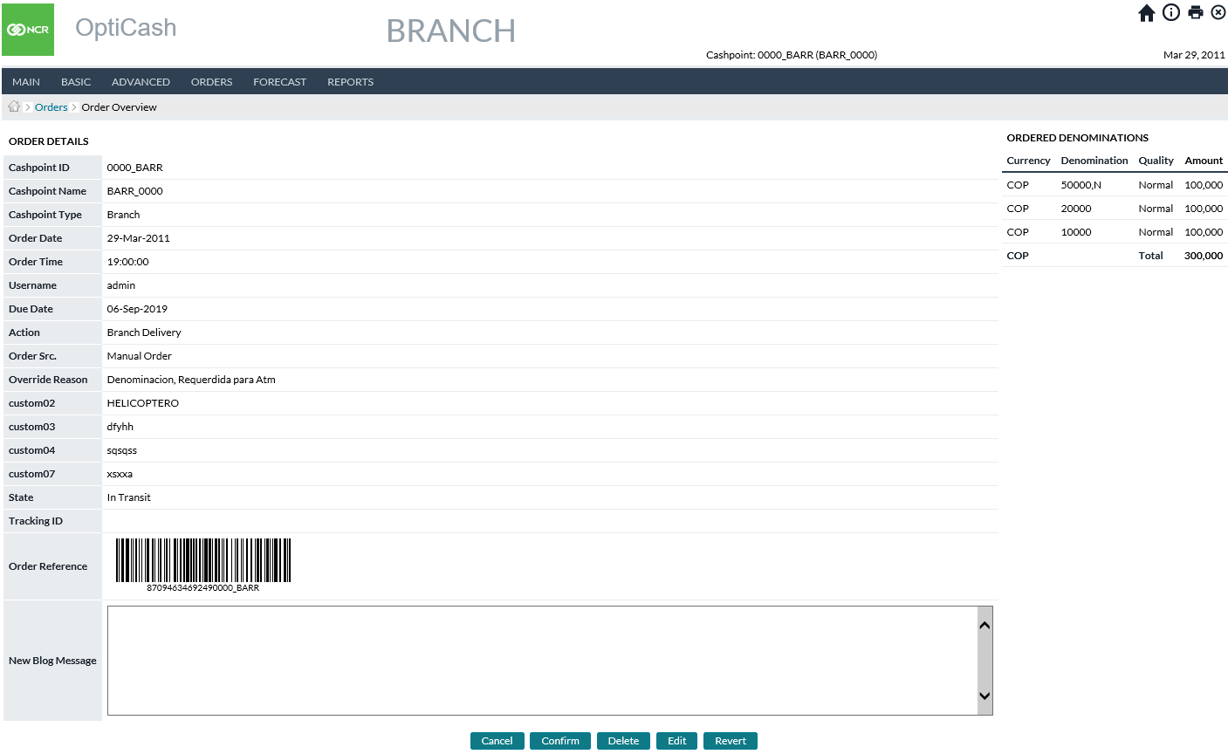

Table 34: Order Page with Workflow

| Fields | Description |
| --- | --- |
| **Cashpoint ID** | Unique alphanumeric code that identifies the Cashpoint. |
| **Cashpoint Name** | The name of this Cashpoint. |
| **Cashpoint Type** | Branch or ATM. |
| **Order Date** | Typically represents today’s date or the date the cash is being ordered. |
| **Order Time** | Time at which the order was committed. |
| **Username** | Name of the user that committed the order. |
| **Due Date** | The due date indicates the date when the order will be completed. Normally, the due date considers the lead-time of the Cashpoint, the service days available, the holiday and other constraints defined in the application. |
| **Action** | Describes the type of service that will be performed (Delivery/Return/Add/Replace) |
| **Order Src. (Source)** | The Type of Order Submitted. For more information about statuses, see Table 47: Order Status Description |
| **Override Reason**  **(if applicable)** | This field is required when the order is a manual order or an overridden recommendation. The override reason is a status indicator that is used to describe the reason for changing a recommendation or creating a manual order. See Order Settings→Override Reasons |
| **State** | Indicates the current state of the order. The State of the order is determined by the workflow setup at the System →Order Settings level. For more information see: Order Settings→Order Workflow |
| **Bag Reference**  **(if applicable)** | Bag Reference field will only be displayed for branch returns. In this field, a 12-character bag reference number can be entered for a branch return for tracking purposes. This option can be turned on or off based on the needs of the bank. Please consult the Installation Guide for more information about turning options on/off. |
| **Ordered Amount**  **(Ordered Denominations Panel)** | This entry must be performed on the right side of the window, in the Ordered Denominations window.  Enter the amount of Cash by denomination and currency that need to be ordered. When amounts are entered the following validations are taken into consideration:  **Delivery Validation**:  1. Denomination Ordered Amount should not be less than Small or Large Order Unit Size for that denomination (Unit sizes are defined at *System → Currencies/Denominations → Denominations*; large or small order unit is assigned at the *Cashpoint level Basic → Denominations*).  2. The total ordered amount should not exceed the maximum capacity of the Cashpoint.  **Return Validation**:  1. Denomination Ordered Amount should not be less than Small or Large Order Unit Size for that denomination (Unit sizes are defined at *System → Currencies/Denominations → Denominations*; large or small unit size is assigned at the Cashpoint level Basic → Denominations).  **Note:** In OptiNet, the Return Increment feature (defined in OptiNet by an Administrator) can be used to validate the Ordered Amount for each denomination instead of Unit Sizes. However, Return Increments will only apply to the OptiNet Branch Order screens for validation, while OptiCash will validate against unit sizes only. |
| **Tracking ID**  **(if applicable)** | A Tracking ID is generated and assigned to all orders that are due on the same day. The assumption with the Tracking ID is that it is used for tracking orders on the same truck that comes in together. If an order needs a separate ID, the Order Tracking ID can be replaced by clicking on the ID. See: Order Tracking ID |
| **Master Order Reference Number** | This is a Reference number that is used to track a specific order. This number cannot be changed and is static to the order |
| **New Blog Message** | When editing processing/entering an Order, users can enter notes or “**blogs**” to attach to the Order and it will be kept in the database as part of the Order’s history |

Return To: Cashpoint Window

### Order Blog & Blog History

Order Blog, Blog History, and Blog & Trace often work in conjunction with Order Workflow as it enables the tracking by username, date/time stamp, and action of each order. The Order Blog History Report allows users to extract blogs for different cashpoint and date combinations and review them.

Existing blogs can also be edited from the Cashpoint Orders screen.

Figure 52: Order Page with Workflow and Blog HIstory

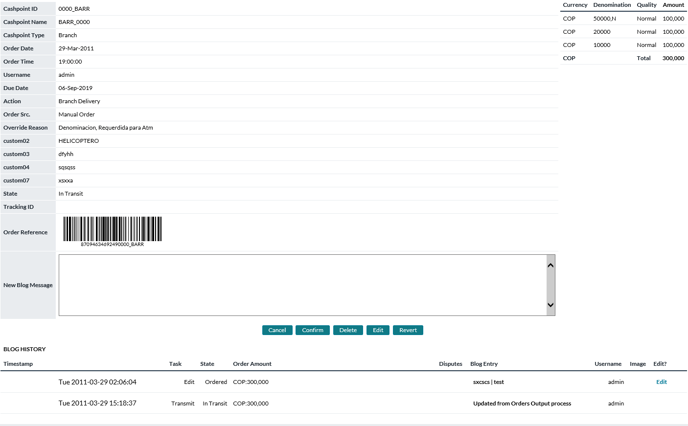

Table 35: Blog HIstory Field Descriptions

| Fields | Description |
| --- | --- |
| **Timestamp** | Date and Time when Blog Entry was entered into the OptiCash database |
| **Task** | Task performed at the time of Blog Entry Creation |
| **State** | State of Order at the time of Blog Entry |
| **Blog Entry** | Note entered by the user or auto created by the system |
| **Username** | UserID who created the Blog Entry |
| **Edit** | Hyperlink to open and Edit the existing Blog Entry. Note: Hyperlink appears only if enabled for the Task. |

### Order Tracking ID

This page is accessed from the Order Overview page and is used to change the Tracking ID for a particular order. By default, all orders that are due on the same day receive the same Tracking ID.

Figure 53: Edit Tracking ID Page

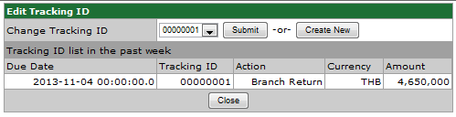

Table 36: Edit Tracking ID Description

| Fields | Description |
| --- | --- |
| **Change Tracking ID** | Lists the Available Tracking ID that can be assigned to the Order. The available Tracking IDs can be selected from the dropdown list and assigned by clicking the ‘**Submit’** button |
| **Submit Button** | Makes the change of the Tracking ID to the Tracking ID selected in the drop-down list to the right of the button |
| **Create New button** | Generates a new Tracking ID for the order |
| **Due Date** | Date the Order is due of the order placed in the last week |
| **Tracking ID** | Details the Tracking ID for the order placed in the last week |
| **Action** | Describes the action of the order placed in the last week |
| **Currency** | Describes the currency of the order placed in the last week |
| **Amount** | Describes the number of orders placed in the last week |

Return To: Cashpoint Window

### Order details page (with claim management configured)

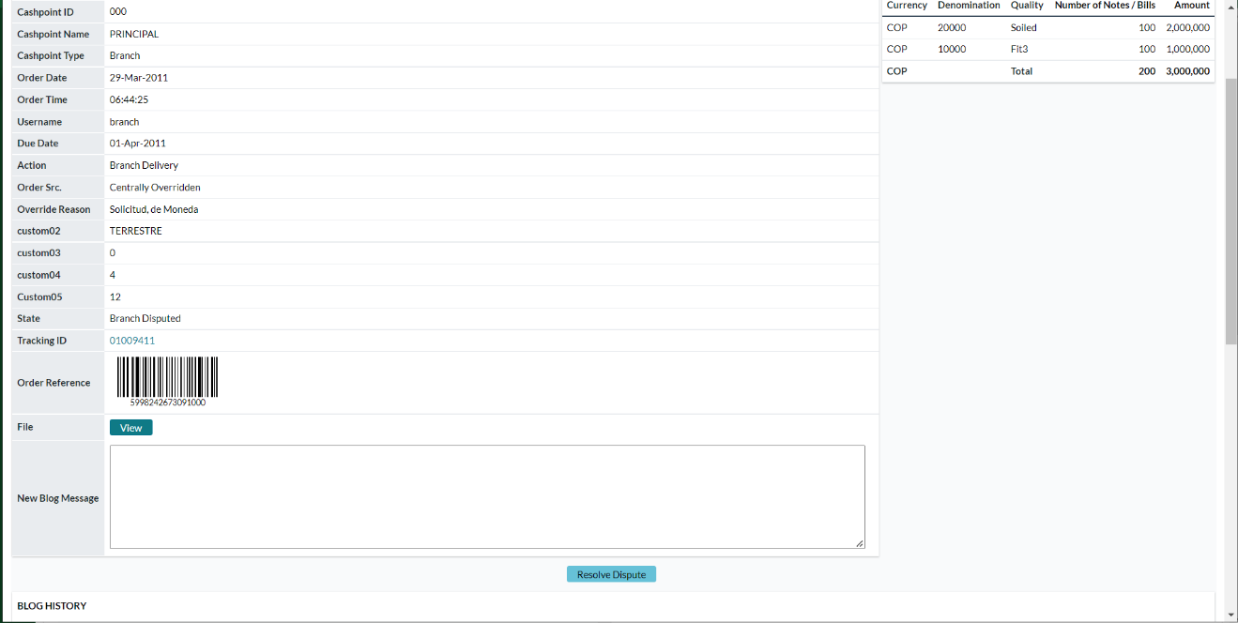

After configuring the claim management feature in the required applications (OptiCash, OptiNet and Carrier-Web). Once the order is disputed and valid dispute details are added only OptiCash users will be able to view this resolve dispute task on the order overview page.

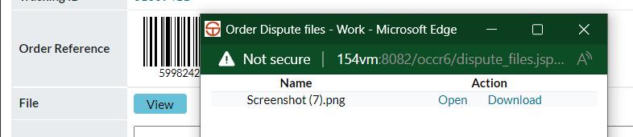

Additionally, users can click on newly added view file options on this page to open a pop-up which will display the list of evidence uploaded via Carrier-Web and OptiNet Applications for Branch Return and Branch Delivery workflow respectively.

## Cashpoint→Forecast→View Forecast

Figure 54: View Forecast Page

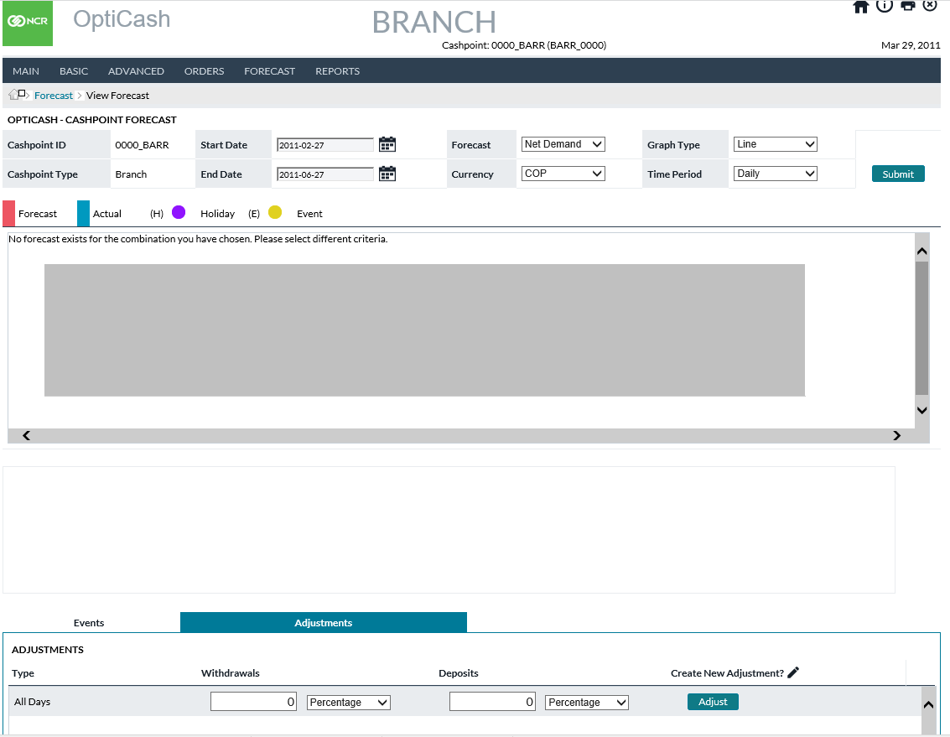

Table 37: View Forecast Description

| Field | Description |
| --- | --- |
| **Start Date** | The date the Forecast graph will start.  **Note**: The graph will only show the date for which Forecast records were created. |
| **End Date** | The date the Forecast graph will end.  **Note**: The graph will only show the date for which Forecast records were created. |
| **Forecast Listbox** | Allows the user to change to the different forecast types. The user must select a forecast type and click on the Submit Button.  Possible selections are:   * Withdrawals * Deposits * Net Demand   **Note:** For ATMs, only Withdrawal is an option. Net Demand is the default initial view for Branches. |
| **Currency Listbox** | Allows the user to change to a different currency. To change the view, the user must select the desired options and click the Submit button |
| **Denom Listbox  (Advanced Devices Only)** | Allows the user to change to a single denomination or in Total. To change the view, the user must select the desired options and click the Submit button |
| **Graph Type** | Allows the user to select between a line or bar graph.  To change the view, the user must select the desired options and click the Submit button |
| **Time Period** | Allows the user to select specific time periods. Choices are:   * Daily * Weekly * Monthly * Mondays * Tuesday * Wednesdays * Thursdays * Fridays * Saturdays   To change the view, the user must select the desired options and click the Submit button |
| **Forecast and History Graphs** | Each data point is a specific date. Two values are plotted:  The Blue line (actual data) represents the historical data loaded in daily files.  The Red line (prediction) represents the forecast data and is based on historical demand, cost, and future events.  Clicking on any data point loads the information in the Forecast Details Pane. |
| **Date** | The date currently selected (by clicking a data point on the graph). |
| **Data Type** | The type of data that is plotted: Withdrawal, Deposit or Net Demand. |
| **Base Forecast** | The value originally forecasted for the day without any adjustments. This figure is for informational purposes only. The Forecasted figure that will be enforced for the Cashpoint is the ‘Forecast’ number. |
| **Forecast** | The value of the Forecast is currently set for the selected day. Forecasts can be adjusted higher or lower due to rounding or Forecast Adjustments applied by an Analyst. |
| **Actual** | The value of Actual Historical data for the selected data point. |
| **Event** | If an Event is in force for the selected day, the name of that event will be listed in this field. |
| **Variance** | The Variance will show the difference between the Forecast and the Actual numbers. |
| **Holiday** | Indicates a non-working day for the Cashpoint and forecast demand will be zero, provided the Cashpoint is flagged as “**closed**” on Holidays. |
| **Exclude** | Indicates if the selected day is excluded in the next forecast generation process. Exclusions are usually necessary when an error in the data load has occurred or extraordinary activity occurs that is unlikely to be repeated. |
| **Forecast Health** | The value indicates the degree of correlation between the forecast and actual data. Generally, any value above 70 indicates a good correlation. The closer the value gets to 100, the higher the correlation. |
| **Events Tab** | Shows a list of the Events and dates assigned to the Cashpoint. |
| **Adjustments Tab** | This tab shows a list of Forecast Adjustments assigned to this Cashpoint.  Forecast Adjustments are used to change the Forecast due to additional trends that may not be captured by the initial forecast. **For example**, if there is a certain demand trend that is affecting Mondays, the user may adjust the forecast specifically for that day of the week using a percentage.  The Forecast Adjustment can be a positive or negative number.  Forecast Adjustments can be assigned to:   * Withdrawals * Deposits * Mixed Notes (only in the case of Advanced Devices with Mixed Note components defined, represents piece count instead of value)   **NOTE**: Adjustments can be entered either as a percentage or as an amount. By selecting the Percentage/Amount drop-down users can decide to increase or decrease the forecasted amount by a percentage, or they can select Amount and tell OptiCash the exact amount desired to be used. |
| **Create New Adjustment Link** | Above the ‘Adjust’ button is a link that allows the user to specify new Forecast adjustments. Forecast adjustments can be applied to the following days:   * All Days (Default for every Cashpoint) * Sundays * Mondays * Tuesdays * Wednesdays * Thursdays * Fridays * Saturdays * Specific Date   **Note:** The ‘**All Days’** Adjustment is overwritten by any day of the week or specific date. The Forecast adjustments are not cumulative. |
| **Adjust Button** | Updates any values changed for the corresponding Forecast Adjustment. |
| **Mass Adjust Button**  **(Advanced Devices Only)** | Updates forecast with adjusted values across all denominations at the same time.  **Note**: This may take a noticeably longer time to complete than single adjustments. |
| **Delete Button** | Deletes the corresponding Forecast Adjustment from the Cashpoint.  **Note**: The All-Days adjustment is required for every Cashpoint. Setting it to zero means it will not affect the Cashpoint forecast. |

Return To: Cashpoint Window

## Cashpoint→Forecast→Generate Forecast

The Generate Forecast page allows the user to generate a new Forecast for the current Cashpoint. The user can create new Forecast Definition IDs or use existing IDs to run the Forecast process.

Users can also select which specific currencies they wish to run the forecast for. All Currencies are also an option.

Figure 55: Forecast Generation Page

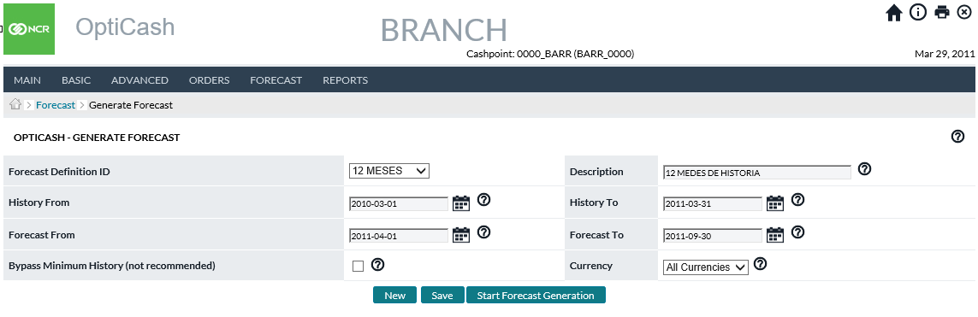

Return To: Cashpoint Window

## Cashpoint→Forecast→Analysis

The Forecast Analysis page gives a summary of the Forecast quality values with a visual indicator (Red, Yellow, Green) representing the quality level. This page is for informational purposes only.

Figure 56: Forecast Analysis Page

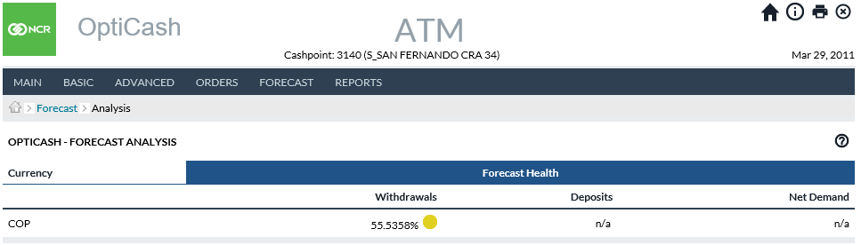

Return To: Cashpoint Window

## Cashpoint→Reports

The reports section of the Cashpoint screen gives the user Cashpoint-specific reports to allow for faster access to critical reports used for analysis purposes. The reports are covered in the Reports Tab section of this document. Please refer to the following reports for additional information:

* Horizons
* Linked Horizons
* History
* Linked History
* Orders
* Recommendations
* Forecast Details

Return To: Cashpoint Window

1. Today Tab

The Today Tab is the starting point for all users when they log on to OptiCash. Most of the day-to-day tasks the users perform can be completed using the information contained under the Today Tab.

All of the pages that are contained under the Today Tab are explained below. The following is a summary of the information that will be covered in this section along with hyperlinks to each topic.

* Today→Dashboard Page
* Today→Current Balance Levels
* Dashboard→To Do List
* Today→Data Alerts Page
* Today→Forecast Health Summary Report
* Today→Orders Workflow Page
* Today→Pre-Emptive Alerts
* Pre-Emptive Alert Report
* Today→Data Health
* Data Health Summary
* Run Data Health Check
* Data Health Indicator Status Details

Return To: Introduction to the Interface

## Today→Dashboard Page

This page is the main screen users will log into when using the application. This is the starting point for OptiCash users to perform most of their daily and weekly tasks.

Figure 57: Today -> Dashboard Page

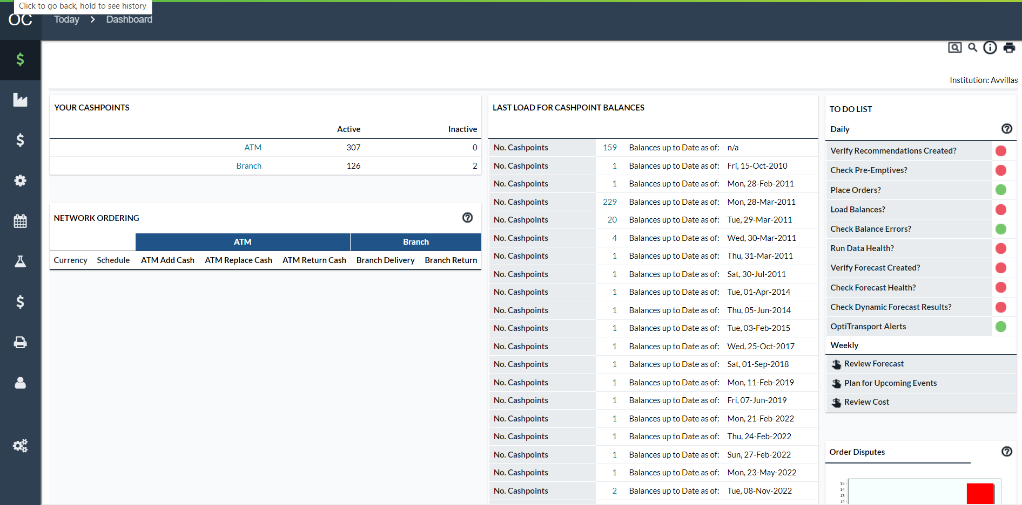

Table 38: Dashboard Page Descriptions

| Today Dashboard | Description |
| --- | --- |
| **Your Cashpoints** | Your Cashpoints displays the number of active and inactive ATMs and /or Branches that have been assigned to this user. Users can run recommendations and forecast for inactive Cashpoints; however, these Cashpoints will not be included in the Today status panels, or alerts/validations on the To Do List. It is also not possible to run data health for an inactive Cashpoint. Clicking on the hyperlinks **Branch** or **ATM** will take you to the Network Cashpoint screen where you can browse through and select individual Cashpoints. See Network→Cashpoints Page |
| **Last Load for Cashpoint Balances** | This section displays when balances were last loaded for the cashpoints assigned to the current user. The list is organized by date and groups the cashpoints by the last day they had balances loaded. Clicking on a link for a particular date will launch the last load snapshot report. |
| **Data Health Indicator** | Displays the general quality of the data. See: *Today→Data Health* |
| **Current Balance Levels** | Hyperlink to Cash Levels Dashboard Report. See: Today→Current Balance Levels |
| **Network Ordering** | The network Ordering screen informs about the orders already committed, overridden, or manually created for branches and ATMs. Clicking on any of the hyperlinks will divert the user to the Orders Page. See: Today→Orders Page  The information shown in this section has details about the orders by Currency and Service Type. The Service Types are as follows:   * **Planned –** Normal Deliveries and Returns * **Unplanned –** Deliveries that fall outside of the regular lead times for Normal Deliveries * **Special –** Shows special orders which have been committed by users of OptiNet. This feature is only visible if the option has been turned on by the administrator. See the administrators guide for more information. |
| **Ordering Status** | The ordering Status screen displays a graphical indicator of the status of the current day’s orders. Clicking on any of the hyperlinks will take the user to the Orders Page. (See: Today→Orders Page). The right side of this section shows:   * **Total Number of Recommendations for Today -** The Total Number of Cashpoints, assigned to this user, which has recommendations that were produced for the day. For example, if there was only one Cashpoint in the system and that one Cashpoint had 10 recommendations, then this field would display 1. * **Recommendations remaining to be processed –** This number is the number of Cashpoints, assigned to this user, which has recommendations that still need to be processed. If a Cashpoint has more than one recommendation and some or all those recommendations are still open, then the indicator will still count that Cashpoint as “remaining to be processed”. * **Recommendations that have been ordered –** This number is the number of Cashpoints, assigned to this user, which has all their recommendations committed.   The graphic represents the total number of Cashpoints with recommendations. The Red area indicates Open Recommendations and the Green, committed recommendations. |
| **To-Do List** | The To-Do List is a daily checklist of the processes or tasks to be executed daily by the users.  See Dashboard→To Do List in more detail. |
| **Open Disputes** | Counts of unresolved disputes based on how long the dispute has been open. |

Return To: Today Tab

## Today→Current Balance Levels

Cashpoint Balance Levels allow for immediate viewing of the most recent cashpoint balances reported to OptiCash. Users can select from among six views to display in the cash levels graph.

Table 39: Current Balance Level Dashboard Types

| Field | Description |
| --- | --- |
| **ATM Balances by Depot** | Summarizes most-recent ATM balances by the Servicing Depot |
| **ATM Balances by ATM** | Summarizes most-recent balances by individual ATM |
| **ATM Balances by Cassette Type** | Summarizes most-recent balances by Cassette type. Users select one or more ATMs and can then summarize balances by Deposit or Withdrawal cassette types. |
| **Depot Actual vs. Target Balance** | Summarizes each Depots Target (projected balance) and compares to each respective Depot’s actual balance. |
| **ATM Actual Balance vs. Target** | Summarizes each ATM’s Target (projected balance) and compares to each respective ATM’s actual balance. |
| **ATM Deliveries and Returns Today** | Summarizes by Deliveries and Returns and by denomination the deliveries and returns to occur on the current business day. |

Return To: Today Tab

Figure 58: Current Balance Levels Dashboard Page

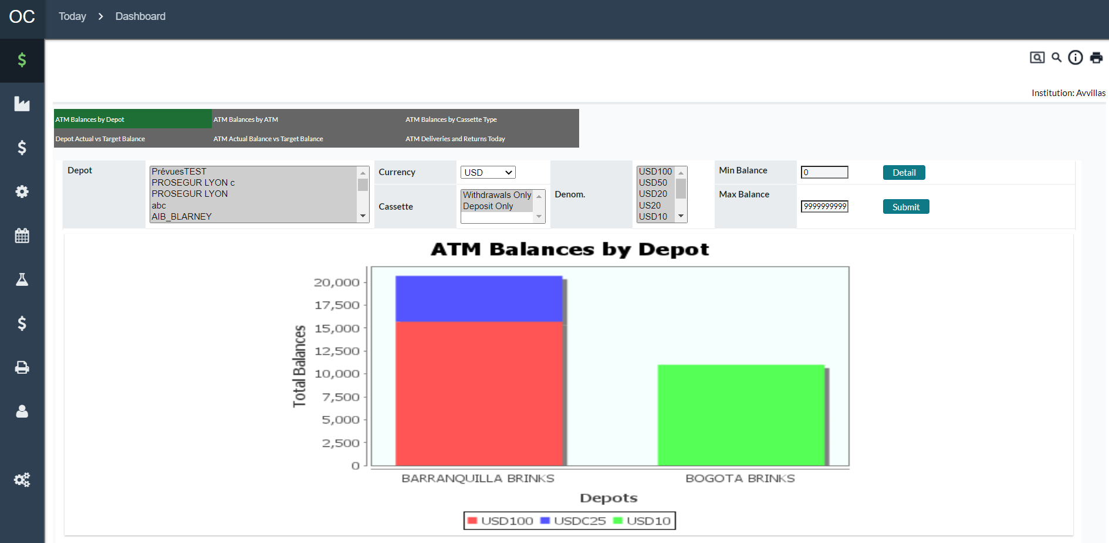

Table 40: Current Balance Level Dashboard Graph Field Descriptions

| Field | Description |
| --- | --- |
| **Cashpoints (Select)**  Not applicable for ATM Balances by Depot or Depot Actual vs. Target Balance | Cashpoint selector for users to designate which ATMs are to be included in the Cash Level Summary |
| **Depot**  Applicable only for ATM Balances by Depot or Depot Actual vs. Target Balance | Depot selector for users to designate which Depots are to be included in the summary |
| **Currency** | User designates which Optimized currency is to be included |
| **Cassette** | User designates which Cassette type (Deposit or Withdrawal) is to be included |
| **Denomination** | Users can select one or more denominations to be included in the Cash Level Summary |
| **Min Balance/Max Balance** | Users can limit the view by selecting minimum or maximum limits to establish a minimum, maximum, or range of values to report. |
| **Detail** | Detail opens a new window which shows by cashpoint or depot the denomination-level amounts |

Return To: Today Tab

## Today→Last Load Snapshot Page

This page details the last load information for all Cashpoints assigned to the current user.

Figure 59: Last Load Snapshot Page

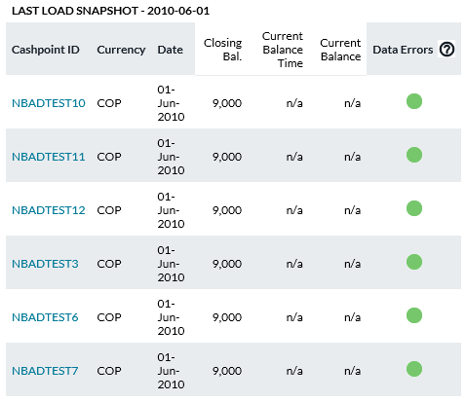

Table 41: Last Load Snapshot Descriptions

| Field | Description |
| --- | --- |
| **Cashpoint ID** | Unique alphanumeric code that identifies the Cashpoint. |
| **Currency** | Currency of the displayed balance. |
| **Date** | Date of the displayed balance. This will be the most recent date for which balances are available. |
| **Closing Bal.** | Closing balance amount. |
| **Data Errors** | **Indicator**: Red indicates that the Cashpoint has had data errors and warnings in the last 7 days or that no data is available.  **Green** indicates that there are no data errors or warnings for this Cashpoint for the balance data in the last 7 days.  Click to see the list of errors and warnings for the Cashpoint. For a description of those messages, see the following section on Loading Batch Balance Files |

### Dashboard→To Do List

The To-Do List is used daily to help perform the processes necessary to complete the orders for all Cashpoints. The list helps users by providing indicators that show the state of the item to be completed as well as hyperlinks to pages and reports that are used to complete these tasks.

Figure 60: To-Do List

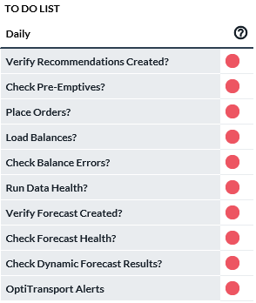

Table 42: To-Do List Description

| To-Do Item | Description |
| --- | --- |
| **Red Indicator** | Indicates there is an issue to be dealt with. **For example**, balances are too old, there are alerts, ordering for the Cashpoints has not been finished, etc. |
| **Yellow Indicator** | Indicates that the item has been checked but some items are still warnings that exist. |
| **Green Indicator** | Indicates that there are no warnings or no actions to be taken. **For example** - there are no alerts, no orders to be completed, etc. |
| **Verify Recommendations Created** | This indicator shows if errors occurred for Cashpoints during the recommendations process. Clicking on the indicator will show the Recommendation Process Validation Report. See Run Recommendations→Recommendation Validation Report for more information.  Red indicates that Errors were found whereas green indicates no problems were found.  **Note**: If the recommendation process did not run at all, this status indicator will not reflect this situation. |
| **Check Pre-Emptives** | Pre-Emptive Alerts help to notify the user that there are Cashpoints that could or will run out of cash in the current and coming days. This allows the user to take pre-emptive steps to avoid cash-out situations.  **Red** - Some Cashpoints have not been checked for pre-emptive alerts today.  **Yellow** - At least one Cashpoint has pre-emptive alerts today.  **Green** - There are no pre-emptive alerts today.  Clicking on the status indicator will direct the user to the Pre-Emptive alerts Page.  See: Today→Pre-Emptive Alerts for more information |
| **Place Orders** | This indicator shows the status of recommendations that need to be processed for the day.  **Red** - There are Cashpoints, assigned to this user, which have open recommendations remaining to be dealt with today.  **Green** – All Cashpoints, assigned to this user, have processed their recommendations.  Clicking on this indicator will direct the user to the Orders Page. |
| **Load Balances** | This indicator signals if balances have been recently loaded. Normally this is 7 days, but this parameter can be changed by the administrator to include more or fewer days depending on the preference.  **Red** – There are active Cashpoints, assigned to this user, with out-of-date balances.  **Green** - The balances are up to date for all Cashpoints assigned to this user.  Clicking on the link will pop-up the last load snapshot report.  If a red legend is displayed, balances must be loaded for those Cashpoints with out-of-date balances. See Processing→Load→Load Balances Page for more information. |
| **Check Balance Errors** | When the daily load files are run, there are a number of validations that take place on the data to ensure high quality. The status indicator will show if errors were found or not.  **Red** - There are errors in the balances recently loaded. See Processing→Load→Load Validation Settings Page for more information on balance errors.  **Green** - There are no errors in the balances that have been recently loaded.  Clicking on the indicator will pop-up the Data Alerts Report. See: Today→Data Alerts Page |
| **Run Data Health** | This indicator is a reminder to run the Data Health Calculator.  **Red** - The data health indicator has not been updated since the last load of the balances.  **Green** – The data health indicator is up to date with the latest balances.  Clicking on this indicator will direct the user to the Data Health Page. For more information See: Today→Data Health |
| **Verify Forecast Created** | This indicator is a reminder to run forecasts for the Cashpoints assigned to the user.  **Red** - Indicates that forecasts have not yet been run or there was an error when running forecasts.  **Green** – All forecasts have been run and there are no errors from the forecasting process. |
| **Check Forecast Health** | This indicator is used both as a reminder to verify and improve forecast quality as well as giving an overview of the overall forecast quality for the Cashpoints assigned to the current user.  **Red** – Indicates poor forecast health for some of the Cashpoints.  **Yellow** – Indicates that forecast health is marginal and there are no Cashpoints with poor health indicators.  **Green** – The network has good forecast health meaning that no Cashpoints that are assigned to the user are marginal or poor.  Clicking on the indicator will bring up the Forecast Health Summary Report. See Today→Forecast Health Summary Report for more information. |
| **Dynamic Forecast Results** | The Dynamic Forecast is a separately licensed process that allows the software to choose cashpoints to be forecasted either once or twice a month depending on the configuration.  When the batch process is run, the software will choose all cashpoints and mark them with a status of “**Pending**”; these cashpoints are then scheduled to run each time the dynamic forecast process is run. The batch process can be set to run for a specified period of time; therefore, it is possible the scheduled run may not be completed during the time period specified; in this case, the pending forecasts will be run the next time the dynamic forecast is run in the order they were added to the pending queue.  Once the forecasts have been run, the results can be viewed by clicking the “**Check Dynamic Forecast Results**” link in the To-Do List. See: Today→Check Dynamic Forecast Results Report |
| **OptiTransport Alerts**  **(appears with OptiTransport Licensed Feature)** | This alert page provides notifications for each route. Users may see either the red T or the purple V. T means that the one day exceeds the maximum trip count defined for the route. The purple V means that the day exceeds the maximum vehicle capacity. |
| Weekly Processes | |
| **Review Forecast** | It is recommended that the users review forecast quality every week as the forecast quality has a direct impact on the quality of recommendations. |
| **Plan for Upcoming Events** | Event setup has a direct impact on the forecast process; therefore, analysts must review events every week. Refer to the section Events Tab for more details on how to review, analyze and maintain calendar and event setup. |
| **Review Cost** | To monitor the costs of the network, analysts have to make sure the cost settings are up to date and the actual cost calculation is being run every week. For more information, see Processing→Cost Calculation |

Return To: Today Tab

### Today→Data Alerts Page

This pop-up window will appear when selecting the “**Check Balance Errors**” Link from the Dashboard To-Do List. The list shows specific instances where errors occurred during the loading of daily balances. For more information on the types of validations and errors that can occur, see: Processing→Load→Load Validation Settings Page

Figure 61: Data Alerts Page

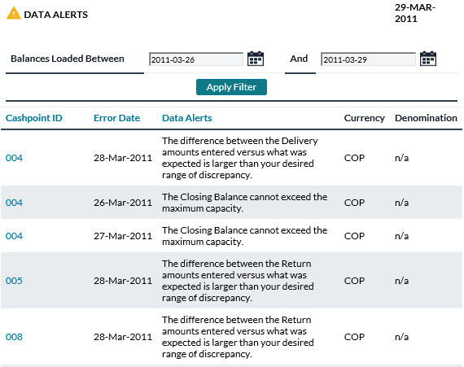

Table 43: Data Alerts Fields

| Field | | Description | |
| --- | --- | --- | --- |
| **Balance Loaded Between / And** | | Allows the user to choose the dates that will be displayed in the report. | |
| **Apply Filter** | | Refreshes the report list with the report specific to the options selected. In this case, if the dates are changed, the user can use the ‘**Apply Filter**’ button to reflect those changes in the report. | |
| **Cashpoint ID** | | Unique alphanumeric code that identifies the Cashpoint. | |
| **Error date** | | The date in history for the Cashpoint that had an error. | |
| **Data Alerts** | | Description of the error or alert. | |
| **Currency** | | The currency for which the error or alert has been reported. | |
| **Denomination** | | The denomination of the currency for which the error or alert has been reported. | |
| **Print** | | Submits the entire report to be printed. | |
| **Close** | | Closes the current report window. | |
|  | **Note**: Click on the hyperlinks **Cashpoint ID, Error Date or Data Alerts** to list the items by these criteria. | |

Return To: Today Tab

### Today→Forecast Health Summary Report

The Forecast Health Summary Report is used to help the OptiCash Analyst review Cashpoint forecasts. The report displays a list of all the active Cashpoints assigned to the current user. The list is always sorted from the lowest Forecast Health value to the highest.

Figure 62: Forecast Health Summary Report

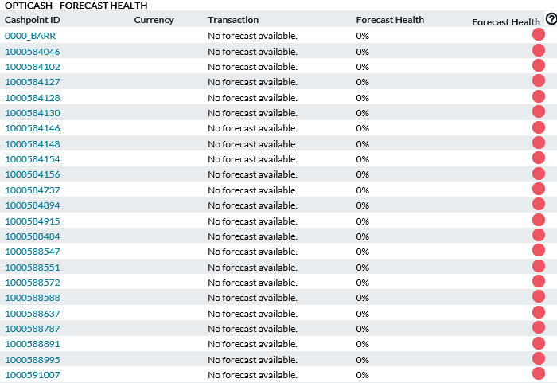

Table 44: Forecast Health Summary Description

| Field | Description |
| --- | --- |
| **Cashpoint ID** | Unique alphanumeric code that identifies the Cashpoint. The user can click on any of the Cashpoint IDs and go directly to the Cashpoint Forecast. |
| **Currency** | Currency ISO Code for the Cashpoint and Transaction type. |
| **Transaction** | The type of Forecast performed. The possible values are:  **Withdrawals** – Forecast based on withdrawal history for the Cashpoint. (Applies to All Cashpoints)  **Deposits** – Forecast based on deposit history for Cashpoints. (Applies to Branches and Advanced Devices only)  **Net Demand** – Forecast based on the total net demand of a cashpoint. The Net Demand is calculated as Deposits minus Withdrawals. The Net Demand Forecast can be either calculated or forecasted based on the forecasting parameters  **Recycled Deposits** – Forecasts based on deposits into Advanced Device type ATMs |
| **Forecast Health** | A value is given to the forecast that represents the general quality of the Forecast. The Forecast Health value is a percentage between 0% and 100% where 0% means a poor forecast. |
| **Forecast Health** | Indicator related to the Forecast Health that gives a graphical representation of the Forecast quality.  **Red –** The Forecast is poor  **Yellow** – The Forecast is moderate  **Green** – The Forecast is good. |
| **Print** | Submits the entire report to be printed. |
| **Close** | Closes the current report window. |

Return To: Today Tab

### Today→Check Dynamic Forecast Results Report

The Dynamic Forecast allows automatic scheduling of forecast processing. It is a separately licensed feature of OptiCash (included in the Virtual Analyst Option Package).

Cashpoints are re-forecasted at a predetermined interval (determined by batch setup). If some cashpoints do not finish in the given time period on a particular day, they are considered “**Pending**” until the following day.

The ‘**Check Dynamic Forecast Results Report**’ is used to view the cashpoints that were processed during the last run of the Dynamic Forecast batch process.

Figure 63: Dynamic Forecast Results Report Page

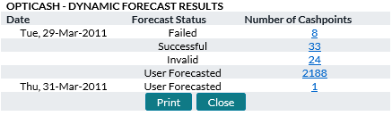

Table 45: Dynamic Forecast Results Description

| Field | Description |
| --- | --- |
| **Date** | The run date and the Status of the forecasts were entered. This is based on the running of the Dynamic Forecast Batch process |
| **Forecast Status** | Indicates the Status of the Dynamic Forecasts  **Pending** – Indicates that the cashpoints have been selected to be re-forecasted  **Successful** – Indicates that the cashpoints were successfully forecasted on that date.  **User Forecasted** – Indicates that the users manually ran the forecast process for those cashpoints. |
| **Number of Cashpoints** | Indicates the number of cashpoints that pertain to the Status of the Dynamic Forecast process.  Clicking on the hyperlink for the Number of cashpoints will produce the ‘Forecast Results’ Report See: Result Details→Recommendation Snapshot Report |

Return To: Today Tab

## Today→Orders Page

This page allows the user to view the status of all Recommendations and Orders for the current day. This page provides tools to help the user filter results and provides links to the Cashpoint ordering screen to see or edit details of the Orders and Recommendations.

Figure 64: Today --> Orders Page

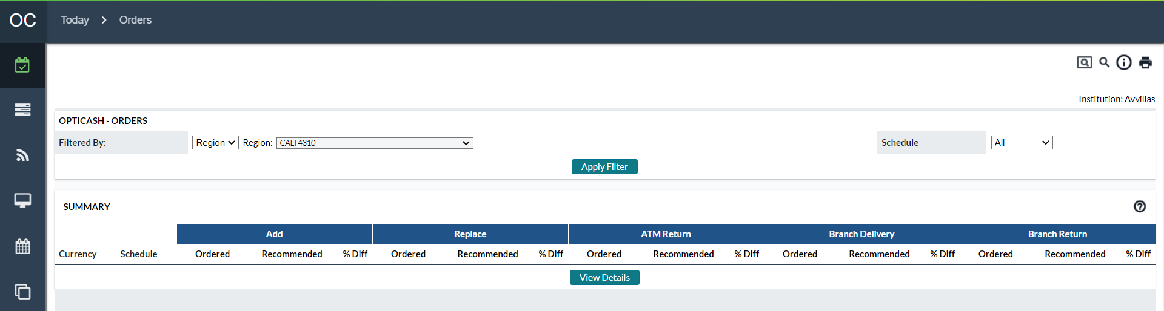

Table 46: Order Page Descriptions

| Function | Description |
| --- | --- |
| **Filtered By** | Allows the user to filter the Details to only select certain Cashpoints. The user can filter by certain groupings of Cashpoints and then refine the selection by selecting a sub-group of that group. For instance, the user can select by Type of Cashpoint and then select the Sub-Group of All, ATM, or Branch.  **Note** that changing the filter types does not automatically update the Summary and Details. To update these sections, you would need to click on the Apply Filter button |
| **Schedule** | Allows the user to apply an additional filter to select Planned or Unplanned deliveries. |
| **Apply Filter Button** | Once the Filtered By Selections has been made, the user can apply that filter which will then update the Summary and Details Sections of the page. |
| **Summary** | Provides a summary of the orders and recommendations for all Cashpoint that fall under the filtered selection. The summary is broken into separate sections for Add/Delivery and Replace Return types of Service. The following is a description of each column of the Summary:  **Currency** – The Currency ISO code for the order which is defined at the system level.  **Schedule** – Refers to the Type of Service. Possible entries are Planned, Unplanned, or All (meaning a total of the Planned and Unplanned)  **Ordered** – The amount that has been ordered. The number to the right in parenthesis is the number of orders that are committed for that category.  **Recommended** – The amount that has been recommended by the system. The number to the right in parenthesis is the number of recommendations that exist for that category.  **% Diff** – The percentage difference between the order and the recommendation. |
| **Details** | Provides the detail of the orders broken down by Cashpoint for the filtered selection. Some of the columns in this section have hyperlinks in blue which allow you to click on the selection to sort the Details in ascending or descending order. Also, some columns allow the user to filter the results. Note that the details will automatically refresh after the selection of the filter.  The following is a description of the columns:  **Cashpoint ID** – Is the unique identifier for the Cashpoint. These IDs are hyperlinks which allow the user to click on them to access the Cashpoint screen and see the details of the Recommendation and Order.  **Cashpoint Type** – Identifies the type of Cashpoint (ATM or Branch)  **Action** – Refers to the type of Service (Add/Delivery, Replace/Return, or Transfer). There is also a drop-down box which allows the user to filter the Details by Service Type.  **Currency** – Refers to the Currency ISO for the given order. There is also a drop-down box which allows the user to filter the Details by Currency Type.  **Due Date** – Refers to the date that the Order will be delivered to the Cashpoint.  **Recommended Amount** – The amount that was recommended to order by the system.  **Ordered Amount** – The order amount that was committed in the system.  **Confirm** – Refers to the way the order was committed. There is also a drop-down box which allows the user to filter the Details by Opened or Declined Recommendations. Explanations of the Order Statuses are listed below  **Status** – Shows an indicator and a percentage difference between the recommended and ordered amounts. The indicator will display Green if the order has been committed with a 0% difference; Yellow if the order is committed but there is a difference between recommended and ordered amounts; Red if the Recommendation is still open |

Table 47: Order Status Description

| Order Status | Description |
| --- | --- |
| **Open Recommendations** | When no action is being taken over a recommendation produced by OptiCash, the status will stay “**Open**”. An open recommendation requires actions to be taken by OptiCash users. These recommendations could be open for many different reasons and one of them could be that no cash is required for that specific day. It is highly recommended that at the beginning of the implementation, all open recommendations are carefully reviewed. |
| **Auto Committed** | The generated recommendation can be set to “**Auto-Committed**” on the network (under *Processing → Recommendations→ Settings*) or the Cashpoint level (under *Orders→ Run Recommendations*). When Auto-Committed is set, recommendations will automatically be committed to orders without a review. In this case, it will not be necessary to load order files since the recommendations will be written directly to the order files. Usually, this feature is used for ATMs, where no branch personnel are reviewing the recommendations. |
| **Accepted Recommendation** | Accepted order status appears when the Branch/ATM staff accepts a recommendation generated by OptiCash. In this case, the total recommended amount is equal to the total ordered amount.  **Note:** The denominations are not taken into consideration, meaning that the staff will be able to accept a recommendation even when they decide on a different distribution of the denominations than those generated by OptiCash.  Remember that in some cases, the recommendation produced by OptiCash not necessarily needs to be accepted. It could be overridden to change the denomination splits and would be reported in this case as a 0% variation. |
| **Overridden Recommendation** | An overridden recommendation occurs when the branch/ATM staff considers the recommendation not viable for the given circumstances. OptiCash considers a recommendation overridden when the total amount recommended differs from the total amount ordered (even when most of the denominations stay intact). In this case, OptiCash will calculate the variation between the totals allowing the users to control changes that could be impacting the goals of the currency management area or simply alerting that corrective actions need to be taken in the OptiCash settings/forecast. |
| **Manual Order/ New Order** | In this case, NO recommendations have been produced in OptiCash, but the Branch/ATM staff decides to place a new order. In some installations, there will be the option to generate zero recommendations so all orders will have to be overridden. This helps some institutions to control that ALL users with OptiNet access take action and overall recommendations being generated. |
| **Centrally Overridden Recommendation** | Central Override status will be displayed when orders are edited by the OptiCash analyst. This will be a central override due to the change of the original status (Accepted, Overridden, and New Order). Reasons for a Central Override could be:  1. Branch/ATM staff needs to order more cash than what was ordered at the beginning of the day.  2. Branch/ATM staff ordered the wrong amount of cash.  3. The central OptiCash analyst considers the amount ordered not aligned with the target of the currency management area.  In any case, it is important to understand that in the OptiNet software it is not possible to create more than one order or edit orders previously ordered, so the OptiCash analyst will act over them.  When the order is centrally overridden, OptiCash software will track the changes produced in the status of the order, allowing the user to report the last changes and the original status of the order. Since orders are a critical part of the currency management cycle, keeping good control of the orders will ensure the best decisions for future recommendations. |
| **Declined Recommendation** | OptiCash allows the user to "**Decline**" a recommendation. This does not create an order but marks the recommendation as "declined". If a recommendation is declined, it will no longer show as an open recommendation in the *Today → Dashboard →Ordering Status chart*. It will also show as "declined" in the details of *Today → Orders→ Order Details window*.  The network level recommendation report will also reflect when a recommendation is declined.  **Note** that the user can go in and accept or override the recommendation later if so desired. |

Return To: Today Tab

## Today→Orders Workflow Page

The Orders Workflow page is used to review orders and quickly move orders from one state to another.

Figure 65: Today --> Orders workflow Page

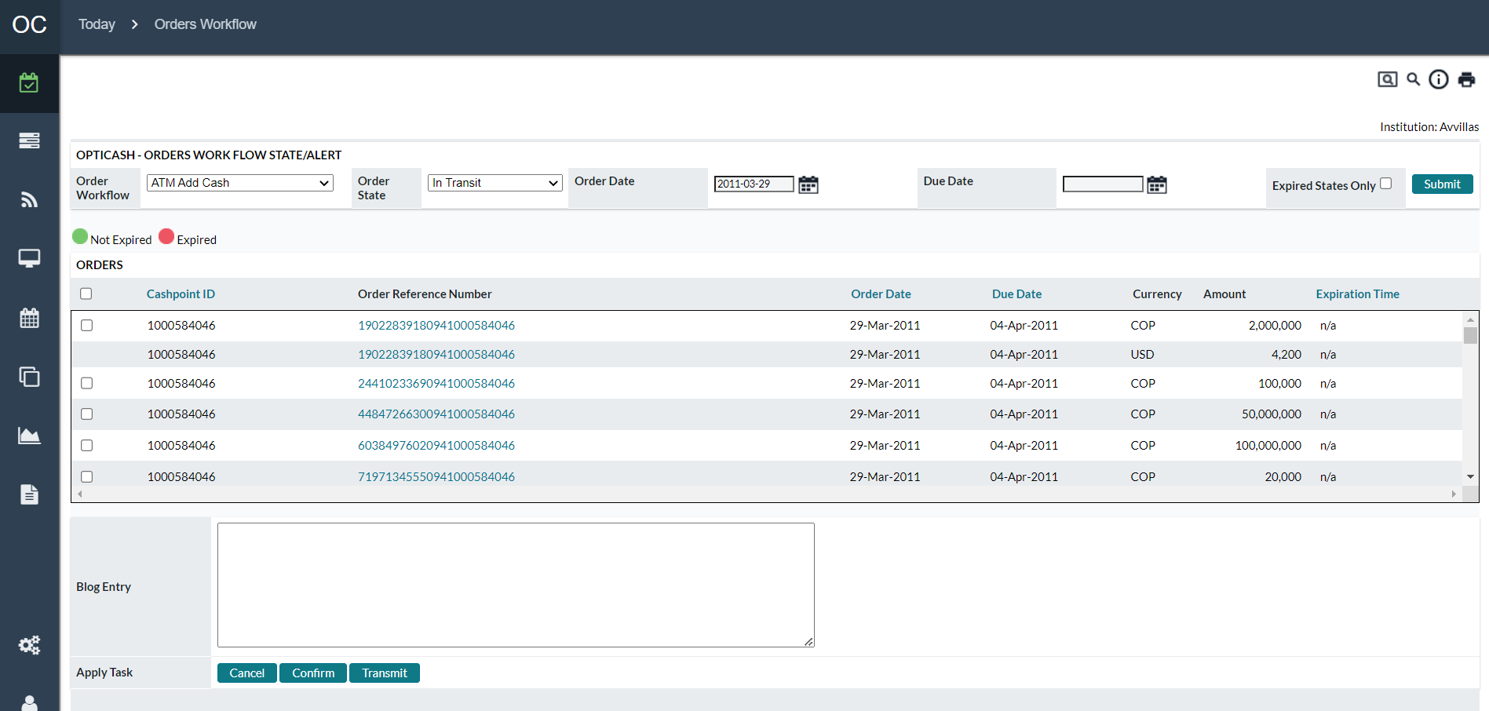

Table 48: Orders workflow Page Descriptions

| Function | Description |
| --- | --- |
| **Order Workflow** | Allows the user to select an order type |
| **Order State** | Allows the user to select an order state |
| **Order Date** | Allows the user to specify an order date |
| **Due Date** | Allows the user to specify an order due date |
| **Expired States Only** | Allows the user to view only those orders past the expiration time for their current state. |
| **Submit Button** | Executes the query to find the orders that pertain to the order parameters specified by the Order Workflow, Order State, Order Date, Due Date, and Expired States Flag. |
| **Checkbox** | Allows the user to select the cashpoints that will be processed for the ‘Apply Task’ |
| **Cashpoint ID** | Indicates the Cashpoint ID of the Cashpoint to be updated |
| **Order Reference Number** | Indicates the Reference number for the order |
| **Order Date** | The date that the order was placed |
| **Due Date** | The date that the order is to be delivered |
| **Currency** | Currency of the Order |
| **Amount** | The amount of the order |
| **Expiration Time** | Time and date that the state of the order is to expire   * The green indicator indicates the State has not expired * The red indicator indicates the State has already expired |
| **Blog Entry** | Allows users to enter information about the transaction in the Blog History |
| **Apply Task button** | Moves the selected orders to the next specified state. |

Return To: Today Tab

## Today→Pre-Emptive Alerts

Pre-Emptive Alerts are used to warn users of possible or probable cash-out situations. This page allows the user to see an overview of the Pre-Emptive Alerts as well as view the detail of the Alerts for each Cashpoint. For details on the Pre-Emptive Report See: Pre-Emptive Alert Report

Figure 66: Pre-Emptive Alerts Overview Page

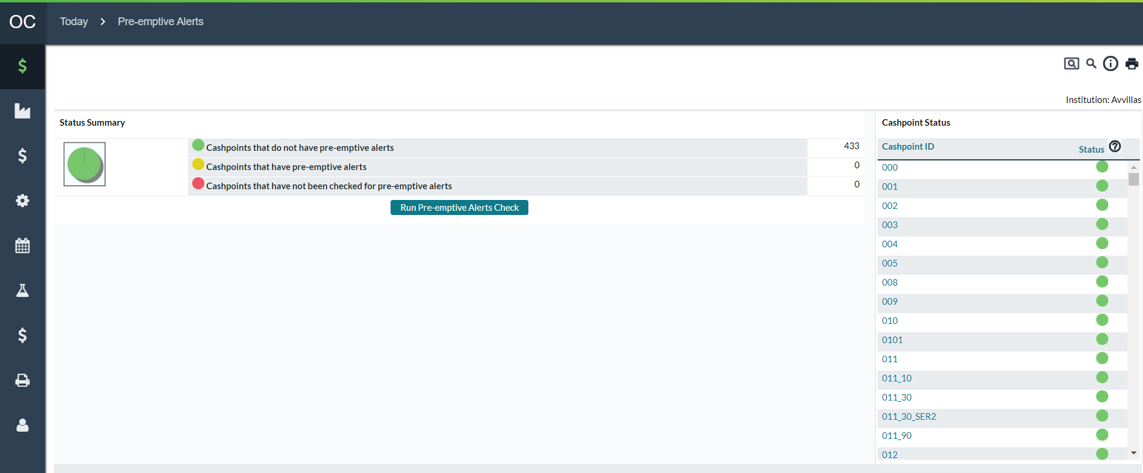

Table 49: Pre-Emptive Alerts Overview Description

| Field | Description |
| --- | --- |
| **Status Summary** | This section gives an overview of the Pre-emptive alerts that have been checked for the current day. The chart gives a graphical representation of the 3 statuses and the results are broken down by type.  **Green –** No Pre-Emptive alerts found.  **Yellow –** Cashpoints have Pre-emptive alerts and they should be reviewed.  **Red –** Cashpoints have not had the Pre-emptive report run. |
| **Cashpoint Status** | This section gives an overview of the Cashpoints that are assigned to the current user and an indicator as to the state of Pre-Emptive Alerts for each. |
| **Cashpoint ID** | Unique alphanumeric code that identifies the Cashpoint. |
| **Status** | A status indicator showing the Pre-emptive alert state. Clicking on the status indicator will take the user to the report for that particular Cashpoint. |
| **Run Pre-emptive Alerts Check Button** | Allows the user to select the Cashpoints for which the Pre-Emptive Alert Check will be run. The user simply needs to select some or all the Cashpoints and submit the report for processing. Once the process has been completed, the report will be displayed for the user. |

Return To: Today Tab

### Pre-Emptive Alert Report

The Pre-Emptive Alert Report shows a summary for a group or a single Cashpoint. The user can use this report to see possible or probable shortfall amounts as well as hyperlinks to the Cashpoint so pre-emptive measures can be taken to avoid a cash-out situation.

Figure 67: Pre-Emptive Alert Report Page

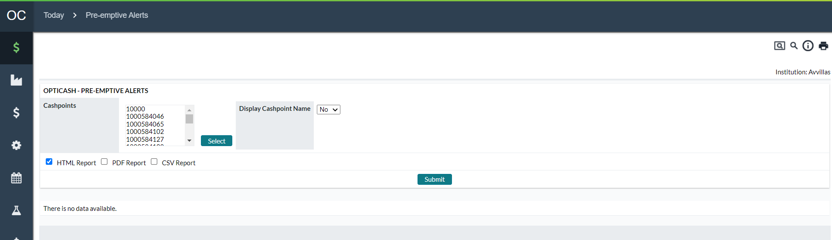

Table 50: Pre-Emptive Alert Report Description

| Field | Description |
| --- | --- |
| **Select Button** | Allows the user to select Cashpoints to be displayed in this report. For more information on selecting Cashpoints, See: Cashpoint Selector |
| **Display Cashpoint Name** | This option will display a column with the Cashpoint name in the report. By default, the report does not display this information. |
| **Submit Button** | Submits the report to be processed. When the report has finished, it will be displayed for the user in the selected format (HTML, PDF, and CSV). For more information on reporting and report options, See: Reports Tab |
| **Date** | The date of the entry. |
| **Cashpoint Type** | Cashpoint type: branch or ATM. |
| **Cashpoint ID** | Unique alphanumeric code that identifies the Cashpoint. The user can click on the hyperlink to go directly to the Cashpoint to take pre-emptive measures to avoid a cash-out situation. |
| **Currency** | ISO Currency identification of the currency for the Cashpoint. |
| **Opening Balance** | The projected opening balance at the beginning of the day for this Cashpoint and currency. |
| **Shortfall Amount** | The amount that the Cashpoint will go is deficient compared to the day’s Required Balance.  **Red -** Indicates an out-of-cash situation meaning the Net Demand of that day is greater than the Opening Balance.  **Yellow** - Indicates that the balance is below the Required Balance. |
| **Required Balance** | The Required Balance is calculated each day based on the Cashpoint parameters and the Cashpoint Net Demand. For more information on Required Balances and Cashpoint Parameters, see: Cashpoint→Main→Overview |
| **Net Demand** | For Branches and Advanced Devices, this field will represent Net Demand (deposits – withdrawals) for the day when this warning/alert will occur.  For Replace Cassette, Add Cash, and Combined ATMs this field represents forecasted customer withdrawals for the day when this warning/alert will occur.  For ATMs, net demand on a service day will represent Pre-Withdrawals from the horizon where Pre-Withdrawals = Pre-Replenishment Percentage x Forecasted Withdrawals.  For ATMs, net demand on a non-service day will represent Withdrawals from the horizon. |
| **Accumulated Demand** | For Branches and Advanced Devices, this field will represent accumulated net demand (deposits – withdrawals) from today’s date (system date) to the day this particular warning/alert will occur.  For Replace, Add Cash and Combined ATMs this field represents accumulated customer withdrawals from today’s date (system date) to the day this particular warning/alert will occur.  Accumulated demand will provide analyst information on how much demand the Cashpoint will have to cover until the projected cash-out situation. |
| **Next Delivery Date** | The date of the next normal delivery that has been recommended by the system (if the recommendation has been generated for this Cashpoint).  The Next Delivery Date includes Normal Recommendations or Confirmed Normal Orders due today or later. However, due to the nature of Emergency Orders and Recommendations, they do not show up as the Next Delivery date or Amount unless they have been confirmed as Orders and are Due to be delivered AFTER the current day. This is because Emergency Orders and Recommendations are not guaranteed and require user intervention to ensure they are confirmed into Orders.  Additionally, if a Cashpoint requires an Emergency Delivery and that shows up as a Recommendation for the current day, the Next Delivery Date may be far into the future because this would be the next Delivery day if the Emergency were to take place. Again, even if the Emergency is confirmed into an order, it will still not show up as the Next Delivery Date unless it is due after the current day. |
| **Next Delivery Amount** | The amount to be ordered for the next delivery date. See “**Next Delivery Date**” for an explanation of how the delivery dates are determined |

Return To: Today Tab

## Today→Data Health

### Data Health Summary

The Data Health indicator provides the user with information regarding the quality of the daily historical data that is loaded into OptiCash. The following will explain the Data Health Summary Pages.

Figure 68: Data Health Summary Page

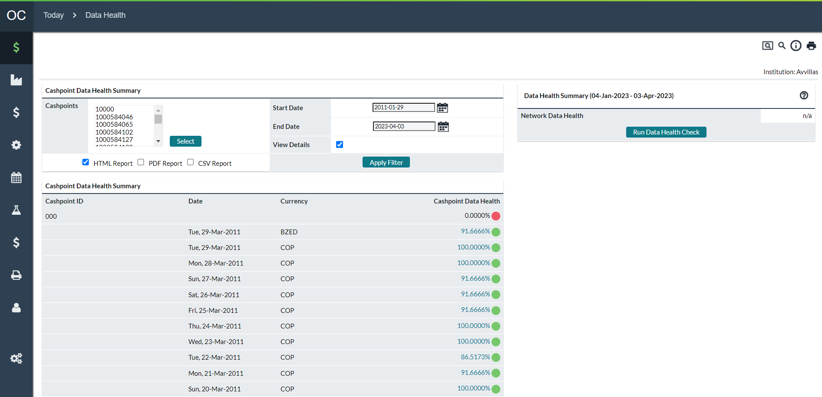

Table 51: Data Health Summary Description

| **Field** | **Description** |
| --- | --- |
| **Select Button** | Allows the user to select Cashpoints to be displayed in this report. For more information on selecting Cashpoints, See: Cashpoint Selector |
| **Submit Button** | Submits the report to be processed (as seen in Figure 67: Data Health Summary Page). When the report has finished, it will be displayed for the user in the selected format (HTML, PDF, and CSV). For more information on reporting and report options, See: Reports Tab |
| **Status Indicators** | The status indicator is a coloured icon which gives a visual indicator as to the quality of the Data health.  **Red –** (Poor Data Health) Indicates there are serious problems with Data Health.  **Yellow –** (Moderate Data Health) Indicates there are some problems with the Data Health.  **Green –** (Good Data Health) Indicates there are little or no problems with Data Health. |
| **View Details Option** | By default, the user will see a summary for each Cashpoint based on the last 90 days of history (This is why the Start and End dates are not editable).  The user has the option to select specific dates by checking the ‘**View Details**’ option. Using this option, the user will be able to select dates and will receive a detailed report for each day for each Cashpoint. |
| **Start Date** | The starting date for the analysis of the data.  **Note**: if the option ‘View Details’ is not selected, then the start date will default to 90 days from the current date. |
| **End Date** | The ending date for the analysis of the data.  **Note**: if the option ‘View Details’ is not selected, then the end date will default to the current date. |
| **Apply Filter** | Submits the Cashpoint selection and display options (Dates and View Details Option) to be processed. The result will be returned in the section of the page called ‘**Cashpoint Data Health Summary**’ depending on the report options selected. |
| **Cashpoint Data Health Summary** | Shows the HTML report for the Cashpoints selected. If the option ‘**View Details**’ is not selected, then the report will show the average Data Health quality for each Cashpoint for the default period of 90 days. If the option ‘**View Details**’ is selected, then the summary information will include the detail for each Cashpoint for each day for the period selected. |
| **Network Data Health** | This is the Calculated Data Health average for all Cashpoints assigned to this user for the last 90 days. |

Return To: Today Tab

### Run Data Health Check

The Data Health indicator is used to alert the user to potential problems with historical data. Data Health needs to be periodically calculated (at least weekly) to ensure that the calculations are up to date and to make sure that there are not any problems with historical data.

Figure 69: Run Data Health Check Page

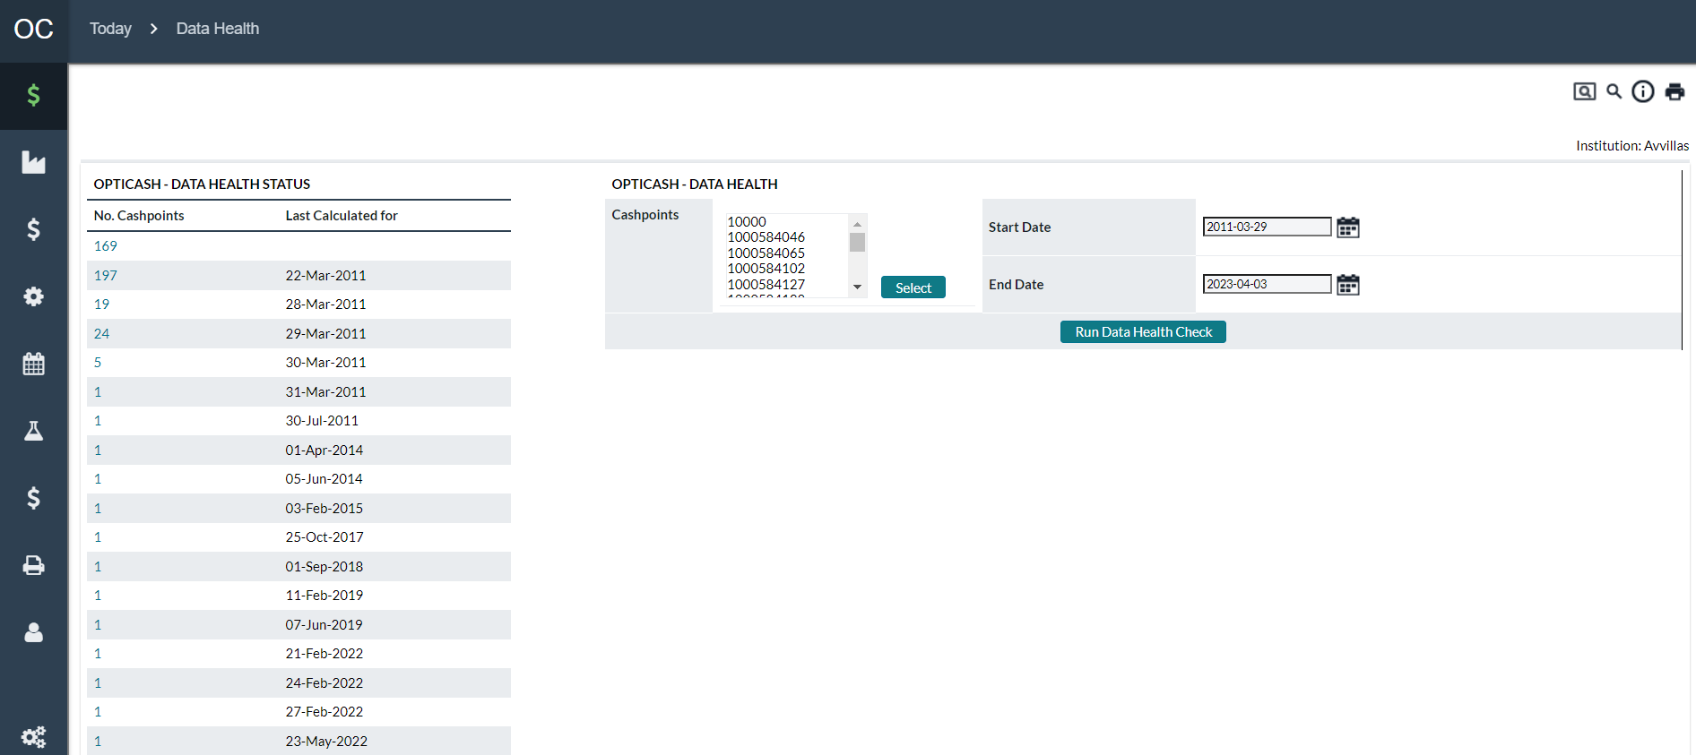

Table 52: Run Data health Check Description

| Field | Description |
| --- | --- |
| **Data Health Status** | Gives an overview of the Cashpoints assigned to the user and the last historic date the data health was calculated. In some cases, there may be several entries. This may happen when some Cashpoints were calculated while others were not. This allows the user to see the Cashpoints and dates for which the calculations must be run. Clicking on the link for the number of Cashpoints will produce a report with the detail by Cashpoint for the calculations. See: Figure 69: Data Health Indicator Status Report |
| **Select Button** | Allows the user to select Cashpoints to be used for the Data Health Calculation. For more information on selecting Cashpoints, See: Cashpoint Selector |
| **Run Data Health Check Button** | Starts the process of calculating Data Health for the selected Cashpoints and dates.  **Caution:** The Data Health Check is a very process-intensive task and could take significant server resources and time to run if many Cashpoints are selected for a large period of time. If this is the case, the calculations should be broken up into smaller groups or shorter periods of time to ensure the calculations are run properly and the process does not affect other users of the system. |
| **Start Date** | The starting date for the analysis of the data. |
| **End Date** | The ending date for the analysis of the data. |

Return To: Today Tab

### Data Health Indicator Status Details

This report appears when the user selects the hyperlink from the **‘Run Data Health Check’** page. This report provides the user with a summary for each Cashpoint detailing the dates and number of days the data health has been calculated.

Figure 70: Data Health Indicator Status Report

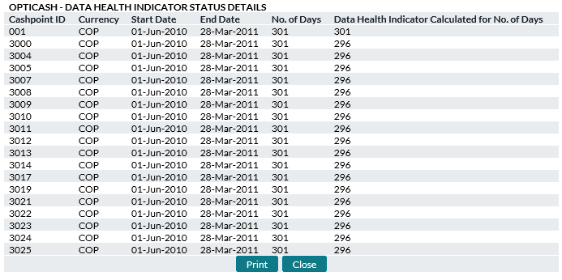

Table 53: Data Health Indicator Status Description

| Field | Description | |
| --- | --- | --- |
| **Cashpoint ID** | Unique alphanumeric code that identifies the Cashpoint. | |
| **Currency ID** | The currency ISO code(s) that is assigned to this Cashpoint. | |
| **Start Date** | The starting date for the analysis of the data. | |
| **End Date** | The ending date for the analysis of the data. | |
| **No. of Days** | Indicates the number of days between the Start and End Dates | |
| **Data Health Indicator Calculated for No. of Days** | This field indicates the number of days that were calculated. Normally, this should be the same number as the ‘**No. of Days’** field. If it is different, it means that some days were either not calculated or were deleted for some reason. In this case, the Data Health should be recalculated. | |
| Return To: Today Tab | |

1. Processing Tab

This Tab provides the user with tools to load, process, and export data. The user can Load historical data and orders; define forecast and recommendation parameters; run Forecast and Recommendation processes; output Order and Recommendation Reports; and calculate the costs for transporting and holding cash.

All the pages that are contained under the Processing Tab are explained below. The following is a summary of the information that will be covered in this section along with hyperlinks to each topic:

* Processing→Process Status
* Processing→Results
* Processing→Load→Load Balances Page
* Processing→Load→Load Orders
* Processing→Load→Load Downtime
* Processing→Load→Load Validation Settings Page
* Processing→Recommendations
* Processing→Orders Output Page
* Processing→Orders Output→Settings
* Processing→Cost Calculation
* Processing→Custom Jobs

Return To: Introduction to the Interface

## Processing→Process Status

The Process Status page shows any system processes that are currently running on the server.

Figure 71: Process Status Page

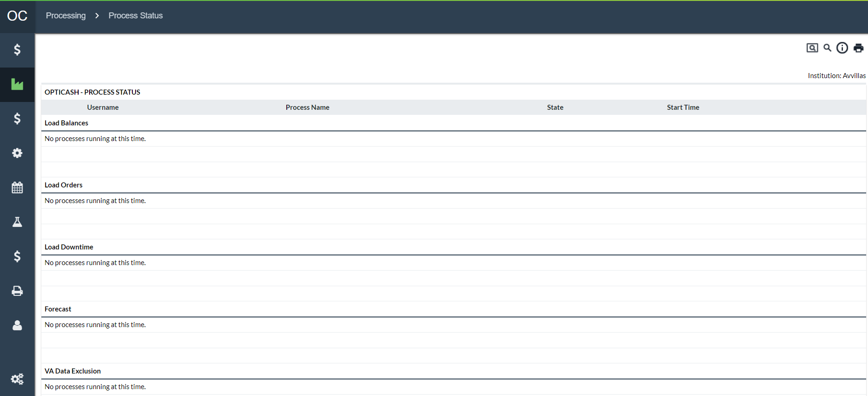

Table 54: Process Status Description

| Field | Description |
| --- | --- |
| **Username** | Name of the user that initiated the process |
| **Process Name** | Name of the process that is running |
| **State** | State of the process that is running (Active or Inactive) |
| **Start Time** | Time the process was started |
| **Load Balances** | The daily balance load process is started through *Processing→Load→Load Balances* or as an automated batch process on the server. |
| **Forecast** | The forecasting process for Cashpoints is started at the Cashpoint level, through *Processing→Forecasting*, or as an automated batch process on the server. |
| **Recommendation** | The recommendation process for Cashpoints is started at the Cashpoint level, through *Processing→Recommendations*, or as an automated batch process on the server. |
| **Recommendation Output** | The Recommendation Output process for Cashpoints is started through *Processing→Recommendation* Output, or as an automated batch process on the server. |
| **Orders Output** | The Orders Output process for Cashpoints is started through *Processing→Order* Output, or as an automated batch process on the server. |
| **Remove Process from Queue** | The ‘**Remove Process from Queue**’ button in the OptiCash interface can be used to delete any of the processes in the queue but **will not delete the process already submitted to the server**.  **For example**, when a forecast process is submitted, it is put into the queue on the processing screen. Then the web browser sends a message to the server to initiate the process for the first one in the queue. Once started on the application server, the process itself cannot be stopped without a system administrator's intervention.  If a job becomes hung up on the application server, it is necessary to delete the process from the OptiCash interface or else the job will be kicked off again as soon as the application server is restarted. |

Return To: Processing Tab

## Processing→Results

The Results page displays a summary of the processes that are run daily in OptiCash.

Figure 72: Results Page

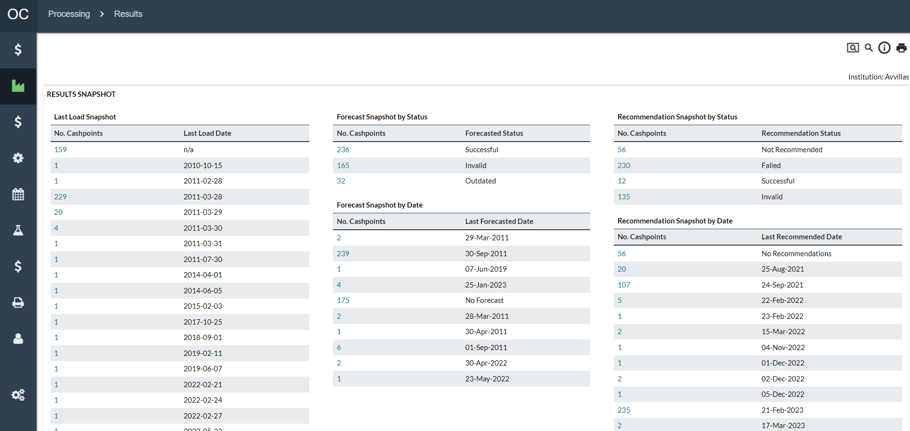

Table 55: Results Description

| Fields | Description |
| --- | --- |
| **Last Load Snapshot** | This functionality was covered in a previous section. Click on the following link to review this information: Today→Last Load Snapshot PageToday→Last Load Snapshot PageToday→Last Load Snapshot PageToday→Last Load Snapshot Page |
| **Data Health Indicator** | This functionality was covered in a previous section. Click on the following link to review this information: *Today→Data Health* |
| **Forecast Snapshot by Status** | The forecast snapshot displays a list of the Forecasts by their run status. The possible values are:  **Not Forecasted** – No Forecast has been run for these Cashpoints.  **Successful** – Forecast ran without problems for these Cashpoints.  **Failed** – A problem occurred with the running of the forecast. Check the Alerts Report at the Cashpoint level to identify and resolve the problem ( See: Cashpoint)  **Outdated** – This means that some parameters were changed for the Cashpoints and the forecasts should be re-run. The existing forecasts are still valid and will work for recommendations, however, due to the change that was made they may not be as accurate because the changes have not been applied to the Cashpoint forecast. |
| **Forecast Snapshot by Date** | Forecast snapshot displays a list of the Forecasts by their run date. |
| **Recommendation Snapshot by Status** | Recommendation snapshot displays a list of the Recommendations by their run status. The possible values are:  **Not Recommended** – No Recommendations have been run for these Cashpoints. (See: Processing→Recommendations→Run Recommendations Page)  **Successful** – The recommendation process ran without problems for these Cashpoints.  **Invalid** – A parameter is not set correctly which is preventing the Cashpoint from being recommended. Check the validation settings on the Recommendation screen  **Failed** – A serious problem was encountered. Please contact NCR Cash Management Support for assistance with this problem. |
| **Recommendation Snapshot by Date** | Recommendation snapshot displays a list of the Recommendations by their run date. |

Return To: Processing Tab

### Result Details→Forecast Snapshot Report

The Forecast Snapshot report displays a summary of the Forecasts that have been run by OptiCash analysts.

Figure 73: Forecast Snapshot Report

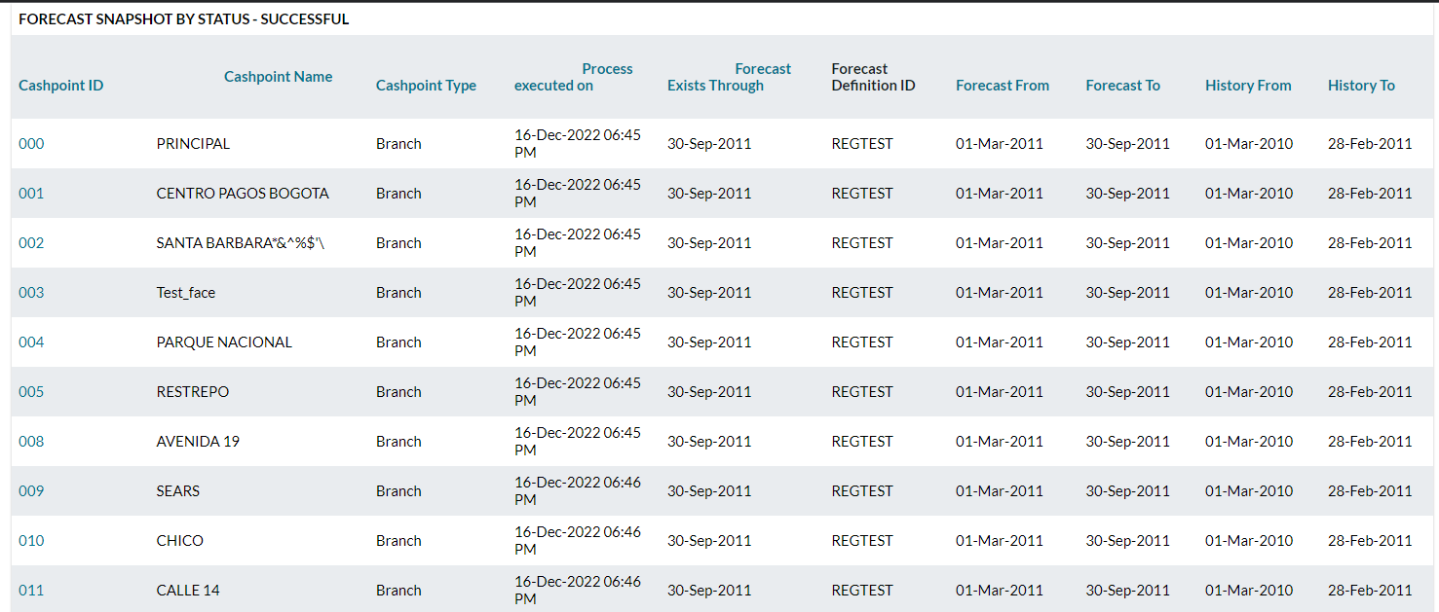

Table 56: Forecast Snapshot Description

| Fields | Description |
| --- | --- |
| **Cashpoint ID** | Unique alphanumeric code that identifies the Cashpoint. |
| **Cashpoint Name** | Cashpoint Name defined at the Cashpoint level |
| **Cashpoint Type** | Type of Cashpoint that was forecasted (ATM/Branch) |
| **Process Executed on** | The date that the Process was the last run. Note that the time will always be 12:00 AM regardless of the time it was run. |
| **Forecast Exists Through** | The date of the last forecasted day for the specified Cashpoint. |
| **Forecast Definition ID** | Unique identifier of the forecast definition that was used to run this forecast. The forecast definition is used to store the parameters for the forecast.  **Note:** The Forecast From/To and History From/To listed in this report come from the currently defined Forecast Definition and do not necessarily reflect the dates that were used to run the forecast. If the parameters of the forecast definition are changed, they will immediately be reflected in this report; therefore, these fields are for information purposes only. |
| **Forecast From** | Forecast From the date that is currently defined for this specified Forecast Definition ID |
| **Forecast To** | Forecast To date that is currently defined for this specified Forecast Definition ID |
| **History From** | History From the date that is currently defined for this specified Forecast Definition ID |
| **History To** | History To date that is currently defined for this specified Forecast Definition ID |
| **Print Button** | Prints the entire report that is on this page. |
| **Close Button** | Closes this page. |

Return To: Processing Tab

### Result Details→Recommendation Snapshot Report

The Recommendation Status report displays a summary of the Recommendations that have been run by the OptiCash analysts.

Figure 74: Recommendation Snapshot Report

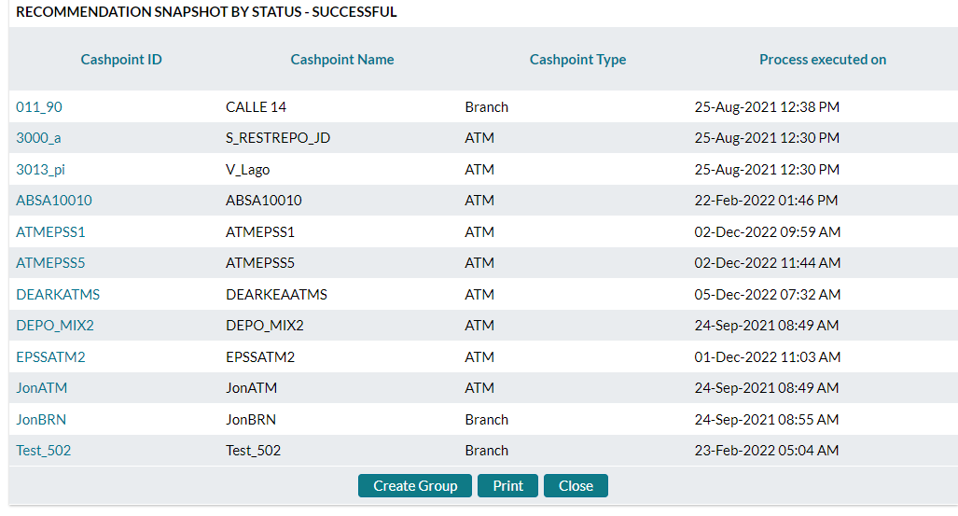

Table 57: Recommendation Snapshot Description

| Processing Results | Description |
| --- | --- |
| **Cashpoint ID** | Unique alphanumeric code that identifies the Cashpoint. |
| **Cashpoint Name** | Cashpoint Name defined at the Cashpoint level |
| **Cashpoint Type** | Type of Cashpoint that was forecasted (ATM/Branch) |
| **Process Executed on** | The date that the Process was the last run  **Note** that the time will always be 12:00 AM regardless of the time it was run. |
| **Print Button** | Prints the entire report that is on this page. |
| **Close Button** | Closes this page. |

Return To: Processing Tab

## Processing→Load→Load Balances Page

The Load Balances page is used to manually load Cashpoint balances into OptiCash. This function is only necessary when the batch processes failed to work as expected.

Figure 75: Load Balances Page

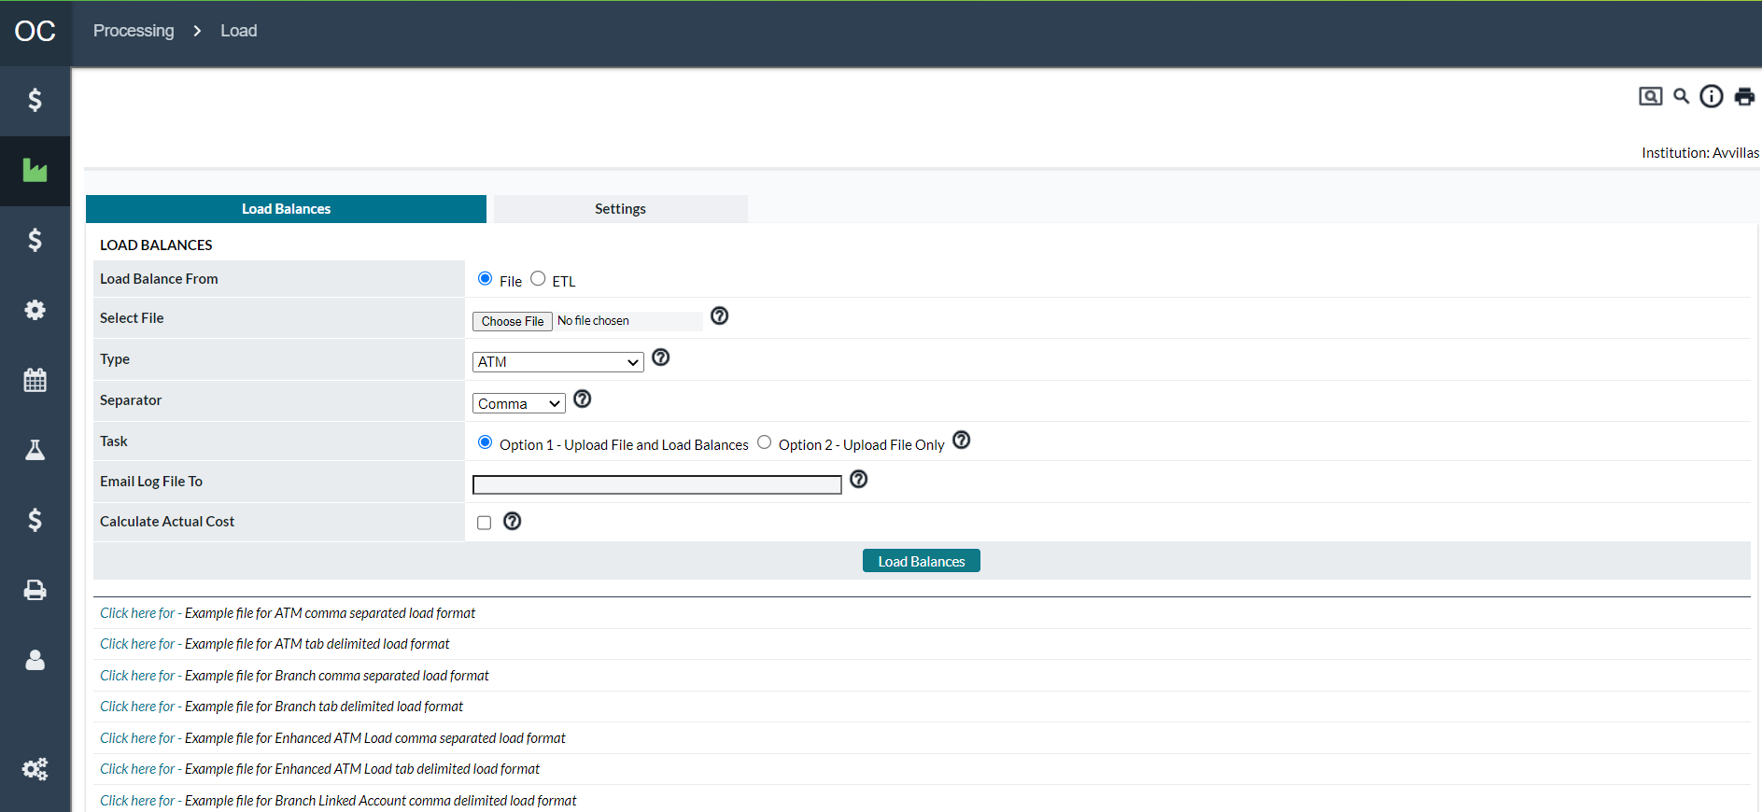

Table 58: Load Balances Description

| In this field: | Enter or specify the following: |
| --- | --- |
| **Load Balance From** | OptiCash allows files to be imported from two sources:  **File**: Users can save a file in the appropriate OptiCash format on their local environment or network, browse to the saved location and upload the file  **ETL:** ETL load comes from a table instead of a file supplied by the user. The customer institution has an outside system that drops the data into one specific table in OptiCash. The ETL load process copies from the table into the branch history. **Available only for Branches**. |
| **Select File** | Click on the **Browse** button to select the file that needs to be loaded. |
|  | **Caution:** When loading balance files via the interface it is recommended that the original path of the load files is different from the import directory (<application-path>/import). The import directory is used to copy files that are being loaded to OptiCash (daily load files, order files, etc). This is to avoid potential issues when the loaded files are replaced by the previously copied files in the import directory.  Additionally, because of the intense record verification there occurs during the loading of balances, the time that is taken to process a file increase exponentially as the file increases in size. Therefore, it is suggested to break the files into smaller files for loading (i.e., 30 days of history). If the loading time is still long, then use even smaller files. |
| **Type** | Select the type of Cashpoint for which the balances are loaded (ATM or Branch). Additional file options are Enhanced ATM Load which provides the capability for more robust ATM data. Branch Linked Account file format also permits the loading of tracking of intra-branch balance tracking by unique account.  Intraday files for both ATM and Branch can also be loaded.  Please refer to the OptiCash Input/Output guide for field descriptions of these files. |
| **Separator** | Select the type of field separator used in the file (Comma and Tab are the options available). |
| **Task** | Select whether to just upload the file to the server or upload the file to the server and process the file to load balances into OptiCash.  If **Option 1** is selected, the load process is scheduled for execution immediately. But the process could take some time to complete. The status of the load process is emailed to the email addresses entered below.  **Option 2** should be used if the process of loading balances is to be scheduled for a later time. Contact the system administrator for detailed information about scheduling the process of loading balances. |
| **Email file to:** | Enter the email addresses of the people who should receive notification of the status of the load process when the load is completed successfully or unsuccessfully. Commas should separate multiple addresses. |
| **Calculate Actual Costs** | When the checkbox is checked, the balance load process will calculate actual costs for the dates being loaded based on cost definitions in the system. Please refer to the section Processing→Cost Calculation for more information on Cost Calculation. |

|  |  |
| --- | --- |
|  | Click on the hyperlinks to see an example of comma-separated or tab-delimited formats for ATMs or branches. |

Return To: Processing Tab

## Processing→Load→Load Orders

The Load Orders page is used to manually load orders into OptiCash. This process is usually done automatically on the server using a batch process. This function is only necessary when the batch processes failed to work as expected.

Figure 76: Load Orders Page

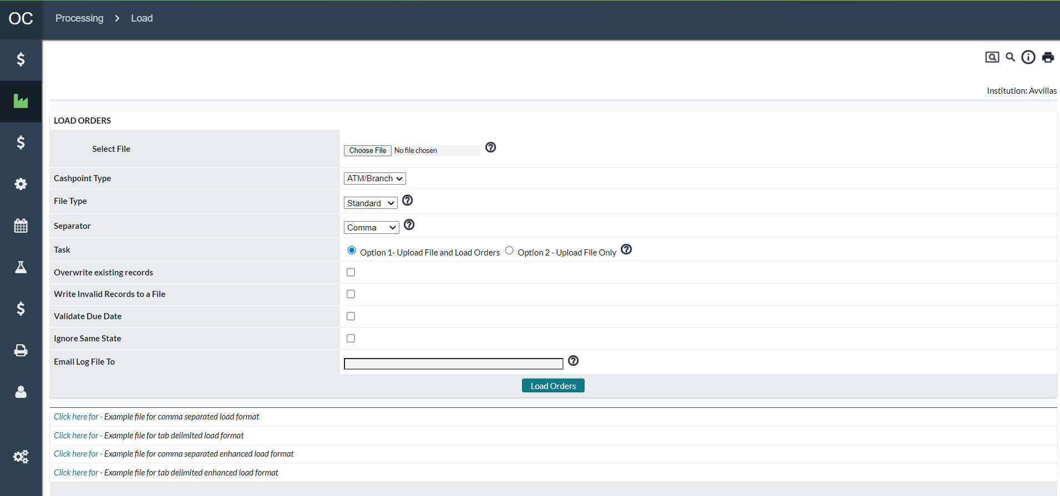

Table 59: Load Orders Description

| Fields | Description |
| --- | --- |
| **Select File** | Click on the **Browse** button to select the file containing orders to upload. The file should follow the OptiCash order load format. |
| **Separator** | Select the type of field separator used in the file. Options available: comma or tab. |
| **Task** | Select whether you would like to just upload the file to the server or upload the file to the server and process the file to load orders into OptiCash.  If **Option 1** is selected, the load process is scheduled for execution immediately. But the process could take some time to complete. The status of the load process is emailed to the email addresses entered below.  **Option 2** should be used if the process of loading orders is to be scheduled for a later time. Contact the system administrator for detailed information about scheduling the process of loading orders. |
| **Overwrite Exiting Records** | In situations where the order files were loaded, found to be in error and then reloaded, you have to use this option.  With this option, the order load process will overwrite any previously existing records for the same date and Cashpoint. |
| **Write Invalid Records to a File** | When order file records cannot be loaded, they will be rejected by the system. If the checkbox is checked, invalid records will be written to a file so that they can be reviewed, corrected, and successfully loaded later. |
| **Validate Due Date** | If checked, the order load process will validate the order date and due date based on the Cashpoint lead time defined in the system. Incorrect records will be rejected and written to the log file. |
| **Ignore Same State** | This feature applies to the Enhanced Order File. It allows users to load Order Files with previously loaded orders and if the Order State is the same as was previously loaded, that record will be ignored.  It is best practice to only orders that are updated relative to what was previously loaded and leave the feature turned off as this will simplify the process in OptiCash. However, some users need to frequently load files in a single day, and this feature will simplify the users’ process by allowing them to not have to validate the file of only records with updates. |
| **E-mail Log File to** | Enter the email addresses of the people who should receive notification of the status of the load process when the load is completed successfully or unsuccessfully. Multiple addresses should be separated by semicolons. |

Return To: Processing Tab

## Processing→Load→Load Downtime

The Load Downtime page is used to upload and insert records relating to the operating statuses of the ATMs. This status can be used to automatically exclude data based on the defined Rules. See: Network→Network Monitoring

Figure 77: Load Downtime Page

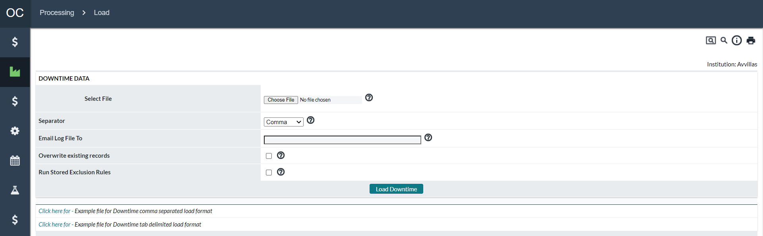

Table 60: Load Downtime Description

| Fields | Description |
| --- | --- |
| **Select File** | Click on the **Browse** button to select the file containing downtime statuses to upload. The file should follow the OptiCash Downtime load format. |
| **Separator** | Select the type of field separator used in the file. Options available: comma or tab. |
| **E-mail Log File to** | Enter the email addresses of the people who should receive notification of the status of the load process when the load is completed successfully or unsuccessfully. Multiple addresses should be separated by semicolons. |
| **Overwrite Exiting Records** | In situations where the Downtime files were loaded, found to be in error and then reloaded, you must use this option.  With this option, the downtime load process will overwrite any previously existing records for the same date and Cashpoint. |
| **Run Stored Exclusion Rules** | Automatically starts the processes of the Enabled Exclusion Rules on the newly loaded data. See: Network→Network Monitoring |
| **Load Downtime Button** | Loads the Downtime files into the system based on the file selected and the options. |

Return To: Processing Tab

## Processing→Load→Load Validation Settings Page

The load validation in OptiCash helps to determine the data health indicators based on validations over the historical data. This screen allows configuring the validation settings for balances. Under the validations settings, you will see a list of warning and error descriptions. You have the option to turn the validation settings on or off by checking the box. Some of the settings require setting a threshold amount. The following table will help to understand the validations provided by OptiCash when loading balances.

Figure 78: Validation Settings Page

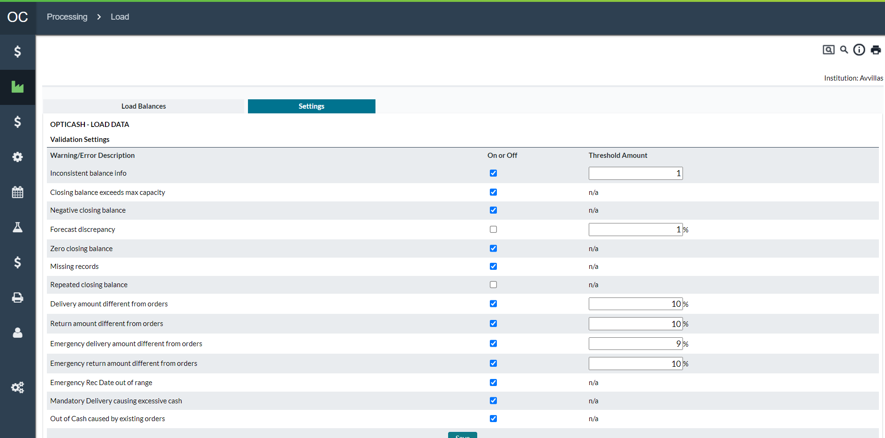

Table 61: Validation Settings Description

| Warning/Error Name | Description of Warning or Error Check |
| --- | --- |
| **Inconsistent Balance Info** | OptiCash validates the quality of the balances loaded on the daily basis. Balance information is used in the OptiCash recommendation process, and inconsistent or poor data quality will adversely affect the quality of the recommendations.  OptiCash will look into balances to make sure the following rules are followed:  The Opening Balance must equal the closing balance of the prior day  The closing balance for the day must follow this calculation:  **For Branches**  Closing Balance = Opening Balance + Delivery - Return +Deposits – Withdrawals + ATM Ship In – ATM Ship Out  **For ATMs**  Closing Balance = Opening Balance + Delivery – (Return) – Withdrawals  Check the box if you want the system to alert you when the balance information is inconsistent.  A warning message is generated when the balance inconsistency amount (amount discrepancy from the calculated closing balance based on the formula above) exceeds the **Threshold Amount** entered here.  **Note** The Threshold Amount will take into consideration both negative and positive discrepancies, as it will alert any absolute value of discrepancy being greater than the threshold amount. |
|  | Usually, the threshold amount is a good tool for clients loading balance details in decimals. The balance calculation formula rounds up the numbers to the nearest whole number.  **Example:**  Balances loaded with the following decimals:  Starting balance 100.5 EUR  Withdrawals 0 EUR  Deposits 10.5 EUR  Closing Balance 111.0 EUR (while other fields are 0).  Rounding of balance data:  Starting balance 101 EUR  Withdrawals 0 EUR  Deposits 11 EUR  Closing Balance 111 EUR  In such a case, OptiCash will generate an alert since the calculation of 101EUR+11EUR = 112EUR. If a threshold amount of 1 is defined, OptiCash will not generate such balance inconsistency error, as the balance discrepancy is not greater than 1. |
| **Closing Balance Exceeds Max Capacity** | OptiCash issues a warning when balances are over the capacity of a Cashpoint. |
| **Negative Closing Balance** | OptiCash generates a warning when the closing balance is negative. |
| **Forecast Discrepancy** | OptiCash compares the Actual Net Demand vs. Forecasted Net Demand using the following percentage calculation:  (Actual Demand– Forecasted Demand)/Forecast Demand = % Forecast Discrepancy  A warning message is generated when the % Forecast Discrepancy (as calculated above) exceeds the **Threshold Percentage**.  If the box is checked, the system will alert of forecast discrepancies, based on the threshold percentage entered. |
| **Zero Closing Balance** | OptiCash generates a warning when the closing balance equals zero. |
| **Missing Records** | OptiCash generates a warning message when a Cashpoint is missing during the daily load process. OptiCash handles the balance calculation; however, the user should be aware that for that specific date, OptiCash is making decisions based on a calculated balance. |
| **Repeated Closing Balance** | OptiCash issues a warning when a closing balance is repeated, that is when the closing balance for today is the same as the prior day. |
| **Delivery Amount Different From Orders** | OptiCash performs the following calculation for historical deliveries:  % Difference = (Historical Delivery – Ordered Delivery Amount) / Historical Delivery  A warning message is generated when the % Difference (as calculated above) exceeds the **Threshold Percentage**.  If the box is checked, the system will alert of different historical delivery amounts versus orders, based on the threshold percentage entered.  Usually, such alerts will point to either data error or carrier in compliance. |
| **Return Amount Different From Orders** | OptiCash performs the following calculation for planned returns:  % Difference = (Historical Return – Ordered Return Amount) / Historical Return  A warning message is generated when the % Difference (as calculated above) exceeds the **Threshold Percentage**.  If the box is checked, the system will alert of different historical return amounts versus orders, based on the threshold percentage entered.  Usually, such alerts will point to either data error or carrier in compliance. |
| **Emergency Delivery / Return Amount Different From Orders** | The same as above, only for unplanned deliveries or returns. |
| **Emergency Rec Date out of range** | In the recommendation process, this alert is caused when an emergency cannot be produced at the beginning of the horizon based on the lead time rule (due_date=order date + lead time). If this is causing cash out later in turn, this will be reported as an Emergency date out of range.  **For example**, the recommendation date for Cashpoint A is March 2, 2007, and the lead time is 1 there is supposed to be an emergency due on March 2, 2007, but based on the lead time rule, the recommendation date for this emergency is March 1, 2007. However, our recommendation date is March 2, 2007, and we cannot go back to assign March 1, 2007, as the recommendation date. The recommendation date then will not produce the emergency. | |
| **Mandatory Delivery causing excessive cash** | This alert warns the user that mandatory service days settings are causing excessive cash in the Cashpoint’s horizon that otherwise would not have been recommended by the OptiCash recommendation process. | |
| **Out of Cash caused by existing orders** | This alert warns the user that a committed pending order is causing an out-of-cash situation; in other words, the order in the pipeline on the horizon is not enough to cover immediate cash needs. | |

Return To: Processing Tab

## Processing→Recommendations

Daily recommendations are typically generated after the prior day’s balance files are loaded or at some future date and time. Recommendations can be generated on a network as well as at a Cashpoint level. The following sections will walk through the Recommendation settings for running Recommendations at a Network level as well as producing the Output Reports.

Before Recommendations can be run, the setting and parameters must be correctly defined. Also, a Recommendation ID must be created from the Setting Page.

All of the pages that are contained under the Recommendation Tab are explained below. The following is a summary of the information that will be covered in this section along with hyperlinks to each topic.

* Processing→Recommendations→Run Recommendations Page
* Run Recommendations→Recommendation Validation Report
* Processing→Recommendations→Settings Page
* Processing→Recommendations→Institution Settings Page
* Processing→Recommendations→Recommendation Output

Return To: Processing Tab

### Processing→Recommendations→Run Recommendations Page

From this page, the recommendations can be run for a selected Recommendation ID. The Recommendation IDs are setup and managed on the Settings Tab. On this page, the user can run and/or validate the recommendations.

Figure 79:Run Recommendation Page

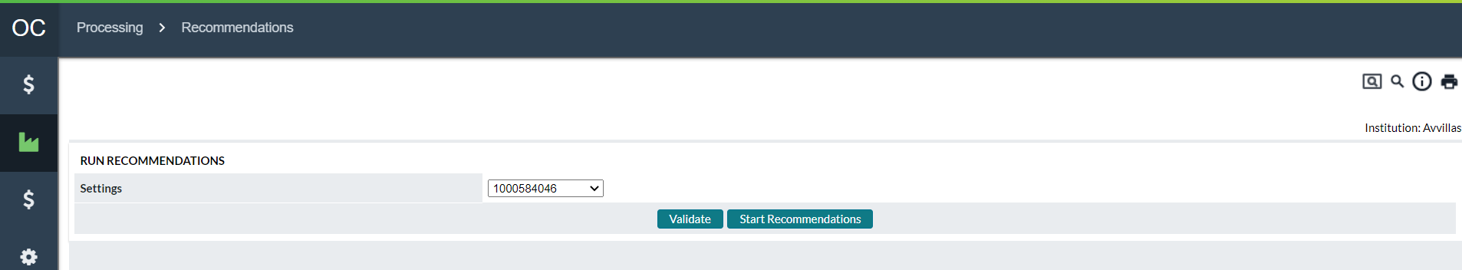

Table 62: Run Recommendation Description

| Fields | Description |
| --- | --- |
| **Settings Tab** | Allows the user to setup or manage Recommendation IDs |
| **Institution Tab** | Allows the user to setup settings and parameters for the institution as it relates to recommendations. |
| **Recommendation Output** | Allows the user to Output the Recommendation report for a specified Recommendation ID. |
| **Settings** | Lists the currently defined Recommendation IDs. The Recommendation ID contains all the settings and Cashpoints that will run during the recommendation process. |
| **Validate Button** | Runs the validation process on the Cashpoints defined in the select Recommendation ID. |
| **Validation Results** | After running the Validation, the user can view the results of the process by clicking on this link. For more details on the results, see:  Run Recommendations→Recommendation Validation ReportRun Recommendations→Recommendation Validation Report |
| **Start Recommendations Button** | Clicking on this button will start Recommendation Process for the Cashpoints and settings defined in the selected Recommendation ID. |

Return To: Processing Tab

### Run Recommendations→Recommendation Validation Report

The Recommendation Validation report is used to help identify if there are problems with Cashpoint settings and to troubleshoot Cashpoints that have a run status of ‘**Invalid’**. This report can be accessed from the *Today→Snapshot* page by clicking on the To-Do List item called ‘**Verify Recommendations Create**’ or by running the Validation Report from the ‘Run Recommendations’ page.

The user can review this report and use the explanations in this section to help correct the problems so all recommendations will run successfully.

Figure 80: Recommendation Validation Report

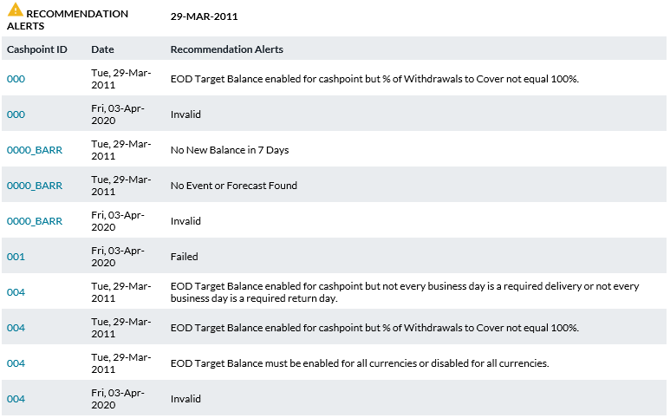

Table 63: Recommendation Validation Description

| Processing Results | Description |
| --- | --- |
| **Cashpoint ID** | Unique alphanumeric code that identifies the Cashpoint. |
| **Date** | The date that the Process was run. |
| **Recommendation Alerts** | Gives a summary of the problem that was encountered during the validation check. If one or more problems are found with a Cashpoint, a separate entry will be made for each problem found. In addition. A general error message will be entered as either ‘**INVALID’** or **‘FAILED’**. Resolve all the conflicts with the Cashpoint and re-run the recommendation process. (See Table 64 for more detail on errors) |
| **Print Button** | Prints the entire report that is on this page. |
| **Close Button** | Closes this page. |

The following table outlines the different types of warnings or errors that could be encountered when running the recommendation validation report.

Table 64: Recommendation Validation Messages

| Warning/Error Name | Description of Warning or Error Check |
| --- | --- |
| Cashpoint Definition Validation | |
| **No Parameters Found** | There are no parameters defined for this Cashpoint. Should be corrected on the Cashpoint screen: *Basic → Parameters*. |
| **No Requirements Found** | There are no requirements defined for this Cashpoint (Cashpoint requirements are some of the parameters stored in separate requirements tables). Should be corrected on the Cashpoint screen: *Basic → Parameters*. |
| **No Delivery Costs Found** | There are no costs defined for this Cashpoint. Should be corrected on the Cashpoint screen*: Advanced → Costs*. |
| **No Denominations Found** | There are no denominations defined for this Cashpoint. Should be corrected on the Cashpoint screen: *Basic → Denominations.* |
| **No Calendars Found** | There are no Calendars assigned for this Cashpoint. This situation should be corrected on the Cashpoint screen: Basic → Service Days or by assigning the Cashpoint to a calendar on *Events→Calendars*. |
| Cashpoint Parameter Validation | |
| **Overnight Earnings Rate is Missing** | Overnight Earnings Rate is not defined. Should be corrected on the network level: *System → Currencies/ Denominations → Currencies.* |
| **Maximum Holding is Missing** | Maximum Capacity is not defined for this Cashpoint. Should be corrected on the Cashpoint screen:  **Branches:** *Basic → Parameters*.  **ATMs:** *Basic → Denominations*. |
| **Minimum Delivery Amount is Missing** | Minimum Delivery Amount is not defined for this Cashpoint. Should be corrected on the Cashpoint screen*: Basic → Parameters.* |
| **Minimum Exception is Missing** | Minimum Exception is not defined for this Cashpoint. Should be corrected on the Cashpoint screen: *Basic → Parameters*. |
| **Optimization Type is Missing** | Maximum Holding Type is not defined for this Cashpoint. Should be corrected on the Cashpoint screen: *Basic → Parameters.* |
| **Both Exception Amount and % are Missing** | Exception Amount and/or Exception % are not defined for this Cashpoint. Should be corrected on the Cashpoint screen: *Basic → Parameters.* |
| **Exception Amount exceeds minimum balance** | Exception Amount exceeds safety stock amount for this Cashpoint. Should be corrected on the Cashpoint screen: *Basic → Parameters.* |
| Cashpoint Requirements Validation | |
| **No All Days Requirements** | Advanced → Parameters should contain a record for ‘All Days’. If missing, this entry should be inserted on the Cashpoint screen: *Advanced Parameters → Parameters*. |
| **Denomination Total Not Equal to Max Hold** | Denomination totalexceeds or is less than the Max Holding for this Cashpoint. Should be corrected on the *Cashpoint screen: Basic → Parameters.* |
| **Pre-Replenishment % Missing for One or More Days** | **For ATMs only**: pre-replenishment % is not defined for this Cashpoint. Should be corrected on the Cashpoint screen: *Basic → Parameters.* |
| **Standard Order Greater than Max Hold** | **For ATMs only**: Standard Order amount is greater than Max Holding for this Cashpoint. Should be corrected on the Cashpoint screen: *Basic → Parameters*. |
| Cashpoint Service Days Validation | |
| **Business Days are Missing** | There are no business days defined for this Cashpoint. Should be corrected on the Cashpoint screen: *Basic → Service Days*. |
| **Unplanned Lead Time is Missing** | There is no lead time for unplanned service defined for this Cashpoint. Should be corrected on the Cashpoint screen: *Basic → Service Days.* |
| **No Delivery Days Defined** | There are no delivery days defined for this Cashpoint. Should be corrected on the Cashpoint screen: *Basic → Service Days*. |
| **ATMs:**  **Replace Cash Lead Time is Missing**  **Add Cash Lead Time is Missing** | There is no lead time for associated service defined for this Cashpoint. Should be corrected on the *Cashpoint screen: Basic → Service Days.* |
| **Add Cash Time of Day is Missing**  **Replace Cash Time of Day is Missing** | There is no cash time of day associated for this Cashpoint. Should be corrected on the Cashpoint screen: *Basic → Service Days by resaving the options.* |
| **Replace Cycle Start Date is Required**  **Add Cycle Start Date is Required** | There is no cycle start date associated for this Cashpoint. Should be corrected on the Cashpoint screen: *Basic → Service Days* by resaving the options. |
| **Branches:**  **Return Cash Lead Time is Missing**  **Delivery Cash Lead Time is Missing** | There is no lead time for associated service defined for this Cashpoint. Should be corrected on the *Cashpoint screen: Basic → Service Days.* |
| **Delivery Cash Time of Day is Missing**  **Return Cash Time of Day is Missing** | There is no cash time of day associated for this Cashpoint. Should be corrected on the Cashpoint screen: *Basic → Service Days* by resaving the options. |
| **Return Cycle Start Date is Required**  **Delivery Cycle Start Date is Required** | There is no cycle start date associated for this Cashpoint. Should be corrected on the Cashpoint screen: *Basic → Service Days* by resaving the options. |
| Depot Validation | |
| **Primary Depot not Found** | There is no depot assigned to this Cashpoint. Should be corrected on the Cashpoint screen: *Basic → Cashpoint Definition.* |
| **Depot Service Days not defined correctly** | Depot assigned to this Cashpoint does not have service days defined correctly. Should be corrected on the network level: *Network → Carriers → Depot*. |

|  |  |
| --- | --- |
| Data Validation | |
| **No New Balance {0} Days** | There is no new balance loaded for the last {No} of days for this Cashpoint. Make sure this Cashpoint is included in the daily load files. |
| **No Balance Available for the Simulation From Date** | There is no balance available for the selected date for **'Create Simulations Time**' for this Cashpoint. Make sure the ‘**from date**’ is defined correctly. Should be corrected at the Cashpoint level: *Simulations → Settings*. |
| **Last Load Balance is Invalid** | Last load balance was invalid (negative, empty, etc.). Make sure the data feed into daily load files for this Cashpoint is correct. |
| **Missing Forecast Records** | No Forecast exists for this Cashpoint. Review why the forecast is not generated, e.g., no history, missing history dates, no calendars assigned, etc. |
| **Balance greater than maximum capacity** | The balance was greater than the maximum capacity for this Cashpoint. Make sure the maximum capacity for this Cashpoint is correctly defined / or the balance was incorrect for this Cashpoint for that day. |
| **Missing Forecast Records for Deposits**  **Missing Forecast Records for Withdrawals** | No Forecast exists for Deposits or Withdrawals for this Cashpoint (branch) Review why the forecast is not generated, e.g., no history, missing history dates, no calendars assigned, etc. |
| Denomination Validation | |
| **Denomination value is invalid(<=0)** | Denomination value contains 0 or a negative value. Should be corrected on the network level: *System → Currencies/ Denominations → Denominations*. |
| **Denomination order unit amount is invalid(<=0)** | Denomination order unit amount contains 0 or negative value. Should be corrected on the network level: *System → Currencies/ Denominations → Currencies.* |
| **Denomination splits total not equal to 100%** | Denomination splits total not equal to 100% for this Cashpoint. Should be corrected on the Cashpoint screen: *Basic → Denominations.* |

|  |  |
| --- | --- |
| Other | |
| **No Event Found** | Check if this Cashpoint has a calendar assigned (*Basic → Service Days*). Then check if that calendar has any events assigned to it *(Events → Calendars*). |
| **Another currency of this Cashpoint is invalid** | This error message will be displayed when denominations are not defined correctly. Should be corrected at Cashpoint level*: Basic → Denominations.* |
| **Invalid / Failed** | This error message will be displayed when recommendations fail due to any other reasons than those listed above. The above-listed errors are the most common messages that can be received from failures/validation of the recommendation process.  However, any other reasons may be environment-related, and therefore, such issues may be identified in the recommendation log file only. |

Return To: Processing Tab

### Processing→Recommendations→Settings Page

To Run Recommendations, the Recommendation process needs to have at least one Recommendation Settings ID defined. The Recommendation Settings ID stores the parameters for running the Recommendation process and the Cashpoints that will be processed. Many different Recommendation IDs can be defined, but only one process can run per Recommendation ID and per user at the same time.

Figure 81: Recommendation Settings Page

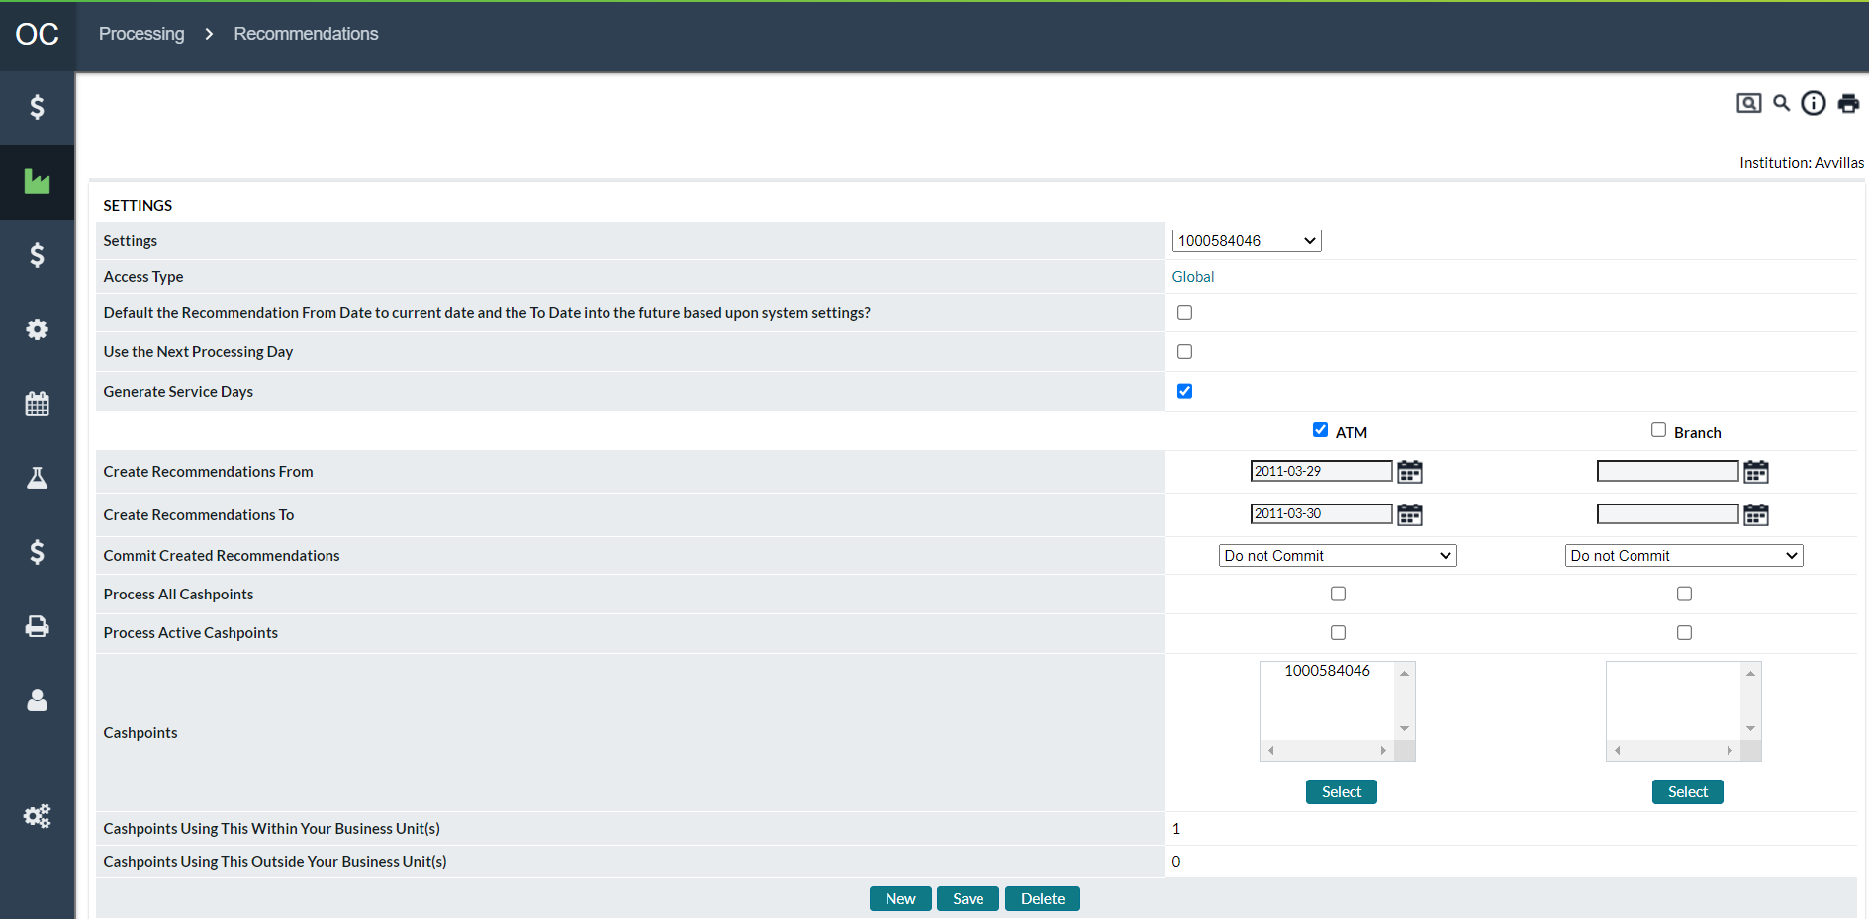

Table 65: Recommendation Settings Description

| In this field: | Enter or specify the following: |
| --- | --- |
| **Settings** | Recommendation Settings ID that stores the parameters and Cashpoints that will be processed. The user can define a new ID by clicking on the ‘**New’** button or update an existing ID by selecting from the List box, updating the parameters, and clicking the ‘Update’ button.  The Recommendation Settings ID must not contain any spaces between the characters nor should it contain special characters (‘{[]}|~`!@#$%^&*)”. |
| **Access Type** | Administrators or users with applicable privileges can set access to Global where all users with privileges can edit this forecast setup. Or access can be set to “Restricted”. Please see [System→Privileges→Business Units (Restricted and Global Privileges)](#_Privileges→Business_Units_(Restrict) for more information on Access Type |
| **Default the Recommendation From Date to current date and the To Date into the future based upon system settings** | Usually, when the batch recommendation process is set with this option, the processes are automatically set to start with the current date (as Recommendation From Date). |
| **Use the Next Processing Day** | This option is used when Recommendations need to be run using the Next Processing Day. This option is used by clients who need to load balances for the current day and then run Recommendations based on the loaded balances. Normally, the Last Load date must be less than the current system date to run Recommendations. This option overrides that limitation and allows Recommendations to be run using the Next Processing day. The processing day is the next Institutional business day that Recommendations would normally be run (i.e., The current day is Friday but Recommendations are not run-on Saturday or Sunday therefore the next Processing day would be Monday).  This setting, as part of a Recommendations Setting ID, will allow Recommendations to be run for the Cashpoints specified for the next business day. If it is necessary that only certain Cashpoints be included in the next business day processing (in other words, not all Cashpoints) then a separate Recommendation Settings ID should be created so as not to affect those Cashpoints that do not need to be Recommended with this setting. |
| **Generate Service Days** | The Service Days diary is a record specifying what services are allowed, holiday status, necessity to order for a later date, and so on for each future date. It is a prerequisite for the optimization portion of the recommendations process. This option specifies whether the recommendation process should recalculate that record or not.  The best practice would be to generate the service days every time recommendations are created. However, this can be a processing-intensive task, so the option to skip that is made available here. An example scenario might be institutions with very large ATM and Branch networks that are having difficulty processing all recommendations created in the time available overnight. They can use the Service Days Generator available in batch to generate service days on the prior day, wait for the end-of-day balances to be received, and then run recommendations without generating service days again. In this way, the processing load is spread out to a more convenient time of day. |
|  | **Note:** Before OptiCash version 8.6 the Generate Service Days was always included in the Recommendations process. Also, if the Service Days diary is not generated in some manner, then the recommendations process will fail. So, it is recommended to Generate Service Days at every opportunity – Uncheck only if you intend to generate service days in another manner. |
| **ATM and Branch Checkboxes** | Allows the user to define if the recommendation process will run for ATMs, Branches, or both. Checking the box releases the parameters below so the user can define them. |
| **Create Recommendation From** | The date that the recommendation process will start. Normally, it should be the day after the last load date. Create Recommendation From date must be before Create Recommendation To date. |
| **Create Recommendation To** | The date to which recommendations will be created. Recommendations are normally run for the current day and several days into the future. This provides some protection if the recommendation process is not run for any reason, recommendations will still be available. |
| **Commit Created Recommendations** | Selecting this option causes Normal (non-Emergency) recommendations to be written directly to the order files. If there is not going to be a review of the recommendations before finalizing them for the service providers, then this option is recommended. Usually, this is applicable for ATMs, **for example**, where no branch personnel are reviewing the recommendations. The three options in the dropdown menu:   * **Do not commit –** no orders are created by the Recommendations process * **Only planned recommendations –** planned recommendations are turned into auto-committed orders, unplanned ones are not * **All recommendations –** all recommendations are turned into auto-committed orders, both planned and unplanned |
| **Process All Cashpoints** | Processes all Cashpoints of the specified type whether they are Active or Inactive. |
| **Process Active Cashpoints** | Processes all Cashpoints that are marked as Active. |
| **Cashpoints** | Allows the user to select specific Cashpoints (using the **Select** button) to be run. This option cannot be used with the ‘Process All Cashpoints’ or ‘Process Active Cashpoints’ options. |
| **Linked Cashpoints Within Your Business Unit(s)** | Whether access is set to Global or Restricted, this count is the number of cashpoints linked to this Forecast Model. |
| **Linked Cashpoints Outside Your Business Unit(s)** | Whether access is set to Global or Restricted, this count is the number of cashpoints not linked to this Forecast Model. |
| **Select Button** | Allows the user to select Cashpoints to be used for the Recommendation ID. For more information on selecting Cashpoints, See: Cashpoint Selector |
| **New Button** | Allows the user to define a new Recommendation Settings ID. |
| **Save Button** | Allows the users to save or update any changes made to the current Recommendation Settings ID. |
| **Delete Button** | Delete the currently selected Recommendation Settings ID. |

Return To: Processing Tab

### Processing→Recommendations→Institution Settings Page

The Institution Settings Page contains parameters that define how the recommendations run. Normally, the OptiCash Analyst will have no reason for making changes to the Recommendation Institution Settings.

Figure 82: Institution Settings Page

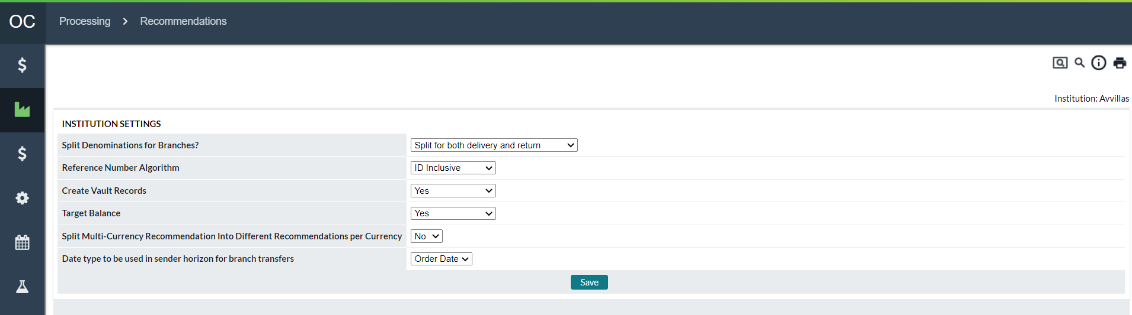

Table 66: Institution Settings Description

| Fields | Description |
| --- | --- |
| **Split Denominations for Branches** | Select an appropriate option depending on whether you would like the recommendations to be generated by denomination split or not. The choices are:   * No split for both delivery and return * Split for delivery and no split for return * No split for delivery and split for return * Split for both delivery and return. |
| **Reference Number Algorithm** | The user can choose either **Incremental** or **ID inclusive** as the form of reference number when orders are accepted/created/edited.  **Incremental Reference Number** will be a 6-digit date (yymmdd) followed by a 10-digit number randomly generated for each order.  **ID Inclusive Reference Number** will consist of 13 random digits + cashpoint ID |
| **Create Vault Records** | This option is only for clients using OptiVault integrated with OptiCash.  When Create Vault Records is set to ‘**Yes’**, during the recommendation process, OptiCash will generate vault records into a separate OptiCash table. These records will then be used for first-level aggregation in OptiVault. This process will create vault aggregation records for the duration of the horizon.  Please refer to the OptiVault user guide for more information on the first-level aggregation for OptiVault. |
| **Target Balance** | When Target Balances is set to ‘**Yes’**, OptiCash will generate a target balance for branches during the recommendation process instead of a recommended action. Bank personnel would then be expected to order delivery/return to meet the recommended target balance.  Target balances may not apply to all customer environments.  For more information on target balance, refer to the section on Target Balances. |
| **Date type to be used in sender horizon for branch transfers** | The options “**Order Date”** and **“Due Date**” are used when users have a Branch-to-Branch Transfer order. OptiCash will show it arriving at the destination on the Due Date and leaving the sender branch on the date chosen here. Due Date means it leaves the sender on the same day it will arrive at the destination, and Order Date means it will leave the sender on the date when the order is placed into the system. |

Return To: Processing Tab

### Processing→Recommendations→Recommendation Output

In some circumstances, it is necessary to create a Recommendation Output Report. The Output is normally created by a process that is run automatically, but the OptiCash user can run this manually from the Recommendation Output Tab.

Figure 83: Recommendation Output Page

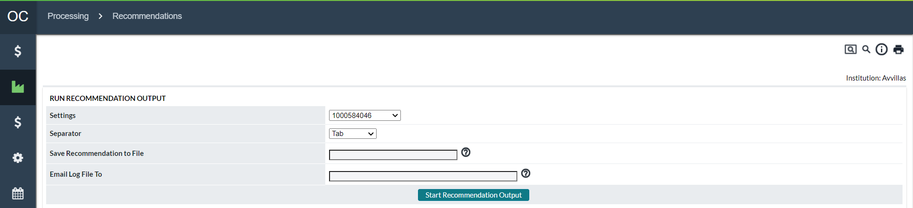

Table 67: Recommendation Output Description

| Fields | Description |
| --- | --- |
| **Settings** | Select the Recommendation Settings ID of the recommendation process for which the output file will be created.  Recommendation Settings IDs are defined under the *Processing → Recommendations → Settings tab*. |
| **Separator** | Select the format for the recommendation output file. The options available are Tab or Comma, indicating Tab or Comma Separated Values. |
| **Save Recommendation to File** | Provide the name for the recommendation output file to be generated by this process. |
| **E-mail Log File To** | Enter the email addresses of the people who should receive notification of the status of the recommendation output process and the generated output files when the process is completed. Multiple addresses should be separated by commas. |
| **Start Recommendation Output Button** | Starts the process to output the Recommendations based on the selected Recommendation Settings ID. After this process has finished, the user should receive an email with the results of the Output Process if the system is set up to send emails and the user-specified his/her email address correctly when running the process. The output files will also be saved on the server for access by a third-party application or system administrator.  **Note:** OptiCash users do not have access to these files from OptiCash. |

Return To: Processing Tab

### Processing→Recommendations→Network Contraints Optimization

OptiCash produces network-level recommendations based upon not only the cashpoint needs but also the route restrictions defined in *Network>Carriers>Route Definitions*. OptiCash will produce network recommendations based on cashpoint-to-route associations and the assigned restrictions based on the amount per truck and other settings.

Figure 84: Network Optimization page

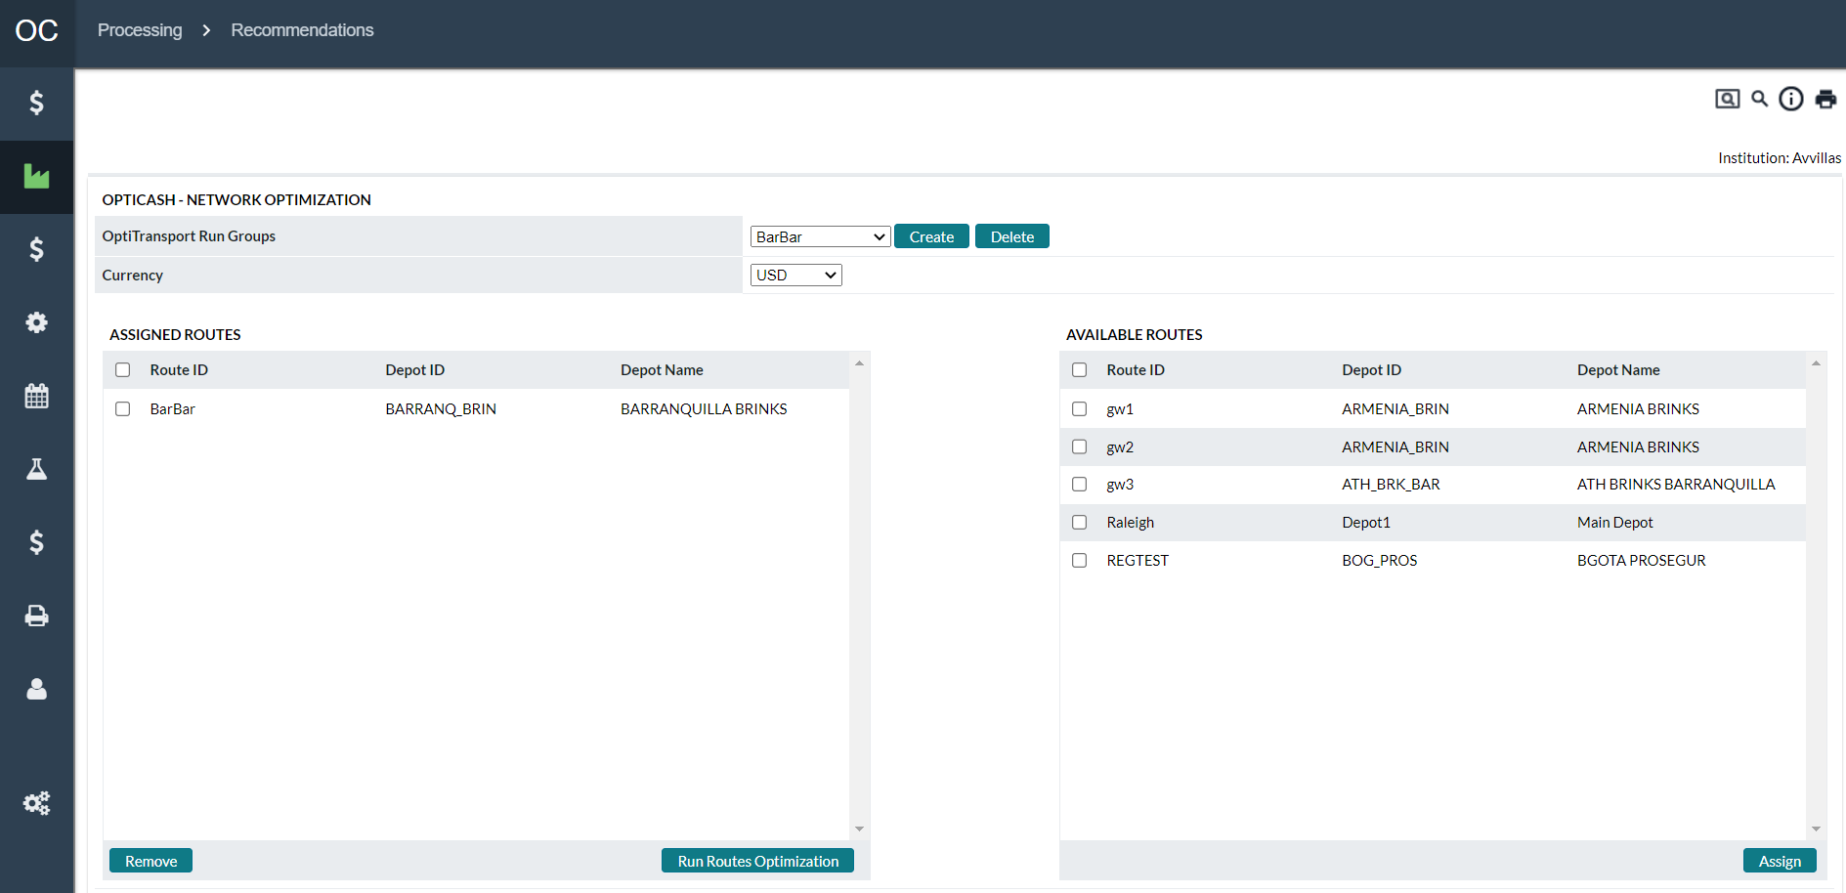

Table 68: Network Contraints Optimization Field Definitions

| Fields | Description |
| --- | --- |
| **OptiTransport Run Groups** | Identifies grouping ID for the Routes to be run as a group for the Network level optimization |
| **Create** | Allows the user to create a new Network Constraint Recommendation ID. |
| **Delete** | Allows the user to Delete a selected Network Constraint Recommendation ID group. |
| **Currency** | Currency ID for which the optimization process is to be run |
| Assigned Routes (routes assigned to process) | |
| **Route ID** | Unique alphanumeric code that identifies the Route. The Route ID can be a maximum of 12 digits and should not contain any spaces or special characters. |
| **Depot ID** | Unique alphanumeric code that identifies the Route with which the Depot is associated. |
| **Depot Name** | Name associated with the Depot ID. |
| Available Routes (routes not assigned to process) | |
| **Assign** | Moves selected cashpoints from Available Routes to Assigned Routes |

Return To: Events Tab

## Processing→Forecast

Forecasting is a sophisticated process in OptiCash that uses historical data and events to predict cash demands for the different Cashpoints in the network. The forecast process can be run for one or many Cashpoints. The user can also choose to run Forecasts in large groups or individually from the Forecast Process Page.

Similar to the Recommendation process, the Forecast process needs to have a Forecast Definition ID (also called a Horizon ID) to run. The difference is the Forecast ID does not store Cashpoint IDs but rather the dates to use from history and the dates to generate the forecast for the future.

Once the Forecast Definition IDs have been created, the user can run the Forecast process using any one of the defined IDs from this page as well as individually from the Cashpoint window.

When forecasts are run in large groups, no other users should run the Forecast process at the same time. This could cause problems if multiple processes are running for the same Cashpoints.

Figure 85: Forecast Page

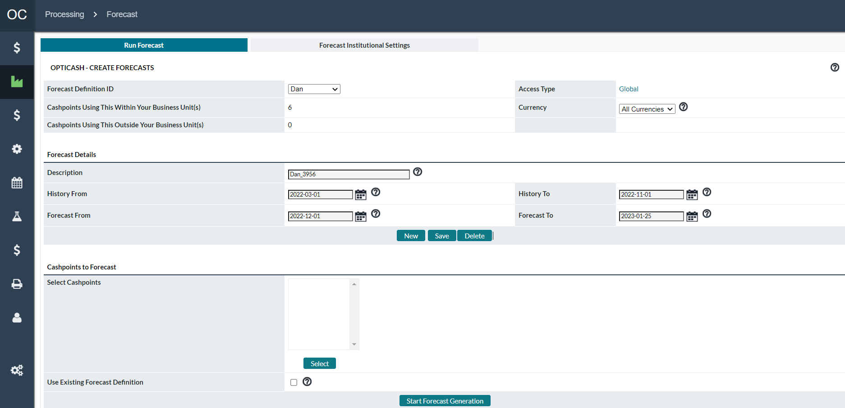

Table 69: Forecast Description

| Field | Description |
| --- | --- |
| **Forecast Definition ID** | Unique alphanumeric ID to identify this set of forecast parameters.  The Forecast Definition ID must not contain any spaces between the characters nor should it contain special characters (‘{[]}|~`!@#$%^&*)”. |
| **Access Type** | Administrators or users with applicable privileges can set access to Global where all users with privileges can edit this forecast setup. Or access can be set to “Restricted”. Please see [System→Privileges→Business Units (Restricted and Global Privileges)](#_Privileges→Business_Units_(Restrict) for more information on Access Type |
| **Currency** | Users can select specific or all currencies to reforecast. When selecting specific currencies, the unselected currencies will retain their existing forecast. |
| **Description** | Complete description for this set of forecast parameters. |
| **History “From/To”** | The historical period on which the forecast will be based. Ideally, this period should be 12 months, but no less than 90 days and should be relatively free of erroneous or poor-quality data that might adversely affect the forecasting engine’s predictions. |
| **Forecast “From”/ “To”** | The beginning and end date for the forecast period you are generating. The total forecast period should be **six months** or longer.  History and forecast date ranges should not overlap, and the forecast should begin exactly one day after the history period ends. **Example:** history range is 01Sep2001 to 31Aug2002 and the forecast date range would be 01Sep2002 to 31Aug2003. |
|  | **Note:** To ensure a good quality forecast, select “from” and “to” dates using full months for both history and forecast selection, so that selection **begins on the first day of a month and finishes on the last day of a later month**. |
| **Use Existing Forecast Definition** | When the batch forecast is run for multiple Cashpoints, this option allows using different Forecast Definition IDs already associated with the Cashpoints selected.  This option is useful when users need to re-run the forecast for a larger group of Cashpoints with different Forecast Definition IDs. It allows running batch forecasts without having to go through multiple Forecast Definition IDs and running them separately for associated Cashpoints. |
| **New Button** | Creates a blank Forecast Definition ID. |
| **Save Button** | Saves any changes made to the currently selected Forecast Definition ID. |
| **Delete Button** | Deletes the currently selected Forecast Definition ID. |
| **Select Button** | Allows the user to select Cashpoints to be used for the Forecast process. For more information on selecting Cashpoints, See: Cashpoint Selector |
| **Linked Cashpoints Within Your Business Unit** | Whether access is set to Global or Restricted, this count is the number of cashpoints linked to this Forecast Model. |
| **Linked Cashpoints Outside Your Business Unit** | Whether access is set to Global or Restricted, this count is the number of cashpoints not linked to this Forecast Model. |
| **Start Forecast Generation** | Starts the Forecast Generation Process for the selected group of Cashpoints and Forecast Definition ID. |

Return To: Processing Tab

### Forecast→Forecast Institutional Settings

Depending on the needs of the institution, it may be necessary to have Forecasted or Calculated Net Demand for Branches and Advanced Devices. The selection of this parameter can be done on the Forecast Institutional Settings Page.

Figure 86: Forecast Institutional Settings Page

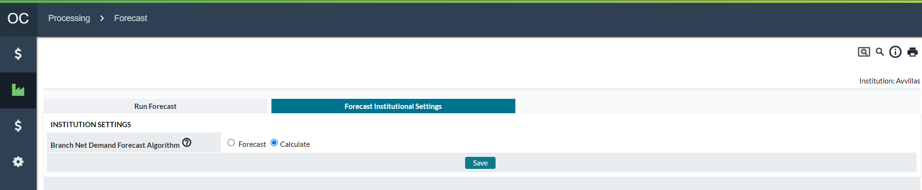

Table 70: Forecast Institutional Settings Description

| Field | Description |
| --- | --- |
| **Forecast** | A Forecasted Net Demand produces a forecast of the Net Demand based on historical Net Demand. This method is used in cases where Cashpoints have unpredictable Withdrawals and Deposits but a stable and predictable Net Demand.  Using this method, the Recommendation process will use the Net Demand Forecast when calculating Balances and making decisions on the amount and frequency of deliveries.  For more information on the forecast’s effect on the recommendation process, see: Cashpoint→Main→Overview |
| **Calculate** | A Calculated Net Demand means that the Net Demand is not forecasted but calculated based on the forecast of Withdrawals and Deposits. This is beneficial to some institutions that have very predictable Withdrawals and Deposits, but the Net Demand is not at all predictable.  Using this method, the Recommendation process will use the Deposits and Withdrawal Forecasts when calculating Balances and making decisions on the amount and frequency of deliveries.  For more information on the forecast’s effect on the recommendation process, see: Cashpoint→Main→Overview |
| **Save Button** | Saves the setting for use with all Cashpoints. |
|  | **Note:** This is an institutional setting; meaning it affects all Branches and Advanced Devices. Please consult NCR Cash Management Support if you have questions about this parameter. |

Return To: Processing Tab

## Processing→Orders Output Page

For some transportation companies or bank accounting systems, the Orders must be transmitted to them in text format. The Orders Output functionality of OptiCash can provide this output and automatically email the file or place it on the server to be picked up by a secondary process. The Output is normally created by a process that is run automatically, but the OptiCash user also can run this manually from the Orders Output Tab.

To Output orders, the user must have an Orders Output Settings ID defined in advance. See: Processing→Orders Output→Settings

Figure 87: Output Orders Page

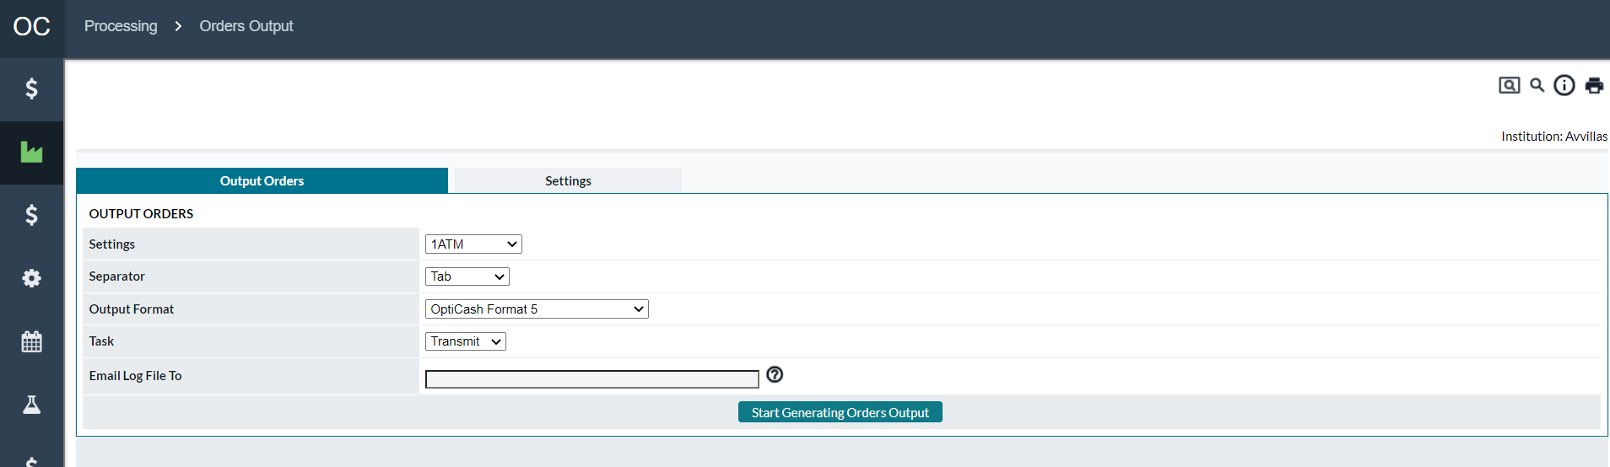

Table 71: Output Orders Description

| In this field: | Enter or specify the following: |
| --- | --- |
| **Settings** | Select Order Output Settings ID for which the output file will be created.  Order Output Setting IDs are defined under the *Processing → Orders Output → Settings tab*. |
| **Separator** | Select the format for the Orders Output file. The options available are Tab or Comma, indicating Tab or Comma Separated Values. |
| **Output Format** | Specifies the format of the files that will be output. The formats to choose from are:   * OptiCash Format 5 * 4.2.2 Daily Note Format * 4.2.2 Daily Note Format with Group |
| **E-mail Log File To** | Enter the email addresses of the people who should receive notification of the status of the Orders output process and the generated output files when the process is completed. Multiple addresses should be separated by commas. |
| **Start Generating Orders Output Button** | Starts the process to output the Orders based on the selected Orders Output Settings ID. After this process has finished, the user should receive an email with the results of the Output Process if the system is set up to send emails and the user specifies his/her email address correctly when running the process. The output files will also be saved on the server for access by a third-party application or system administrator.  **Note**: OptiCash users do not have access to these files from OptiCash. |

Return To: Processing Tab

## Processing→Orders Output→Settings

To run the Orders Output Process, at least one Orders Output Settings ID must be defined. The Orders Output ID contains all the parameters and Cashpoints that need to be outputted. The following section will describe each of the parameters to help the user create or edit an Existing ID.

Figure 88: Orders Output Settings Page

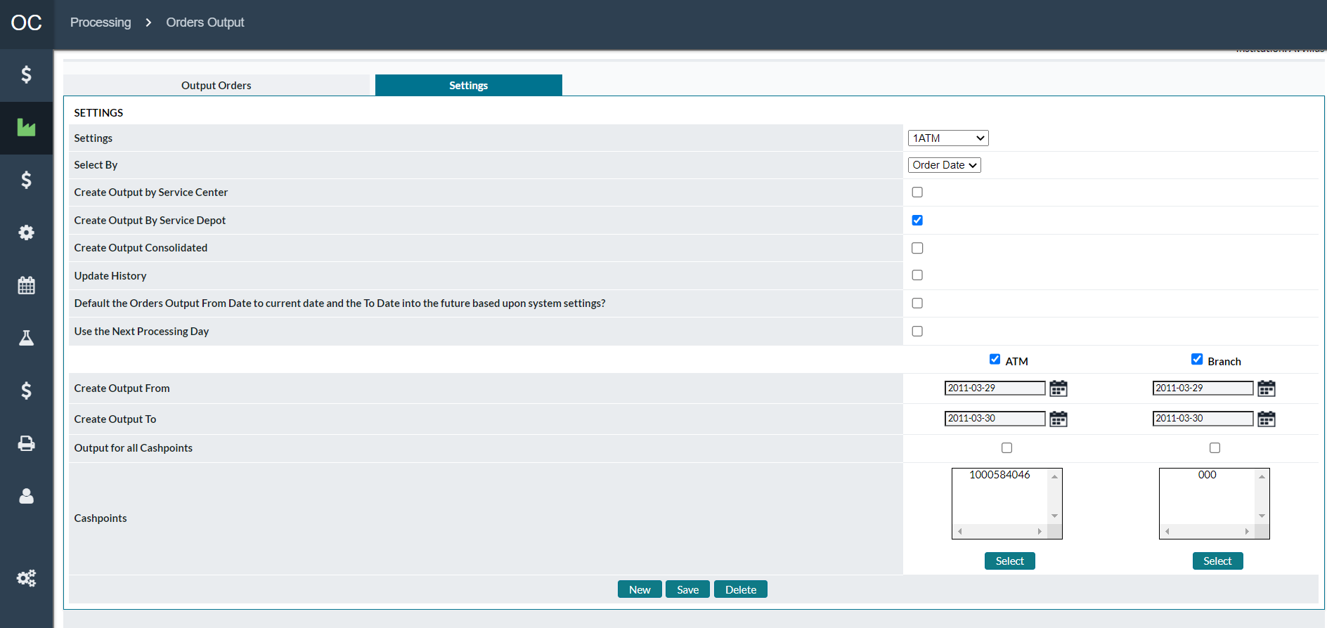

Table 72: Orders Output Settings Description

| Fields | Description |
| --- | --- |
| **Settings** | The Orders Output Settings ID for the order output process. This identifier contains the parameters and Cashpoints that will be outputted when the process is run.  Initially, the user will need to create at least one ID. After the ID has been created, select it from the drop-down list (or create a new one by clicking on the New button).  The Orders Output ID must not contain any spaces between the characters, nor should it contain special characters (‘{[]}|~`!@#$%^&*)”. |
| **Select By** | Determines how the orders will be displayed in the output.   * **Order Date** - The orders will be displayed by the date the order has been committed. * **Due Date** - The orders will be displayed by the date the order is due to be completed. |
| **Create Output by Service Center** | When selected, the output will create the outputs by Center with each file containing the orders for the Cashpoint in that Center. |
| **Create Output by Service Depot** | When selected, the output will create the outputs by Depot with each file containing the orders for the Cashpoint in that Depot. |
| **Create Output Consolidated** | When selected, the output will create the outputs by Cashpoint in a single file as opposed to multiple files which may result from Output by Service Depot/Service Center. |
| **Update History** | Is used when the balance information is not correct; check the box so that the delivery and return amounts are updated with the order information. |
| **Default the Orders Output From Date to current date and the To Date into the future based upon system settings** | If checked, the system will default the Create Output Fro*m* date to the current system date and Create Output To date as the current system date + 7 days. |
| **Use the Next Processing Day** | This option is used when the Orders Output needs to be run using the Next Processing Day. This option is used by clients who need to load balances for the current day and then run the Orders Output based on the Recommendations that have been processed for the next business. Normally, the Last Load date must be less than the current system date to run the Orders Output. This option overrides that limitation and allows the Orders Output process to be run using the Next Processing day. The processing day is the next Institutional business day that Recommendations would normally be run (i.e., The current day is Friday but Recommendations are not run-on Saturday or Sunday therefore the next Processing day would be Monday). |
| **ATM or Branch Checkbox** | Allows the user to define if the recommendation process will run for ATMs, Branches, or both. Checking the box releases the parameters below so the user can define them.  **Note**: For commercial orders, select the Branch Cashpoints that are assigned to the Clients. |
| **Create Output From** | The date that the Orders Output process will start. Normally, it should be the day after the current day. |
| **Create Output To** | The date to which the Orders Output process will run. |
| **Output for all Cashpoints** | Processes all Cashpoints that are marked as Active. |
| **Cashpoints** | Allows the user to select specific Cashpoints (using the **Select** button) to be run. This option cannot be used with the ‘Process All Cashpoints’ or ‘Process Active Cashpoints’ options. |
| **Select Button** | Allows the user to select Cashpoints to be used for the Orders Output process. For more information on selecting Cashpoints, See: Cashpoint Selector |
| **New Button** | Allows the user to define a new Orders Output Settings ID. |
| **Save Button** | Allows the users to save or update any changes made to the current Orders Output Settings ID. |
| **Delete Button** | Delete the currently selected Orders Output Settings ID. |

Return To: Processing Tab

## Processing→Cost Calculation

OptiCash takes the cost of cash (both holding and transportation) into consideration when deciding the amount and frequency of deliveries. To measure the performance of the Cashpoints, OptiCash needs to have the costs calculated for each day of historical data. This process can be automated during the daily loading of Historical Data, however, it is sometimes necessary to re-calculate costs when there were changes in costs or new history is loaded.

There are three different types of costs that can be calculated in OptiCash. All of them are calculated in the same way, but they are used in different ways.

* **Actual Costs** - Used in reports to show the daily, weekly, or monthly costs for holding and delivering cash or used to compare against Projected Costs or Model Costs.
* **Projected Costs** – Calculated and used as a benchmark for comparison against Actual Costs. Normally, users calculate projected costs at the beginning of the month. The projected costs are based on the current information that is on the horizon. The software stores the calculations so a comparison can be made daily to see the actual costs verses the projected costs.
* **Model Costs** – Used in Modeling & Simulations to calculate the costs associated with the Model. Modelling & Simulations allow the user to run different scenarios to see the impact of changing parameters or to see what the maximum savings could be for Cashpoints. Comparisons can be made between the Actual and Model Costs to view the differences between real production and the simulated environment.

The following sections will explain the Cost options and methods in more detail:

* Cost Calculation→Actual Costs/Projected Costs/Model Costs
* Cost Calculation→Cost Options Page
* Cost Calculation→Cost Calculation Details Report

Return To: Processing Tab

### Cost Calculation→Actual Costs/Projected Costs/Model Costs

The following three images show the Cost Calculation pages for the different cost types. All look similar and are used in the same way, but simply calculate their respective cost.

Figure 89: Actual Cost Calculation Page

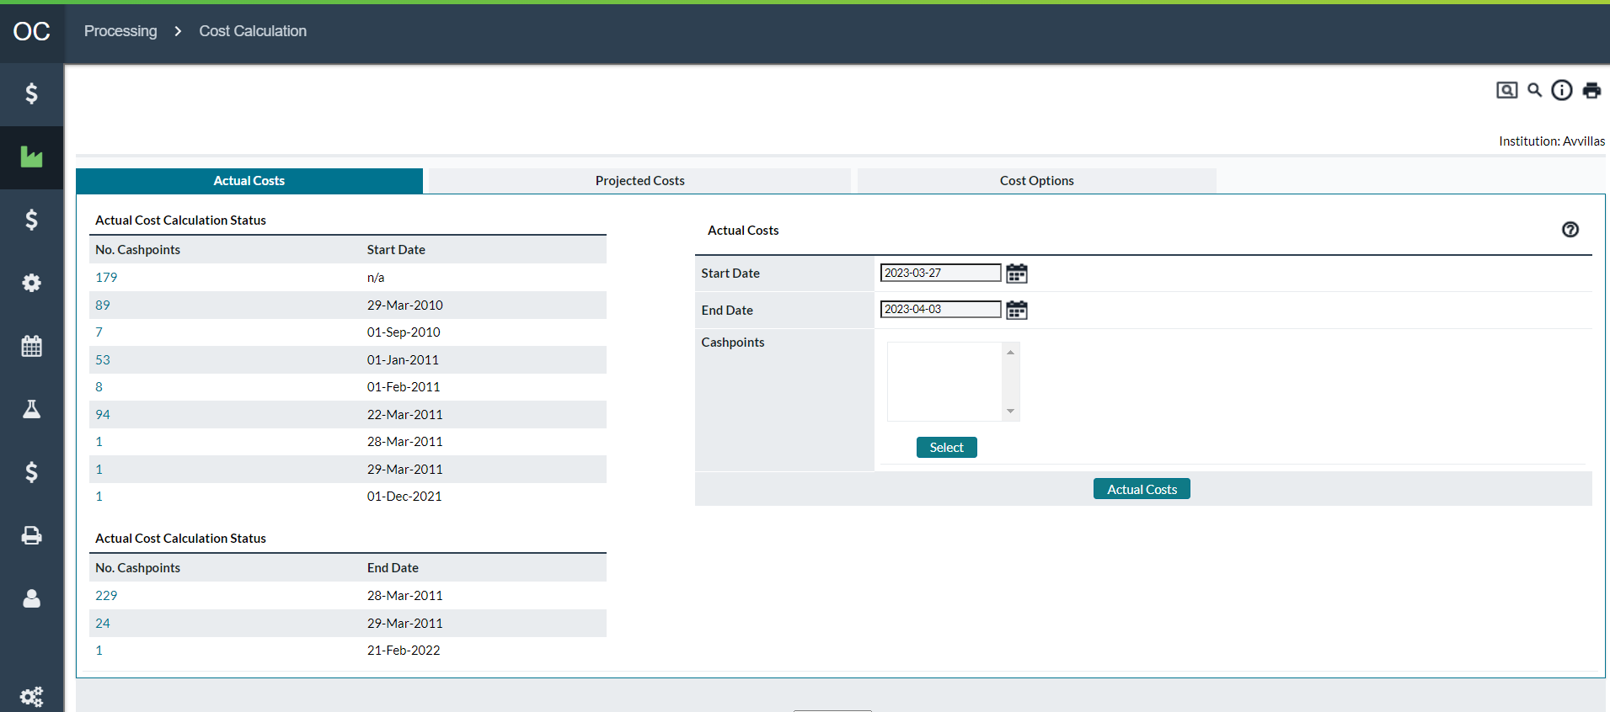

Figure 90: Projected Cost Calculation Page

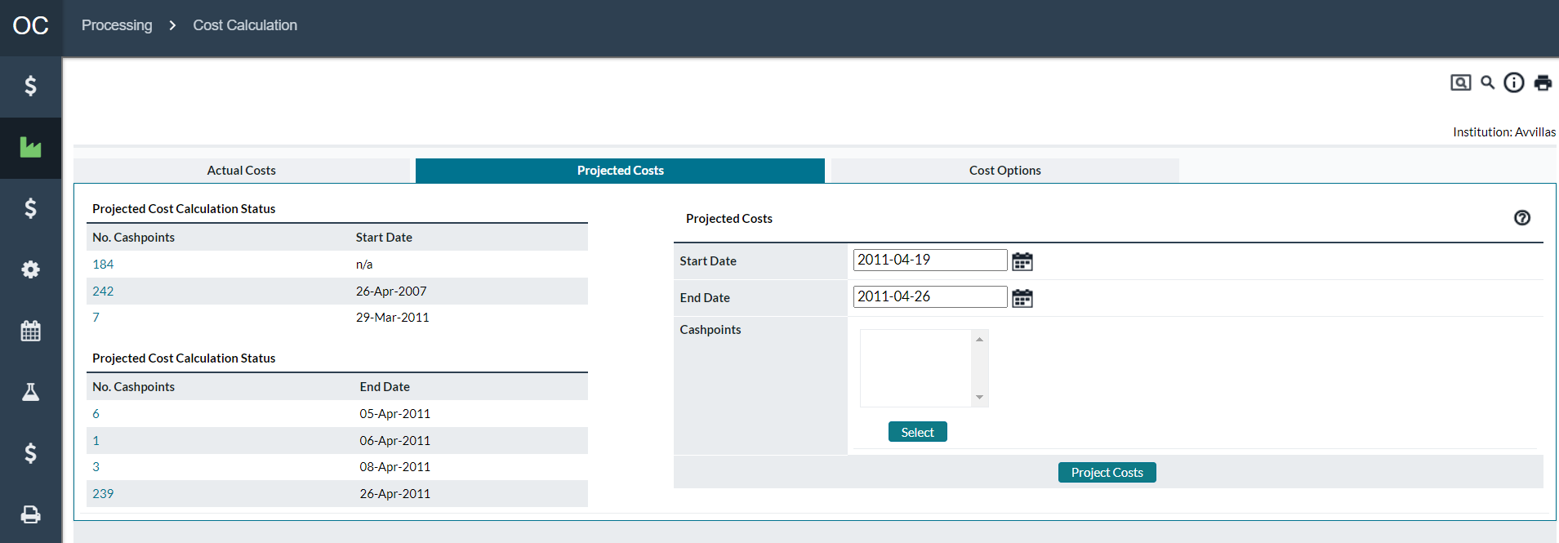

Figure 91: Model Cost Calculation Page

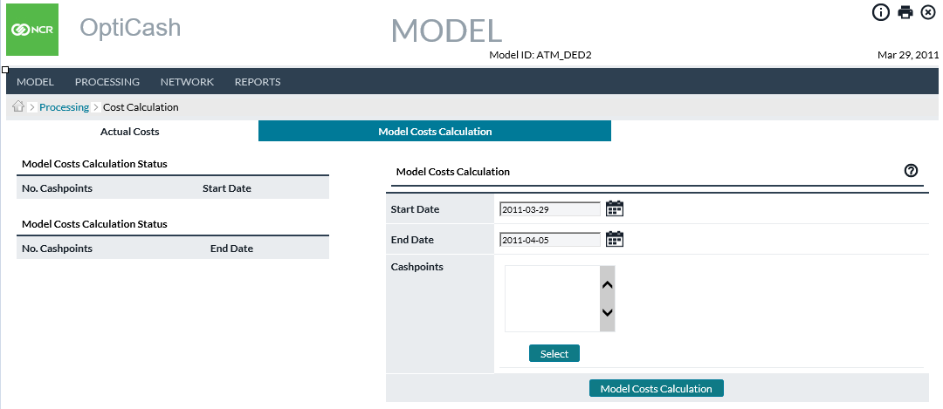

Table 73: Cost Calculation Description

| Fields | Description |
| --- | --- |
| **Actual/Projected/Model Cost Calculation Statuses** | On the left side of all the Cost Calculation pages is a status summary that shows the starting and ending dates for the cost calculations. There may be different entries on this page depending on the Cashpoints that were processed and when it was completed.  Clicking on any of the hyperlinks will lead the user to a report detailing each Cashpoint and the starting and ending dates for the cost calculations. |
| **Start Date** | The day that Cost Calculation will begin |
| **End Date** | The last day's Costs will be calculated. |
| **Select** | Allows the user to select Cashpoints to be used for the Cost Calculation. For more information on selecting Cashpoints, See: Cashpoint Selector |
| **Actual/Projected/Model Cost Calculation Button** | Calculates the cost specific to the Cost Calculation model for the Cost Options that have been defined. For more information on the Cost Options see: Cost Calculation→Cost Options Page |

Return To: Processing Tab

### Cost Calculation→Cost Options Page

Several different cost elements make up the overall costs for a Cashpoint. The user can choose which costs to calculate on the Costs Options page. The different cost elements are explained in detail below.

Figure 92: Cost Option Page

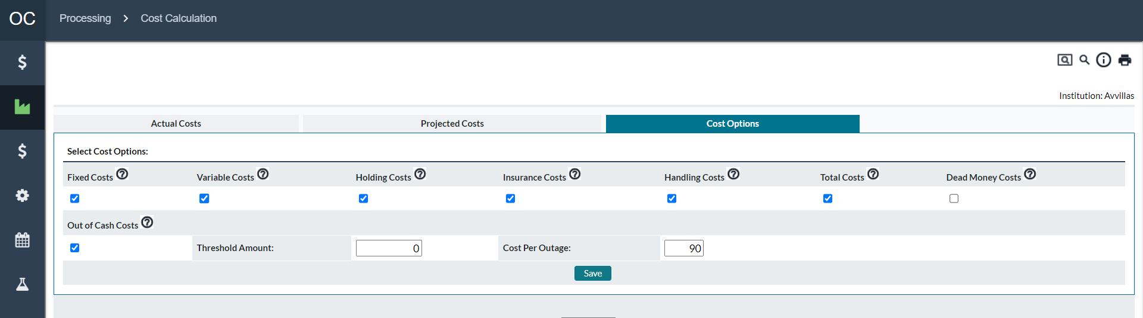

Table 74: Cost Option Description

| Cost | Description |
| --- | --- |
| **Fixed Costs** | Fixed cost per delivery regardless of the amount of cash being transported.  Fixed costs are set and assigned to the depots under the *Network→Carriers→ Depots→ Assign Service Costs*  (note Service Cost panel described in the section Cashpoint Service Costs). |
| **Variable Costs** | Variable costs are based on the amount of cash being transported. In some cases, variable costs may be on a sliding scale or range. For example, the carrier is charging 0.003 EUR for 1 EUR transported when the delivery is between 0 -20,000 EUR and 0.0025 EUR for 1 EUR transported when the delivery is between 20,001-40,000 EUR.  Variable costs (or cost per unit/per $ costs) are set and assigned to the depots under the *Network→Carriers→ Depots→ Assign Service Costs*  (note Service Cost panel described in the section Cashpoint Service Costs). |
| **Holding Costs** | Costs associated with holding cash (for instance, lost potential savings from interest rates).  Holdings costs are based on Overnight Earning Rates defined under *System→Currencies/Denominations→Currencies*  (**Note:** The Administer Currencies panel described in the section [System→Currencies/Denominations→ Currencies](#_Currencies/Denominations(Currencies)). |
| **Insurance Costs** | The currency insurance rate is the rate charged to insure funds kept in Cashpoints (0, 7, 15, etc.). This is an annual rate and is typically covered by the FDIC in the U.S. market.  Insurance Costs are defined under *Cashpoint → Advanced → Costs or assigned from Network→Defaults→choose Cashpoint type→Costs* (refer to section Cashpoint Service Costs for more information) |
| **Handling Costs** | Total internal costs associated with the processing/handling of cash delivery. This may include the value of employees’ time required during the delivery, and any other overhead or administrative costs.  Handling Costs are defined under *Cashpoint → Advanced → Costs* or assigned from *Network→Defaults→choose Cashpoint type→Costs→ Costs* (refer to section Cashpoint Service Costs for more information) |
| **Total Costs** | If this option is selected, the report will calculate and display the sum of all checked cost components. |
| **Dead Money Costs** | Costs associated with cash not being used while in transit.  **Return Time** – indicate the number of days the residual cash is in transit.  **Delivery Time** – indicate the number of days the delivery is in transit. |
| **Out-of-Cash Costs** | Costs associated with out-of-cash situations.  **Threshold amount** – indicate an amount below which the Cashpoint is considered out-of-cash.  **Cost per outage** – indicate the cost set by the institution for cash outage (i.e., penalty, admin fee, etc.). |
| **Save** | Saves the settings for use in all Cost Calculations. |

Return To: Processing Tab

### Cost Calculation→Cost Calculation Details Report

When a user selects a Calculation Status hyperlink from any of the Cost Calculation pages, the following report will be displayed. The report will contain those Cashpoints the entry that was clicked. (i.e., in Figure 88: Actual Cost Calculation Page if the user clicks on the entry with 17 Cashpoints, then the report would be specific to those 17 Cashpoints).

Figure 93: Cost Calculation Details Report

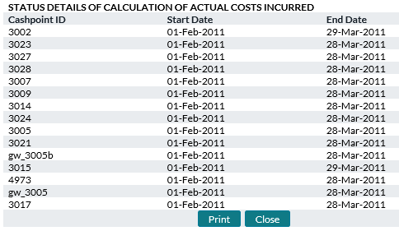

Table 75: Cost Calculation Details Description

| Fields | Description |
| --- | --- |
| **Cashpoint ID** | Unique alphanumeric code that identifies the Cashpoint. |
| **Start Date** | The first date that Costs were calculated. |
| **End Date** | Last date that Costs were calculated. |
| **Print** | Sends the entire page to be printed. |
| **Close** | Closes the window without making any changes. |

Return To: Processing Tab

## Processing→Custom Jobs

The Custom Job page is used to manually launch processes that have been developed as a custom integration for a particular client installation. For more information on this functionality, please see the installation guide or contact NCR Cash Management Support.

To invoke a Custom Job, click on the link for the custom job to be run.

Return To: Processing Tab

1. Network Tab

The Network Tab is where the Network structure is defined. On this tab, users can search for Cashpoints; navigate to different pages or reports; define the network structure and defaults or assign parameters to Cashpoints.

The following is a summary of the information that will be covered along with hyperlinks to each topic:

* Network→Cashpoints Page
* Network→Defaults Page
* Network→Carriers Page
* Network→Regions Page
* Network→Groups Page
* Network→Clusters Page
* Network→Balance Types
* Network→Commercials
* [Network→Network](#_Network→Network_Monitoring) Monitoring

Return To: Introduction to the Interface

## Network→Cashpoints Page

The Cashpoints page is a handy way to search for Cashpoints that are assigned to the current user by browsing through a list of Cashpoints. This page allows you to filter the results by selecting one of many different characteristics of the Cashpoint.

On the left side of this page are a number of links that allow the user to filter the results in the report list with the Cashpoints specific to the selected criteria. Clicking on one of the main categories or sub-categories will make the list on the right refresh with the Cashpoints specific to that group and assigned to the current user.

**Region** – Shows a list of each Region that is defined in OptiCash. Clicking on the general ‘Region’ link will load all Cashpoints. Clicking on the **[+]** icon will expand the Region link to show all the Regions defined in OptiCash. The user can then choose a specific region, which will load all Cashpoints for the specified region. For more information on Regions, see: Network→Regions Page

**Network** – Shows the Centers, Servicers, and Depots defined in OptiCash. Clicking on the general ‘Network’ link will load all Cashpoints. Clicking on the **[+]** icon will expand the Network link to show all Centers defined in OptiCash. Further clicking on the Center’s **[+]** icon reveals the Servicers, and finally under the Servicer’s **[+]** Icon, the Depots. Clicking on any one level will show the Cashpoints at that level and below. (i.e., Clicking on a Center shows all Cashpoints assigned to the Servers and Depots below). For more information on Carriers, see: Network→Carriers Page

**Group** – Shows the User Defined Groups defined in OptiCash. Clicking on the general ‘Group’ link will load all Cashpoints. Clicking on the **[+]** icon will expand the Group link to show all User Groups defined in OptiCash. Clicking on any User Group name will show the Cashpoints assigned to the specified User Group.

**Type** – Shows the Types of Cashpoints defined in OptiCash. Clicking on the **[+]** icon will expand the Type link to reveal ATM or Branch. The user can also select ATMs by Replenishment type (Add Cash/Replace Cassette, etc.). Clicking on any Cashpoint Type will show the Cashpoints which fall into that category.

Once the report has loaded, the user can find information specific to the Cashpoints as well as click on the hyperlinks to navigate to different pages or reports. Clicking on the hyperlinks in the report header will sort the list according to that column.

Figure 94: Network Cashpoints Page

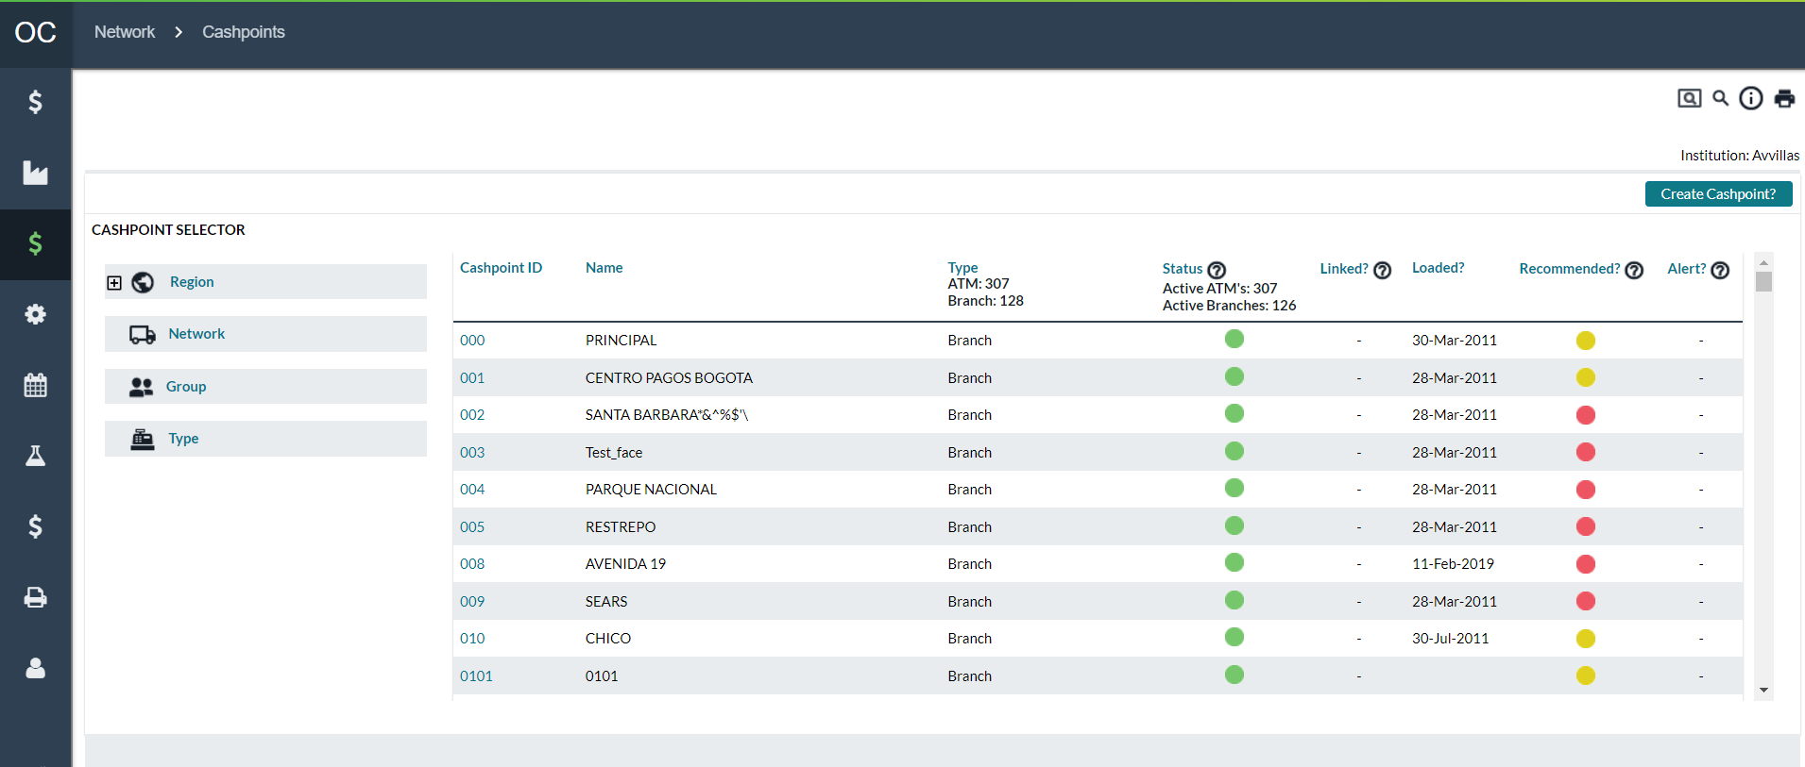

Table 76: Network Cashpoints Description

| Fields | Description |
| --- | --- |
| **Create Cashpoint Link** | The link on the upper right side of the screen allows the user to create a new Cashpoint using a step-by-step wizard. See: Network→Cashpoints→Create Cashpoint Wizard |
| **Cashpoint Selector** | A list of categories, which the user can use to filter based on Region, Network, Group, or Type. See the text above for a detailed description of each. |
| **Cashpoint ID** | Unique alphanumeric code that identifies the Cashpoint. Clicking on the Cashpoint ID hyperlink takes the user directly to the Cashpoint window for the selected Cashpoint. |
| **Name** | The name of the Cashpoint as defined in the Cashpoint settings |
| **Type** | The type of Cashpoint (Branch, Add Cash ATM, Replace Cash ATM, Add/Replace ATM, or one of the various Advanced Device types).  The header of this column also lists the total number of ATMs and Branches in the currently displayed list. |
| **Status** | Shows the status of the Cashpoint using a coloured indicator.  **Red** – Inactive  **Green –** Active  The header of this column also lists the total number Active of ATMs and Branches in the currently displayed list. |
| **Linked** | Shows an icon for those Cashpoints which are linked to other Cashpoints. Clicking on the ‘Link’ Icon will show a list of Cashpoints to which the selected Cashpoint is linked. The Cashpoints in this list have hyperlinks that allow you to access the Cashpoint directly. For more information on Cashpoint linkage, see: Cashpoint→Basic→Linkage |
| **Loaded** | Shows the date that historical data was loaded for the Cashpoint. |
| **Recommended** | Shows an icon showing the status of the Recommendation for this Cashpoint.  **Red –** Indicates the Recommendation process was not run for this Cashpoint.  **Yellow –** Indicates the Recommendation process ran but was not successful resulting in an Invalid or Failed status.  **Green –** Indicates the Recommendation process ran successfully for this Cashpoint. |
| **Alert** | Shows a warning icon if there are alerts within the last 7 days for the Cashpoint. |

Return To: Network Tab

### Network→Cashpoints→Create Cashpoint Wizard

The Create Cashpoint Wizard is used to create a Cashpoint by selecting or assigning all the parameters.

There are 7 steps to completing the Cashpoint Wizard. The user works through each screen filling out the necessary information. At the bottom of each page is a link to take you to the next or previous steps.

The steps are summarized below with links to the pages that will explain individual fields if necessary.

**Definition -** Cashpoint General Definitions

**Denominations -** Cashpoint Currencies and Denominations

**Parameters -** Cashpoint Parameters

**Service Days -** Cashpoint Business and Service Days

**Service Costs -** Cashpoint Service Costs

**Privileges –** Select the Groups that will have access to the Cashpoint

**Create –** Review and Accept the parameters to create the Cashpoint

**Note:** Starting 10.0 version, Only branches can be created and ATMs can be created only in EPSS portal and OptiCash should sync the terminals created.

Return To: Network Tab

## Network→Defaults Page

The Defaults page allows the user to set default values and Mass Assign them to Cashpoints. The default values are used in the creation of new Cashpoints or are loaded to a Cashpoint when a user clicks the ‘**Default’** button at the Cashpoint level. Saving default values does not automatically propagate the defaults to the Cashpoints; to do this, the parameters must be Mass Assigned.

From the Defaults Page, the user can set defaults and Mass assign the following elements:

**Cashpoint Parameters:** For a detailed description of the parameters, see: Cashpoint Parameters

Costs: For a detailed description of the parameters, see: Cashpoint Service Costs

**Denominations:** For a detailed description of the parameters, see: Cashpoint Currencies and Denominations

**Advanced Parameters:** For a detailed description of the parameters, see: Cashpoint→Advanced→Parameters

**Service Shifts:** For a detailed description of the parameters, see: Cashpoint Business and Service Days

**Forecast Adjustments:** For a detailed description of the parameters, see: Cashpoint→Forecast→View Forecast

Return To: Network Tab

## Network→Defaults→Administer Default Settings

Figure 95: Administer Default Settings

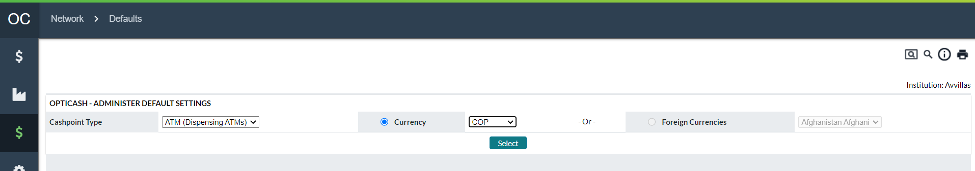

Return To: Network Tab

### Network→Defaults→Parameters

Figure 96: Parameters

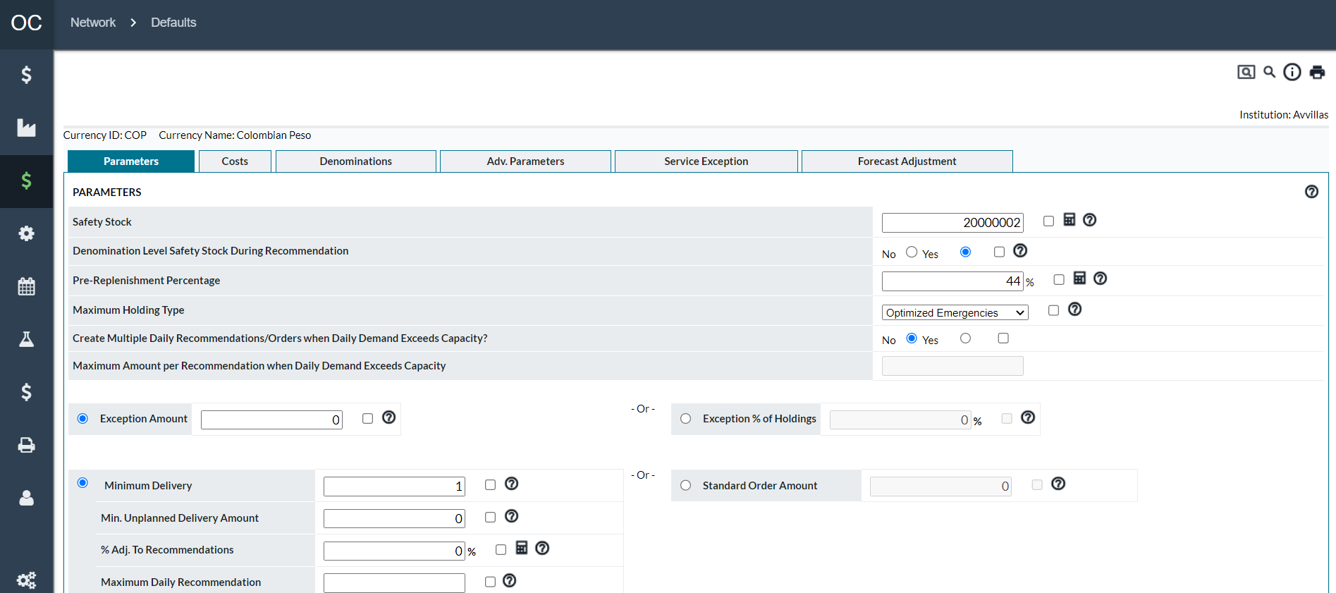

Return To: Network Tab

### Network→Defaults→Costs

Figure 97: Costs

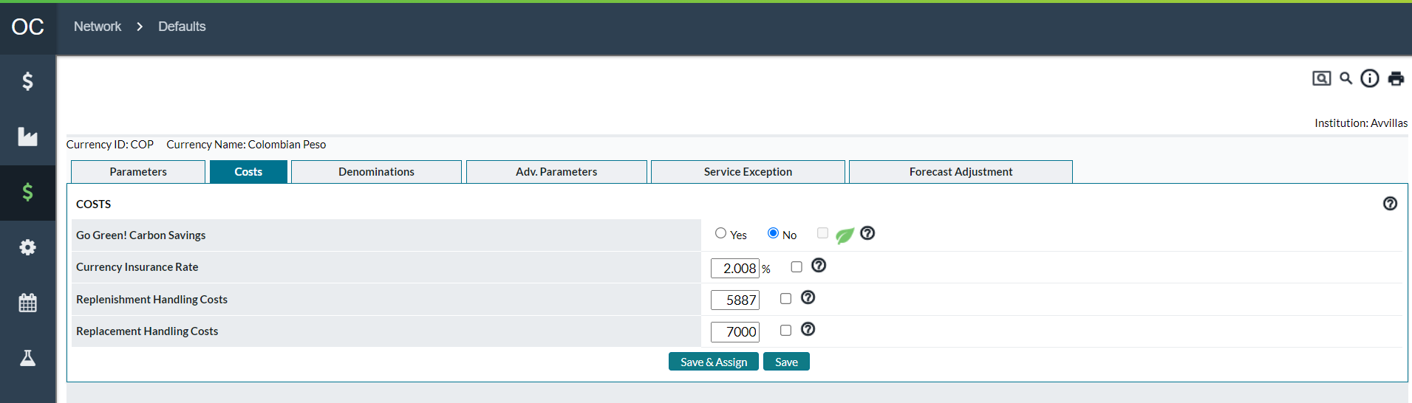

Return To: Network Tab

### Network→Defaults→Denominations

Figure 98: Denominations

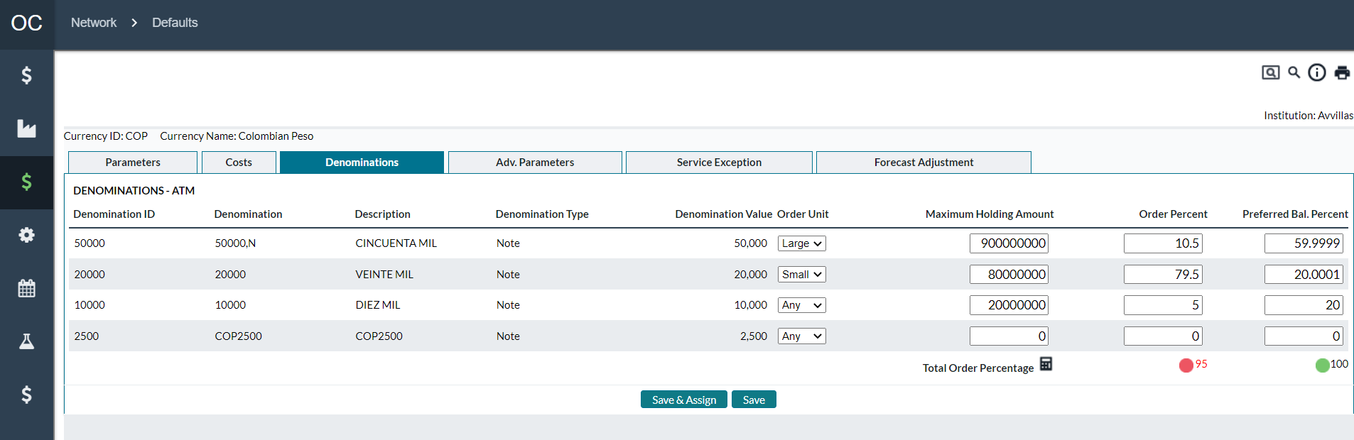

Return To: Network Tab

### Network→Defaults→Advanced Parameters

Figure 99: Advanced Parameters

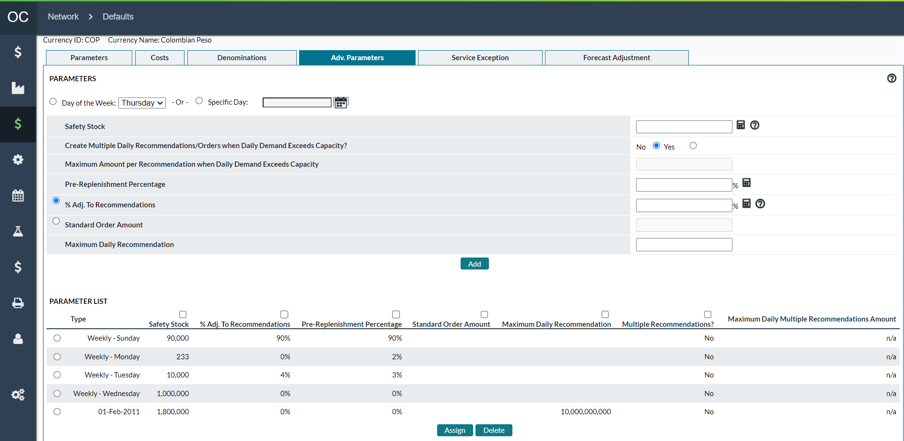

Return To: Network Tab

### Network→Defaults→Service Exceptions

Figure 100: Service Exceptions

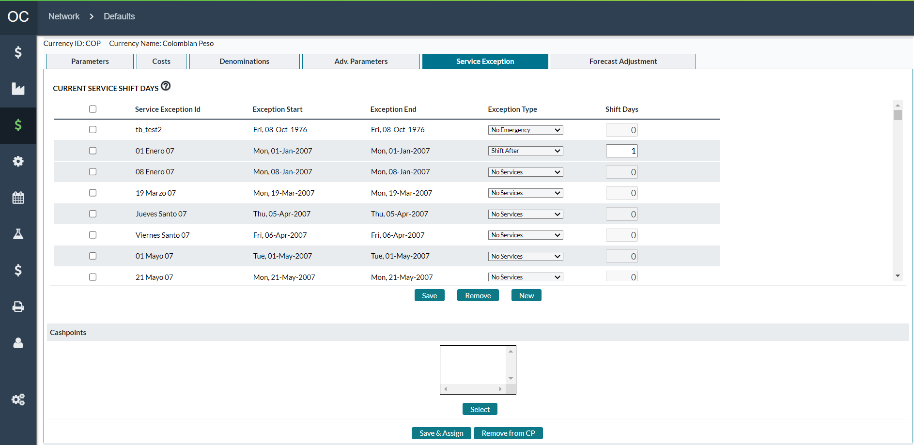

Return To: Network Tab

### Network→Defaults→Forecast Adjustments

Figure 101: Forecast Adjustments

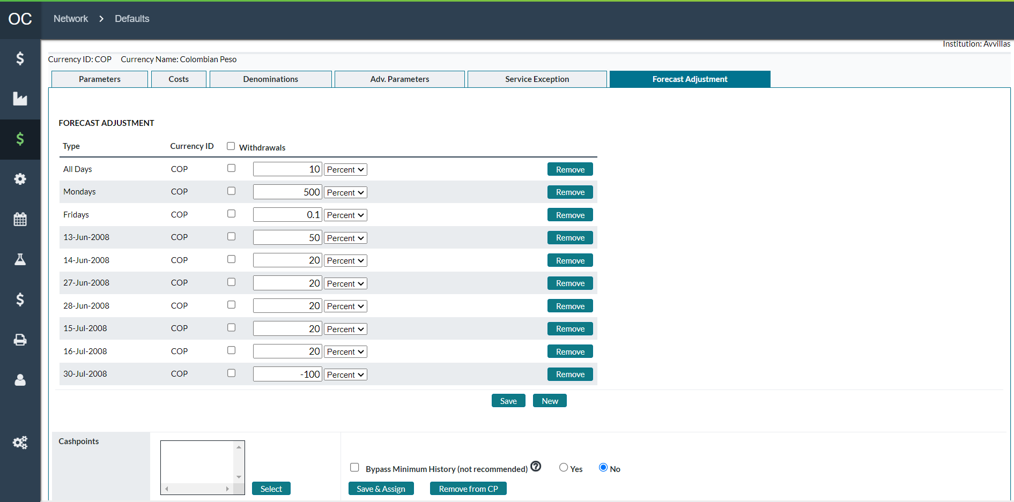

Return To: Network Tab

### Mass Assigning

To allow users to quickly update Cashpoint parameters, OptiCash provides a mechanism to do so throughout OptiCash.

Mass assigning works the same for all parameters:

Select the parameter(s) to set

Set the value(s) for the parameter(s)

Selects the Cashpoint(s)

Click the Assign button to finalize the transaction.

Return To: Network Tab

### Network→Defaults→Assign Foreign Currency Settings Page

Normally, Foreign Currencies are ordered using the same lead times that are used for Optimized Currencies. In some circumstances, it may be necessary to have delivery, return, or unplanned days for Foreign Currencies that are different from the settings for Optimized Currencies. The ‘**Assign Foreign Currency Settings**’ page allows the analyst to set up special Foreign Currency days and lead times and assign them to Cashpoints.

This functionality allows the OptiCash analyst to set different delivery days and lead times for each Cashpoint and Currency as it may be the case that some Cashpoints have different lead times than others for Foreign Currencies. If Foreign Currency parameters are not assigned to a Cashpoint, the Cashpoint will be bound by the Lead times and delivery days that are defined for Optimized Currencies.

Figure 102: Assign Foreign Currency Settings Page

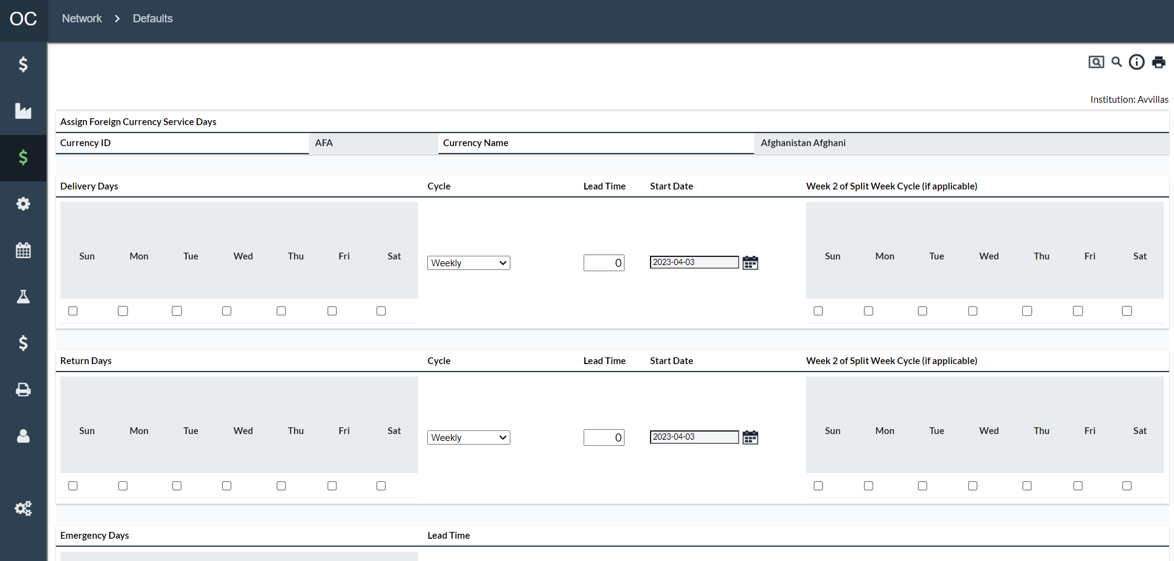

Table 77: Assign Foreign Currency Settings Description

| Field | Description |
| --- | --- |
| **Select** | Allows the analyst to select a currency to be defined and assigned to Cashpoints. |
| **Submit Button** | Submits the Currency selected in the ‘**Select’** dropdown list box to define and assign to Cashpoints. |
| **Currency ID** | The 3-digit Currency ID of the selected currency |
| **Currency Name** | The name of the currency that corresponds to the Currency ID |
| **Delivery Days** | The days of the week that the selected Foreign Currency can be delivered for Normal Deliveries |
| **Return Days** | The days of the week that the selected Foreign Currency can be delivered for Normal Returns |
| **Emergency Days** | The days of the week that the selected Foreign Currency can be delivered for Emergency Deliveries and Returns |
| **Cycle** | The ordering Cycle that is applicable for the Cashpoint. The available options are:   * **Weekly –** Service is done every week * **Bi-Weekly –** Service is done every 2 weeks * **Tri-Weekly –** Service is done every 3 weeks * **Fourth Week –** Service is done every 4 weeks * **Monthly Week 1 –** Service is done only the first week of the month * **Monthly Week 2 –** Service is done only the second week of the month * **Monthly Week 3 –** Service is done only the third week of the month * **Split Week –** Service alternates on different schedules from one week to the next. |
| **Lead Time** | The number of days before the delivery is due that the order needs to be placed. This must be specified for each delivery type (Delivery, Return, Emergency) |
| **Start Date** | This is used to determine the starting point for delivery days for cycles other than Weekly. The Start Date is used to identify when the cycle starts and the remaining days will be calculated from that point forward based on the date selected. |
| **Week 2 Split Week Cycle** | This is only applicable when the ‘**Split Week’** cycle is selected. These dates indicate the delivery days for the second week of the Cycle. |
| **Cashpoints To Be Assigned** | This box will list the Cashpoints that were selected to be assigned the defined parameters for the Selected Currency. Cashpoints are added to the list by clicking the ‘**Select’** button. |
| **Select Button** | Allows the analyst to select Cashpoints that will be assigned the Foreign Currency Settings for the Selected Currency. The Cashpoints are not assigned until the ‘**Assign’** button is clicked. |
| **Assign Button** | Completes the assignment of the Foreign Currency settings defined on the page for the selected Currency. |
| **Remove Currency Settings Button** | Allows the user to remove the Currency Settings from Cashpoints selected in the ‘Cashpoints To Be Assigned These Settings’ list. Cashpoints must first be selected by clicking the ‘ **Select’** button before the removal process can be completed. |
| **Cancel Button** | Exits the page without making any changes or assignments. |

Return To: Network Tab

## Network→Carriers Page

In OptiCash, the cash distribution network is set up to allow flexibility in reporting and the assignment of parameters and costs. The Carriers structure helps by allowing Cashpoints to be grouped by Centers, Servicers and Depots.

The structure of the Cash Distribution Network Starts at a high level with Centers. Centres are used to group Servicers; Servicers group together with Depots, and Depots deliver cash to Cashpoints. This structure is illustrated below.

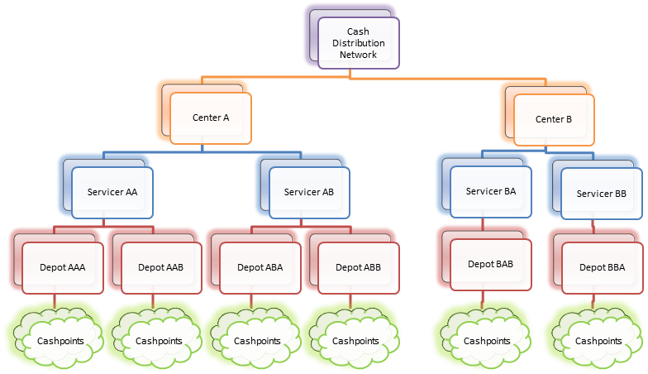

A least one Center, Servicer, and Depot must exist to run Recommendations. The following pages will cover the Carrier Structure:

* Carriers→Centers
* Carriers→Servicers
* Carriers→Depots

Return To: Network Tab

### Carriers→Centers

Centers are internal money centers or vaults. Usually, a money center is a central clearing point for branches and ATMs in close physical or geographic proximity. Orders can be consolidated at the money center level for transmission to the corresponding or designated service provider. In some environments, the service providers may deliver cash to the money centers for further distribution to the Cashpoints. Therefore, centers might be considered the highest point of delivery or return for Cashpoints and will have assigned servicers to them.

Figure 103: Centers Page

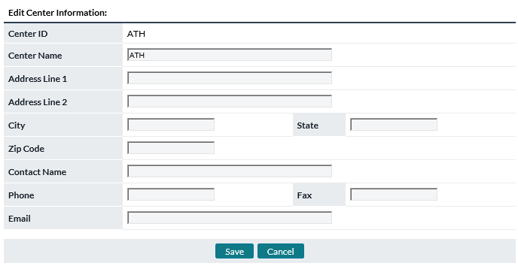

Table 78: Centers Description

| Field | Description |
| --- | --- |
| **Add Button** | Allows users to Add a new Center ID. |
| **Edit Button** | Allows users to Edit an existing Center ID. |
| **Delete** | Allows users to Delete an existing Center ID.  **Note:** A Center cannot be deleted if there are Cashpoints, Depots, or Servicers assigned to it. |
| **Center ID** | Unique alphanumeric value for the identification. The ID is limited to 12 characters and cannot contain any spaces or special characters. |
| **Center Name** | Name used to identify the Center. |
| **Address Line 1** | Line 1, Street address. |
| **Address Line 2** | Line 2, Street address. |
| **City** | City in which the Center is located. |
| **State** | State in which the Center is located. |
| **Zip Code** | Zip code or postal code. |
| **Contact Name** | Name of the contact person. |
| **Phone** | Telephone number. |
| **Fax** | Fax number. |
| **E-mail** | E-mail address of the contact person |
| **Save Button** | Saves the new or edited Center ID. |
| **Cancel Button** | Exits the Edit window without making changes. |

### Carriers→Servicers

Servicers are the carriers that are contracted by the institution to deliver and pick up cash. Ultimately the orders generated by the system must be routed to the appropriate servicers so that the movement of cash occurs when and where it is needed, and for the desired amounts.

To optimize the movements of cash to and from Cashpoints, it is necessary to know the costs associated with transporting the cash. Servicers and service depot data are input into the system for this purpose.

Each servicer and their depots are set up in the system with their associated costs. When a depot is set up, it is linked to an appropriate servicer defined during this step. Then, each Cashpoint must be linked to the appropriate servicer depot so that the associated costs are incorporated into the optimization process.

Figure 104: Servicers Page

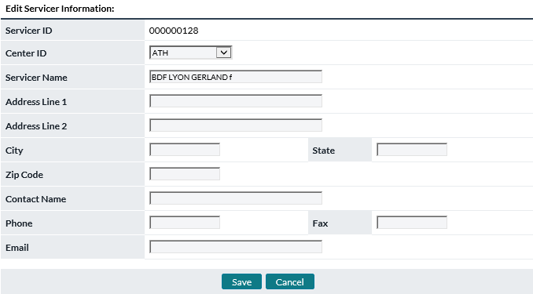

Table 79: Servicers Description

| Field | Description |
| --- | --- |
| **Add Button** | Allows users to Add a new Center ID. |
| **Edit Button** | Allows users to Edit an existing Center ID. |
| **Delete Button** | Allows users to Delete an existing Center ID.  **Note:** A Center cannot be deleted if there are Cashpoints, Depots, or Servicers assigned to it. |
| **Servicer ID** | Unique alphanumeric value for the identification. The ID is limited to 12 characters and cannot contain any spaces or special characters. |
| **Center ID Selection** | The Center ID that this Servicer belongs to. |
| **Servicer Name** | Name used to identify the Servicer. |
| **Address Line 1** | Line 1, Street address. |
| **Address Line 2** | Line 2, Street address. |
| **City** | City in which the Servicer is located. |
| **State** | State in which the Servicer is located. |
| **Zip Code** | Zip code or postal code. |
| **Contact Name** | Name of the contact person. |
| **Phone** | Telephone number. |
| **Fax** | Fax number. |
| **E-mail** | E-mail address of the contact person |
| **Save Button** | Saves the new or edited Servicer ID. |
| **Cancel Button** | Exits the Edit window without making changes. |

Return To: Network Tab

### Carriers→Depots

Typically, a service provider will initiate cash deliveries from designated depots. Therefore, costs associated with a particular service provider are tied to the corresponding depot. Each depot must have a service provider and service costs and service days must also be specified. Additionally, each Cashpoint must be assigned to a depot. Care should be taken when defining depots because an error may adversely affect the recommendation and simulation processes.

Cost data allows the system to evaluate the relevant costs of moving cash. Service costs may be fixed per trip, variable per unit of currency delivered, variable by type of service (branch delivery, branch return, ATM cassette replacement, ATM cash add) and/or variable by type of delivery schedule (regular schedule versus unplanned).

Figure 105: Depots Page

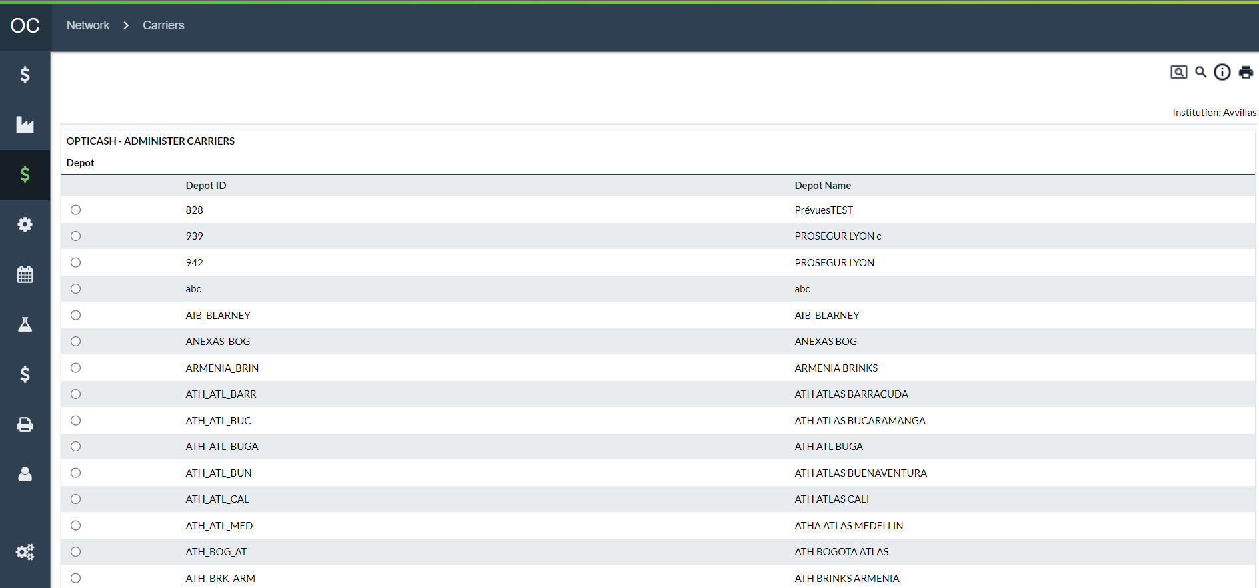

Table 80: Depots Description

| Fields | Description |
| --- | --- |
| **Add Button** | Allows the user to add a new Depot. |
| **Edit Button** | Allows the user to edit an existing Depot. |
| **Delete Button** | Allows the user to delete an existing Depot.  Note: Depots that have Cashpoints assigned to them cannot be deleted. Reassign Cashpoints to another Depot to delete a Depot. |
| **Assign Service Costs** | Allows the user to Mass Assign Service Costs to Cashpoints.  For more information, see: Depots→Depot Add/Edit Page |
| **Assign Service Days** | Allows the user to Mass Assign Service Days to Cashpoints.  For more information, see: Depots→Assign Service Days |
| **Assign Cashpoints** | Allows the user to Mass Assign Cashpoints to a Depot.  For more information, see: Depots→Assign Cashpoints |
| **Assign As Secondary Depot** | Allows the user to Mass Assign The Secondary Depot to Branches.  For more information, see: Depots→Assign As Secondary Depot |

Return To: Network Tab

#### Depots→Depot Add/Edit Page

This page allows users to Add/Edit the default values for the Depot. The values stored here can be Mass Assigned to Cashpoints; they do not automatically filter down to Cashpoints.

Figure 106: Depot Add/Edit Page

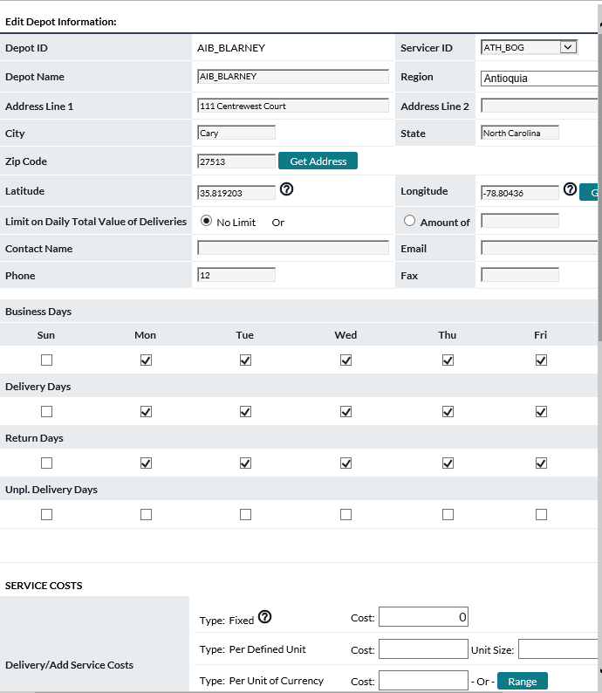

Table 81: Depot Add/Edit Description

| Fields | Description |
| --- | --- |
| **Depot ID** | Unique alphanumeric value for the identification. The ID is limited to 12 characters and cannot contain any spaces or special characters. |
| **Servicer ID Selection** | The Servicer ID that this Depot belongs to. |
| **Depot Name** | Name used to identify the Depot |
| **Region** | Region to which this depot belongs. |
| **Address Line 1** | Line 1, Street address. |
| **Address Line 2** | Line 2, Street address. |
| **City** | City in which the Depot is located. |
| **State** | State in which the Depot is located. |
| **Zip Code** | Zip code or postal code. |
| **Contact Name** | Name of the contact person. |
| **Phone** | Telephone number. |
| **Fax** | Fax number. |
| **E-mail** | E-mail address of the contact person |
| **Service Days** | The default Business and Service days can be specified here. Once set, they can be Mass Assigned to Cashpoints assigned to this Depot.  For more information on Service Days, see: Cashpoint Business and Service Days |
| **Service Costs** | The default Service Costs can be specified here. Once set, they can be Mass Assigned to Cashpoints assigned to this Depot  For more information on Service Costs, see: Cashpoint Service Costs |
| **Save Button** | Saves the new or edited Servicer ID. |
| **Cancel Button** | Exits the Edit window without making changes. |

Return To: Network Tab

#### Depots→Assign Service Costs

The Assign Service Costs Function allows the user to assign costs quickly to Cashpoints belonging to a Depot.

Figure 107: Assign Costs Page

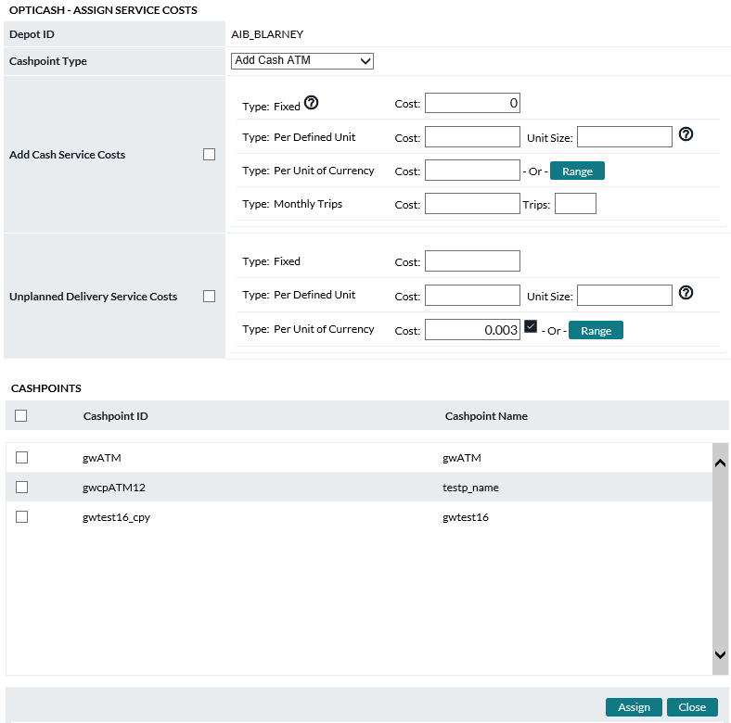

Table 82: Assign Costs Description

| Fields | Description |
| --- | --- |
| Cashpoint Type | Specifies the type of Cashpoint that costs will be assigned to. Once a Cashpoint Type is selected, the list of Cashpoints will load with all Cashpoints related to that type.  **Note:** Be sure to select each Cashpoint type individually to ensure all Cashpoint types are updated. |
| **Costs** | The default costs are shown automatically. These costs can be changed so they can be assigned to Cashpoints. To update costs to Cashpoints, select the cost element with the checkbox on the right of the Cashpoint Type, select Cashpoints, and click assign.  For more information on Service Costs, see: Cashpoint Service Costs |
| **Assign Button** | The user can select one or all Cashpoints to assign costs. The user must also select the check box next to the parameter that is to be assigned. |
| **Close Button** | Closes the page without making changes. |

Return To: Network Tab

#### Depots→Assign Service Days

The Assign Service Days Function allows the user to assign Business and Service Days quickly to Cashpoints belonging to a Depot.

Figure 108: Assign Service Days Page

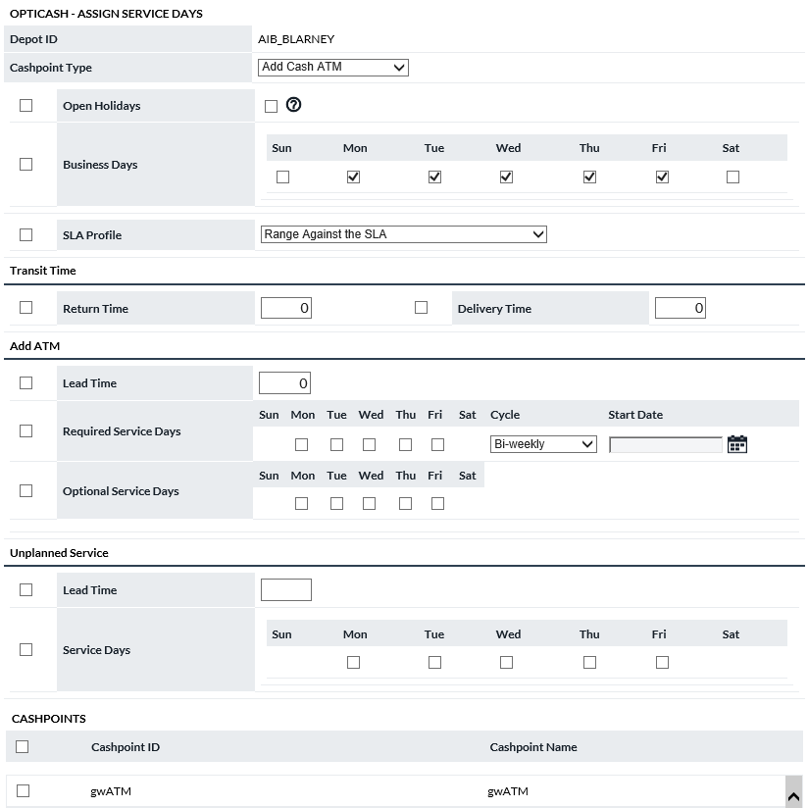

Table 83: Assign Service Days Description

| Fields | Description |
| --- | --- |
| **Cashpoint Type** | Specifies the type of Cashpoint that Service days will be assigned to. Once a Cashpoint Type is selected, the list of Cashpoints will load with all Cashpoints related to that type.  **Note:** Be sure to select each Cashpoint type individually to ensure all Cashpoint types are updated. |
| **Transit Time** | Transit Time is used by cost calculation to determine Dead Money Costs. The number of days that money is delivered to or returned by this cashpoint spends in transit. Dead Money Cost is the number of days times the Overnight Earnings Rate. |
| **Service Days** | The default Business and Service Days are shown automatically. These selections can be changed so they can be assigned to Cashpoints. To update one or all Service Day elements to Cashpoints, select the Service Day element with the checkbox on the right of the Cashpoint Type, select Cashpoints, and click assign.  For more information on Service Days, see: Cashpoint Business and Service Days |
| **Assign Button** | The user can select one or all Cashpoints to assign Service Days. The user must also select the check box next to the parameter that is to be assigned. |
| **Close Button** | Closes the page without making changes. |

Return To: Network Tab

#### Depots→Assign Cashpoints

The Assign Cashpoints Function allows the user to assign Cashpoints quickly to a Depot.

Figure 109: Assign Cashpoints Page

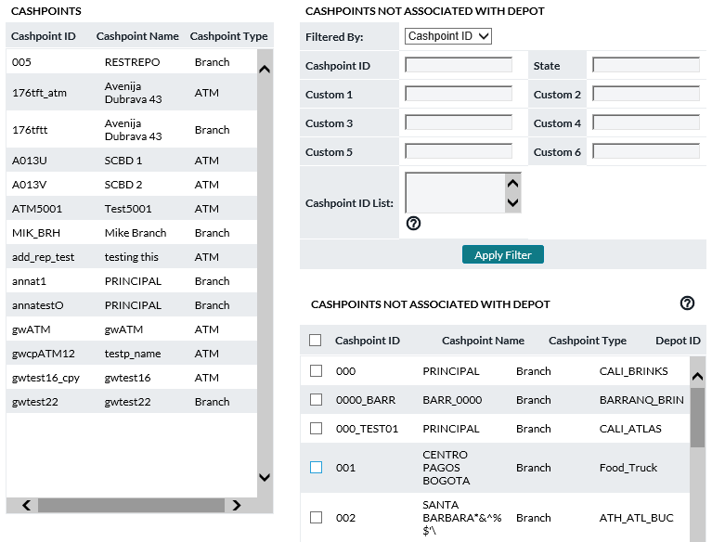

Table 84: Assign Cashpoints Description

| Fields | Description |
| --- | --- |
| **Cashpoints Not Associated with Depot** | Allows the user to search for a Cashpoints to assign to this Depot. Select the Cashpoints and click the Assign button.  **Note**: There is no way to un-assign a Cashpoint from a Depot. To remove a Cashpoint from a Depot, it must be assigned from the Assign Cashpoints page or at the Cashpoint level. |
| **Assign Button** | The user can select one or all Cashpoints to assign Cashpoints to the Depot. |
| **Close Button** | Closes the page without making changes. |

Return To: Network Tab

#### Depots→Assign as Secondary Depot

The Assign As Secondary Depot Function allows the user to assign Cashpoints quickly to a Secondary Depot.

Figure 110: Assign Secondary Depot Page

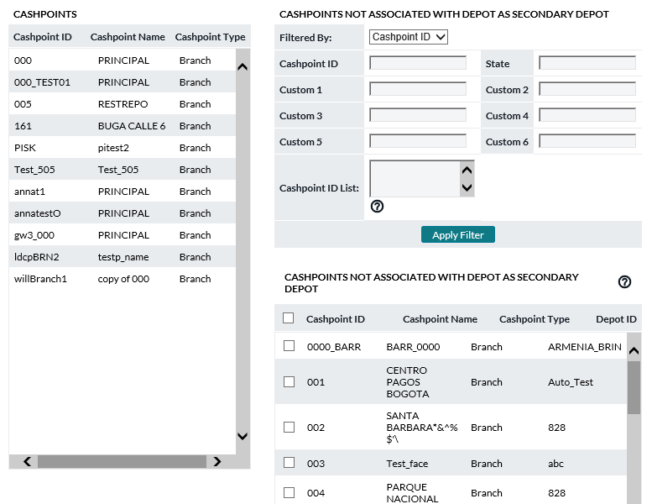

Table 85: Assign Secondary Depot Description

| Fields | Description |
| --- | --- |
| **Cashpoints Not Associated with Depot** | Allows the user to search for a Cashpoints to assign to this Depot. Select the Cashpoints and click the Assign button.  **Note**: There is no way to un-assign a Cashpoint from a Depot. To remove a Cashpoint from a Depot, it must be assigned from the Assign Cashpoints page or at the Cashpoint level. |
| **Assign Button** | The user can select one or all Cashpoints to assign Cashpoints to the Depot. |
| **Close Button** | Closes the page without making changes. |

Return To: Network Tab

### Carriers→SLA Profile

Carriers may have contractual commitments to service cashpoints within a certain amount of time after having received the order and/or having it in transit. OptiCash allows for two different types of carriers compliance; Hour and Range. “**Hour**” indicates that the carrier is required to deliver cash within a certain amount of time. “Range” indicates that the carrier is to deliver cash in a range of hours. SLA Profiles are assigned at the cashpoint level on the *Cashpoint>Basic>Cashpoint Definition page*.

Figure 111: SLA Profile Page

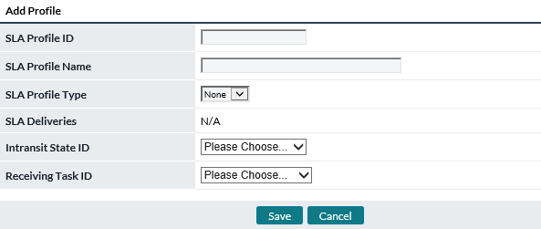

Table 86: SLA Profile Description

| Fields | Description |
| --- | --- |
| **SLA Profile ID** | Unique identifier for each SLA Profile created |
| **SLA Profile Name** | Descriptive name given to each SLA Profile |
| **SLA Profile Type** | Users can select the type of profile to be defined.   * **None** – if no time-tracking of deliveries is to be done and only the OptiCash system is updated then users may leave as this type * **Hour** – if the carrier has a set number of hours in which to deliver cash * **Range** – if the carrier is required to deliver between a set range of times |
| **SLA Deliveries** | SLA Deliveries will allow the user to set the number of hours if Profile type “**Hour**” is utilized, and the user can also select the time range if “**Range**” is selected. If “**None**” is used as the profile type, then this field will default to N/A. |
| **Intransit State ID** | Indicates the Workflow state that when set in OptiCash will trigger the SLA time tracking |
| **Receiving Task ID** | Indicates the Workflow state that when set will indicate the delivery has been made |

Return To: Network Tab

### Carriers→Route Definitions

Carriers may impose routing restrictions such as the total number of trips they can manage in each day or the amount of cash they may have on a delivery vehicle at any one time. Route Definitions as part of the OptiTransport tool allow this sort of management within the optimization process.

Table 87: OptiTransport Route Definitions Page

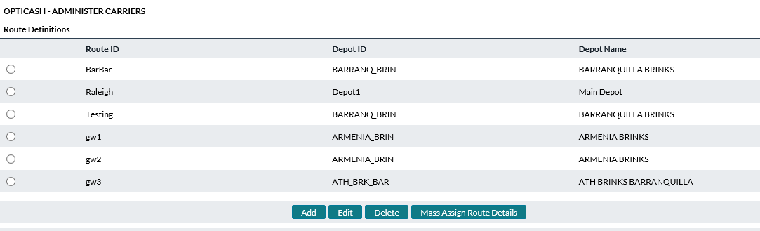

Table 88: Route Definitions

| Fields | Description |
| --- | --- |
| **Add Button** | Allows the user to add a new Route Definition. |
| **Edit Button** | Allows the user to edit an existing Route Definition. |
| **Delete Button** | Allows the user to delete an existing Route Definition.  **Note**: Routes that have Cashpoints assigned to them cannot be deleted. Reassign Cashpoints to another Route to delete. |
| **Mass Assign Route Details** | Allows the user to Associate Cashpoints with the defined Route Details. |

Return To: Network Tab

#### Carriers→Route Definitions→Add

The Add function allows users to define and add new route definitions for Carriers as part of the OptiTransport functionality.

Table 89: Add Route Definitions Page

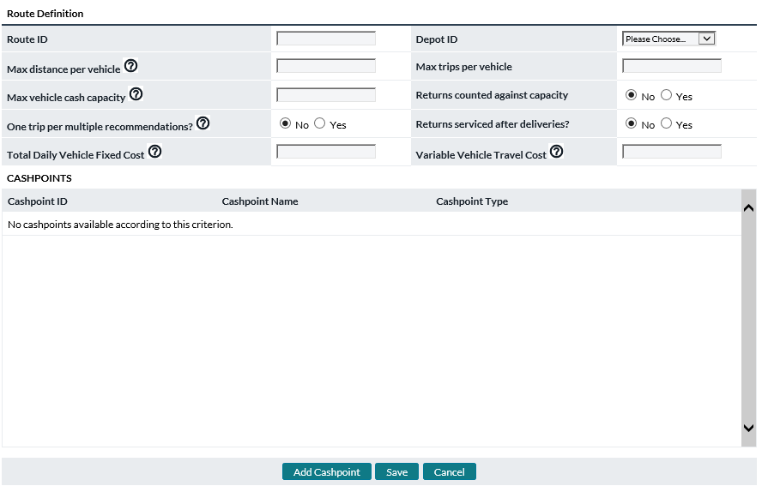

Table 90: route Definition Fields Description

| Fields | Description |
| --- | --- |
| **Route ID** | A unique ID assigned to the route being defined |
| **Depot ID** | Depot ID with which the defined route is to be associated |
| **Max Distance per Vehicle** | Maximum travel distance per day in kilometres |
| **Max Trips per Vehicle** | Maximum number of trips for the route in a single day |
| **Max Vehicle Cash Capacity** | The maximum amount of cash (value) in a single day |
| **Returns Counted Against Capacity** | Yes/No field indicating whether anticipated Returns are to be calculated as part of the total vehicle capacity |
| **One Trip per Multiple Recommendations** | Yes/No field indicating whether multiple trips in the same day to the same cashpoint should be counted as one trip or many individual trips |
| **Returns Serviced After Deliveries** | Yes/No field to indicate whether all scheduled Returns are to be serviced after all scheduled Deliveries |
| **Total Daily Vehicle Fixed Cost** | This is the fixed cost of operating a truck on a given day no matter how long it travels, or how many cashpoints it serves.  **Note:** This is not the same with the Delivery Handling cost or Return Handling cost we set on cashpoint pages. Users can still define handling costs on cashpoint pages in addition to the fixed vehicle operation costs. |
| **Variable Vehicle Travel Cost** | Defines the cost per vehicle per kilometre travelled. |
| **Cashpoints** | Add the Cashpoints that will belong to this route.  **Note**: A cashpoint can only belong to 1 route at a time. Also, Latitude and Longitude fields will need to be filled for the cashpoint before adding to the route. |

## Network→Regions Page

Most users will want to group the cash delivery points (ATMs and Branches) into regions or different zones for different administrative purposes. Typically cash delivery points are grouped according to the organizational needs of the institution. This makes the operation of the system easier and will be very helpful when Users assign grouped parameters or any kind of settings and when they generate reports for management or daily operations.

Regions are custom-defined and may include nationwide geographic boundaries, administrative zones, or other regional divisions required for reporting purposes.

Figure 112: Regions Page

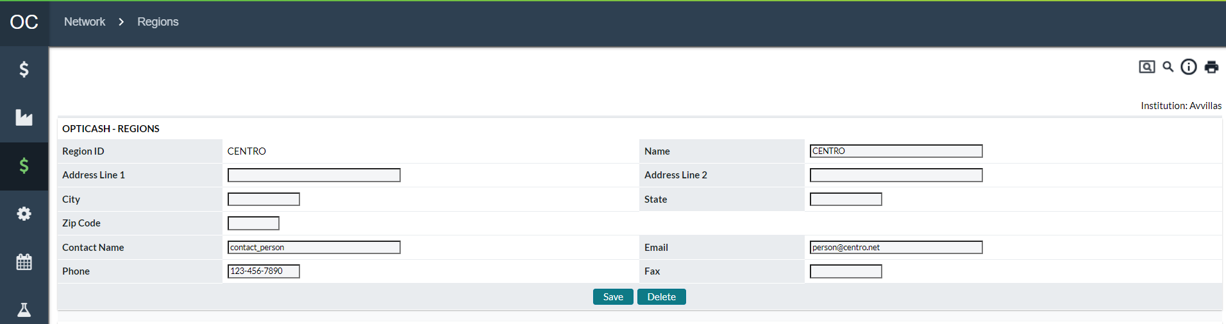

Table 91: Regions Description

| Fields | Description |
| --- | --- |
| **Add Button** | Allows the user to add a new Region. |
| **Edit Button** | Allows the user to edit an existing Region. |
| **Delete Button** | Allows the user to delete an existing Region.  **Note**: Regions that have Cashpoints assigned to them cannot be deleted. Reassign Cashpoints to another Region to delete a Region. |
| **Region ID** | Unique alphanumeric value for identification. |
| **Name** | Name used to identify the region. |
| **Address Line 1** | Line 1, Street address. |
| **Address Line 2** | Line 2, Street address. |
| **Contact Name** | Name of the contact person. |
| **City** | City in which the region is located. |
| **State** | State in which the region is located. |
| **Zip Code** | Zip code or postal code. |
| **Contact Name** | The contact name. |
| **E-mail** | E-mail address of the contact person. |
| **Phone** | Telephone number. |
| **Fax** | Fax number. |

Return To: Network Tab

## Network→Groups page

Groups are arbitrary structures or hierarchies available for use by the user. Cashpoint (ATMs and/or Branches) or Commercial groups may be based on geographic areas, cash distributing routes, cost centers, management responsibility, and reporting or operational boundaries at the user’s discretion OptiCash also allows for specific groups for Commercial Clients if licensed.

Figure 113: Groups Page

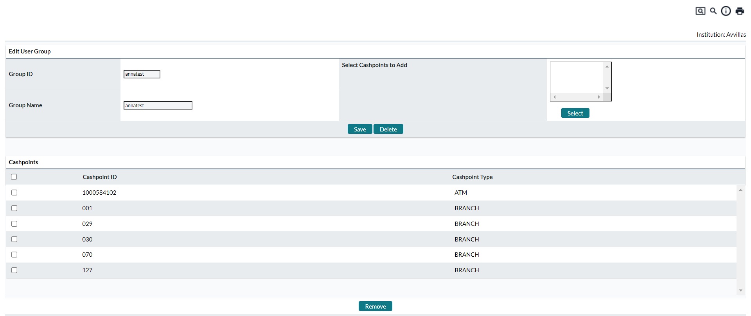

Table 92: Group Type Selection

| Fields | Description |
| --- | --- |
| **Commercial Clients** | Allows for the creation of or editing of groups of Commercial Clients. These are separate from ATMs and Branches. |
| **ATM/Branch** | Allows for the creation of or editing of groups of ATMs and/or Branches. These are separate from Commercial Clients. |

Table 93: Groups Description

| Fields | Description | |
| --- | --- | --- |
| **Create Button** | Allows the user to create a new Group by setting a Group ID, Description, and Cashpoints. | |
| **Group ID** | Unique alphanumeric code that identifies the Group. The Group ID can be a maximum of 12 digits and should not contain any spaces or special characters. | |
| **Group Name** | A name used to identify the contents of the group. (I.e., Offsite_ATMs) | |
| **Save Button** | Saves a New Group or changes to an existing Group. | |
| **Delete Button** | Deletes the Group ID.  **Note**: The delete feature only deletes the Group ID, it does not affect the Cashpoints themselves. | |
| **Select Button** | Allows the user to select Cashpoints that will be added to the Group. | |
| **Remove Button** | Allows the user to remove selected Cashpoints from the group. This is done by checking the Cashpoints that are to be removed and clicking the Remove button.  **Note**: There is no undo function for Removing Cashpoints from Groups; take caution when removing Cashpoints. | |
| Return To: Network Tab |  |

## Network→Clusters page

Clusters are groups of cashpoints close to one another. ATMs within the same physical structure utilize the side-by-side Cluster aggregation functionality, and that functionality utilizes the side-by-side Linkage and a parent ATM to aggregate one order for several machines.

The Cluster functionality defined under *Network>Clusters* is for ATMs in the same geographical area such as a neighbourhood or part of a city, and it works to determine a particular day(s) that is proper for all the ATMs to receive their order.

Figure 114: Clusters List Page

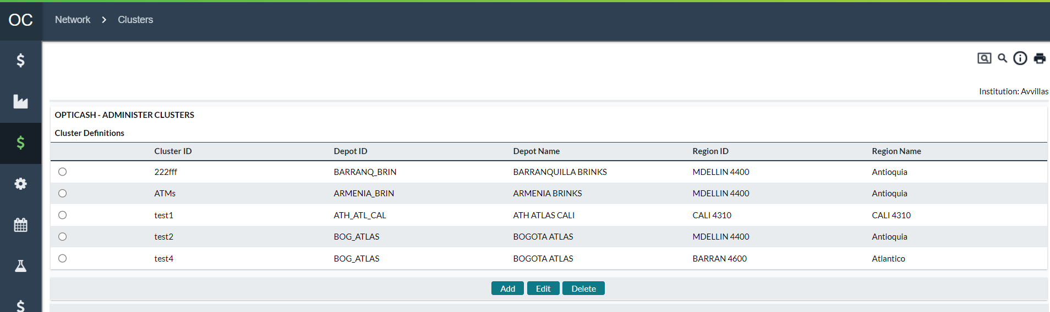

Figure 115: Cluster Add/Edit Page

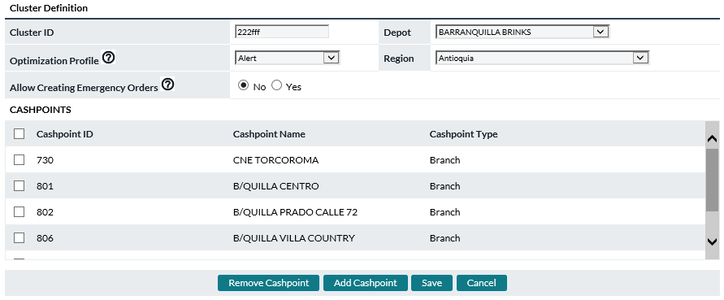

Table 94: Cluster Definition Fields

| Fields | Description |
| --- | --- |
| **Cluster ID** | Identifier for this cluster. |
| **Depot ID** | Depot which services this cluster. |
| **Depot Name** | Name of Depot which services this cluster. |
| **Region ID** | Region where this cluster is located. |
| **Region Name** | Name of Region where this cluster is located |
| **Optimization Profile** | Choose which method should be used in the Recommendations process for this cluster:  **Individual Optimization**: Cluster cashpoints have their recommendations created individually, without an attempt to service the cluster at the same time. Clustering can be used for reporting purposes.  **Alert**: Like Individual Optimization above but adds messages to the Recommendations process log describing what would happen if Cluster Optimization were to be enabled. For testing purposes when first beginning with clusters.  **Cluster Optimization**: Recommendations process will attempt to service cluster cashpoints on the same day as often as possible. |
| **Allow Creating Emergency Orders** | Yes/No. During Cluster Optimization, there may occur a case where some cashpoints in the cluster have already scheduled services very soon and to synchronize other cashpoints an emergency schedule order would have to be created. This option controls whether the emergency will be created (Yes = emergency order for some cashpoint which allows avoiding additional trip later. No = no emergency order and likely additional trip later.) |

Return To: Network Tab

## Network→Balance Types

Balance Types is used to manage the different branch accounts available with the enhanced Cashpoint Linkage and sub-account functionality.

Heretofore, OptiCash cashpoints (both ATM and Branch) have had single “**in-total**” balances. OptiCash/OptiNet now facilitates the tracking, reporting, and optimization of multiple accounts within a single branch along with parent/child linking to those accounts when applicable.

Four basic account types are standard and pre-built in OptiCash. OptiCash Users have the ability via the Balance Type screen to create more. See Cashpoint→Basic→Linkage for definitions of the three standard accounts.

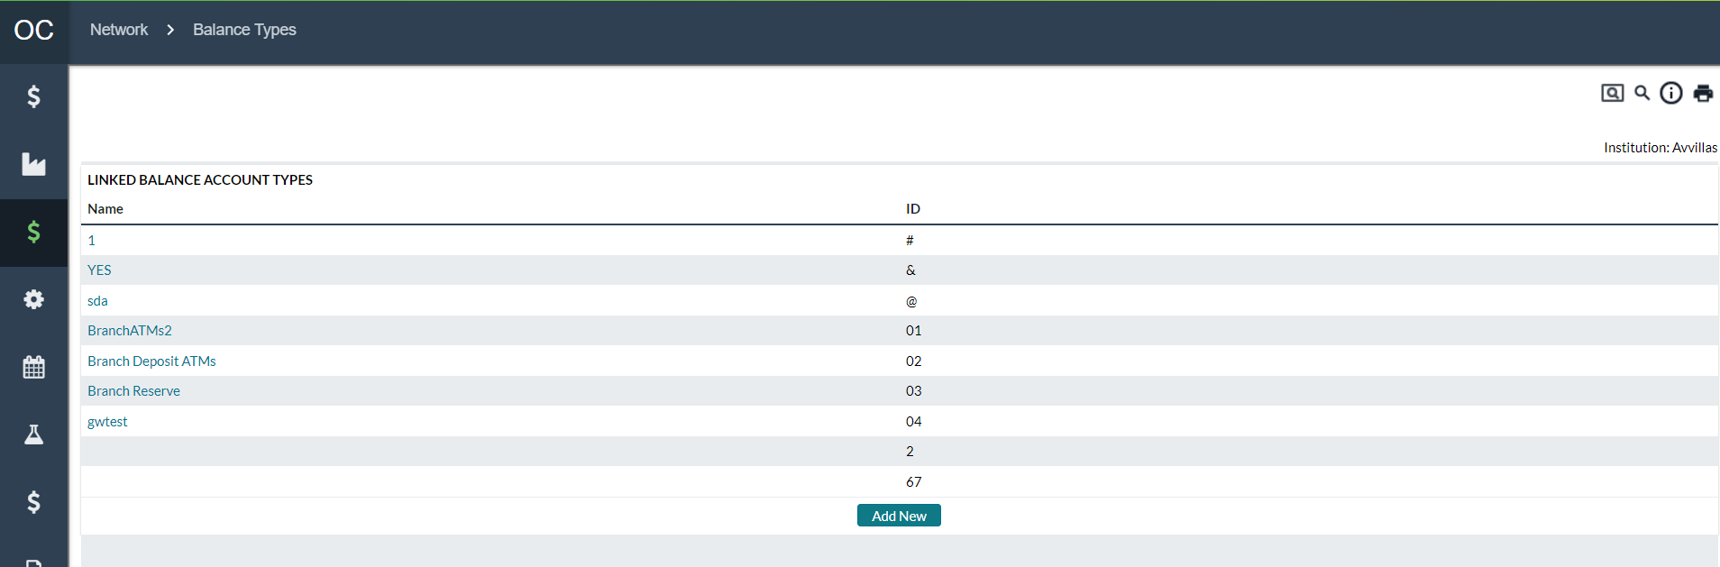

Account Names are hyperlinked allowing users to review existing accounts. Users can change the name of the account, delete it, or cancel out and make no changes.

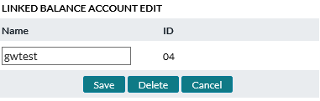

By clicking on the Add New button on the Balance Types screen, the user will receive a new screen to create a new account. By clicking on Save, the account will be created and available for use by network branches.

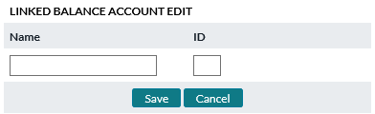

Return To: Network Tab

## Network→Commercials

The Commercials page is used to manage identifiers for commercial customers that will allow branches to place orders in OptiNet for commercial clients assigned to their Cashpoints.

The hierarchy of commercial orders depends on a corporate identifier that has one or many clients associated with it. The clients can then be managed by a Cashpoint. Only one Cashpoint can manage a client (See Corporate A example), however, one Cashpoint can manage many clients (See Corporate B example).

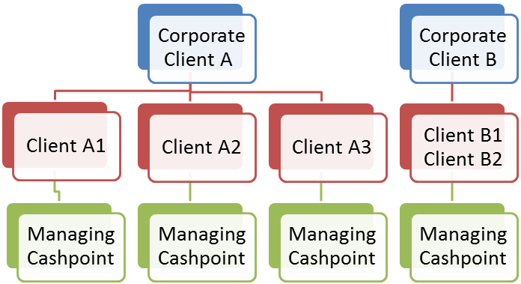

The following pages will cover this structure:

* Commercials→Corporate Page
* Commercials→Client Page

### Commercials→Corporate Page

The Corporate page allows for the creation of new Corporate IDs with which Client IDs can be associated. At least one Corporate ID needs to exist to create Client IDs.

Figure 116: Corporate Page

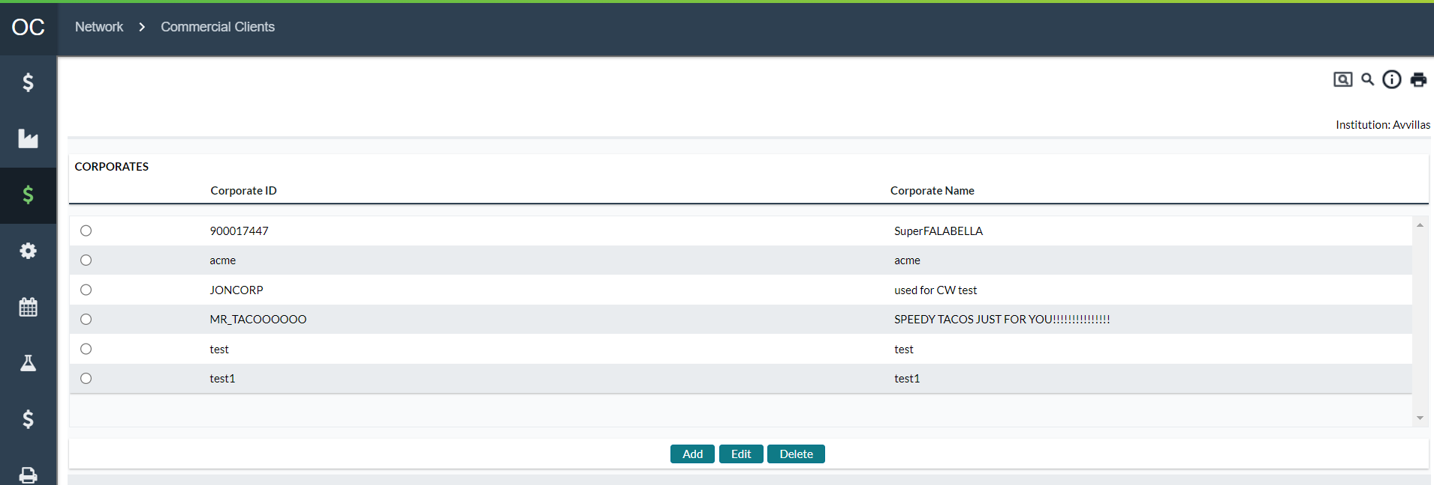

Table 95: Corporate Description

| Fields | Description | |
| --- | --- | --- |
| **Corporate ID** | Unique alphanumeric identifier to define the Corporate ID | |
| **Corporate Name** | Name of the corresponding Corporate ID. | |
| **Add Button** | Allows the user to add a new Corporate ID. | |
| **Edit Button** | Allows the user to edit an existing Corporate ID that has been selected in the list of existing IDs. | |
| **Delete** | Allows the user to delete a Corporate ID. | |
| **Address 1** | Address of the Corporation | |
| **Address 2** | Address of the Corporation | |
| **City** | City of the Corporation | |
| **State** | State of the Corporation | |
| **Phone** | Phone Number of the Corporation | |
| **Save Button** | Saves the entry after changes have been made | |
| **Cancel Button** | Cancels any changes that have been made and return to the previous page. | |
| Return To: Network Tab |  |

### Commercials→Client Page

The Client page allows for the creation of new Client IDs that can be associated with a Branch to allow orders to be placed. At least one Corporate ID needs to exist to create Client IDs.

Figure 117: CLient Page

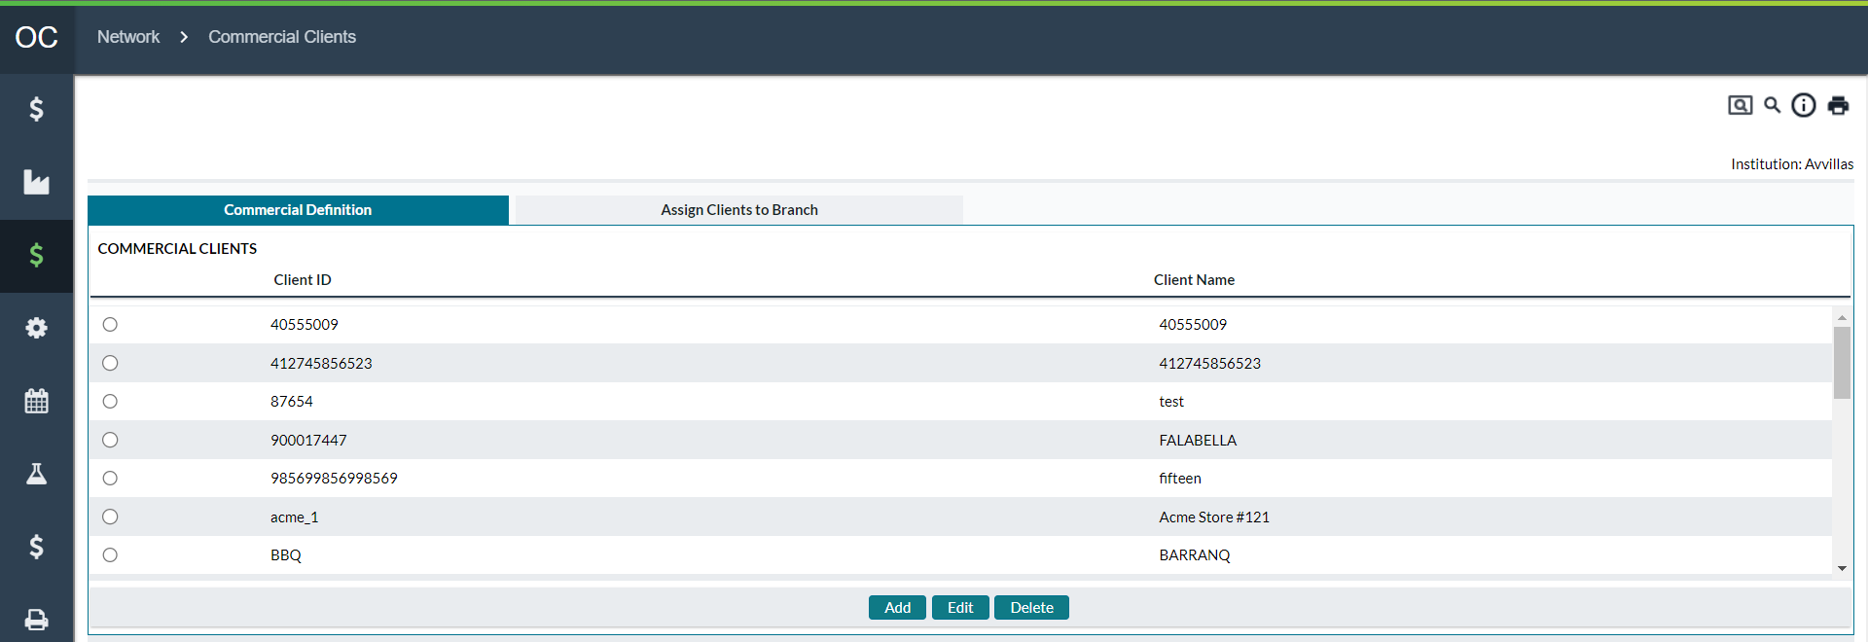

Table 96: CLient Description

| Fields | Description |
| --- | --- |
| **Corporate ID** | Unique alphanumeric identifier to define the Corporate ID |
| **Client ID** | Unique alphanumeric identifier to define the Client ID |
| **Client Name** | Name of the corresponding Client ID. |
| **Add Button** | Allows the user to add a new Client ID. |
| **Edit Button** | Allows the user to edit an existing Client ID that has been selected in the list of existing IDs. |
| **Delete** | Allows the user to delete a Client ID as long as no orders exist for the Client. |
| **Carrier** | Depot ID of the carrier that will deliver the Order |
| **Managing Branch** | The Cashpoint ID of the Branch responsible for placing the orders for the Client |
| **Select** | Allows the user to select a Cashpoint to assign to the Client.  **Note**: Only one Cashpoint may be selected to be assigned to a Client. |
| **Save Button** | Saves the entry after changes have been made |
| **Cancel Button** | Cancels any changes that have been made and return to the previous page. |

### Commercials→Commercial Definitions Page

Each Commercial Client needs a general definition or description of what it is and where it fits into the network. The Commercial Definitions page allows the analyst to provide demographic data for each client.

Figure 118: CLient Definition Page

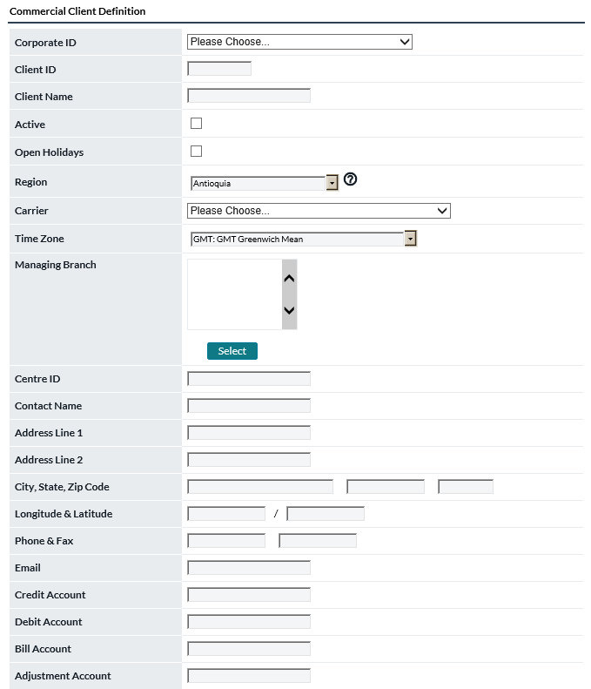

Return To: Network Tab

Table 97: Client General Definitions

| Client Element | Description |
| --- | --- |
| **Client ID**  **(Required)** | Unique alphanumeric code that identifies the client.  The ID can be a maximum of 12 digits. It must not contain any spaces between the characters nor should it contain special characters (‘{[]}|~`!@#$%^&*)”.The software will give an error message if the user tries to enter an invalid character. |
| **Client Name**  **(Required)** | An alphanumeric name can be given to the Cashpoint to help identify it from other Cashpoints.  The Cashpoint Name can be a maximum of 80 Characters. Certain special characters will be rejected (i.e., single, or double quotes), but spaces are acceptable for this field. The software will give an error message if the user tries to enter an invalid character. |
| **Active** | Flag to indicate whether the client is presently active |
| **Region** | The analyst will select the client’s region from a drop-down. See the *Network>Region* page in this reference guide for a full definition of Regions |
| **Carrier** | This field indicates with Carrier (depot) supplies the client. |
| **Time Zone** | The Time Zone where the client is located.  This is for informational purposes only currently. It does not affect any other processes. |
| **Centre ID** | Identifies the cash centre (supplier) for the client |
| **Contact Name** | Contact person’s name for this Cashpoint. The Contact Name can be a maximum of 80 characters.  This is for informational purposes only currently. It does not affect any other processes. |
| **Address Line 1** | Address information for this Cashpoint. Address Line 1 can be a maximum of 80 characters  This is for informational purposes only currently. It does not affect any other processes. |
| **Address Line 2** | Additional address information for this Cashpoint. Address Line 2 can be a maximum of 80 characters.  This is for informational purposes only currently. It does not affect any other processes. |
| **City, State, Zip Code** | **City** where this Cashpoint is located. The City can be a maximum of 30 characters.  **State** where this Cashpoint is located. The State can be a maximum of 15 characters.  The **postal code** of the Cashpoint. The Zip Code can be a maximum of 10 characters.  This is for informational purposes only currently. It does not affect any other processes. |
| **Phone & Fax** | The **phone number** for the contact person of this Cashpoint. The Phone Number can be a maximum of 15 characters  The **fax number** for this Cashpoint. The Fax Number can be a maximum of 15 characters.  This is for informational purposes only currently. It does not affect any other processes. |
| **Email** | **Email** **address** for the contact person for this Cashpoint. The Email Address can be a maximum of 80 characters.  This is for informational purposes only currently. It does not affect any other processes. |
| **Credit Account** | Account for receiving cash being deposited by the client during a cash return |
| **Debit Account** | Account for taking cash out for client deliveries. |
| **Bill Account** | The bank account is available for billing cash handling services provided to the financial institution. |
| **Adjustment Account** | Account available for the financial institution to debit/credit overages/underages in cash settlement. |
| **ABA ID** | ABA (American Bankers Association) ID number field |
| **Custom 1 – 6** | OptiCash users can store a variety of information at the Client level using custom fields. These fields can hold data such as internal account numbers, classification information, etc. Using the custom fields, the user can search for a particular value in a custom field.  **For example**, if Custom 1 was the color of the Client and you were searching for blue Clients, you could enter ‘Blue’ in the Custom 1 field to find all blue Cashpoints  Custom Fields can be a maximum of 50 characters each.  **Note**: The user is only able to search by these fields when using the Filtered By Client ID or Client Name options. |

### Commercials→Commercial Parameters Page

Client Parameters allow the user to define specific fields regarding the functionality of the client.

Figure 119: CLient Parameters Page

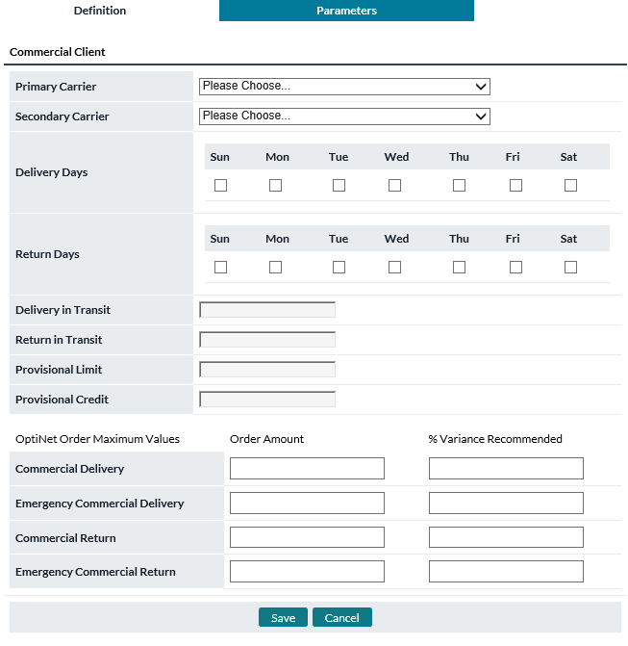

Return To: Network Tab

Table 98: Client Parameter Definitions

| Client Element | Description |
| --- | --- |
| **Carrier 1** | Primary Cash Carrier/Armored Car servicing the client |
| **Carrier 2** | Secondary Cash Carrier/Armored Car servicing the client |
| **Delivery Days** | Days the client is available to receive cash deliveries |
| **Return Days** | Days the client is available to ship cash returns |
| **Delivery in Transit** | Transit time (in days) for cash deliveries |
| **Return in Transit** | Transit time (in days) for cash returns |
| **Provisional Limit and Provisional Credit** | Limit or Credit amount allowed to the client by the financial institution in excess of their cash on deposit to cover cash needs. This is usually an amount that is allowed to the client because of an ongoing good relationship with the financial institution. The client would normally use one field or the other. |

Return To: Network Tab

### Commercials→Assign Clients to Branch Page

The Assign Clients to Branch page allows clients to be mass assigned to Branches. A Branch must first be selected then the list of Clients can be updated with the ‘Apply Filter’ button to display the list of Clients to Assign.

Figure 120: Assign Clients To THE Branch Page

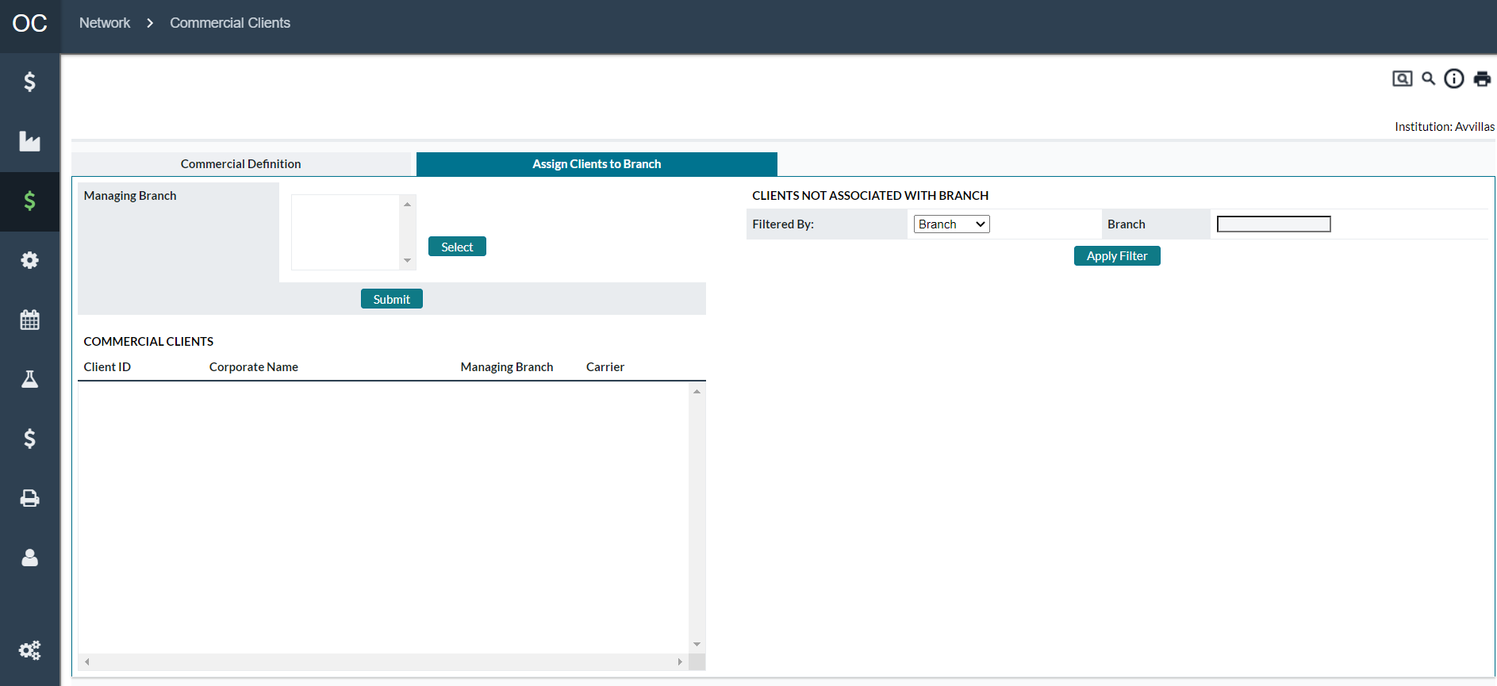

Table 99: Assign Clients to Branch Description

| Fields | Description | |
| --- | --- | --- |
| **Select Button** | Used to select a single Cashpoint as the target of the Client Assignment.  **Note**: Only one Cashpoint ID can be selected at a time. Once the Cashpoint is selected (and the submit button is clicked), the user can see the commercial clients currently assigned to the Cashpoint. | |
| **Client ID** | The ID of the client that is assigned to the Cashpoint | |
| **Corporate Name** | Name of the Corporation the Client belongs to. | |
| **Managing Branch** | Currently assigned Cashpoint as the managing branch for the Client ID. | |
| **Carrier** | The Depot ID of the carrier that will deliver the Commercial Order. | |
| **Apply Filter Button** | Allows the list of clients to be filtered down based on the Filtered By criteria | |
| **Filtered By:** | Allows the list of Clients to be filtered based on different criteria.   * **Branch –** Filters on a match of the Branch Cashpoint ID. If nothing is indicated, all Clients will be returned * **Corporate –** Displays a list of Corporate IDs that can be selected to filter the results. * **Depot –** Displays a list of Depots that can be selected to filter the results | |
| **Assign Button** | Assigns the selected Client IDs to the Cashpoint ID selected. | |
| **Submit Button** | Displays the list of Commercial Clients currently assigned to the Cashpoint ID selected. This shows the list of commercial clients without showing available Client IDs. | |
| Return To: Network Tab |  |

## Network→Network Monitoring

Network Monitoring allows for rules to be set up to automatically exclude Cashpoint History based on the availability of the ATM. The rules work in conjunction with the Downtime report that is loaded into OptiCash daily. Based on the data in the Downtime report, historical data can be excluded based on rules and parameters assigned to the rules.

The process can be run manually, in the batch process when loading downtime files, or in the manual loading process from the *Processing→Load page*.

Figure 121: Network Monitoring Page

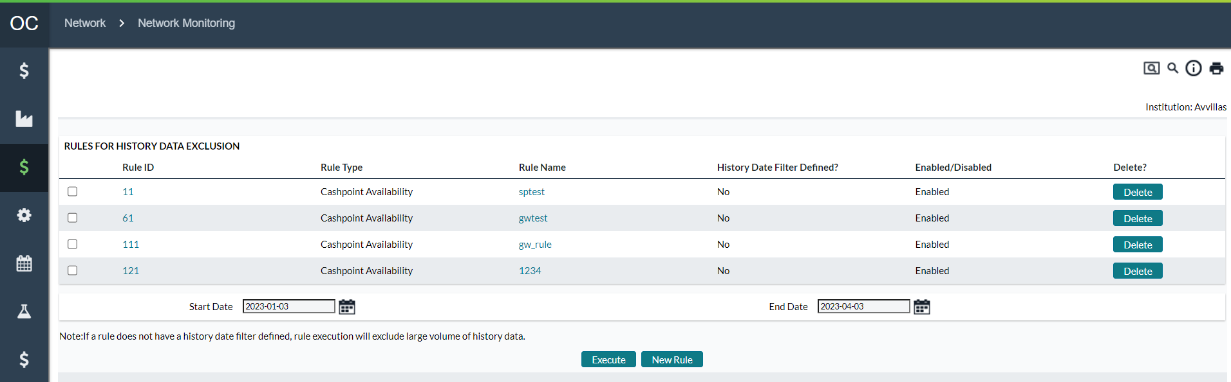

Table 100: Network Monitoring Description

| Fields | Description | |
| --- | --- | --- |
| **Rule ID** | Unique Identifier that is automatically assigned to the Rule | |
| **Rule Type** | Describes the type of Rule defined:  Currently, the following Rule Types are allowed:   * Cashpoint Availability | |
| **Rule Name** | Name of the Rule as defined in the Rule parameters | |
| **History Date Filter Defined** | Displays the status of the Date Filter. If no date filter is applied to the rule, the process will execute on all history which can reduce the performance of the system while the exclusion process is running. | |
| **Enabled/Disabled** | Indicates if the Rule is active or not. | |
| **Delete Button** | Deletes the corresponding Rule ID | |
| **Execute Button** | Executes the rules selected in the list of defined rules | |
| **New Rule Button** | Allows the user to define a new Rule. See Network Monitoring→New Rule | |
| **Edit Rule** | Click on the hyperlink of the desired Rule to view the details and make changes to the rule criteria. See Network Monitoring→New Rule | |
| **Start Date** | Starting date of the date filter. This is used to determine the starting date of history to begin searching for exclusion information. | |
| **End Date** | Ending date of the date filter. This is used to determine the ending date of the history to be searched for exclusion information. | |
| Return To: Network Tab |  |

### Network Monitoring→New Rule

The following page is used to define new or edit existing Exclusion Rules. This page is used to define the name of the rule, activate, or deactivate the rules, or apply/delete/edit Filter Criteria. The Associated Filters are designed to limit the number of records that get excluded to ensure that only select records that meet specific criteria are excluded.

Figure 122: New/Edit Rule Page

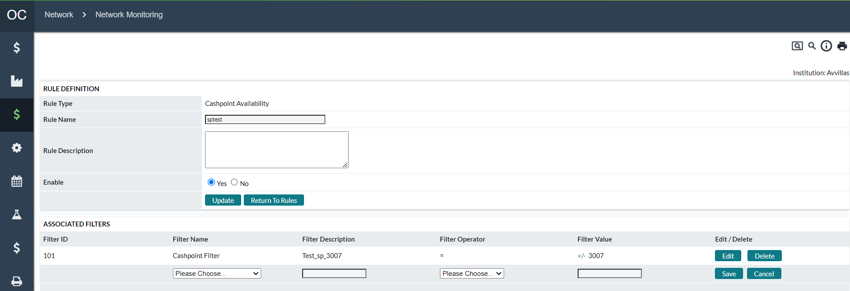

Table 101: New/Edit Rule Description

| Fields | Description | |
| --- | --- | --- |
| **Rule Type** | Describes the type of Rule defined:  Currently, the following Rule Types are allowed:   * Cashpoint Availability | |
| **Rule Name** | Name of the Rule as defined in the Rule parameters | |
| **Rule Description** | The description of the rule helps users understand the purpose of the rule. | |
| **Enabled/Disabled** | Indicates if the Rule is active or not. | |
| **Update Button** | Updates any changes made to the currently displayed Rule since the last time the Save button was clicked | |
| **Return To Rules button** | Returns to the Rules page without saving any information on the page. | |
| **Delete Button** | Deletes the corresponding Filter | |
| **Edit Button** | Edits the corresponding Filter | |
| **Save Button** | Saves the corresponding Filter | |
| **Cancel Button** | Cancels the changes made since the last save and refreshes the page | |
| **Filter ID** | Unique Identifier automatically assigned to each new Filter criteria created. | |
| **Filter Name** | The name of the Filter that will be added. The user will choose from a list of available filters:   * **Cashpoint Filter –** Allows the filter to apply to a range of Cashpoints * **History Date Filter –** allows filtering the dates * Downtime Reasons 01-09 – Allows specifying a specific downtime reason * **Total Uptime Filter-** Filters by the total uptime percentage * **Closing Balance –** Filters based on the closing balance * **Opening Balance –** Filters based on the opening balance * **Normal Delivery –** Filters based on Normal deliveries * **Normal Return –** Filters based on Normal Returns * **Unplanned Delivery –** Filters based on Unplanned Deliveries * **Pre-Withdrawal –** Filters based on Pre-Withdrawal amounts * **Withdrawal –** Filters based on Withdrawal amounts. | |
| **Filter Description** | Description of the Filter | |
| **Filter Operator** | Defines the operator that will be used to compare the Filter Name’s value. For all Filter Names except for Cashpoint Filter, the following Filter Operators apply:   * = - Equals the Filter Name Value * != - Does NOT equal the Filter Name Value * < - Is less than the Filter Name Value * > - Is greater than the Filter Name Value * <= - is less than or equal to the Filter Name Value * >= - Is greater than or equal to the Filter Name Value * For Cashpoint Filters the following Operators apply: * = - Equals a single Cashpoint ID * ! = - Does NOT equal a single Cashpoint ID * IN – Is in the following list of Cashpoints (Multiple Cashpoints may be selected) * NOT IN – Is not in the following list of Cashpoints (Multiple Cashpoints may be selected) | |
| **Filter Value** | The Value that will be evaluated against the Selected Filter Name value. | |
| Return To: Network Tab |  |

1. Events Tab

Events can be national or local holidays as well as non-holiday occurrences. Events are important because they typically impact the demand for cash in an ATM or branch, although the actual impact could have a similar effect or be quite different when comparing an ATM with a branch.

The following is a summary of the information that will be covered along with hyperlinks to each topic.

* Events→Calendar Page
* Events→Events Page
* Events→Year Type Page

Return To: Events Tab

## Events→Calendar Page

Calendars are used in OptiCash to group similar Holidays and Events that relate to a group of Cashpoints. These Calendars can then be assigned to Cashpoints who will use the Events to make appropriate adjustments during the Forecast process.

Users can also define whether a Calendar applies to all currencies or only one or a smaller population of currencies. When creating a new Calendar users will provide the Calendar ID, Calendar name, and they will select which currencies are to be affected by the calendar.

Figure 123: Calendar Page

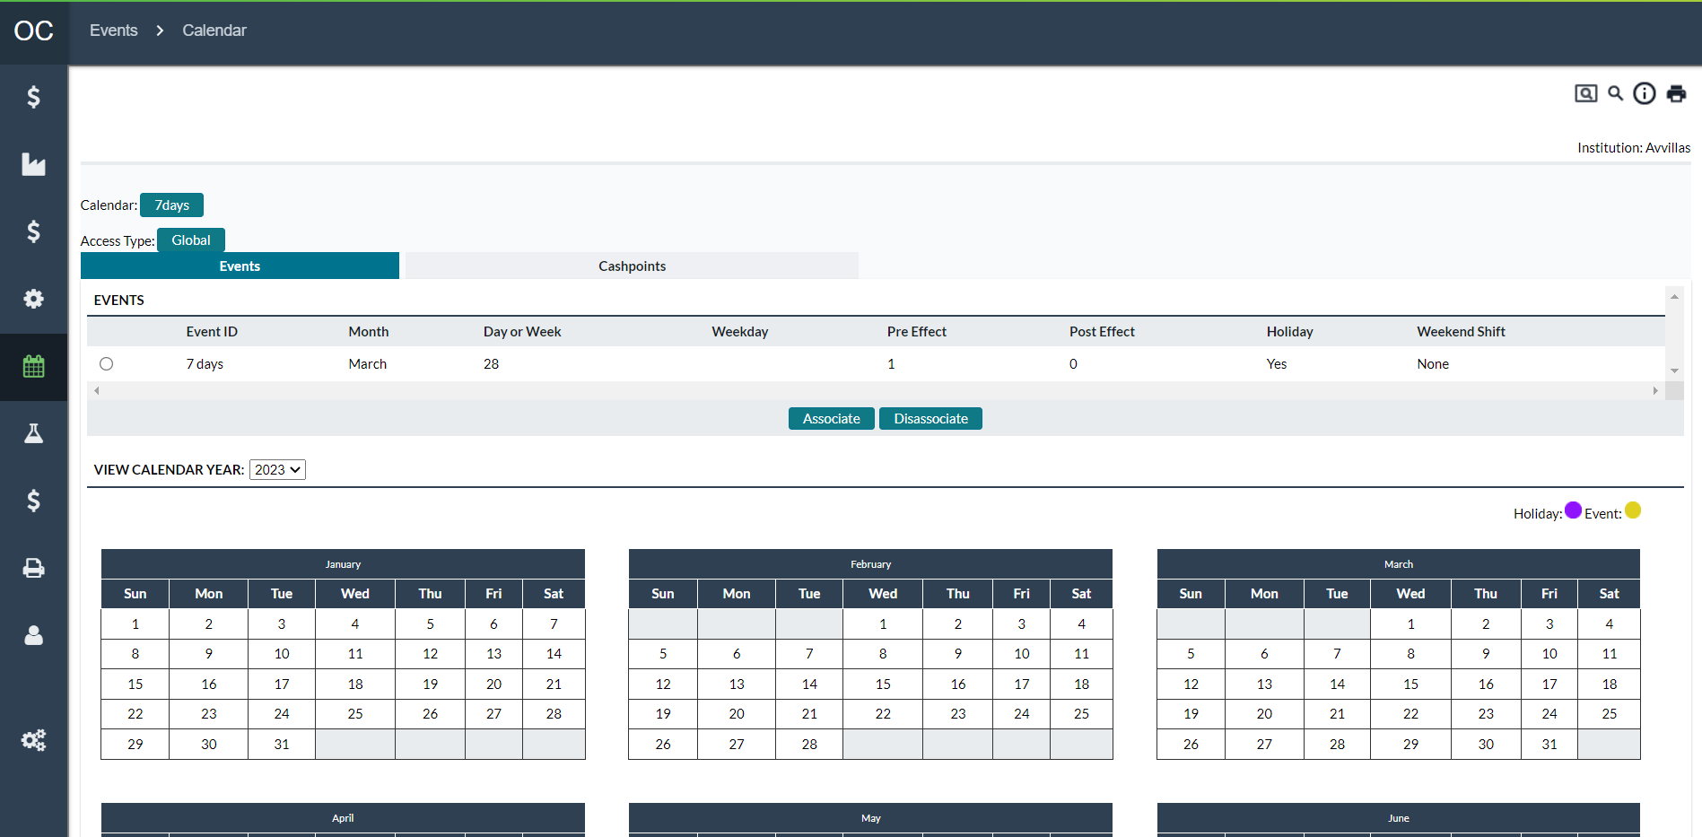

Table 102: Calendar Description

| Fields | Description |
| --- | --- |
| **Create Button** | Allows the user to create a new Calendar by setting a Calendar ID and Description. Once created, the Calendar can have Events and Cashpoints assigned to it. |
| **Access Type** | Administrators or users with applicable privileges can set access to Global where all users with privileges can edit this forecast setup. Or access can be set to “**Restricted**”. Please see [System→Privileges→Business Units (Restricted and Global Privileges)](#_Privileges→Business_Units_(Restrict) for more information on Access Type |
| **Associate** | Allows the user to associate Events to the current calendar. |
| **Disassociate** | Allows users to select Events from the Calendar list and remove them from the current Calendar. |
| **Cashpoints Tab** | Allows users to review, add, or remove Cashpoints from the calendar. See: Calendars→Cashpoints |
| **View Year** | This section of the Calendar Page shows a graphical view of the current Events assigned to this Calendar. This is for informational purposes only |
| **Check Event Collisions Link** | Checking Event Collisions is now on the main Reports tab. The “**Cashpoint Event Collisions**” report is found under the System Settings Report heading on the OptiCash Reports tab. |

Return To: Events Tab

### Calendars→Cashpoints

Figure 124: Calendar Cashpoints Page

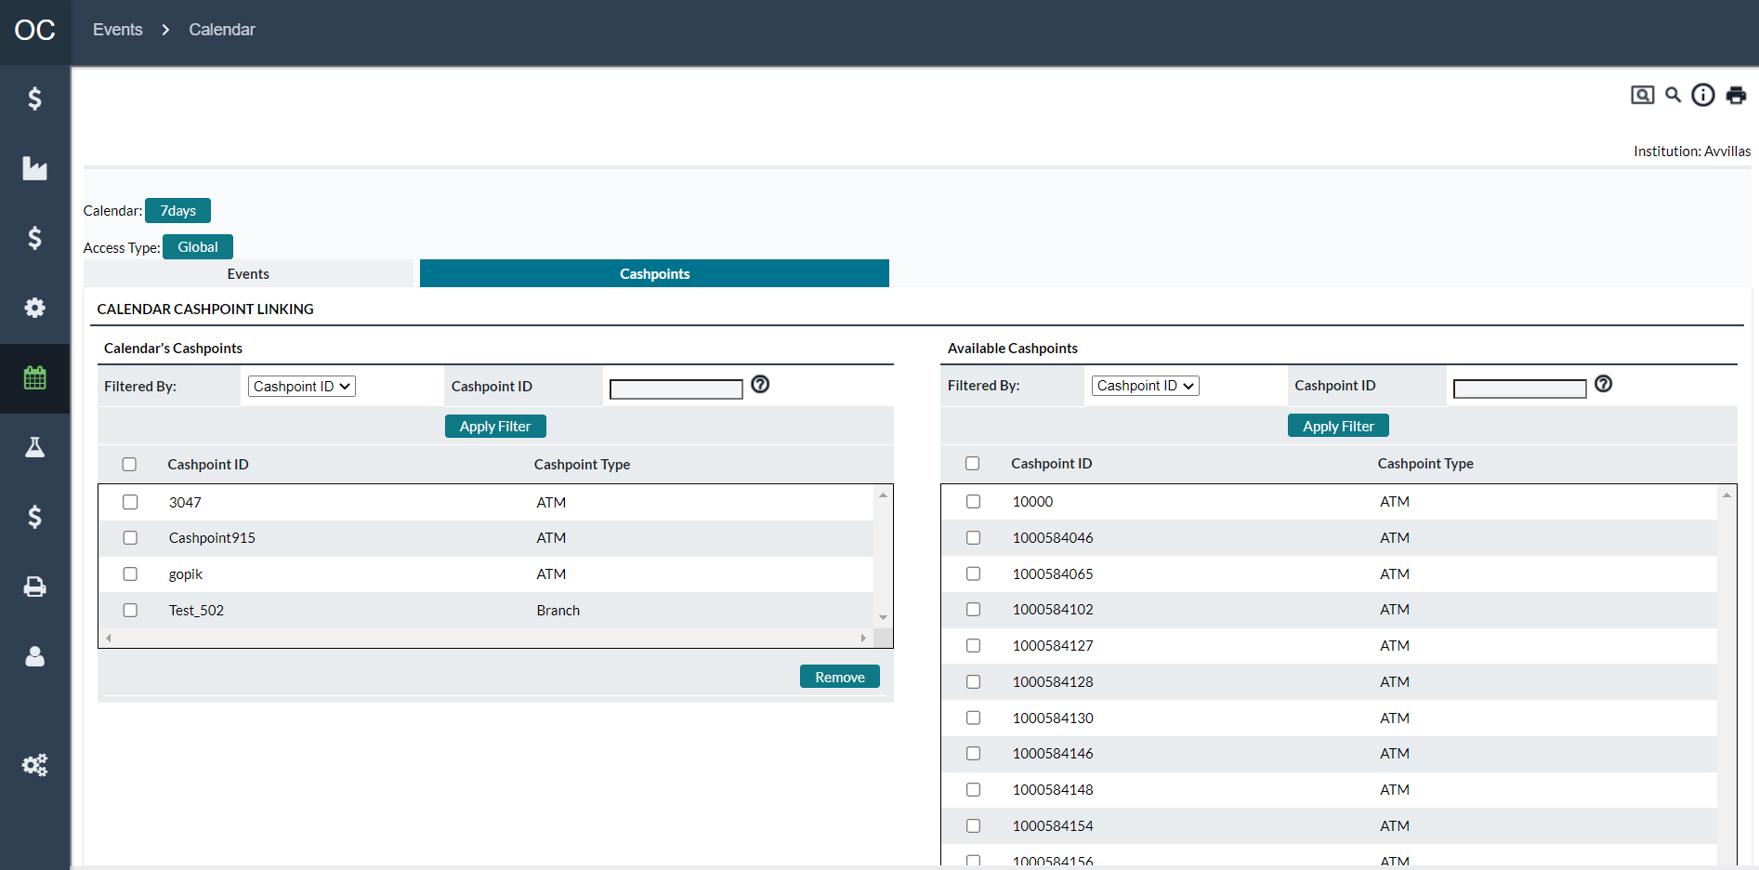

Table 103: Calendar Cashpoints Page

| Fields | Description |
| --- | --- |
| **Create Button** | Allows the user to create a new Group by setting a Group ID, Description, and Cashpoints. |
| **Group ID** | Unique alphanumeric code that identifies the Group. The Group ID can be a maximum of 12 digits and should not contain any spaces or special characters. |
| **Access Type** | Administrators or users with applicable privileges can set access to Global where all users with privileges can edit this forecast setup. Or access can be set to “**Restricted**”. Please see [System→Privileges→Business Units (Restricted and Global Privileges)](#_Privileges→Business_Units_(Restrict) for more information on Access Type |
| **Group Name** | A name used to identify the contents of the group. (I.e., Offsite_ATMs) |
| **Save Button** | Saves a New Group or changes to an existing Group. |
| **Delete Button** | Deletes the Group ID.  **Note**: The delete feature only deletes the Group ID, it does not affect the Cashpoints themselves. |
| **Select Button** | Allows the user to select Cashpoints that will be added to the Group. |
| **Remove Button** | Allows the user to remove selected Cashpoints from the group. This is done by checking the Cashpoints that are to be removed and clicking the Remove button.  **Note**: There is no undo function for Removing Cashpoints from Groups; take caution when removing Cashpoints. |
| **Linked Cashpoints Within Your Business Unit(s)** | Whether access is set to Global or Restricted, this count is the number of cashpoints linked to this Forecast Model. |
| **Linked Cashpoints Outside Your Business Unit(s)** | Whether access is set to Global or Restricted, this count is the number of cashpoints not linked to this Forecast Model. |

Return To: Events Tab

## Events→Events Page

Events are defined in OptiCash to bring special attention to certain days such as paydays or holidays. The Events are assigned to Calendars which are then assigned to Cashpoints for use in the Forecasting and Recommendation processes.

Figure 125: Events Page

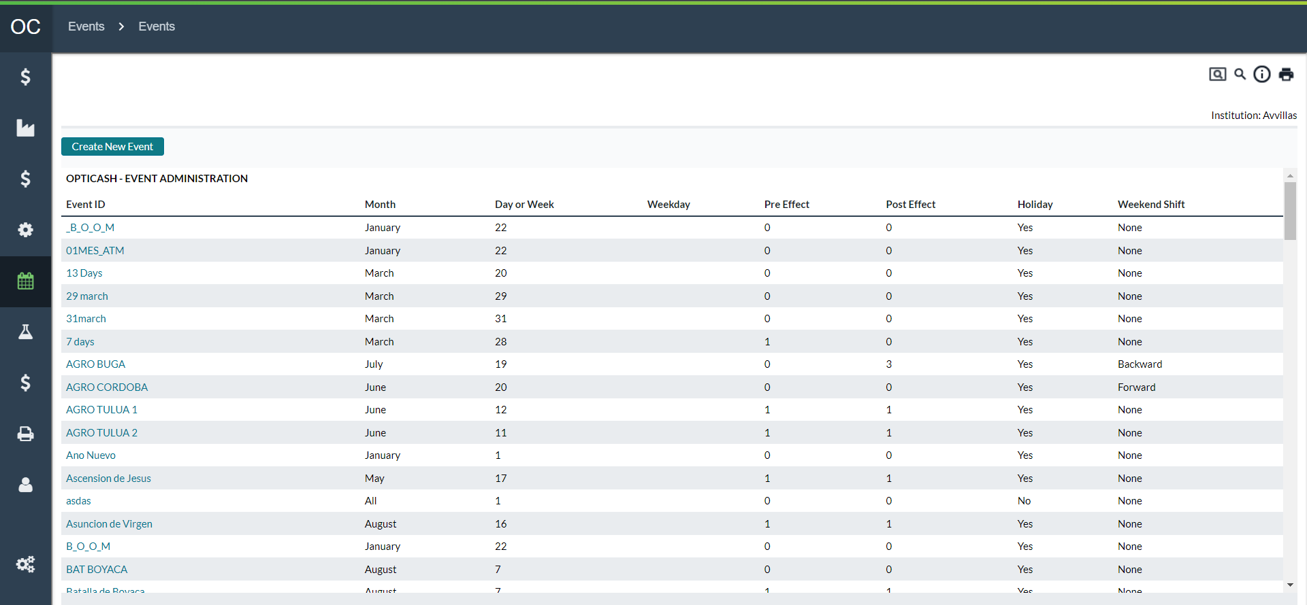

Table 104: Events Page Description

| Fields | Description |
| --- | --- |
| **Add Button** | Allows the user to create a new Event. |
| **Update Button** | The user can select one of the events from the event list and click the Update button the change dates or Event definitions. |
| **Delete Button** | The user can select one of the events from the event list and click the Delete button to delete it from the system.  **Note:** Events cannot be deleted if they are assigned to a Calendar. |

Return To: Events Tab

### Events→Add/Edit Event

The Add/Edit Event Page allows the user to define new or modify existing Events.

Figure 126: Add/Edit Event Page

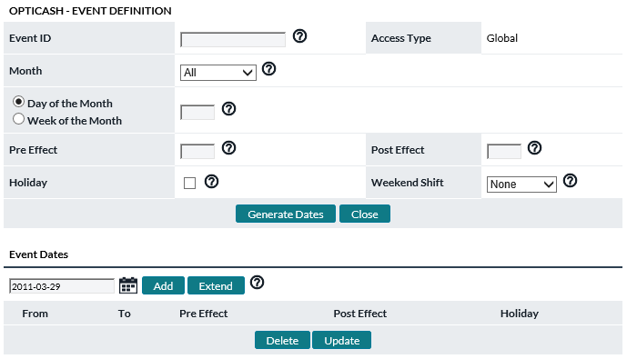

Table 105: Add/Edit Event Description

| Fields | Description |
| --- | --- |
| **Event ID** | Unique alphanumeric code that identifies the Event. |
| **Month** | Specify the month in which this event occurs. If the event occurs every month, select “**All**”. |
| **Access Type** | Administrators or users with applicable privileges can set access to Global where all users with privileges can edit this forecast setup. Or access can be set to “**Restricted**”. Please see [System→Privileges→Business Units (Restricted and Global Privileges)](#_Privileges→Business_Units_(Restrict) for more information on Access Type |
| **Day of Month** | Enter the number of the day of the month on which this event occurs. Note: the event must always fall on the same day of the month each year. If the day varies from one month/year to the next, then do not use this field. Instead, use the next field called “**Week of Month**” (see below). |
| **Week of Month** | The week of the month on which the event occurs (i.e., enter “1” if the event always falls in the first week of the month, “2” if the event always falls in the second week of the month, “5” for last week of month). If a value in this field is entered, you must also specify a day of the week on which the event occurs (see below). This feature will help to define those events that do not occur on the same day each year; for instance, Mother’s Day will occur second Sunday of May each year. |
| **Day of Week** | If the Week of the month is selected, a new field **Day of Week** will occur. Click on the **Down** arrow and select the day of the week on which this event falls. |
| **Pre-effect / Post-effect** | The anticipated “**ripple effect**” from a major event or holiday on cash demand. This is the anticipated days both before (pre-effect) and after (post-effect) that an event will have on cash demand. For example, a major holiday like December 25 (Christmas) will likely have significant effects both before and after the actual holiday. Enter the actual number of days when the “**ripple effect**” is expected to extend out from the event. |
| **Holiday** | Optional selection. Click in the check box next to holiday to indicate that an event is also a holiday. Note: an event is not necessarily a holiday. **For example**, an event could be payday every other Wednesday. A holiday is a national or regional event that could affect the delivery of cash to a Cashpoint if the carrier does not deliver on that holiday. In this case, if the check box is selected, OptiCash will plan for this contingency and forecast for cash to be delivered before the holiday, if necessary. |
| **Weekend Shift** | Click the **Down** arrow to select the expected shift in cash demand when an event falls on the weekend (Saturday or Sunday). The possible choices are:  **Backward:** shifts demand to the Friday before the weekend.  **Forward:** shifts demand to the following Monday.  **None:** indicates no anticipated shift in demand and keeps the original event date.  **Note**: This field is only active when the Day of Month field is populated with a value greater than zero (0). |
| **Generate Dates Button** | Generates Event Dates based on the definition of the Event (present year plus 2 years in the past and 2 years into the future). The dates can then be selected and individually updated if needed. |
| **Add Button** | Allows Users to manually enter dates. This is an alternative to Generating dates. |
| **Update Button** | Updates the select date. |
| **Delete Button** | Deletes the selected date. |

Return To: Events Tab

## Events→Year Type Page

Choosing a Year Type in OptiCash determines the basis for time-sensitive cash demand pattern detection in the forecast process. Two options are offered: Gregorian Calendar (Solar), and Islamic Calendar (Lunar).

Figure 127: Year-Type Page

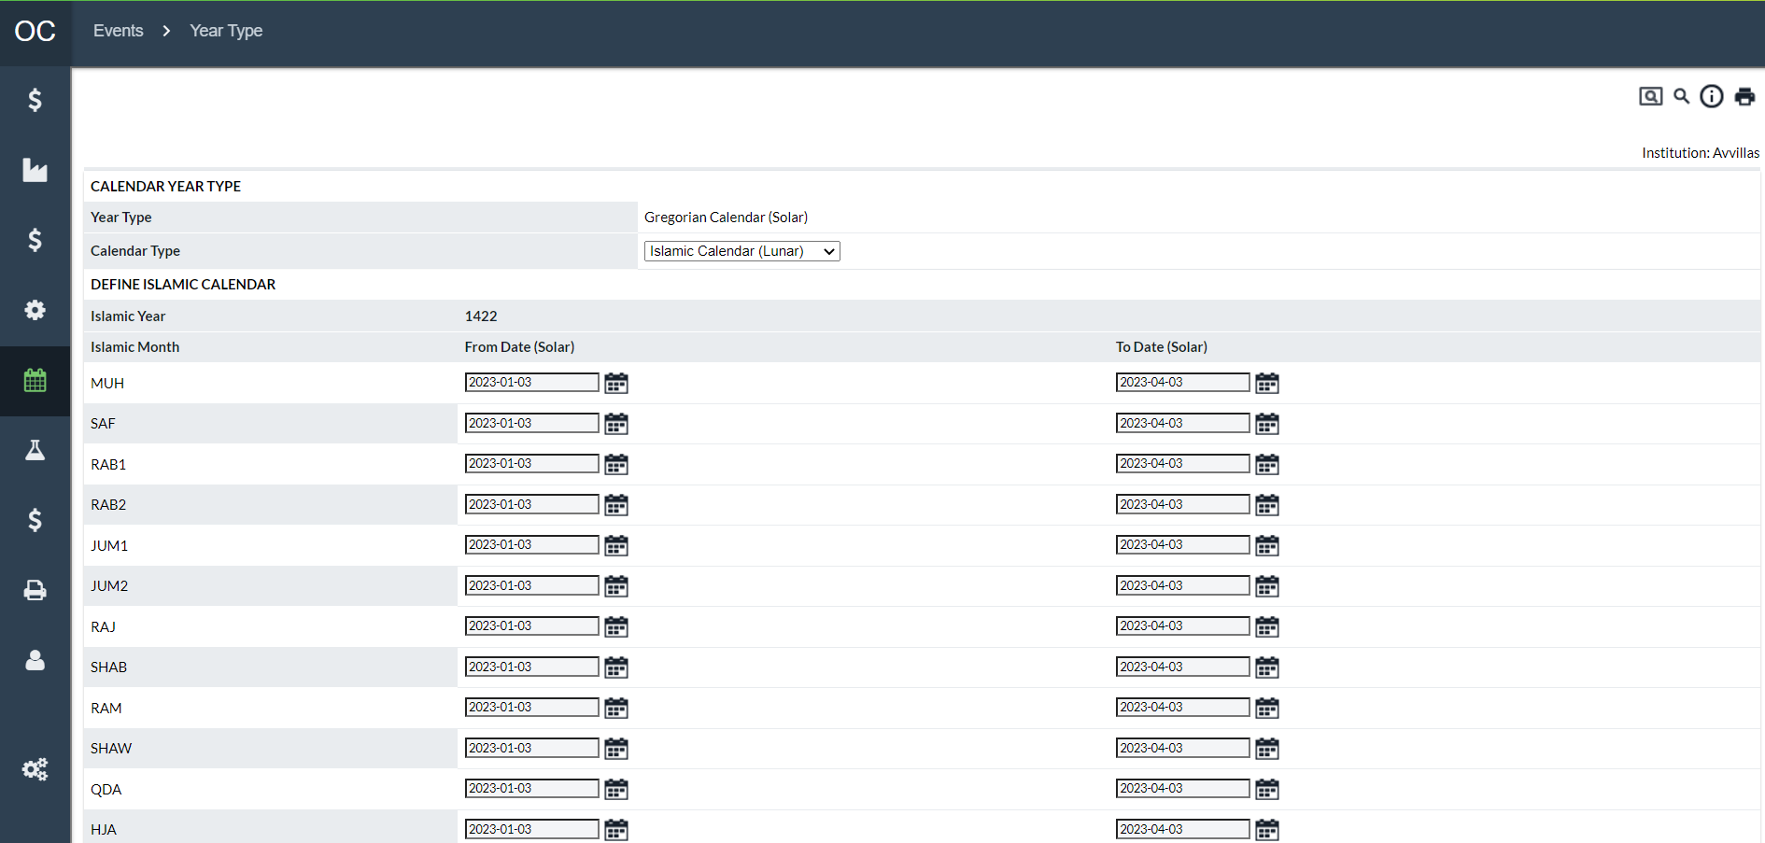

Table 106: Year-Type Description

| Fields | Description |
| --- | --- |
| **Active Year Type** | The Year Type currently in effect for the system |
| **Calendar Type** | Allows the user to select the Calendar type from the Dropdown list. Click **Save** to assign the Year Type.  Gregorian (Solar Calendar)  Islamic (Lunar Calendar) |
| **Islamic Year** | Specifies the Islamic Year and allows the user to enter the Solar Date equivalents to the Islamic Months |
| **Islamic Month** | Breakdown of the Islamic months and allows the user to select the Solar date equivalents for the Lunar Month |
| **Save** | Saves the Selection and assigns the new settings to the system. |
| **Cancel** | Closes the window without saving any information. |

Return To: Events Tab

1. System Tab

The System Tab contains tools normally used by administrators to set up the system or perform maintenance functions.

The following is a summary of the information that will be covered along with hyperlinks to each topic:

* System→Institution Page
* System→Privileges Page
* System→Order Settings Page
* System→Maintenance Page
* System→View Logs
* System→Audit Log Browser
* System→About Page

Return To: Introduction to the Interface

## System→Institution Page

Figure 128: Institution Page

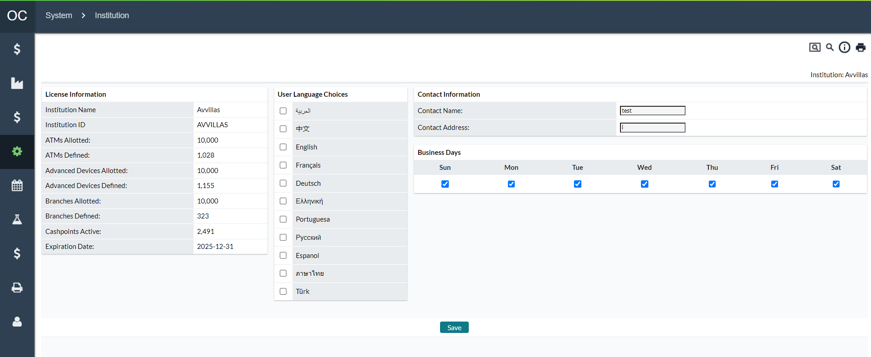

Table 107: Institution Description

| Fields | Description |
| --- | --- |
| **Institution Name** | Name of the institution to which the software is licensed. This information cannot be changed. |
| **Institution ID** | Identifier of the institution to which the software is licensed. This information cannot be changed. |
| **Cashpoints Allotted** | Number of Cashpoints the institution is licensed for. This information can only be changed by purchasing licenses for additional Cashpoints.  **Note**: This is broken out by cashpoint license types which are ATM, Advanced Devices, and Branches |
| **Cashpoints Defined** | Number of Cashpoints that are defined on the system. **If the number of Cashpoints defined (both inactive and active) exceeds the number allotted, the system will not allow users to log into the system or use any functionality.**  **Note**: This is broken out by cashpoint license types which are ATM, Advanced Devices, and Branches |
| **Cashpoints Active** | Number of Cashpoints currently active in the system. |
| **Expiration Date** | Expiration date of the current licenses |
| **Contact name** | Contact name for the institution. This information can be changed by the user |
| **Contact Address** | Contact address for the institution. This information can be changed by the user |
| **Business Days** | The general business days for your institution.  **Note:** These are used as default Processing Days for new cashpoints. Each cashpoint has its Processing Days which inform Lead Time calculations (i.e., how many days before the service due date that a Recommendation will be presented to the user) |

Return To: System Tab

## System→Privileges Page

The Privileges pages allow the administrator to set up users and user groups called Business Units. Users can access the system only if they are a member of a Business Unit. The Business Units have Users assigned to them as well as Cashpoints and Rights.

Figure 129: Privileges Page

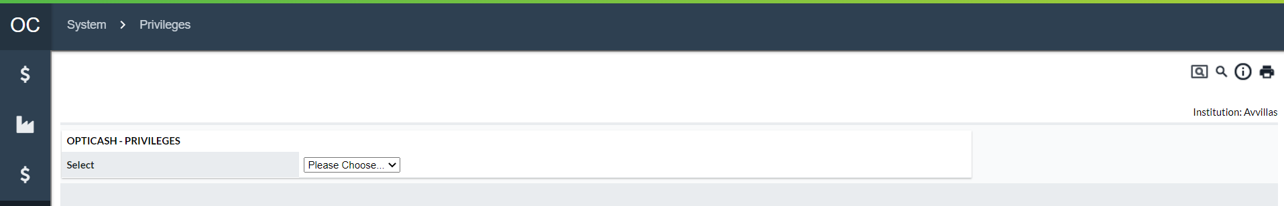

Return To: System Tab

### Privileges→Users

To access OptiCash, users must have a User ID and password pre-defined by a system administrator.

Figure 130: User Information Page

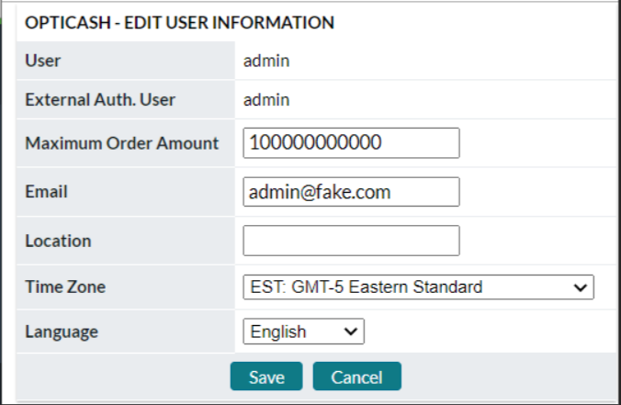

Figure 131: user Information Page (OptiNet Branch Users)

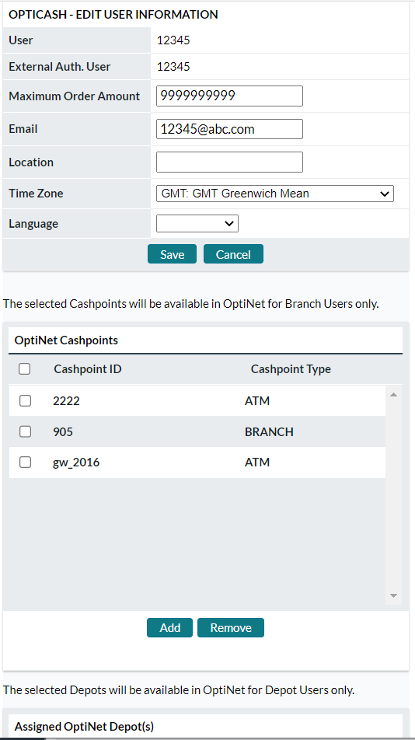

Table 108: User Description

| Field | | Description | |
| --- | --- | --- | --- |
| **User** | | Enter a unique alphanumeric value for this user. | |
|  | **Note:** There should be no special characters and spaces in the User ID. | |
| **Password** | | Enter a unique alphanumeric password for this user. | |
| **External Authentication User** | | Enter external authentication if available.  **Note** with external authentication administrator should NOT provide a username or password to the application.  Instead, user identification information is acquired from the application server.  Typically, users have already signed on through an appropriately secure method for the portal or set of services they are given access.  This method is compatible with standard single sign-on schemes for web-based applications. | |
| **OptiNet User Type** | | Select the user type from the options available in the drop-down list: Administrator, Analyst User, Branch User and Depot User.  When the **Branch User** type is selected, OptiCash Administrators will be able to assign OptiNet Workflow Profiles to each user thus allowing only the specified ordering Tasks to be possible for each user. Additionally, access to specific cashpoints in OptiNet can be assigned from the user profile in OptiCash via the OptiCash Cashpoint Selector.  When the **Depot User** type is selected, OptiCash Administrators will be able to assign one or more Depots to the user when logged into OptiNet. | |
| **Locked** | | Locked Flag indicates that the user’s account has been locked and the user is not able to log onto the system. A user’s account can be locked due to an administrator’s intervention or by the user failing to successfully log in within the system's defined limit of failed logins. | |
| **Maximum Order Amount** | | Maximum threshold is unique to each user. Users cannot order more than the limit.  **NOTE**: It only applies in OptiNet. There are also OptiNet Maximum Order Amount settings for individual cashpoints. When both could apply, the smaller will take effect. | |
| **Email** | | User’s email address. Presently only for informational purposes, but may be used for future functionality additions | |
| **Location** | | User’s location. Presently only for informational purposes, but may be used for future functionality additions | |
| **Time Zone** | | User’s timezone. Presently only for informational purposes, but may be used for future functionality additions | |
| **Language** | | User’s Language. Can select from English, French, Spanish, and Russian. Presently only for informational purposes, but may be used for future functionality additions | |

Return To: System Tab

### Privileges→Business Units

Business Units (formerly User Groups) are assigned specific privileges and users are then assigned to the Business Unit. All users in OptiCash must be assigned to a Business Unit and privileges are most easily managed by assigning them at the Business Unit level. Additional customized Business Units can be added to the database, but there are two by default in OptiCash:

* **Admin:** The Admin or System Administrator has complete administrative access to all functions in OptiCash. The ADMIN creates and maintains users, Business Unit and assigns access privileges from within User Administration.
* **Users:**  The User has, by default, access to most areas of OptiCash, but cannot access the Setup module. However, the System Administrator can customize the privileges for the USERS group to allow for any level of access to application functionality.

**Note**: If OptiCash is setup to restrict privileges to User and Business Units, then new Business Units will need to be created to accommodate this system restriction. The reason is that the default users/Business Units have all system permissions available and therefore enabling the restriction does not automatically change the Business Unit permissions.

Privilege levels are highly customizable, and the System Administrator can assign privileges to any part of OptiCash at the following levels:

* **View**: users can only view limited data
* **Edit**: users can add and edit data
* **Administer**: users have administrative rights to the data
* **Override/Accept Recommendations**: Users can override or accept recommendations
* **Enter/Import Balances**: Users can import or enter balances
* **Network Monitor**: Allows the user to enter the Network Monitoring Pages
* **Order Task**: Gives the user access to the applicable Order Task for Ordering Workflow
* **Menu group access:** Gives the user access to all functions under a particular menu. Processing, Network, Events, System, Models, Virtual Analyst.

Every user in OptiCash must be assigned to a Business Unit and privileges are easily assigned to groups so that all users in a group will have the same access and privileges.

To establish data privileges for Business Unit groups, follow the steps described below:

Table 109: Group Details Window

| Tabs | Description |
| --- | --- |
| **Members** | Members are users in the Business Unit that have all the privileges that are assigned to that Business Unit under the Rights tab.  To remove/add members to this group follow the button functions described in the next table. |
| **Users** | The users tab is deprecated and non-functional. |
| **Cashpoints** | Members of the Business Unit, who have rights to view, edit and administer certain Cashpoints, will have those Cashpoints assigned to them under the Cashpoints tab.  Follow the steps described in the next table to assign Cashpoints to the Business Unit. |
| **Rights** | For a full review and definition of available rights, please see Table 99 Business Unit Rights |

Table 110: Button Functions

| In order to: | Follow these steps: |
| --- | --- |
| Remove (members, users, Cashpoints, or rights). | 1. Select the item to remove from the left panel.  2. Click Remove.  3. Click OK to confirm this action. |
| Add (members, users, Cashpoints, or rights). | 1. Select the item to add from the right panel.  2. Click Add.  3. Click OK to confirm this action. |

Table 111: Business Unit Rights

| Rights | Description |
| --- | --- |
| **Administer System** | Grants all privileges |
| **Users – View** | May view a list of users and their basic info |
| **Users – Edit** | May add/remove users and reset passwords for specified users |
| **Users – Administer** | May add/remove users and reset passwords for all users.  **Note**: Consider combining with the Business Units – Administer privilege. New users without the rights granted through Business Units aren’t much use. |
| **Business Units – Administer** | May assign rights to groups of users. |
| **Cashpoints – View** | May view data and parameters related to specific cashpoints. |
| **Cashpoints – Accept Recommendations** | May accept recommendations causing them to become orders. Limited to yes/no on OptiCash recommendations. |
| **Cashpoints – Override Recommendations** | May create orders by modifying OptiCash recommendations. |
| **Cashpoints – Enter Balances** | May input history information for specified cashpoints |
| **Cashpoints – Edit** | May view and modify parameters and data for specified cashpoints. |
| **Cashpoints – Import Balances** | May load history information using file import processes. |
| **Cashpoints – Administer** | May view and modify parameters and data for cashpoints. Includes function to change large numbers of cashpoints at once. |
| **Carriers – View** | May view data and parameters for carrier entities such as Depots, Servicers, and Centers. |
| **Carriers – Administer** | May view and modify data and parameters for carrier entities such as Depots, Servicers, and Centers. |
| **Network Monitor** | May use the Network Monitoring feature (if licensed). This feature allows the recording of ATM up or down time and uses that data to improve the forecast. |
| **Processing** | Allows access to all functions under the Processing tab. |
| **Processing Status** | May view the status of in-progress processes |
| **Processing Load** | May run import processes to load data into OptiCash. |
| **Processing Recommendation** | May modify recommendation settings and run the recommendation creation process. |
| **Processing Forecast** | May modify forecast settings and run forecast creation process. |
| **Processing Order Output** | May generate order output. |
| **Processing Cost Calculation** | May run the process to calculate projected & actual costs (used in reporting). |
| **Processing Custom Jobs** | May run jobs under Processing > Custom Jobs tab (specific to your institution). |
| **Network** | Allows access to all functions under the Network tab. |
| **Network Regions** | May view and modify Region settings. |
| **Network Groups** | May view and modify cashpoint Groups. |
| **Network Balance Types** | May view and modify the types of balances kept at branches. |
| **Network Commercials** | May view and modify commercial client entities and the branches assigned to serve them. |
| **Calendar Administration** | May view and modify calendars shared between cashpoints. |
| **Events Administration** | May view and modify events shared between calendars. |
| **Events** | Allows access to all functions under the Events tab. |
| **System** | Allows access to all functions found under the System tab.  **Note**: This includes access to the privilege controls and should be used with care. |
| **System - Institution** | May view and modify the Institution page |
| **System - Currencies/Denominations** | May view and modify Currencies/Denominations setup functions. |
| **System - Order Settings** | May view and modify Order Settings. |
| **System - Maintenance** | May view and execute Maintenance functions. |
| **System - View Logs** | May view logs. |
| **System - Audit Browser** | May view audit records. |
| **Models** | Allows access to the simulation functions. |
| **Virtual Analyst** | Allows access to Virtual Analyst functions (if licensed). These functions primarily improve forecasts by automatically selecting optimal history periods, auto exclusion of data anomalies, and breaking into multiple forecast processes by time constraints. |

Return To: System Tab

### Privileges→Business Units (Restricted and Global Privileges)

In prior releases of OptiCash, access rights were granted to User Groups which are now Business Units. That functionality continues with the current release, but certain functionalities now have additional access restrictions available to them. Forecasts, Recommendations, Events, and Calendars can now either be:

**Global:** If a user belongs to a Business Unit that has the applicable privilege(s), the user can edit/modify/delete the given Forecast model, Recommendation model, Event, or Calendar. (By default, all pre-existing settings/events/calendars will be considered “**Global**”.)

**Restricted:** If a user belongs to a Business Unit for which proper access has been granted to the Forecast/Recommendation/Calendar/Event, that user (assuming the proper Business Unit privileges) will be able to edit, modify, or delete the item in question.

If the user belongs to a Business Unit that has not been given access, then the user will have “**Read Only**” or “**Use Only**” rights. **For example**, users would be able to use the Forecast Model for their cashpoints, but they would be unable to edit, modify, or delete.

Access type can be edited from the Forecast, Recommendation, Event, or Calendar by following the Global/Restricted hyperlink.

Business Unit creation is moved into EPSS portal starting from 10.0 version.

OptiCash user can edit the Business Unit except Members and Rights.

* Refer ‘[**CM apps Installation and EPSS Integration guide10.0.pdf**](https://confluence.ncr.com/download/attachments/629449444/CM%20apps%20Installation%20and%20EPSS%20Integration%20guide10.0.pdf?version=1&modificationDate=1672851011000&api=v2)’ for creating and managing Business Units and Rights.

Figure 132: Business Unit Editing Page

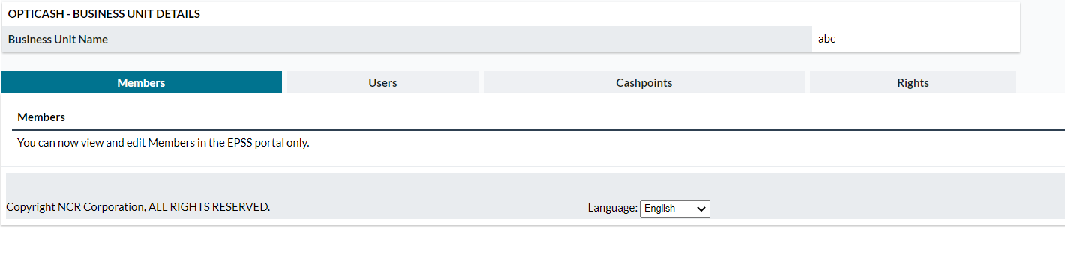

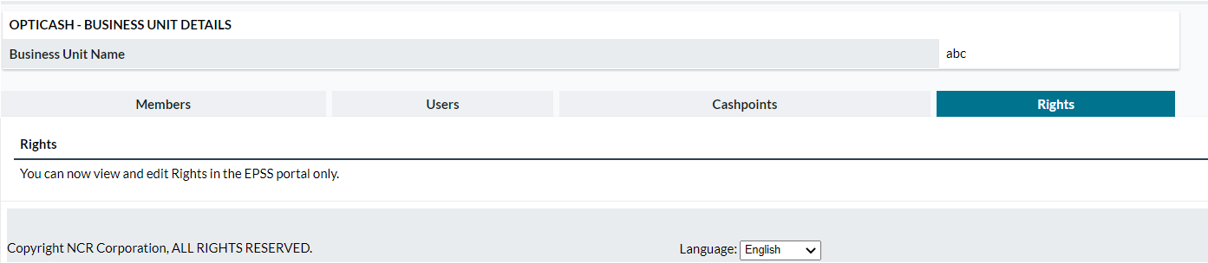

Return To: System Tab

Table 112: Business Units Field Descriptions

| In order to: | Follow these steps: |
| --- | --- |
| **Global Access/Restricted to Business Unit** | Select either. Global will give full access and privileges to all users. Restricted will limit to only the Associated Business Units. |
| **Assigned Business Units List** | Shows the Business Units given access if the administrator has selected “Restricted” access |
| **Available Business Units List** | Shows the Business Units not given access. |
| **Access Type** | Administrators can select either “**Edit**” access for full privileges or “**Use Only**” which grants Units the ability to utilize the functionality but not be able to edit or delete. |
| **Add** | When assigning Available Units, the user will check the box next to the Business Unit and then select “Add” to place the Unit in the Associated list. |
| **Close** | When all actions are completed, the User can select “**Close**” to close the window. |

Return To: System Tab

### Privileges→OptiNet Workflow Profiles

User Administrators can create Workflow Profiles for OptiNet Branch Users. Each profile can have 1 or more Workflow Tasks associated with it. See the Order Workflow Editing Description table for a complete listing of workflow tasks.

OptiNet Branch users are assigned a Workflow Profile and can perform only those Order Tasks defined in the profile. There is no limit to the number of OptiNet Workflow Profiles that can be created, and they can be edited from OptiCash as business needs change.

When reviewing or assigning Tasks to a profile, the associated tasks are listed on the left-side table of the Profiles page and the Available (unassociated) tasks are listed on the right side. Administrators can select individual or multiple tasks and Remove or Add them to update the profile.

**Note:** This functionality is removed in opticash and this is configured in EPSS.

Figure 133: Edit OptiNet Workflow Profiles Page

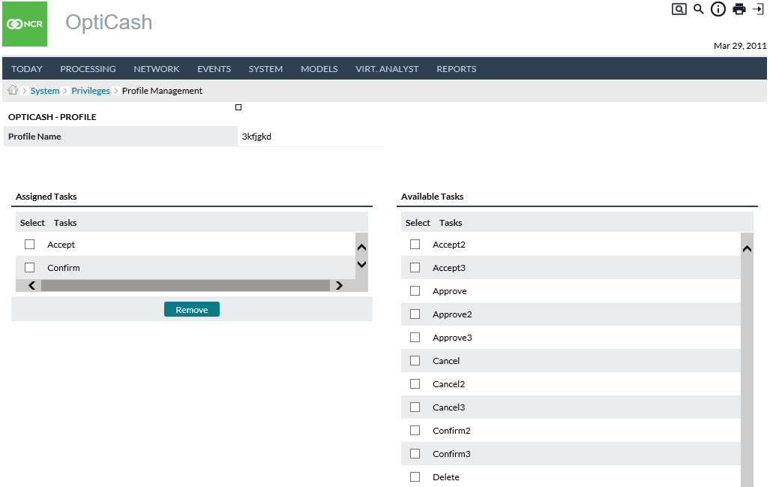

Return To: System Tab

## System→Currencies/Denominations Page

The Currencies/Denomination Tab allows the user to define the currencies and denominations that users will assign to Cashpoints so they are ordered and managed. The user has the option to configure Currencies, Denominations, Non-Cash Media, Foreign Exchange Rates, and Non-Optimized Currencies from this page by selecting the appropriate function from the dropdown box.

The following functions are covered in this section:

* Currencies/Denominations→Currencies Page
* Currencies/Denominations→Denominations Page
* Currencies/Denominations→Cash Qualities Page
* Currencies/Denominations→Foreign Currency Denominations Page
* Currencies/Denominations→Non-Cash Media Page
* Currencies/Denominations→Exchange Rate Page

Return To: System Tab

### Currencies/Denominations→Currencies Page

OptiCash is a multi-currency system. It allows the users to create different currencies and denominations for each one of the currencies so it can be managed for OptiCash at the Cashpoint level. OptiCash engine cased the recommendation process in preliminary historical analysis of the split, so the correct and precise definition of the currency will allow the user to manage Cashpoints from the process and reporting point of view.

Figure 134: Currencies Page

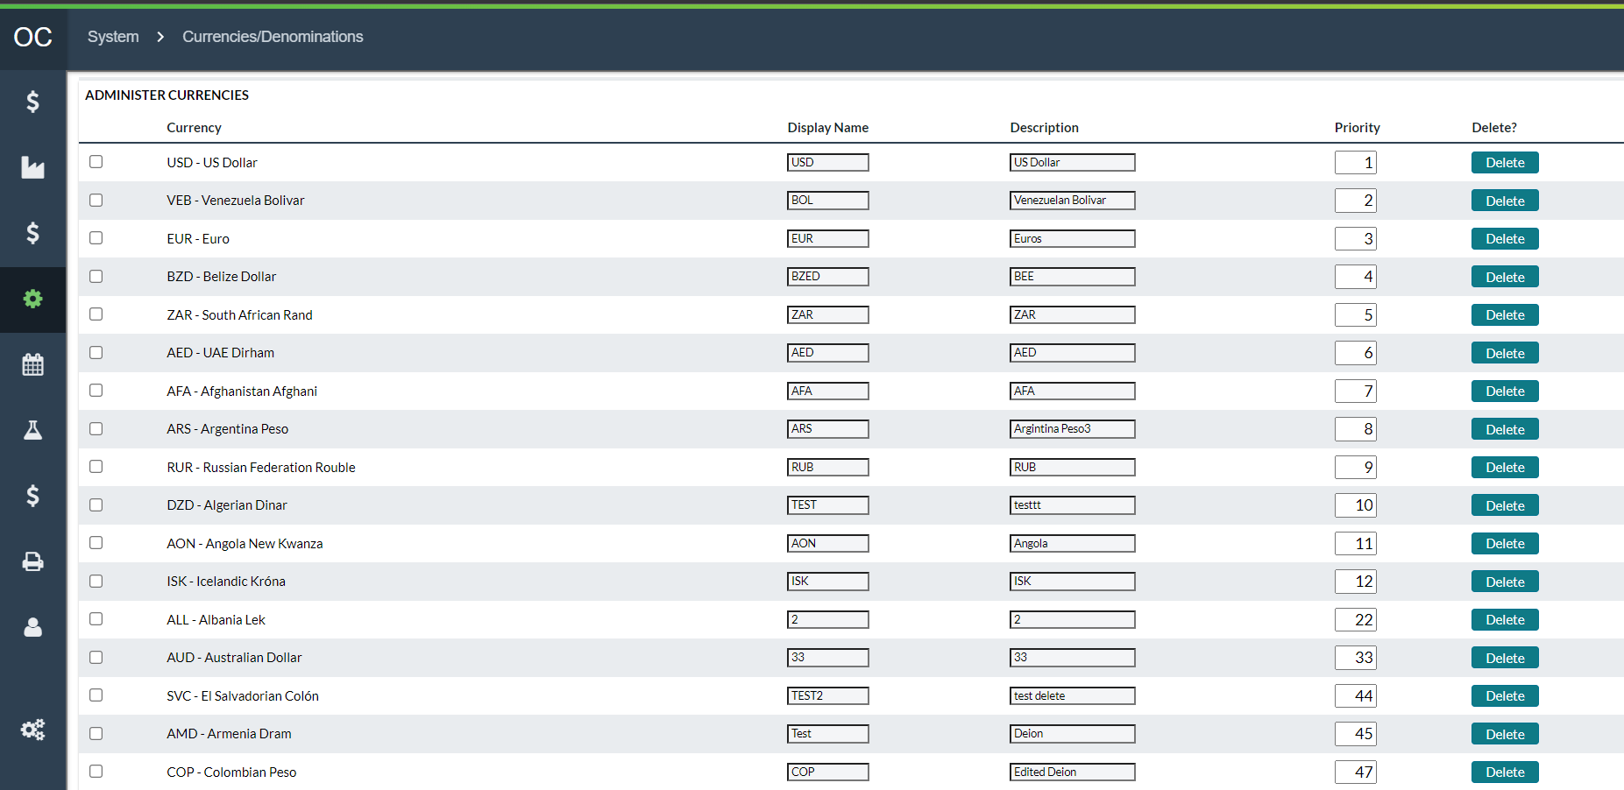

Table 113: Currencies Description

| Field | Description |
| --- | --- |
| **Display Name** | The display name will be used on all screens. |
| **Description** | Description of the currency. |
| **Priority** | A unique priority for the currency. The priority of the currencies defines the master/slave relationship for the currencies dispensed at the Cashpoint. The priority of the currency decreases as the numeric value of the priority increases. So, priority value of 1 is the highest and will be defined for the master currency. For any given Cashpoint recommendation process, its master currency drives the optimization/delivery parameters (refer to the example below for more on multi-currency synchronization). |
| **Multi-Currency Synchronization** | Currency priority identifies which currency is more important: master/ local/ dominant versus slave/ foreign/ recessive currencies. For example, in Switzerland, Swiss Franc (CHF, priority=1) may have a higher priority than Euro (EUR, priority=2). Therefore, CHF drives the delivery optimization, and any subsequent EUR deliveries should fall on the same service days of the CHF.  The currency priorities are defined by the bank institution and are applied across all Cashpoints in the network. However, sometimes there could be a case (e.g., an ATM along the border), where the demand for the slave currency (e.g., EUR) is greater than the master currency (e.g., CHF). In this case, the slave currency must drive optimization instead of the master (CHF) to avoid cash-out situations. This means that there may be days where EUR has a delivery but not CHF because the demand for the slave (EUR) is greater than the master (CHF) on a localized level.  Therefore, OptiCash will process recommendations considering the demand of both currencies and synchronize the priorities accordingly.  From a cost perspective, delivery costs are always associated with the master currency assuming that the delivery costs of a master and slave currency are the same and these costs are always reflected in the master currency for accounting/reporting purposes. |

### Currencies/Denominations→Denominations Page

The Denominations Page allows the user to setup the denominations that can be assigned to a Cashpoint for optimization purposes. To add a denomination, the base currency must first be defined. For additional information on currencies, see: Currencies/Denominations→Currencies Page

Figure 135: Denominations Page

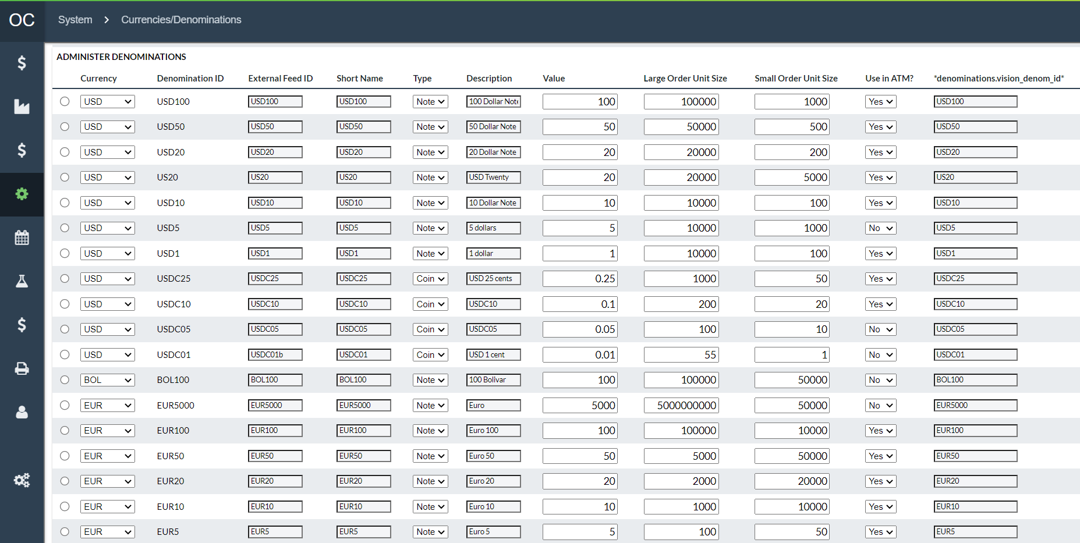

Table 114: Denominations Description

| Field | Description |
| --- | --- |
| **Currency** | Select currency from the drop-down list. |
| **Denomination ID** | Unique alphanumeric value for this denomination. |
| **External Feed ID** | The APTRA VISION Hourly ATM Data Feed process may refer in its input to this denomination by a different identifier. Enter that identifier here. |
| **Short name** | Alternate short description for this denomination. |
| **Type** | Select either Note or Coin. |
| **Description** | Complete description to uniquely identify this denomination. |
| **Value** | The numeric value for the denomination. Please note for coins, numbers with greater decimal points than 2 cannot be entered. Only 2 maximum decimal points are allowed (e.g., the US 1-cent coin with the value of $0.01 can be entered). |
| **Large Order Unit Size** | The large size value for the denomination. Found by multiplying the number of notes or coins in a specific package presentation by the value of the denomination. |
| **Small Order Unit Size** | The small size value for the denomination. Found by multiplying the number of notes or coins in a specific package presentation by the value of the denomination. |
| **Available for ATMs** | Select Yes or No depending on whether the corresponding denomination is available in the ATMs. |
| **Recycling ATMs:**  **Capacity (in Notes)** | The number of notes that can fit in each cassette for the denominations:  **Dispense –** The cassette that dispenses cash that is delivered by the carrier  **Recycler –** The cassette that dispenses cash that was previously deposited by customers  **Cash-In –** The cassette for notes that cannot be recycled. |

|  |  |
| --- | --- |
|  | **Caution:** If a denomination is already assigned to a Cashpoint, it is not possible to delete it. If you attempt to do this, you will receive a warning message. To proceed with the deletion, first, remove the denomination from the Cashpoint. |

Return To: System Tab

### Currencies/Denominations→Cash Qualities Page

OptiCash allows for System-level definitions of note quality. By defining cash quality branches can supply more detailed information to the vault network. Cash Quality designation is possible for all cashpoint Order types.

Quality is defined at the system level meaning that different note qualities cannot be assigned on an individual cashpoint level. Users can load any denomination quality in a cashpoint’s balance as long as that denomination is assigned to the cashpoint and the quality exists at the institution level.

Figure 136: Cash Quality Page

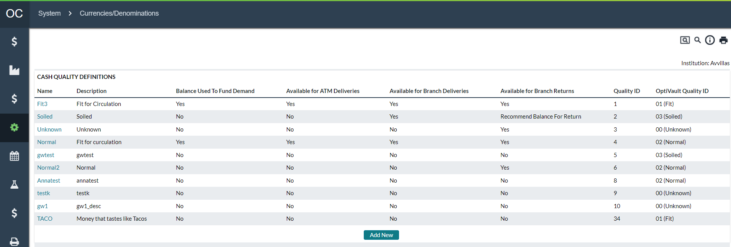

Return To: System Tab

Table 115: Cash Quality Definitions Field Descriptions

| Field | Description |
| --- | --- |
| **Name** | Name assigned by OptiCash Analysts for each note quality required. (Values in the field are hyperlinked to be able to access and edit the existing definitions). |
| **Description** | A detailed description of each note's quality |
| **Balance Used to Fund Demand** | Pre-set selection of Yes or No. When Yes is selected, notes of this quality can be used to fulfil customer demand. This means that the cashpoint’s Horizon balances will include only qualities where this is yes |
| **Available for ATM Deliveries** | Global setting for all ATMs. This field designates where the cash of this quality can be specified when ordering cash deliveries for ATMs |
| **Available for Branch Deliveries** | Global setting for all Branches. This field designates where the cash of this quality can be specified when ordering cash deliveries for Branches. |
| **Available for Branch Returns** | Global setting for all Branches. This field designates if the cash quality type can be specified for branch currency returns (from branch to vault/funding source). This setting has three options: Yes, No, and Recommend for Branch Returns. When the 3rd option “Recommend for Branch Returns” is selected, OptiCash will make every attempt to get rid of this balance of cash when recommending a return. |
| **Quality ID** | This is a unique identifier of quality. |
| **OptiVault Quality ID** | When used, OptiVault is limited to 4 pre-determined qualities. OptiCash will allow the assignment of as many qualities as required. If OptiVault is used and utilizing reports from OptiCash this field allows for the mapping of OptiCash qualities to one of the 4 OptiVault qualities. |

New qualities can be added by selecting “**Add New**” at the bottom of the Cash Qualities screen. Users simply complete each field and select “**Save**”.

Users can also edit existing qualities by selecting the hyperlinked Quality Name, making the edit(s), and selecting “**Save**”. For details regarding fields on the New/Edit screen see the Cash Quality Description table.

Figure 137: Cash Quality Add/Edit Page



Return To: System Tab

### Currencies/Denominations→Foreign Currency Denominations Page

This feature is only visible when licensed. For more information, or to license this feature, please contact your local NCR Cash Management representative.

OptiCash is a multi-currency system. It allows the users to create different currencies and denominations to be managed at the Cashpoint level. Usually, the main local currency and, in some instances, foreign currencies that represent enough volume in history are included in the OptiCash optimization process. Such currencies are optimized currencies, for which history is loaded, definitions are maintained and processes such as forecasting, and recommendation are run.

However, some banks may be ordering foreign currencies that are not included in the optimization process due to their low volume and orders for such currencies are placed based on the specific needs of each branch. The foreign currency ordering module allows branches to decide how many foreign currency denominations to order and place such orders via OptiCash and/or OptiNet.

Figure 138: Foreign Currency Description

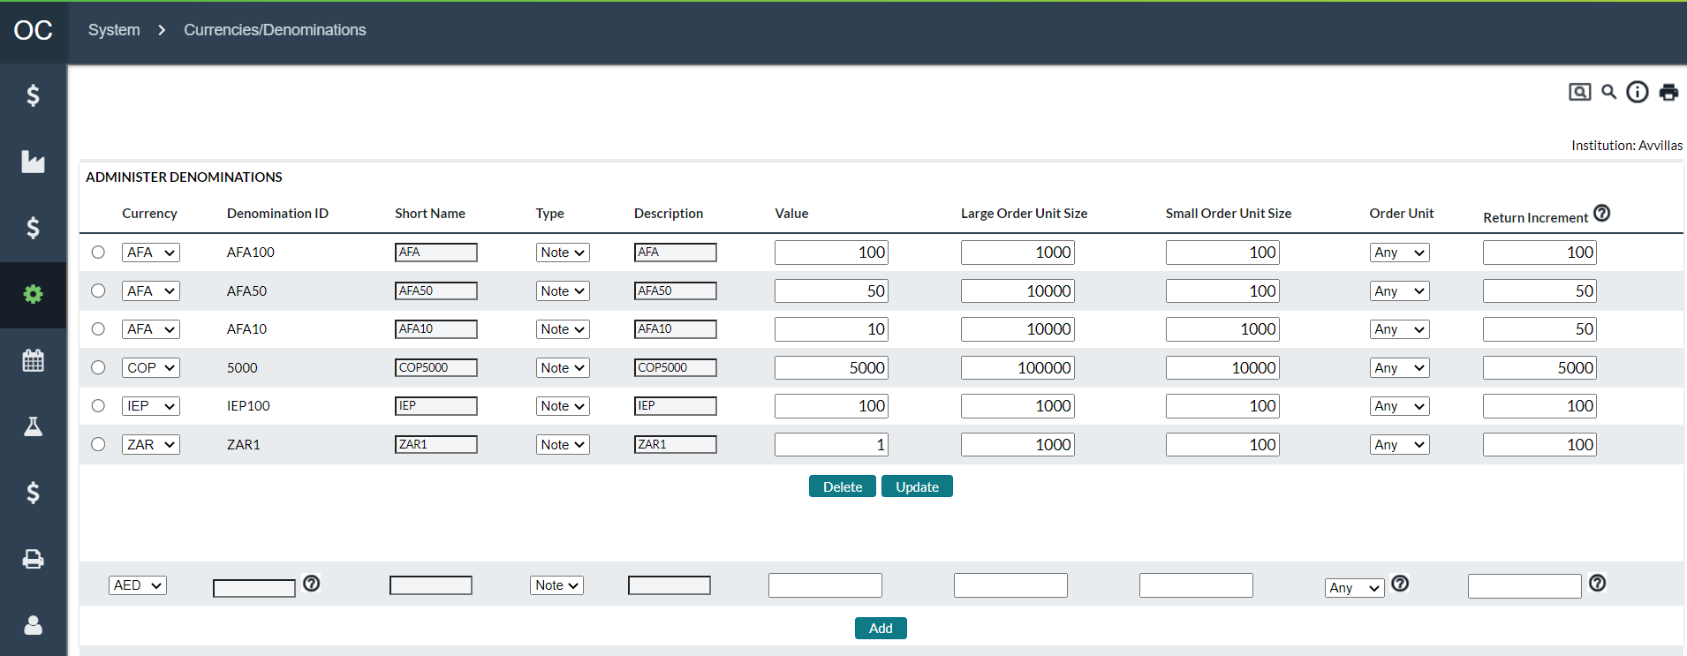

Table 116: Foreign Currency Description

| Field | Description |
| --- | --- |
| **Currency** | Select currency from the drop-down list. |
| **Denomination ID** | Unique alphanumeric value for this denomination. |
| **Short name** | Alternate short description for this denomination. |
| **Type** | Select either Note or Coin. |
| **Description** | Complete description to uniquely identify this denomination. |
| **Value** | The numeric value for the denomination. |
| **Large Order Unit Size** | The large size value for the denomination. Found by multiplying the number of notes or coins in a specific package presentation by the value of the denomination. |
| **Small Order Unit Size** | The small size value for the denomination. Found by multiplying the number of notes or coins in a specific package presentation by the value of the denomination. |
| **Order Unit** | Denomination package size: Large, Small or Any.  This is a mandatory field, which determines which unit size is used as a minimum order amount for that denomination in the recommendation process. In addition, this setting is used in the order detail entry screen for validation to make sure amounts for each denomination do not fall below the minimum order unit size. |
|  | **Note** By selecting Any in the Order Unit field, the recommendation process and order entry screens will use denomination value as a minimum order amount. |
| **Return Increment** | While Order units are used for deliveries, return increments are used for branch returns only. Amount entered here will determine the minimum amount to be ordered for branch returns.  **Note** Return Increments will only be used for OptiNet order screens for branch users. OptiCash order detail screens will not validate against order unit sizes as defined above.  In addition, for foreign currency return increments to work in OptiNet screens, return increments for optimized currencies has to be turned on in OptiNet by OptiNet Administrator. |

### Currencies/Denominations→Non-Cash Media Page

OptiCash provides an ability to manage non-cash media, e.g., postage stamps, movie/event tickets, travel tickets, etc. that are available at a Cashpoint. In such cases, when the carrier services a Cashpoint, non-cash media will also be delivered to a Cashpoint on the same trip. When non-cash media is defined for a Cashpoint, OptiCash recommendation will include the standard order amount for this media. Non-cash media can be mass-assigned to Cashpoints under the System tab.

Figure 139: Non-Cash Media Page

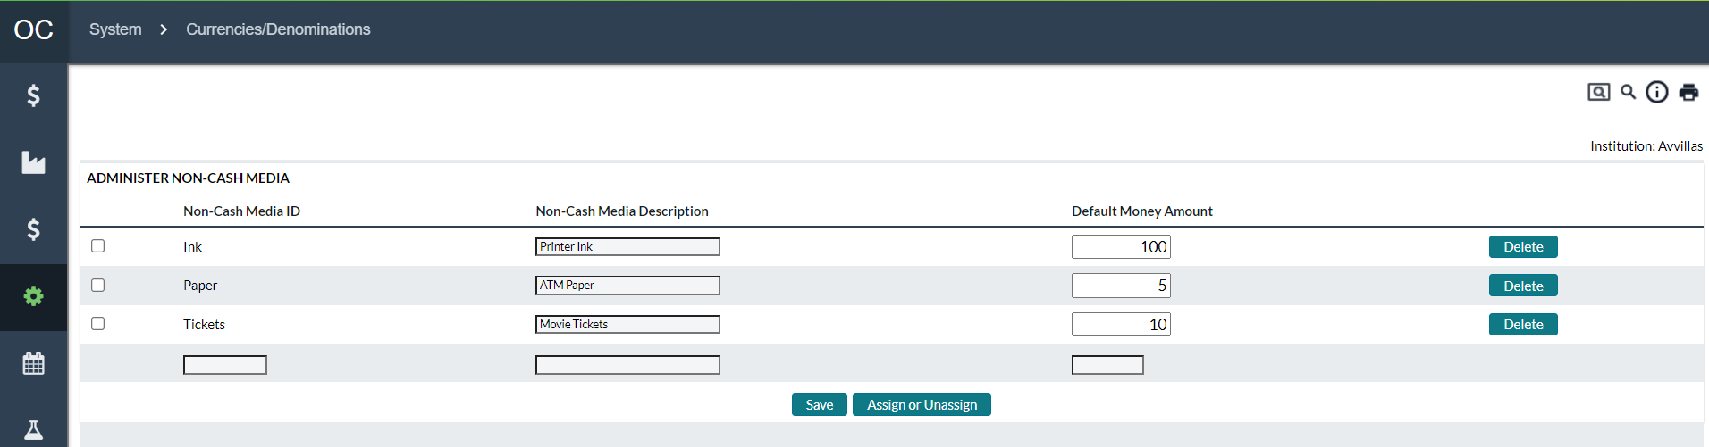

Table 117: Non-Cash Media Description

| Field | | Description | |
| --- | --- | --- | --- |
| **Non-Cash Media ID** | | Unique alphanumeric value for identification of this Media. | |
| **Non-Cash Media Description** | | Description of Non-Cash Media. | |
| **Default Money Amount** | | The default order amount of the Non-Cash Media. This amount can be changed at the Cashpoint level. | |
| **Delete Button** | | Deletes the corresponding Non-Cash Media entry.  **Note**: Non-Cash Media entries can only be deleted if they are not assigned to a Cashpoint. | |
| **Save Button** | | Adds or Saves changes to an existing Non-Cash Media Entry  **Update Entries -**  Entries can be updated by changing the editable values and selecting the checkbox on the right. Clicking the save button will save changes for any item which a check next to it.  **New Entries** – New entries are created by filling out the empty fields at the bottom of the list (Non-Cash Media, Description, and Default Amount). Clicking the Save button will add the new entry to the list. | |
| **Assign or Unassign Button** | | Selected media can be assigned to the Cashpoints by clicking on this button.  Once clicked, the Cashpoint Selection Pane will appear and allow the user to select Cashpoints and either Assign or Unassign the Non-Cash Media. | |
|  | **Note:** When a recommendation with Non-Cash media is generated, order amounts for the media cannot be edited in the OptiCash/OptiNet recommendation detail screen. The standard order amount will always be used in each recommendation as defined in the ‘Default Money Amount’ field. | |

### Currencies/Denominations→Exchange Rate Page

When working in a Multi-Currency environment, the recommendation process must consider the exchange rate between different currencies to make accurate decisions on which currencies to prioritize and optimize as well as calculate costs. The Currency Exchange Rate can be set daily if necessary.

**Note**: If exchange rates are changed for days in the past, it is best to re-calculate Actual Costs to ensure the figures are correct.

Figure 140: Exchange Rate Page

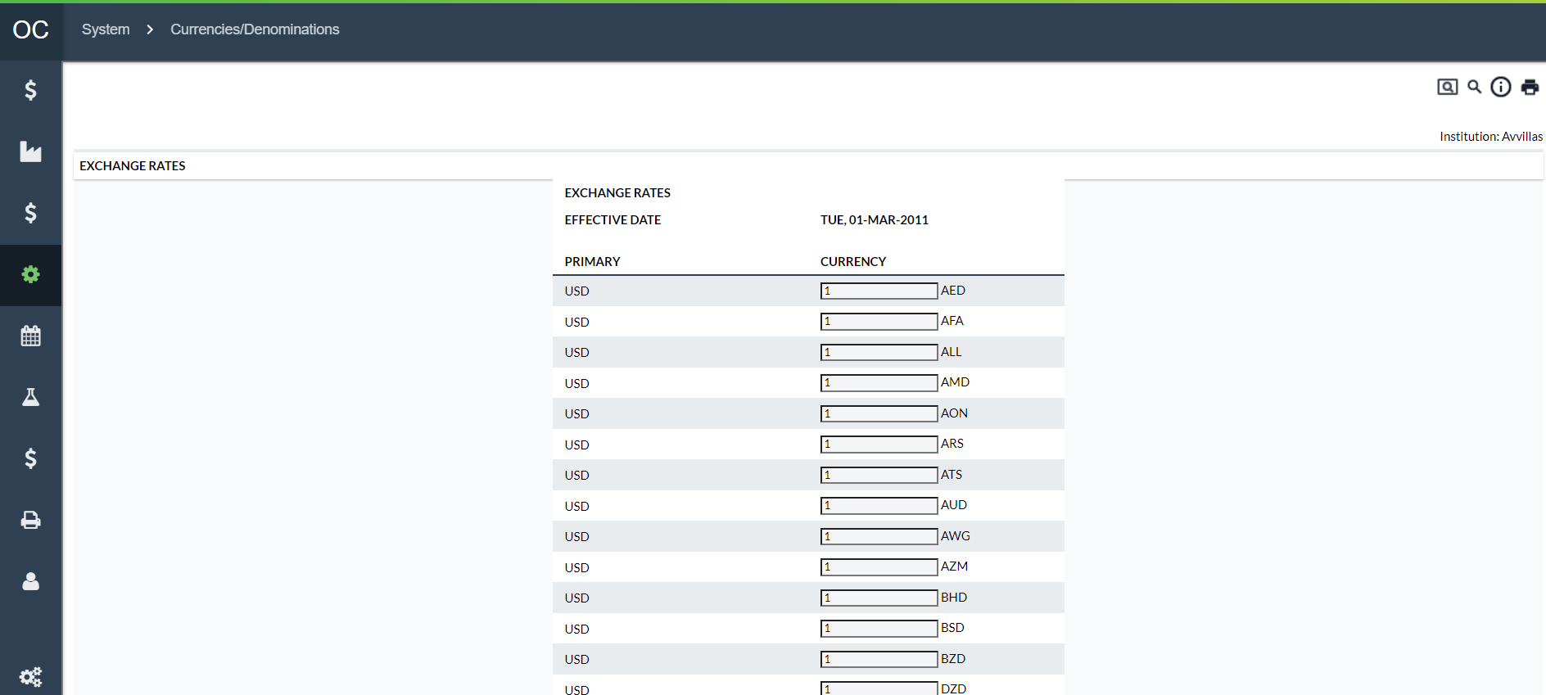

Table 118: Exchange Rate Description

| Field | Description |
| --- | --- |
| **Save Button** | Saves the Entry |
| **Cancel Button** | Cancels the function without saving |
| **Delete Button** | Deletes the currently displayed entry |
| **Primary** | The Primary Currency defined in the system |
| **Currency** | The Currency for which the rates are being defined |
|  | **Note**: The main currency should always be set to 1 |

### Currencies/Denominations→Interest Rates

Currency interest rates fluctuate over time, and it may be necessary to perform reporting or modelling based on different rates for their respective historical periods. Under the Interest Rates, page users will set currency interest rates using a start date. Thus, OptiCash retains the interest rates that were in effect for historical periods. This enables more accurate historical reporting as the cost will reflect any differences in interest rates over different periods.

**Note**: If exchange rates are changed for days in the past, it is best to re-calculate Actual Costs to ensure the figures are correct.

Figure 141: Interest Rate Page

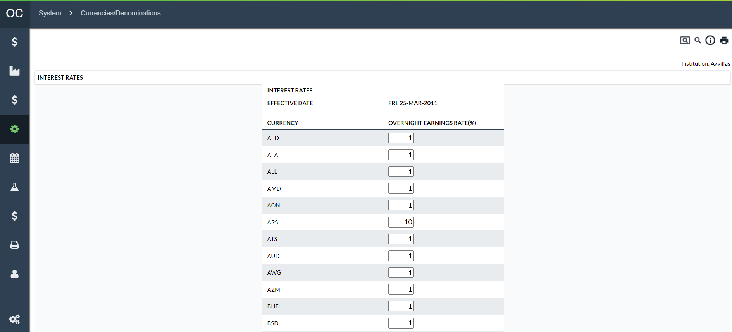

Table 119: Interest Rate Description

| Field | Description |
| --- | --- |
| **Save Button** | Saves the Entry |
| **Cancel Button** | Cancels the function without saving |
| **Delete Button** | Deletes the currently displayed entry |
| **Currency** | The Currency for which the rates are being defined |
| **Overnight Earnings Rate (%)** | The rate of return available funds will earn or the opportunity cost of maintaining excess cash in the branch or ATM. This should be an annualized rate. |

### Currencies/Denominations→Inner Wallet Types

OptiNet users can create Return Orders in OptiCash that allow the OptiCash users and the depot to know the amount of cash being returned in the upcoming service. An enhancement on these types of return orders is the ability for Branch users to notify the Depot and OptiCash users of branch returns. These returns could be commercial deposits, excess cash, or other types of items that may need to be returned such as documents, tickets, etc.

For the OptiNet user to enter these types of returns, an Inner Wallet Type needs to be created in OptiCash. Once created in OptiCash, the OptiNet users will have access to these types to create Pre-Notification Orders.

Figure 142: Inner Wallet Type Page

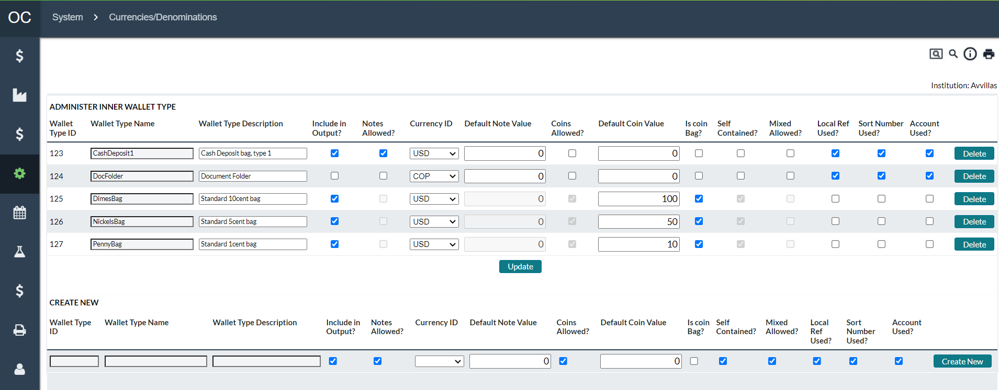

Table 120: Inner Wallet Description

| Field | Description |
| --- | --- |
| **Wallet Type ID** | Unique alphanumeric code that identifies the Wallet Type.  The Wallet Type ID can be a maximum of 12 digits. It must not contain any spaces between the characters nor should it contain special characters (‘{[]}|~`!@#$%^&*)”.The software will give an error message if the user tries to enter an invalid character. |
| **Wallet Type Name** | The name given to the Wallet Type. This name will be displayed in reports, and in the OptiNet user interface as the displayed name of the Wallet. The Wallet Type Name is limited to 40 characters. |
| **Wallet Type Description** | The description of the Wallet Type. This can be used for further explanation of the Wallet Type in case the Wallet Type Name is not sufficient for a proper explanation. The Wallet Type Description is limited to 80 characters. |
| **Include in Output** | An option that is used to indicate if the wallet type will be included in output reports. |
| **Notes Allowed** | The option used to indicate if this type of wallet can contain notes |
| **Currency ID** | This is the currency selected by default for this wallet type. OptiNet users may select from all available currencies when entering specific wallets, but the currency selected here will be the one shown initially. |
| **Default Note Amount** | If a wallet type is likely to contain a certain amount, then it can be entered here. OptiNet users will be able to change the amount when entering specific wallets, but the amount entered here will be shown initially. |
| **Coins Allowed** | The option used to indicate if this type of wallet can contain coins |
| **Is Coin Bag** | The option is used to indicate if this wallet type represents coin bags. Coin bags go through a slightly different workflow in OptiNet, see the **OptiNet User Guide** for more details. |
| **Self Contained** | The option is used to indicate if wallets of this type are self-contained. Self Contained means that instead of 2 layers of containers – Outer Bag and Inner Wallet – the inner wallet functions without an Outer Bag. |
| **Mix Allowed** | The option is used to indicate if wallets of this type can be placed in Mixed Bags. Mixed Bags are outer containers that contain more than 1 type of Inner Wallet. |
| **Local Ref Used** | The option is used to indicate if OptiNet users should be offered the Local Reference field when entering wallets of this type. |
| **Sort Number Used** | The option is used to indicate if OptiNet users should be offered the Sort Number field when entering wallets of this type. |
| **Account Used** | The option is used to indicate if OptiNet users should be offered the Account Number field when entering wallets of this type. |
| **Delete Button** | Deletes the adjacent Wallet Type |
| **Update Button** | Updates any changes made to the currently defined and displayed Wallet Type IDs. It is not necessary to select a particular Wallet Type ID to update as this button will update all changes made to the Wallet Type Name or Description |
| **Create New Button** | Adds a new Inner Wallet Type ID to the list. To create a new Inner Wallet ID, a unique Wallet Type ID, Name, and Description must be defined. Any missing values will cause an error and the user will be prompted to enter the missing information. |

## System→Order Settings Page

The Order Settings page is used to set up parameters and processes related to the processing of orders by analysts and branch users.

The following functions are covered in this section:

* Order Settings→Override Reasons
* Order Settings→Order Workflow
* Order Settings→Order Custom Field Definitions
* Order Settings→Custom Field to Order Linkage

Return To: System Tab

### Order Settings→Override Reasons

Override reasons are used during the ordering process to explain why a manual order was created or why a recommendation was overridden or edited. Users can specify any number of Override Reasons on this page; however, it is required that at least one Override reason is defined as it is required for use with Manual, Overridden, and Edited orders.

Figure 143: Instituion Page

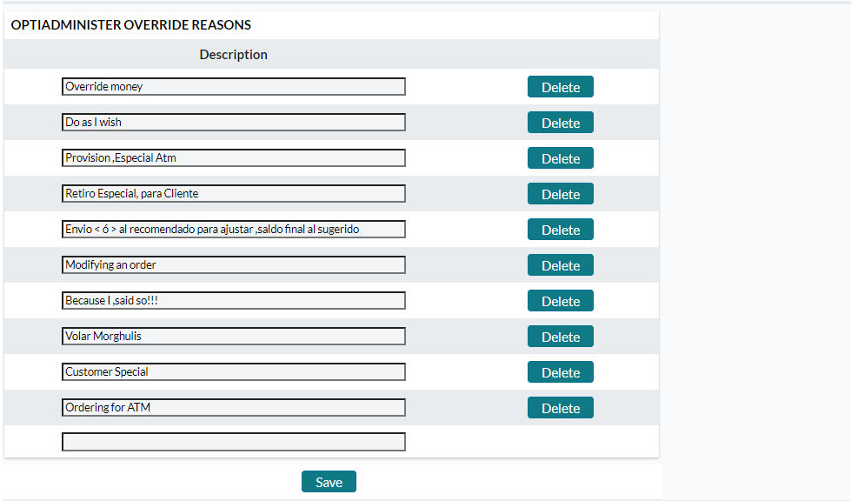

Table 121: Institution Description

| Fields | Description |
| --- | --- |
| **Save Button** | Saves the information on the page. If a new override reason was specified, it will save that entry as well. |
| **Cancel Button** | Cancels any changes that were made on the page it refreshes the page with the original information. |
| **Delete Button** | Deletes the override reason in the field adjacent to the button. |

### Order Settings→Order Workflow

Order Workflow functionality tracks the status of orders from creation to fulfilment and confirmation. If Order Workflow is not licensed, standard OptiCash Order Workflow will apply and access to the Workflow Editor will be disabled.

An Order Workflow consists of States that an order can be in at a given time, and Tasks or actions that can be performed from a given State. In the example diagram below, black text in bubbles is States, while red text next to arrows represents Tasks. For instance, Orders can be ‘**Ordered’** by Branch users but a regional supervisor has to ‘Approve’ the order before it goes on to be transmitted to the carrier.

Workflows can be uniquely defined for ATM Add, ATM Replace, ATM Emergency Add, ATM Emergency Replace, Branch Delivery, Branch Return, Branch Emergency Delivery, Branch Emergency Return, Branch to Branch Transfer, Commercial Client Delivery, and Commercial Client Return.

Figure 144: Example of an Order Workflow

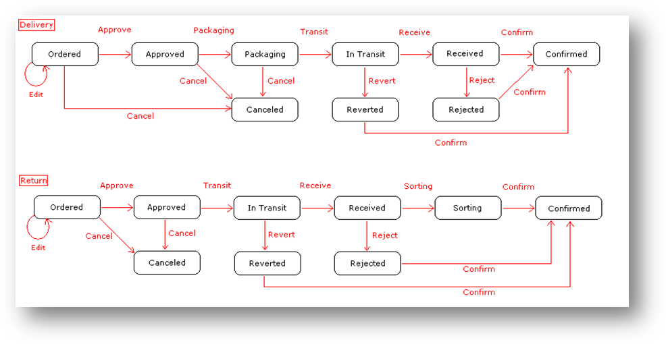

Figure 145: Order Workflow Page

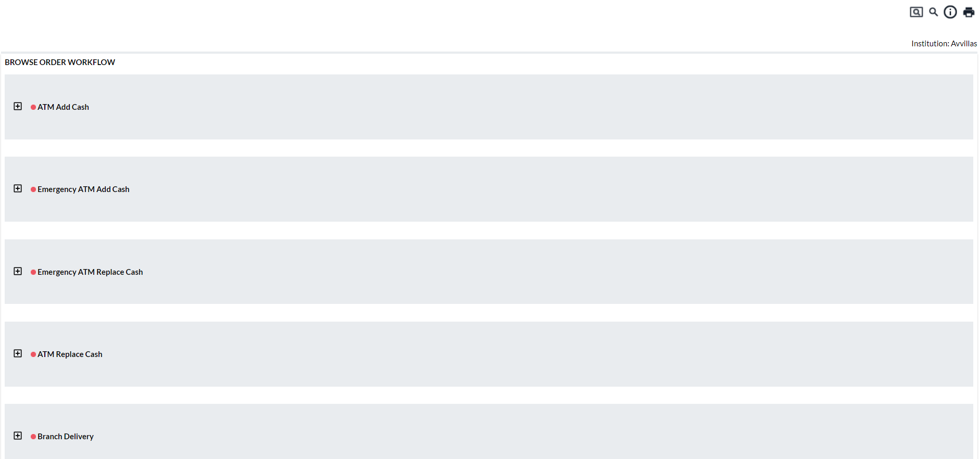

Table 122: Order Workflow Description

| Fields | Description |
| --- | --- |
| **Browse Order Workflow** | **Order Types –** Each order type is listed in the Order Workflow list. Clicking on the **‘+**’ icon will expand the States, Tasks, and New States for each order type.  **States –** Describes the current State of the order. This means that when the order is in a particular state, the Tasks and New States are available below the specified state. Clicking on the **‘+**’ icon for a State will expand the available Tasks and New States assigned to the workflow.  **Tasks –** Tasks are the actions that can be taken for the order at a particular state. The Task selected will move the order into the associated ‘New State’  **New States –** This is the State that the order will be in once the Task has been selected during the order workflow. |
| **Edit Workflow Button** | Clicking on this button will enter a new page where the user can select the order type from a list to be edited. This process can be simplified by expanding desired order type from the list and clicking on one of the states listed. |

### Order Workflow Editing

Orders workflow can be edited by selecting one of the ‘**Order States’** from the Browse Order Workflow page or by clicking on the **‘Edit Workflow’** button and selecting the appropriate order type.

Figure 146: Order Workflow Editing Page

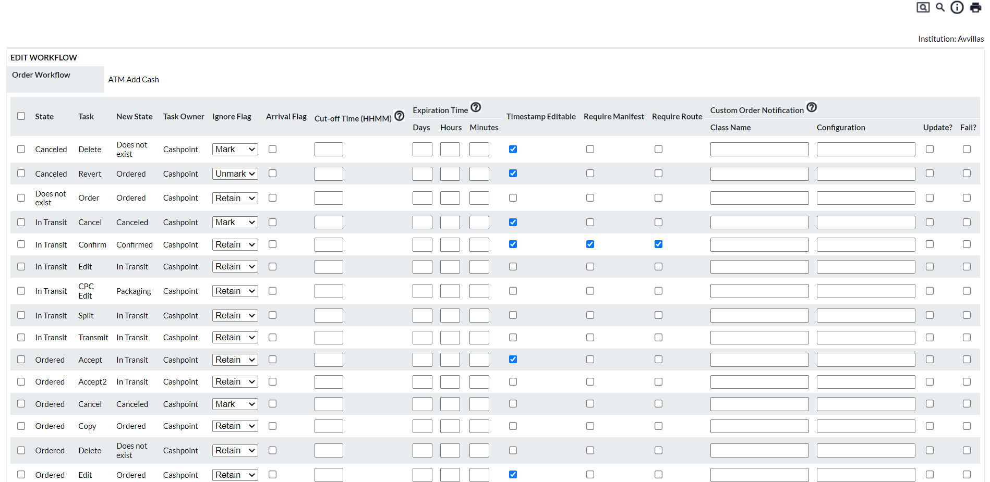

Table 123: Order Workflow Editing Description

| Fields | Description |
| --- | --- |
| **Checkbox** | Allows the user to select the item for which the Update or Delete buttons will apply |
| **Update button** | Saves any changes made to the selected item(s) in the list. |
| **Delete button** | Deletes any item(s) selected in the list.  **NOTE**: The State **‘Does not exist’** cannot be deleted as this is a default system State. |
| **Add Task to Workflow button** | Allows the Analyst to Add an Order Task to the Order Workflow. |
| **State** | Indicates the current State of the order; this means that when an order for the associated order type is this state, then the adjoining ‘**Task’** and resulting **‘New State’** will be available (depending on permissions). |
| **Task** | The Task is what will be displayed to the user in the form of a button on the Order Page. The Tasks available for the assignment are:   * **Accept, Accept2, Accept3 –** Accepts the Order * **Approve, Approve2, Approve3 –** Approves the Order * **Cancel, Cancel2, Cancel3 –** Cancels the Order * **Confirm, Confirm2, Confirm3 –** Confirms the Order * **Delete, Delete2, Delete3 –** Allows the Order to be deleted * **Edit, Edit2, Edit3 –** Allows for the editing of an order * **Order –** Analysts place the order * **Reject, Reject2, Reject3 –** Rejects the Order * **Revert, Revert2, Revert3 –** Reverts the Order * **Open Dispute, Open Dispute2, Open Dispute3 –** Begins a dispute * **Update Dispute, Update Dispute2, Update Dispute3 –** Change details of a disputed order * **Resolve Dispute, Resolve Dispute2, Resolve Dispute3 –** Marks a disputed order as having been resolved   Those tasks that have more than one entry i.e., Approve, Approve2, Approve3 are provided to give flexibility around permissions as well as cut-off times for certain functions. This is also because it may be the case that multiple people will have to Approve an order before it goes to the next State.  Some of the tasks have several new States that can be assigned to them; **for example**, Approving an order can lead to Approved, In Transit, Ordered, etc. Other states such as Delete have only one option which is “**Does Not Exist”**  **NOTE**: Certain Tasks have an effect other than changing the State of the order these include:   * **Delete –** Deletes the order * **Edit** tasks allow users to change certain fields regarding an Order (denominations, amounts, etc.) * **Order -** A special task referring to the creation of Orders. * **Transmit -** Transmit tasks represent the Orders Output function. The Orders Output will include only those orders currently in a State for which a Transmit task is defined starting in that State. * **Open Dispute** allows users to enter disputed amounts of an already delivered order. If the order has previously been disputed and resolved, then the dispute is reopened. * **Update Dispute** allows the user to update dispute amounts. * **Resolve Dispute** resolves the dispute and updates the order amount with info from the dispute. |
| **New State** | This is the State the Order will be in after the user accomplishes the ‘**Task’** (in other words clicks on the ‘**Task’** button in the Order) |
| **Task Owner** | Workflow Administration Users select either “**Cashpoint**” or “**Funding Source”.** Selecting **“Cashpoint**” means that the cashpoint receiving the cash must complete that Workflow Task. Selecting “**Funding Source**” means that the sending cashpoint must complete it. |
| **Ignore Flag** | Users select between “**Mark**”, “**Unmark**”, and “**Retain**”  **Mark**: Tells OptiCash that the Order will not arrive if the associated Task occurs  **Unmark:** Tells OptiCash to again consider the Order to be received or going to be received if it was Marked not to arrive in the prior State  **Retain**: Tells OptiCash to keep whatever “**Ignore Flag**” status was in place with the prior order State |
| **Arrival Flag** | Indicates whether this task means the order has physically arrived at its destination. The “Arrival” function in CarrierWeb mobile will trigger this action. |
| **Cut Off Time** | The time in ‘**HHMM’** format that the user has to accomplish the Task. After this time has elapsed, the branch user will no longer have the ability to perform the task. |
| **Expiration Time** | The amount of time that the task is valid. This means the user has a soft cut-off time. They are still able to process the orders, but any expired tasks performed will be flagged to the OptiCash Analyst.  Tasks can be processed in days, hours, and minutes with any combination in between (i.e., 2 days and 1 minute) |
| **Timestamp Editable** | Indicates whether the timestamp recorded when this Task is executed can be changed afterwards. For example, if a cash delivery arrives at a branch at 10:00, but the branch staff takes the action of “**Receive**” task at 13:00, then editing “**13:00**” to “**10:00**” would be appropriate. |
| **Require Manifest** | Indicates if the system should require that an order manifest exist before this Task can be executed. |
| **Require Route** | Indicates if the system should require that a Route Plan exist for this order before this Task can be executed. |

Return To: System→Order Settings Page

### Order Settings→Order Custom Field Definitions

Order Custom Fields can be used in many ways to allow analysts to collect data for orders that are not available on the standard order pages.

Ten custom fields are available and can be activated or deactivated as necessary for one type of cashpoint or all cashpoint types.

Figure 147: Order Custom Field Definitions Page

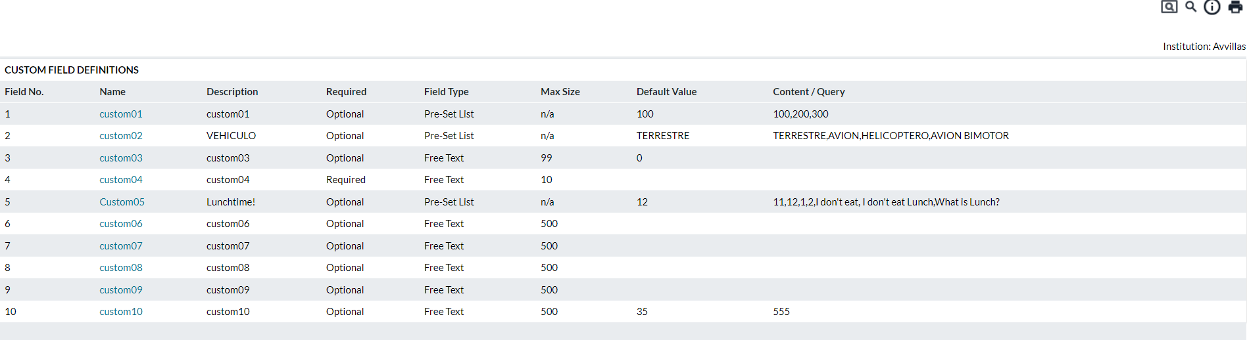

Table 124: Order Custom Field Definitions Description

| Fields | Description |
| --- | --- |
| **Field Number** | Indicates the Order Custom Field ID |
| **Name** | Indicates the Name of the Order Custom Field. This will be what is displayed to the user on the order pages. |
| **Description** | Describes what the Order Custom Field is for. These fields will not be displayed on the order pages. |
| **Required** | Indicates the status of the Order Custom Field:   * **Inactive –** Not in service for any cashpoints * **Optional –** Is an optional field that does not have to be specified * **Required –** Requires that the value be specified to complete the order |
| **Field Type** | Indicates the type of Custom Field being specified:   * **Free Text –** Provides a field for users to type any information necessary to communicate to the analyst. This text field allows any information to be displayed up to the maximum size specified. * **Pre-set List –** Displays a list that users can choose from. This list is defined in the Content/Query field as a comma-separated list. * **SQL Query –** Displays a list of information (similar to Pre-set List but automatically populated from an SQL query.) Queries can only be set up by an administrator. |
| **Max Size** | Indicates the maximum size of the field for Free Text fields |
| **Default Value** | Indicates the information that should be in the field by default. |
| **Content / Query** | Indicates the content (comma-separated list) or SQL query that is to be used to populate the options. |
| **Editing Values** | Clicking on any of the Custom Field Name hyperlinks will take the user to the editing page to allow for the editing of the custom field. |
| **Save button** | Saves changes made during editing. |
| **Cancel button** | Cancels any changes made to the Order Custom Fields |

### Order Settings→Custom Field to Order Linkage

To allow Order Custom Fields to apply to a particular type of order and/or cashpoint type, the Order Custom Fields can be associated with the applicable cashpoint and order types.

Figure 148: Custom Field to Order Linkage Page

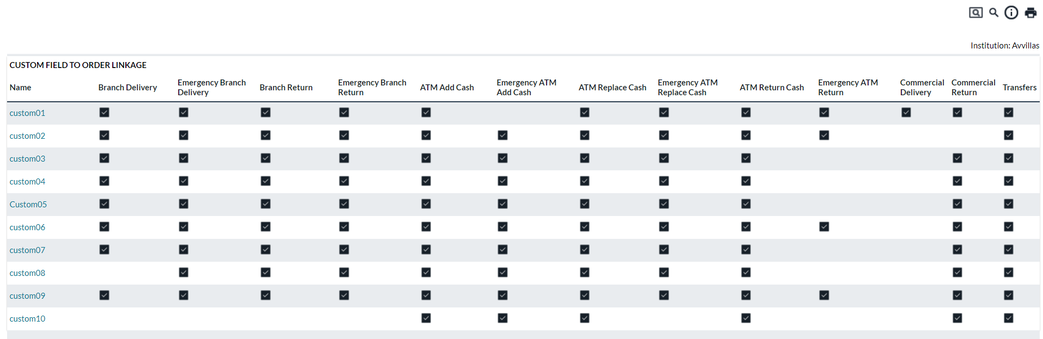

Table 125: Custom Field To Order Description

| Fields | Description |
| --- | --- |
| **Name** | Indicates the Name of the Order Custom Field as defined on the Order Custom Field Definition Page |
| **Save button** | Saves changes made during the editing process |
| **Cancel button** | Cancels any changes made during the editing process |
| **Editing Linkage** | To edit the linkage for an Order Custom Field, click on the Name hyperlink to access the parameters. |

Return To: System→Order Settings Page

1. System→Maintenance Page

The Maintenance Page allows users to perform system maintenance functions for OptiCash and Cashpoints. The user must select the desired option from the dropdown list to access the maintenance option. Most tasks should only be performed by system administrators or a user who is experienced in the system operations. Keep in mind that changes made to data in OptiCash are permanent and cannot be undone once they are committed.

The following functions are covered in this section:

* System→Maintenance→Cashpoint Maintenance
* Cashpoint Maintenance→Copy Cashpoint
* Cashpoint Maintenance→Rename Cashpoint
* Cashpoint Maintenance→Delete Cashpoint
* Cashpoint Maintenance→Activate/Deactivate Cashpoints
* System→Maintenance→Copy History
* System→Maintenance→Purge Data
* System→Maintenance→Include/Exclude History
* System→Maintenance→JDBC→Table Cleaning
* System→Maintenance→ATM Side-by-Side Cluster Aggregation
* System→Maintenance→Update Pre-service Amount
* System→Maintenance→Export Cashpoints

Return To: System Tab

## System→Maintenance→Cashpoint Maintenance

The Cashpoint Maintenance is used to manage Cashpoints and maintain the system. It allows the users to copy, rename, activate, deactivate, and delete Cashpoints. The following functions are covered in this section:

* Cashpoint Maintenance→Copy Cashpoint
* Cashpoint Maintenance→Rename Cashpoint
* Cashpoint Maintenance→Delete Cashpoint
* Cashpoint Maintenance→Activate/Deactivate Cashpoints
* System→Maintenance→Copy History

Return To: System→Maintenance Page

#### Cashpoint Maintenance→Copy Cashpoint

A Cashpoint can be copied to a new Cashpoint or an existing Cashpoint. This function can be used to create an identical Cashpoint with the same definition, parameter and denomination settings, the same service days, etc. This function is useful when defining side-by-side Cashpoints or Cashpoints that are in the same area. When copying a Cashpoint, most data and parameters are copied, but not recommendations and orders.

Figure 149: Cashpoint Copy Page

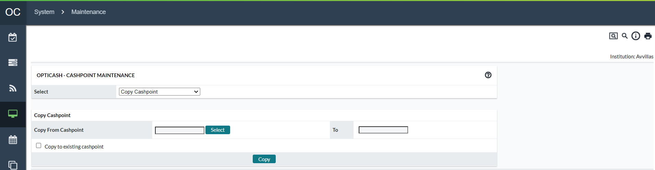

Table 126: Cashpoint Copy Description

| Field | Description |
| --- | --- |
| **Copy from Cashpoint** | Select the Cashpoint from which the data will be copied. |
| **To** | Enter the name of the new Cashpoint to which the data will be copied or check the box below to select an existing Cashpoint. |
| **Copy to Existing Cashpoint** | Check the box if the data will be copied to an existing Cashpoint. When the box is checked, a new field will appear allowing you to select the existing Cashpoint. |

Return To: System→Maintenance→Cashpoint Maintenance

#### Cashpoint Maintenance→Rename Cashpoint

The Cashpoint maintenance also allows renaming Cashpoints if the user needs to do so. Remember that at this level, only the Cashpoint ID can be renamed. Renaming other definition settings such as Cashpoint name, address, etc. is possible at the Cashpoint level in the Cashpoint definition window, under the Basic tab.

Figure 150: Rename Cashpoint Page

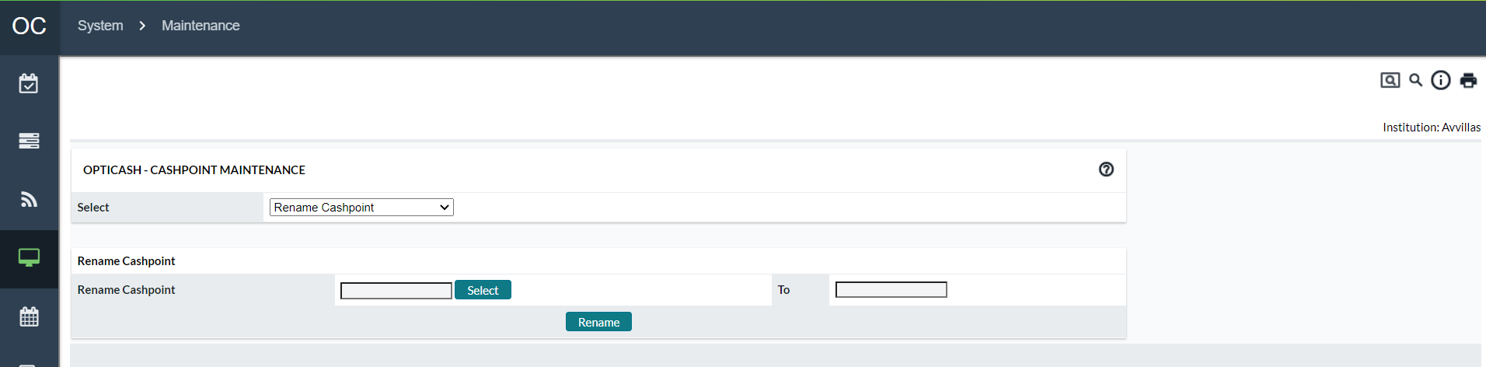

Table 127: Rename Cashpoint Description

| Field | Description |
| --- | --- |
| **Select Button** | Select the Cashpoint that will be renamed. |
| **To** | Enter the Cashpoint ID that the Cashpoint will be referred to. |
| **Rename Button** | Executes the renaming process. |

Return To: System→Maintenance→Cashpoint Maintenance

#### Cashpoint Maintenance→Delete Cashpoint

Deleting a Cashpoint will delete this Cashpoint from the network with all its data, including definition, history, forecast, recommendation, and orders data.

Figure 151: Delete Cashpoint Page

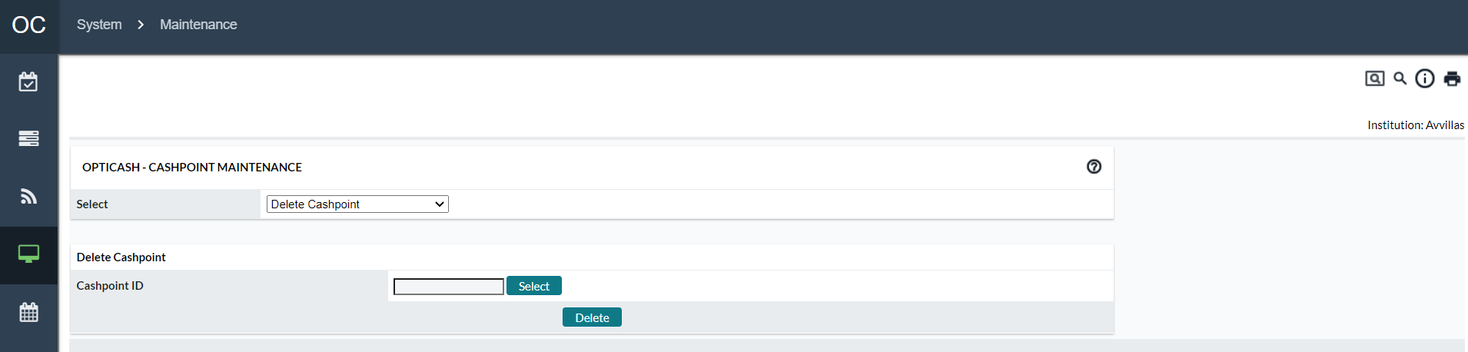

Table 128: Delete Cashpoint Description

| Field | Description |
| --- | --- |
| **Select Button** | Select the Cashpoint that will be renamed. |
| **To** | Enter the Cashpoint ID that the Cashpoint will be referred to. |
| **Rename Button** | Executes the renaming process. |

|  |  |
| --- | --- |
|  | **Note:** System will only allow you to select inactive Cashpoints for deletion. Therefore, Cashpoints have to be deactivated at a Cashpoint level before the deletion. |
|  | **Warning:** Deleting Cashpoints is a permanent deletion. There is no way to undo the process once it has been completed. All data relating to the Cashpoint deleted will be lost. |

Return To: System→Maintenance→Cashpoint Maintenance

#### Cashpoint Maintenance→Activate/Deactivate Cashpoints

Once a Cashpoint(s) is ready for production, it needs to be activated. While a single Cashpoint can be activated/deactivated at the Cashpoint level, this function allows the user to activate/deactivate a group of Cashpoints at one time.

Figure 152: Activate/Deactivate THE Cashpoint Page

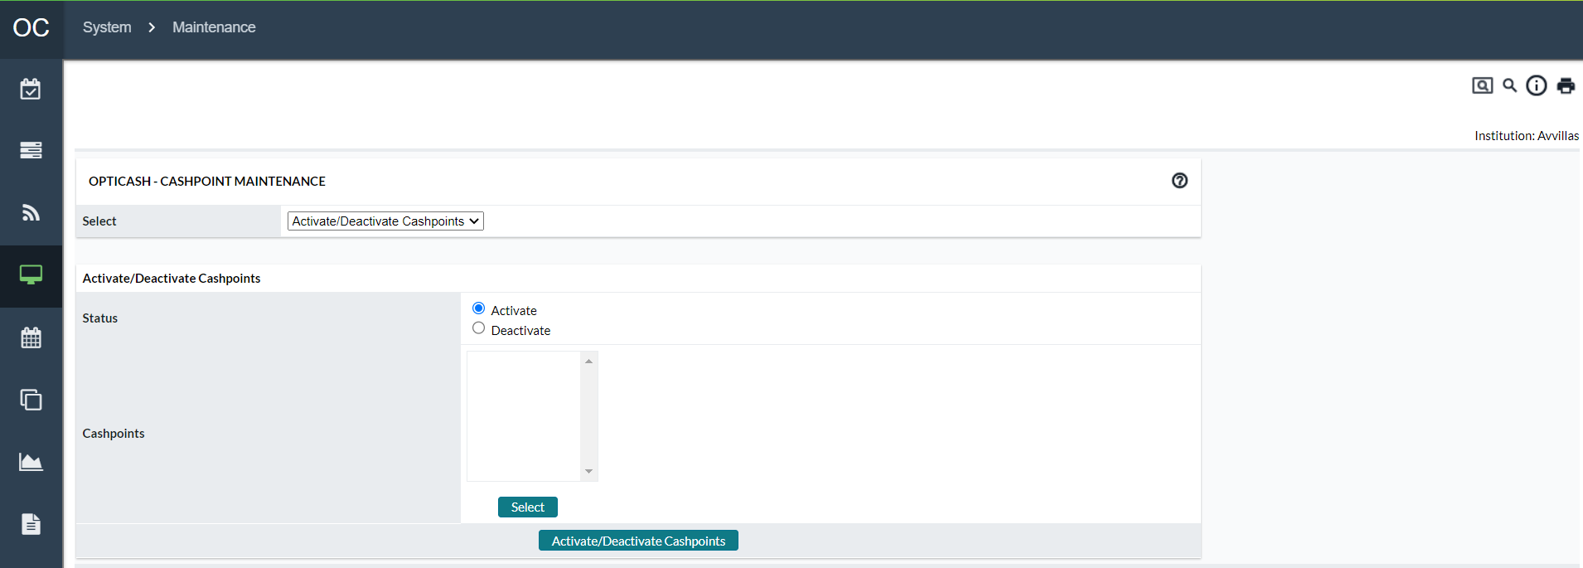

Table 129: Activate/Deactivate Cashpoint Description

| Field | Description |
| --- | --- |
| Status | Determines the action that will be taken on the selected Cashpoints. |
| Select Button | Select the Cashpoints to be activated/deactivated  **Note**: Depending on the option selected under status, the opposite Cashpoint statuses will be shown. (i.e., If Activate is selected only Deactivated Cashpoints will be shown.) |
| Activate/Deactivate Button | Performs the selected Action in the Status section on the Cashpoints selected. |

Return To: System→Maintenance→Cashpoint Maintenance

#### System→Maintenance→Copy History

The Copy History function is used to copy or extract a total or partial history period from (or to) different Cashpoints. When a new Cashpoint has been added to your network with no historical data to load, the recommended procedure is to copy the history of a nearby Cashpoint – one that would have a similar cash demand pattern as the new one. This works very well until the new Cashpoint can establish its cash demand history to create forecasts and recommendations.

Figure 153: Copy THE History Page

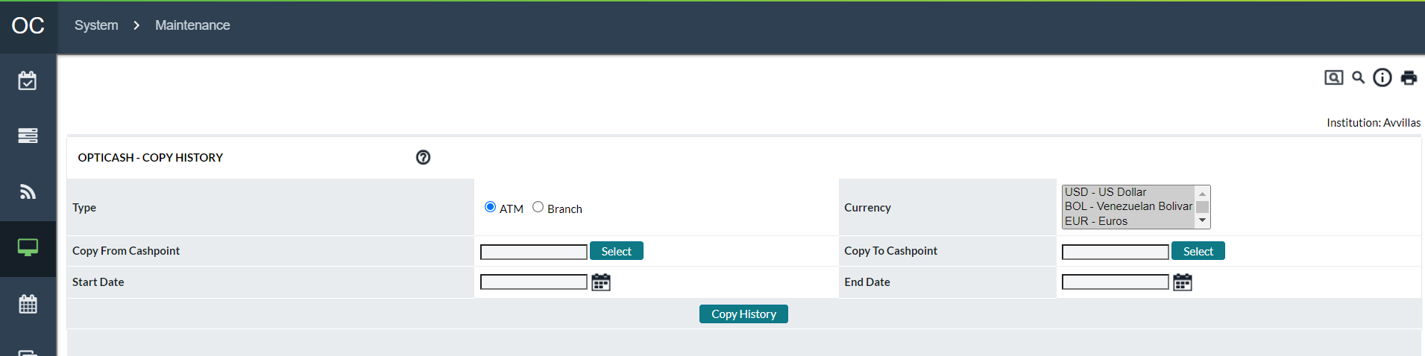

Table 130: Copy History Description

| Field | Description |
| --- | --- |
| **Select Button** | Select the Cashpoint that will be renamed. |
| **Type** | Allows the user to select the type of Cashpoint from which the history will be copied.  **Note**: it is not possible to copy ATM data to a Branch and vice versa. |
| **Start Date** | The starting day in history that will be copied |
| **End Date** | The ending day in history will be copied. |
| **Currency** | The currencies for which history will be copied. |

Return To: System→Maintenance Page

## System→Maintenance→Purge Data

The Purge Data function is used to permanently delete data from the OptiCash database. Data can be selectively deleted from the following categories: History, Forecast, Recommendations, and Orders.

Some examples of when data may need to be purged from the OptiCash database would include:

* The wrong days were loaded in the daily files, in which case, indicate the time period that needs to be purged and re-load the fixed daily files.
* Purging the forecast table of all data before regenerating the forecast. Therefore, it will reduce the time required to regenerate the forecast.
* Purging data accumulated during several years of operations.

|  |  |
| --- | --- |
|  | **Caution**: Purging will cause data to be permanently deleted from the OptiCash database! Once deleted, this data cannot be recovered unless a backup copy of the database is already made! |

Figure 154: Purge Data Page

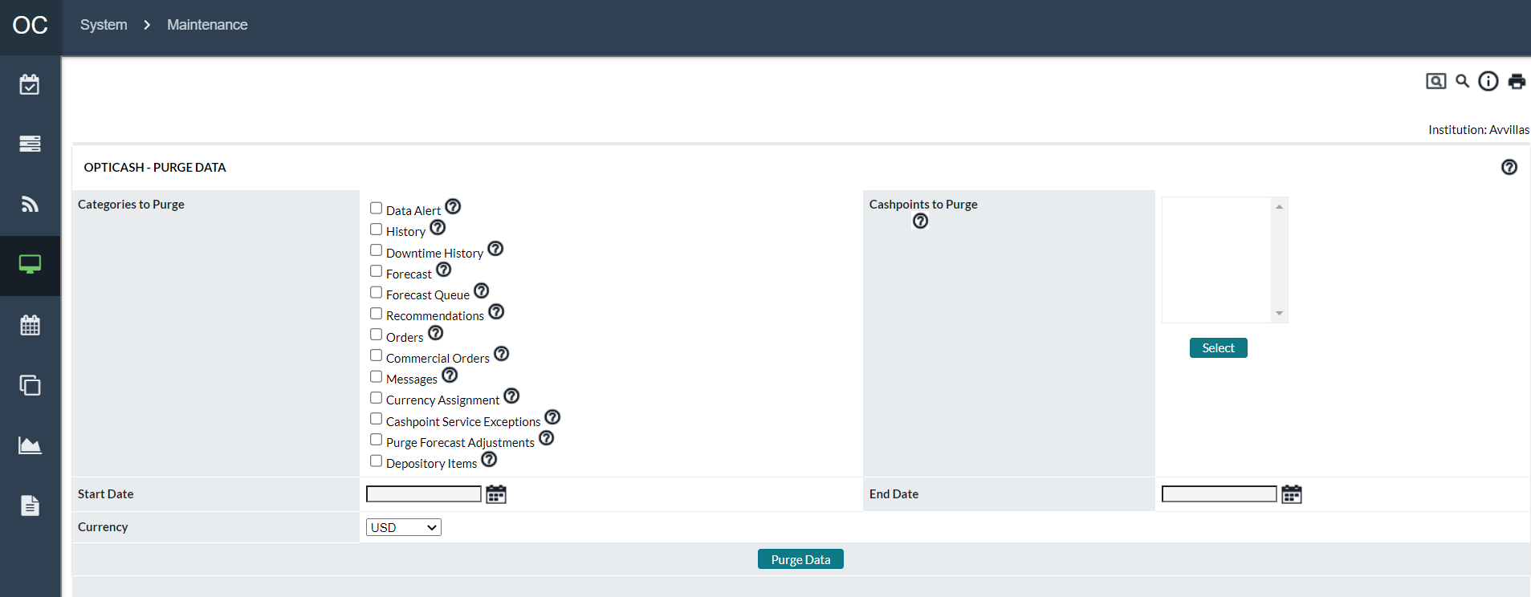

Table 131: Purge Data Description

| Field | Description |
| --- | --- |
| **Data Alerts** | To delete data alerts from the daily load process, check the box, indicate “**From**” and “**To**” Dates for the purge, and select the currency and Cashpoints for which the data alerts will be purged by clicking on the Select button.  **Note** Deleting the data alerts will not have an impact on the data health as errors calculated in the data health are stored in a separate table and are run/ re-run as an independent process.  Deleting data alerts will purge historical alerts that are displayed on the network level: *Today → Dashboard →To Do List → Check Balance Errors*, or on the Cashpoint level: *Main → Overview → Cashpoint Status → Alerts*  **Note** The number of days used in alerts of data errors is handled by the setting ‘The number of days in history from today during which the user is alerted on the *Today->Dashboard-> To Do List*’ under /maint/ URL. However, dates can still be selected on the network level. |
| **History** | To delete historical data, check the box; indicate “**From**” and “**To**” Dates for the purge and select Cashpoints for which the history data will be purged by clicking on the Select button.  **Date Selection** (recommendation only): Generally, users should purge history greater than two full years plus the current year.  **For example**, if today is July 16, 2004, the user can drop all history data before 01-Jan-2002. Then in January 2005, the users can drop all data before 01-Jan-2003. Repeat each January advancing by one year. The forecast engine uses twenty-four months of historical data. |
| **Downtime History** | Deleting Downtime history deletes the entries from the CP_AVAIL table for the Cashpoints and dates selected. No Currency applies to the deletion of Downtime History |
| **Forecasts** | Check the box to delete forecasts and select Cashpoints for which the forecast will be purged by clicking on the Select button.  **Date Selection** (recommendation only): Generally, users should purge forecasts greater than one full year plus the current year.  ***For example***, if today is July 16, 2004, the user can drop all history data before 01-Jan-2003. Then in January 2005, the users can drop all data before 01-Jan-2004. Repeat each January advancing by one year. Old forecast data is never used by the software but could result in the display of the forecast. However, it is not recommended to use more than 12 months in historical data selection, therefore, forecast data greater than one year will not be displayed. |
| **Forecast Queue** | Check the box to purge any Cashpoints currently existing in the forecast queue. This option will ignore the Cashpoints selected and the 'Start Date' and 'End Date' options. The forecast queue can be accessed at *Processing > Processing Status > Forecast*. If there is a message “**No processes running at this time**” this indicates there are no forecasts that have been generated. The forecast queue holds all forecast processes and releases it once the process has been completed. Occasionally, several users will generate a forecast simultaneously causing the process to hang up; therefore, no forecast process will generate until the forecast queue is purged. |
| **Recommendations** | To purge recommendations, check the box; indicate “**From**” and “**To**” Dates for the recommendations to be purged and select Cashpoints by clicking on the Select button.  **Note** Purging old recommendations will automatically purge old horizon for the same time frame selected for recommendations.  **CAUTION**: Some users may run variance reports for periods greater than the past sixty days. The users should only purge data that the business will not use.  **Date Selection** (recommendation only): generally, users should purge recommendations greater than three full months plus the current month. For example, if today is July 16, 2005, drop all data before 01-April-2005. Repeat each month advancing by one month.  If users are running semi-annual/annual variance, they should select the dates accordingly.  **NOTE**: Recommendations are purged by the Due Date, not the Recommendation Date. |
| **Orders** | To delete order information, check the box; indicate “**From**” and “**To**” Dates for the order information to be purged and select Cashpoints by clicking on the Select button.  **CAUTION**: Some users may run variance reports for periods greater than the past sixty days. The users should only purge data that the business will not use.  **Date Selection** (recommendation only): generally, users should purge recommendations greater than three full months plus the current month. For example, if today is July 16, 2005, drop all data before 01-April-2005. Repeat each month advancing by one month.  If users are running semi-annual/annual variance reports, they should select the dates accordingly.  **NOTE**: Orders are purged by the Due Date, not the Order Date. |
| **Messages** | This purge option is used for deleting messages in OptiNet generated in communication between the branch user and the analyst in OptiNet. Please refer to the OptiNet user guide for more information.  Check the box to purge all the messages that were generated between the selected **'Start Date'** and **'End Date'**.  **Note** The selection of Cashpoints and currency does not affect the purge of messages, as it will purge all messages during the time period selected. The messages will not be archived no matter the **'Archive'** option is checked or not.  **Date Selection** (recommendation only): Generally, users should purge messages greater than one full month plus the current month.  **For example**, if today is July 16, 2005, drop all data before 01-June-2005. Repeat each month advancing by one month. |
| **Currency Assignment** | Purge currency assignment, including orders, recommendations and other related data for the selected '**Cashpoints**' and **'Currency'**. This function ignores the selected **'Start Date'** and **'End Date**'. |
| **Cashpoint Service Shifts** | This will purge all Service Shifts and Service Exceptions from the system for the selected Cashpoints and dates. Please refer to [Cashpoint → Basic → Service Days](#_Cashpoint(Basic(Service_Days) for more information on service exceptions. |
| **Purge Forecast Adjustments** | This will purge the forecast adjustments for the specified Cashpoints.  **Note** No dates are used or needed. This option is also found on Cashpoint-level screens. Forecast Adjustments are discussed further in the section [Cashpoint → Forecast → View Forecast](#_Cashpoint(Forecast(View_Forecast) |
| **Depository Items** | This will purge the Container Bags and the associated Wallets for the specified Cashpoints.  **Note** that no dates are used or needed. |

|  |  |
| --- | --- |
|  | **Note:** The above recommendations for data selections are only provided as suggestions; however, each institution needs to determine how much data it would like to have available. Before purging data, the database should be backed up. |

Return To: System→Maintenance Page

### System→Maintenance→Include/Exclude History

To assure the creation of accurate forecasts, it is possible to include or exclude ATM or branch history. In the case, there is a problem with the data or the daily files that would adversely affect the forecast, one or more day's worth of historical data can be excluded. Similarly, days that have been previously excluded can also be **“re-included”** into the database in case such exclusions were made in error. So, the exclusion does not delete the data from history, it merely excludes the data from being considered as part of the demand pattern whenever the forecast is being created. In case the status from the Cashpoint history is provided, the software will automatically exclude the information. This automatically excludes functionality in OptiCash making the forecast creation easier, since sometimes, it is complicated to determine data that should be excluded.

Figure 155: Include/Exclude THE History Page

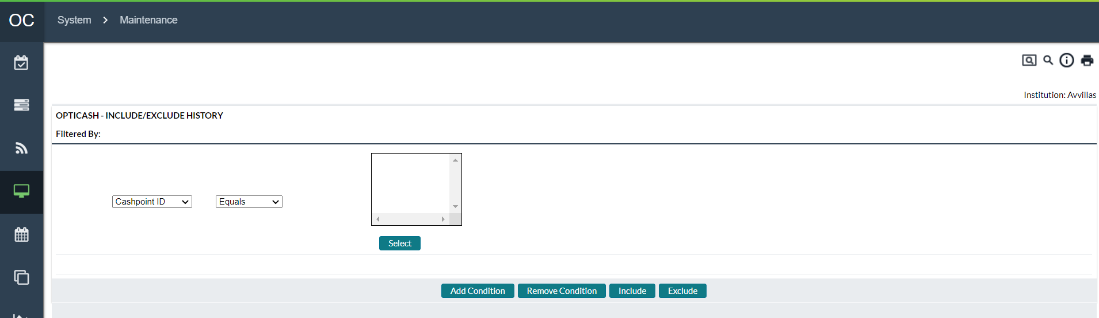

Table 132: Include/Exclude History Description

| Options | Description |
| --- | --- |
| **Cashpoint ID** | This option allows selecting Cashpoint(s) that need to be included /excluded in history. Select the Cashpoint(s) by clicking on the Select button. Once the Cashpoint(s) have been selected, click on Include or Exclude button depending on intentions. |
| **Currency** | Allows selecting currencies to be included/excluded from the history. Select currencies as necessary from the drop-down list. |
| **Date** | Allows selecting specific dates to be included/excluded from the history. Use the Calendar button to indicate the dates. |
| **Open Balance** | This option gives the ability to include/exclude various balance data by specifying a particular amount or choosing options such as:  *Withdrawals → Greater Than → Open. Balance*    To enter a numerical value, enter the amount in the – Or -field |
| **Deliveries** |
| **Returns** |
| **Unplanned Delivery** |
| **Unplanned Return** |
| **Withdrawals** |
| **Pre-withdrawals** |
| **Closing Balance** |
| **Deposits** |
| **Required Balance** |
| **Status** | Allows to include/exclude from the history those Cashpoints that are not active / or active. Select either Operational or Not Operational from the drop-down list. |
| **Exclude** | Allows including the data that has been previously excluded from history. |

Return To: System→Maintenance Page

## System→Maintenance→JDBC→Table Cleaning

Select this tool if there are database problems due to corrupt data, problems with the operating system, hardware, power, or any application problems. The time that the rebuild will take depends on the size of the database.

Return To: System→Maintenance Page

## System→Maintenance→ATM Side-by-Side Cluster Aggregation

This tool is used to aggregate child ATM history to parent ATM in a side-by-side ATM Cluster scenario. This functionality is different than the Clusters defined under *Network>Clusters*.

Return To: System→Maintenance Page

## System→Maintenance→Update Pre-service Amount

The pre-service Amount is used for calculating the pre-replenishment percentage using historical data. For those Customers, who have identified that the Pre-Service amount is not correct and cannot be used in the Pre-Replenishment percentage calculation, OptiCash can calculate the Pre-Service Amount. However, this calculation can only be applied for Replace Cash ATMs, based on the formula:

Opening Balance – Returns = Pre-Service Amount

If the user uses the pre-service amount calculation, the calculated pre-service amount will be updated and applied to ATM history. Once the calculated pre-service amount is applied to history, this amount will be used on the pre-replenishment percentage calculation. Just as in the pre-replenishment percentage calculation, the pre-service amount requires the following criteria to be adhered to; otherwise, the pre-service amount will not be calculated:

The opening balance & return amounts must be defined on the delivery days as defined within the Cashpoint’s Service Days screen.

The opening balance and/or return amount cannot be 0 or missing.

The return amount cannot be greater than the opening balance.

Return To: System→Maintenance Page

## System→Maintenance→Export Cashpoints

This tool allows customers to extract multiple Cashpoints to be sent to NCR Cash Management support when necessary. Cashpoint extract utility will extract all the related Cashpoint data necessary to replicate the customer’s environment, including all Cashpoint settings, history, horizon, etc.

Return To: System→Maintenance Page

## System→View Logs

The View Logs function allows users to access system logs. Users should only access this page when directed to do so by a system administrator or an NCR Support Representative.

Figure 156: View Logs Page

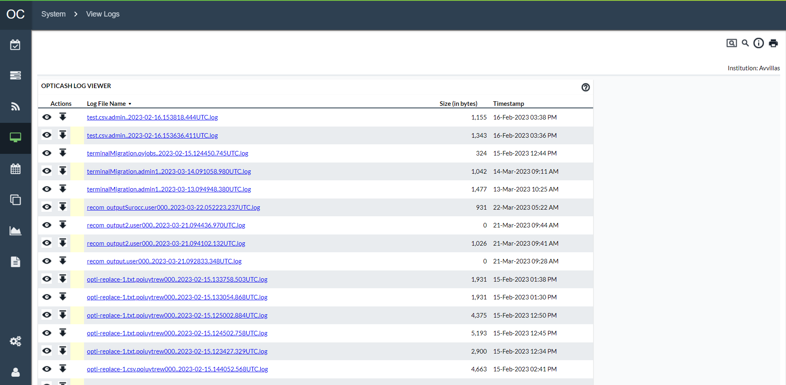

Table 133: Log Viewer Description

| Field | Description |
| --- | --- |
| **Actions** | Shows the available actions that are allowed for the given each Log File entry  - Allows the user to view the Log file in the web browser.  - Allows the user to download the Log file to the local computer which can then be opened by a text file editor.  **NOTE**: The size of the logs. Large files may take a long time to load in a web browser or may not be visible in all text file editors. Check with your system administrator if you have questions about viewing large files. |
| **Log File Name** | Name of the log file that was generated. Clicking on the log file name will prompt the user to download it to the local computer to be viewed with a text file editor. |
| **Size** | Size of the file in bytes for each log file. |
| **Timestamp** | Timestamp of the Log file (generally this is the time the log was created, but it could also be the last time it was modified). |

Return To: System Tab

## System→Audit Log Browser

OptiCash can track user activity in the system. The Audit Browser allows the OptiCash user to view the transactions that took place in the system as well as filter down the results to find a specific transaction.

The Audit Log Browser begins with a filter page that allows the user to filter the results of the Audit Log to quickly find the desired information.

Figure 157: Audit Log Browser Search Page

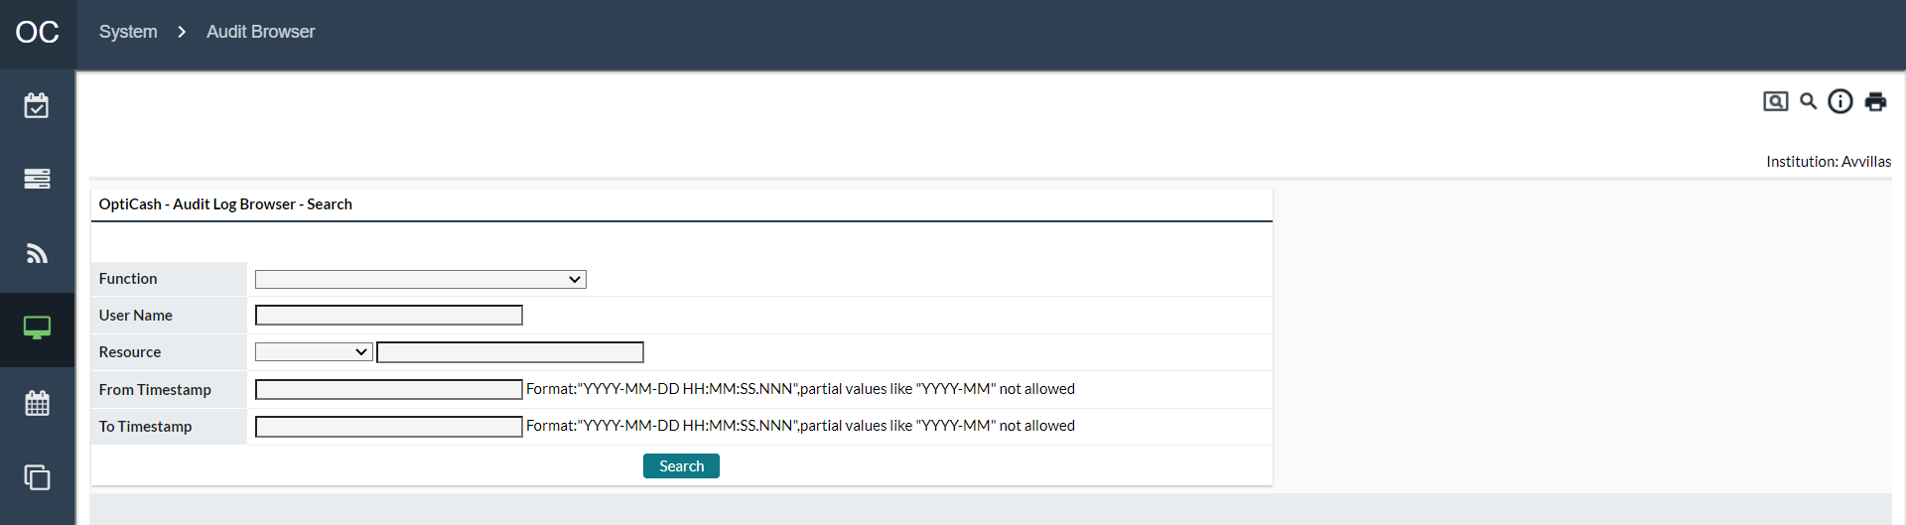

Table 134: Audit Log Browser Search Description

| Field | Description |
| --- | --- |
| **Function** | A list that is populated by the current Functions that have already been performed in the Audit Log. If the Function is not listed, it has not yet been performed. |
| **User Name** | The User Name of the person who performed the action. The search is case-sensitive, but a partial word and wildcard searches are possible. |
| **Resource** | A list that is populated by the current system resources that have been accessed in the Audit Log. If the Resource is not listed, it has not yet been accessed. |
| **From/To Timestamp** | Date and time that the action was performed The user can enter a date, the date/time, or leave the field blank. Leaving the field blank will return all rows. For instance, if the user wanted all records after June 1, 2009, the user would enter 2009-06-01 in the From field and leave the To field blank.  The entry must conform to the correct format of YYYY-MM-DD HH:MM:SS:NNN  YYYY = Year (4 digits)  MM = Month (2 digits)  DD = Day (2 digits)  HH = Hour (2 digits)  MM = Minute (2 digits)  SS = Second (2 digits)  NNN = Nanoseconds (3 digits)  **Example**: June 1, 2009, at 3:15 pm would be 2009-06-01 15:15:00:0000 |

Figure 158: Audit Log Browser Search Results Page

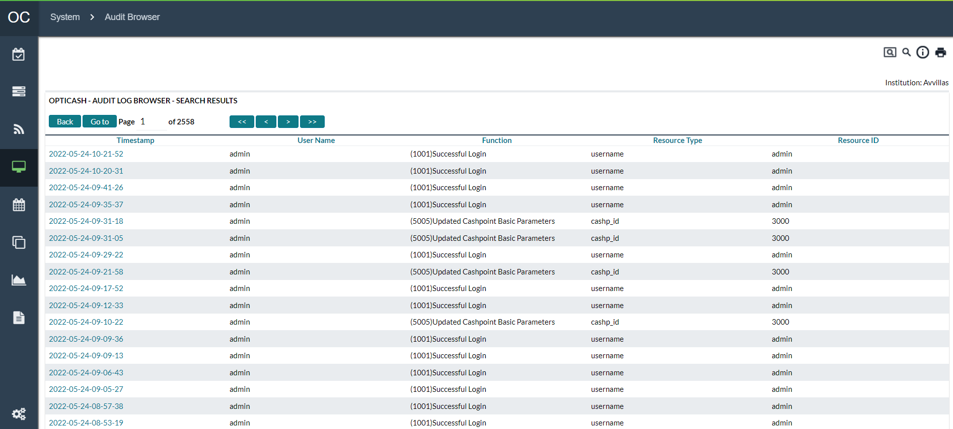

Table 135: Audit Log Browser Search Results Description

| Field | Description |
| --- | --- |
| **Go To Button** | Navigates to the page number specified in the Page field |
| **Page** | Indicates the current page currently being viewed out of the total number of pages. Changing the page number and selecting the ‘**Go To’** button navigates directly to that page. |
| **Navigation (<< < > >>)** | Navigates forward or backwards to a particular page.  << First Page  < Back one page  > Forward one page  >> Last Page |
| **Timestamp** | Date and time stamp for the Audit Log entry. Clicking on the column header will resort to the list (ascending or descending depending on the current view).  Clicking on a Timestamp hyperlink will bring the user to the Transaction detail report. See: Table 136: Audit Log Browser Transaction Detail Description |
| **User Name** | User name of the person who performed the action. Clicking on the column header will resort to the list (ascending or descending depending on the current view). |
| **Function** | The function that was performed for the specific Audit Log entry. Clicking on the column header will resort to the list (ascending or descending depending on the current view). |
| **Resource Type** | The Resource type that was accessed. Clicking on the column header will resort to the list (ascending or descending depending on the current view). |
| **Resource ID** | The Resource ID that is associated with the Resource type. Clicking on the column header will resort to the list (ascending or descending depending on the current view). |

The Transaction Detail report shows more in-depth information about some transactions that are performed on the system. The Transaction detail is accessed by clicking on the Timestamp hyperlink from the Audit Log Browser Results. Not all transactions will have transaction details associated with them.

Figure 159: Audit Log Browser Transaction Detail Page

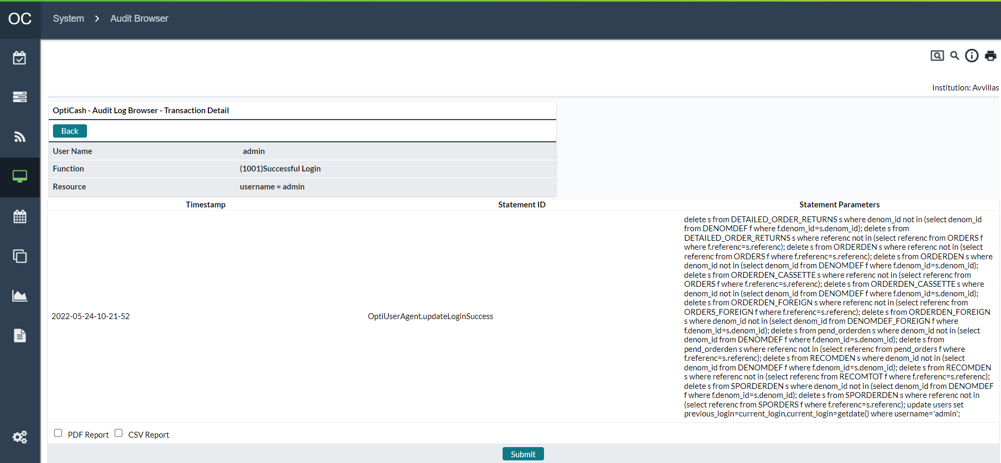

Table 136: Audit Log Browser Transaction Detail Description

| Field | Description |
| --- | --- |
| **User Name** | User name of the person who performed the action. |
| **Function** | The function that was performed for the specific Audit Log entry. |
| **Resource** | The Resource type that was accessed. |
| **Timestamp** | Date and time stamp for the Audit Log entry. |
| **Statement ID** | The action code that is associated with the database change. |
| **Statement Parameters** | Parameters executed at the database level. This will often include the most specific details on a particular action. Example: if a Cashpoint’s parameters are saved, this will list the new parameters submitted to the database. Note: if the system administrator configures partial auditing, then Statement Parameters will be blank. |

Return To: System Tab

## System→About Page

This page gives a system summary to tell users the current version of both the software as well as the subcomponents used by the OptiCash system.

The user can see the current version and build of the application. This page also displays the user’s last successful and failed login time.

This page is for informational purposes only and will vary from version to version.

Return To: System Tab

1. Virtual Analyst Tab

If licensed, the Virtual Analyst helps to improve forecasting results by running several Forecasts using different periods of time to produce the best results possible. The Virtual Analyst Tab allows the user to select how the Virtual Analyst will work as well as the ability to review reports produced by the Virtual Analyst.

The following functions are reviewed in this section:

* Virtual Analyst→Settings
* Virtual Analyst→Reports

Return To: Introduction to the Interface

## Virtual Analyst→Settings

The settings for the Virtual Analyst are configurable on a System-wide basis. In other words, it is not possible to run the Virtual Analyst for some Cashpoints and normal forecasting for others.

Figure 160: Virtual Analyst Page

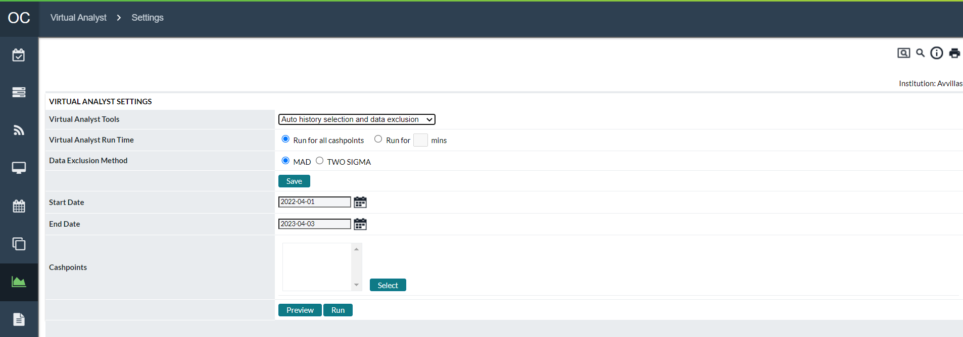

Table 137: Virtual Analyst Description

| Field | Description |
| --- | --- |
| **Virtual Analyst Tools** | Allows the user to select how the Virtual Analyst will run.  **No Auto History Selection or Data Exclusion** – The Virtual Analyst is not activated  **Auto History Selection Only** – The Virtual Analyst will perform the Automatic History Selection, but not perform any data exclusions  **Auto Data Exclusion Only** – The Virtual Analyst will automatically Exclude data, but will not perform the Automatic History Selection  **Auto History and Data Exclusion** – The Virtual Analyst will automatically Exclude data and perform automatic History Period Selection. Note: These options will produce better results but will also drastically increase the time it takes to run forecasts. |
| **Virtual Analyst Run Time** | **Run for all Cashpoint** – The Forecast will run the select Virtual Analyst functions for all Cashpoints selected until finished.  **Run for X minutes** – The Forecast will run using the specified options for up to this period of time. This is used to ensure that the Forecasting process does not run for such a long period of time as to disrupt production or interfere with other processes, including Recommendations. Note: When the specified time period ends, the forecast will finish the current cashpoint -- so if time tolerances are very small, you should reduce this amount slightly. |
| **Data Exclusion Method** | Allows the user to choose the statistical method used to exclude data.  **MAD** – Median Absolute Deviation. It is a statistical method that involves finding the median and deviation from that median and using it to establish upper and lower bounds. Adjustments were also made for the day of the week and yearly seasons, among others. Outside of those bounds are excluded. This is typically a more aggressive choice than TWO SIGMA (more exclusions).  **TWO SIGMA** – The 2 Sigma Algorithm uses a simpler tactic of grouping certain similar data points and excluding those that are outside of twice the standard deviation.  Both above methods mark history records for exclusion (much like a user would do manually). This means that exclusion only needs to be done 1 time over any given time period – not each time the Forecast process runs. |
| **Save Button** | Saves the selected settings |
| **Start Date** | For use with selected Data Exclusion Method |
| **End Date** | For use with selected Data Exclusion Method |
| **Cashpoints** | Select cashpoints for use with Data Exclusion Method |
| **Preview Button** | Displays a brief preview screen where the user can select which exclusions to apply. Uses the selected Start Date, End Date, and Cashpoints. |
| **Run Button** | Runs the selected Auto Data Exclusion method as a background process. Uses the selected Start Date, End Date, and Cashpoints. |

Return To: Virtual Analyst Tab

|  |  |
| --- | --- |
|  | **Auto History Selection**: When running the forecast process with Auto History Selection, do not include the latest history data in the history period. It is recommended to forecast using whole months and to keep 7 days to 1 month of actual history after the period used for the forecast process.  **For example,** if the latest historical data available is the 3rd of October, then the forecast process is recommended to run with History to 31st of August. If history was instead available to 15th October, for example, then the recommended forecast period would include History To 30th September.  The history data immediately following the history period used by the forecast process is important because the Virtual Analyst’s Auto History Selection will use the last ~30 days of history for evaluating the quality of forecast results. If too much of that evaluation period is also included in the forecast process regression model, then the quality would be artificially high and that could lead to sub-optimal decisions. |
|  | **MAD and TWO SIGMA Data Exclusion:** All settings that designate the status of history should be set before running the Virtual Analyst’s Auto Data Exclusion. These include event and holiday definitions, business day settings, and the Cashpoint designation of open or closed during holidays.  History data often naturally reflect these occurrences with a significant increase or decrease in demand. Thus, if event/holiday/business days are not properly defined, the Virtual Analyst may (improperly) flag them as anomalies that should be ignored when calculating demand forecast. |

## Virtual Analyst→Reports

When the Virtual Analyst runs, it produces reports on the decisions that were made in terms of data selection and exclusion.

The following reports are reviewed in this section:

* Auto History Selection Results

Return To: Virtual Analyst Tab

### Auto History Selection Results

When the ‘**Auto History Selection’** option is used, the OptiCash Virtual Analyst runs several forecast models to decide on the amount of history which will create the best forecast. The Auto History Selection Results Report provides the user with the dates of history that were selected by the Virtual Analyst for each Cashpoint.

Figure 161: History Selection Page

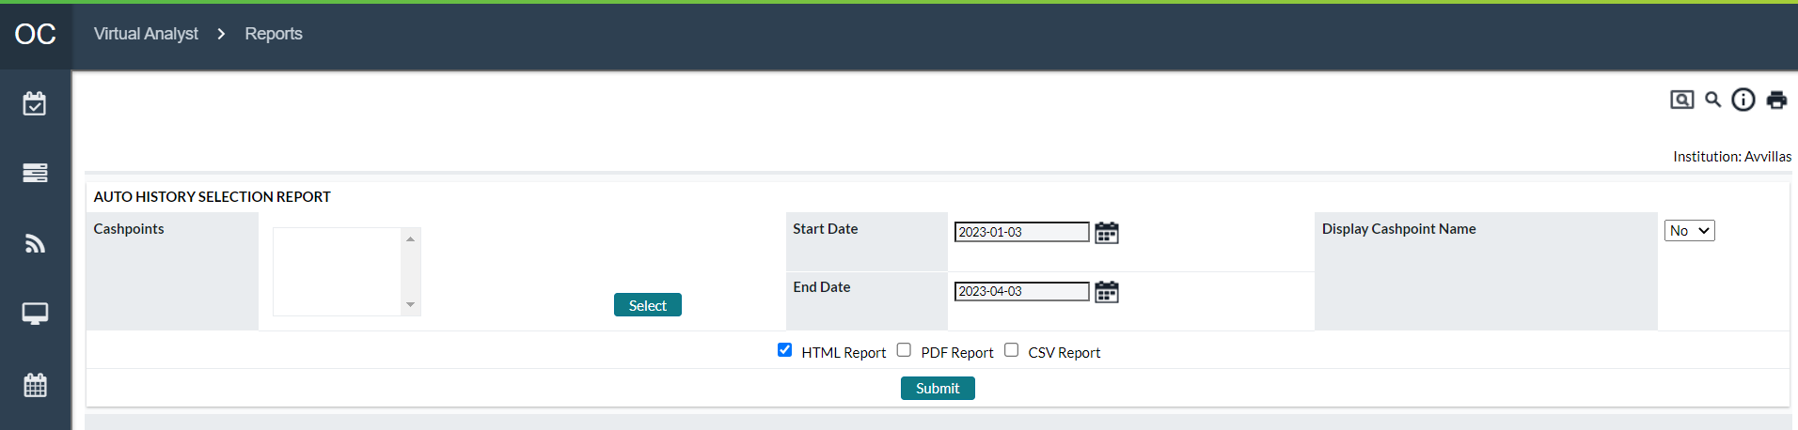

Table 138: History Selection Description

| Field | Description |
| --- | --- |
| **Cashpoint ID** | Unique identification of the Cashpoint. |
| **Cashpoint Name** | Descriptive name of the Cashpoint (user-defined). This field is only visible if ‘**Display Cashpoint Name’** is selected in the report options. |
| **Currency** | Unique identification of the currency. |
| **Forecast Date** | The forecast process runs on the date for which details are being provided. |
| **Horizon ID** | Also known as Forecast Definition ID. This name refers to a set of stored forecast parameters: History From and To dates, plus Forecast From and To dates. |
| **History From** | The forecast process references historical data between this date and the History To date. |
| **History To** | The forecast process references historical data between this date and the History From the date. |
| **Forecast From** | The forecast process predicts cash demand between this date and the Forecast To date. |
| **Forecast To** | The forecast process predicts cash demand between this date and the Forecast From the date. |
| **Excl. Method** | This field tells which exclusion method was used. |
| **Forecast Health** | R-Square evaluation over the entire model forecast period. R-Square is a statistical measure describing how well-forecasted values match actual values. This value is used in forecast health evaluations elsewhere in OptiCash. |
| **MAPE** | Mean Absolute Percentage Error. The ratio of the sum of absolute values of forecasting errors to the sum of actuals. This is applied over a limited evaluation period to facilitate comparison to other models. |
| **DOAIP** | Days Out of Accepted Interval Percentage. Percentage of daily forecast values outside of an acceptable interval from actual values. This is applied over a limited evaluation period to facilitate comparison to other models. |
| **R-Square** | R-Square is a statistical measure describing how well-forecasted values match actual values. This is applied over a limited evaluation period to facilitate comparison to other models. |
| **Is the model selected** | Yes or No. If yes, this is the set of forecast results selected for actual use after comparison to other models. |
| **Data Type** | What type of data is being forecasted: Withdrawals, Deposits, or Net Demand. |

Return To: Virtual Analyst Tab

1. Reports Tab

OptiCash reporting functionality captures and presents information generated during normal processes.

The following is a summary of the information that will be covered along with hyperlinks to each topic:

* Reports Overview
* Report Basics
* System Settings Reports
* Historical Reports
* Planning Reports
* Metrics & MI Reports

## Reports Overview

The reports are broken into 4 sections and are summarized in the table below.

Table 139: Report Summary

|  |  |
| --- | --- |
| Report Name | Report Output |
| System Settings Reports | |
| **Cashpoint Contacts** | Displays contact information of the Cashpoints selected, including the name of the contact person, telephone, and e-mail address. |
| **Cashpoint Details** | Displays basic information associated with the Cashpoints selected such as center, region, depot, contact information and status of the Cashpoints. |
| **Cashpoint Parameters** | Displays report on parameters by Cashpoint. |
| **Cashpoint Denominations** | Displays report on denominations by Cashpoint. |
| **Advanced Device Components** | Details each component at each Advanced Devices. Components can be Dispense only, Deposit only, and Recycling. This report details each component and its key parameters and settings. |
| **Cashpoint Service Costs** | Displays report on service costs defined in the Cashpoint settings. |
| **Cashpoint Service Days** | Displays report on service days defined in the Cashpoint settings. |
| **Cashpoint Service Exceptions** | This report displays service exceptions currently assigned to the selected Cashpoints. |
| **Cashpoint Service Schedule** | Displays a report that shows the service dates and available days of service based on the Cashpoint service days produced by the recommendation process each night. |
| **Cashpoint Event Collisions** | Produces a Report by Cashpoint detailing overlaps in Events, Holidays, and Calendars. Collisions can adversely affect Forecasting and any results in the report should be investigated and corrected. |
| **Cashpoint Forecast Adjustment Percentages** | This report displays forecast adjustments currently assigned to the selected Cashpoints. Forecast Adjustment is used when a user wants to update the forecast due to additional trends that may not be captured by the initial forecast.  **For example**, if there is a certain demand trend that is affecting Mondays, the user may adjust the forecast specifically for that day of the week using a percentage. |
| **Cashpoint Groups** | Displays details on groups of Cashpoints defined in the network, listing Cashpoints in a particular group, and indicating dates of when they were created and updated. |
| **Commercial Cashpoint Groups** | Displays details of Groups that are limited to Commercial Clients |
| **Cashpoint Linkage** | Reports the Cashpoint relationship or linkage. |
| **Institution Details** | Displays institution-level definition, including institution general details, Cashpoints defined in the network and other institution-level settings like denomination split settings. |
| **Network Contacts** | Displays contact information of the depots, centers, servicers, and regions. |
| Historical Reports | |
| **History** | Displays all history details. |
| **History by Denomination** | The denomination report provides a history report with a denomination breakdown.  **Caution:** The results of the report could be quite large. |
| **Intraday History** | The report shows the intraday historical data loaded for either ATMs or Branches. |
| **Downtime** | A report showing the availability of an ATM based on the data loaded daily into OptiCash |
| **Orders** | Displays the orders committed during any given day by Cashpoint and status. |
| **Commercial Orders** | A report listing the commercial orders committed by the Branch users in OptiNet. |
| **Order Custom Fields** | A report listing the orders and custom field values combined. |
| **Bag Reference Numbers** | Displays the orders and bag reference numbers for branch returns. This report will only be enabled if the ‘**Use Bag Reference’** feature is turned on in /maint/ URL. |
| **Special Orders** | Displays special orders that were placed in OptiNet. These orders do not affect the horizon and optimization of the Cashpoint. One example of special order is an order for a commercial client. This order will not be displayed in the horizon and will not be accounted for in the recommendation process, because it was placed for a single client’s request under certain circumstances.  This report will only be enabled if the ‘**Special Order’** feature is turned on in the /maint/ URL. |
| **Linked Orders** | Displays orders for branches with linked ATMs in a **‘Linked Order’** scenario. The report provides information by denomination on the total amount ordered for the branch and the total sum of orders for the linked ATMs.  This report will only be enabled if the ‘**Linked Order Screen’** feature is turned on in the /maint/ URL. |
| **Recommendations** | Displays the results of the recommendation process on a daily or monthly basis. Also summarizes emergency and forecasted orders. |
| **Special Requirements** | Reports all the messages that have been communicated between the OptiCash user and analyst (or OptiNet branch user) regarding their special requirements for balances or orders. |
| **Target vs. Historical Balance** | Results will be displayed only if the target balance feature is enabled.  When this feature is used, the report will display the target balance against the historical actual balance. |
| **Target Balance vs. Historical Recommendation** | Results will be displayed only if the target balance feature is enabled.  When this feature is used, the report will display the target balance against the historical recommendation. |

|  |  |
| --- | --- |
| Planning Reports | |
| **Forecast Average Cycle Discrepancy** | This report displays a list of Forecast Average Discrepancy Levels between the actual and forecasted values for selected Cashpoints during specified cycles. |
| **Forecast Comparison** | A Report created for ATMs to compare forecast health for different periods. The result shows a percentage difference between the periods which can be applied to a Cashpoint as a Forecast Adjustment. |
| **Forecast Details** | Displays forecast summary and forecast detail. |
| **Forecast Definition** | Displays forecast definitions in the system including the history and forecast dates for the forecast and Cashpoint details. |
| **Expired Forecasts** | Displays forecast that is ready to expire. |
| **Forecast Health** | Displays forecast health analysis by comparing forecast versus actual demand over all historical data. |
| **Forecast Health (Calculated)** | The calculated forecast health report provides a calculated percentage of the shared variation between forecasted and actual values for a defined period of time. |
| **Horizons** | Displays horizon information (predicted demand, deliveries, returns, and balances) for selected Cashpoints. |
| **Emergency Recommendation Analysis** | Displays information on emergency action recommendations, including prior and following deliveries, and expected shortfall amount. |
| **Downtime Order Impact Analysis** | Displays a report that describes any impact the downtime may have on orders that are in the pipeline |
| **Downtime Recommendation Impact Analysis** | Displays a report outlining any impacts on the current day’s recommendations |
| **Linked Recommendations** | Displays all the recommendations that were generated for the linked Cashpoints in two available scenarios: ATM Cluster or Branches with linked on-site ATMs. |
| **Recycler Maximum Capacity Check** | Displays current maximum capacity for recycler ATMs and provides alerts based on maximum capacity threshold percentage. |

|  |  |
| --- | --- |
| Metrics & MI Reports | |
| **Cash Position** | Reports all information indicating the position of cash in the Cashpoints: average and maximum opening balances, number of deliveries, amounts delivered and number of cashouts. |
| **Cash Utilization** | Reports cash utilization percentage per Cashpoint per delivery cycle. |
| **Costs (Actual)** | Displays the actual cost of the network. |
| **Costs (Charted Actual)** | Displays the actual cost distribution in a pie chart. |
| **Costs (Actual vs. Projected)** | Gives an overview of network performance by displaying the costs for actual history vs. OptiCash’s previously projected costs. |
| **Order Override Reasons** | Displays all reasons for override actions committed when placing an order. |
| **Order Status** | Displays the status of all orders that have been committed in a given period of time. |
| **Recommendation Compliance** | Reports variance between recommendations and orders as well as the variance between previously forecast and actual demand. |
| **Target Balance Lost Opportunity** | Results will be displayed only if the target balance feature is enabled.  When this feature is used, the report will calculate lost opportunity cost based on the overnight earnings rate and the difference between the historical actual balance and target balance. |
| **Target Balance Lost Opportunity with Linked ATMs** | Results will be displayed only if the target balance feature is enabled.  When this feature is used, the report will calculate lost opportunity costs for branches with linked ATMs in a ‘**Linked Order’** scenario. |
| **Target Balance Branch Cash Lost Opportunity Summary** | Results will be displayed only if the target balance feature is enabled.  When this feature is used, the report will calculate lost opportunity costs and display results in a month-by-month summary. |
| **Horizon Comparison** | The horizon comparison report is only used for the branches. The primary objective of the horizon comparison report is to compare Cashpoint’s actual (historical) closing balance to what the closing balance would have been if the branch complied with the OptiCash recommendation. This report may be used to monitor order compliance and the effectiveness of the OptiCash recommendation. |

Return To: Reports Tab

## Report Basics

All reports work in the same manner in OptiCash but provide different information for the user. In each case, the user must select Cashpoints, Options, and Report Types and Submit the request to view the report. The basic report elements will be described in this section.

Figure 162: Report Generation Page

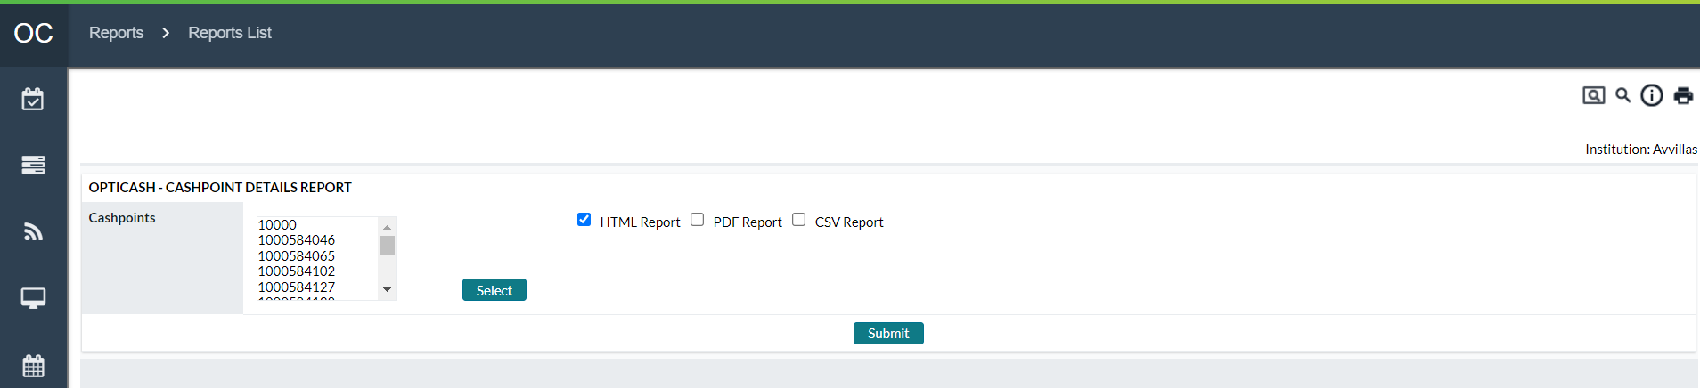

Table 140: Report Description

| Field | Description |
| --- | --- |
| **Select Button** | Allows the user to choose Cashpoints to be included in the report. For more information on Cashpoint Selection, see: Cashpoint Selector |
| **HTML Report** | By default, this option is always selected for all reports. The HTML report means that the report will be viewed on the screen in the web browser.  **Note:** Be careful with the amount of data that is requested. Large requests can take a lot of time to process and may slow down system performance. |
| **PDF Report** | When this option is checked, OptiCash will produce the report in a PDF format that can be downloaded, viewed, and printed using Adobe Acrobat Reader.  After the user clicks the **Submit** button, the report will process and create a hyperlink for the user to access the PDF report. The hyperlink appears above the HTML report on the left side of the screen called “**View PDF (for print)”** |
| **CSV Report** | When this option is checked, OptiCash will produce the report in a CSV (comma-separated file) format. This format can be used to import data into Excel or another spreadsheet application to do advanced analysis or reporting.  After the user clicks the Submit button, the report will process and create a hyperlink for the user to access the CSV report. The hyperlink appears above the HTML report on the left side of the screen called “**Save CSV (for import)”** |
| **Submit Button** | Processes the report request using the options and Cashpoints selected. |

|  |  |
| --- | --- |
|  | **Note**: If the CSV format is selected in the output options, by default the report will be saved in your ‘**dynreports’** folder (where the web application server is located). However, you can also click on the hyperlink ‘Save CSV (for import)’ to save the file to the desired location. |
|  | **Note**: When running a network-level report that will return a large amount of data, an error message may be received caused by memory shortage. To avoid this, reduce the selection of Cashpoints (for instance, if all active Cashpoints have been selected, try to select only half of the Cashpoints) or the time period (select 30 days instead of 90 days).  If the error message is still displayed, the users who have administrative rights can change the Java settings in your web application server management console. Java settings must be changed by setting max heap size following specific web application instructions. After this, the server must be rebooted. |

Return To: Reports Tab

## System Settings Reports

System Settings Reports provide information about the Cashpoints, parameters, settings, and schedules. These reports are beneficial when verifying that parameters are set correctly or to save as a backup in the event the parameters are inadvertently changed.

The following is a summary of the information that will be covered along with hyperlinks to each topic:

* Cashpoint Contacts
* Cashpoint Details
* Cashpoint Parameters
* Cashpoint Denominations
* Advanced Device Components
* Cashpoint Service Costs
* Cashpoint Service Days
* Cashpoint Service Exceptions
* Cashpoint Service Schedule
* Cashpoint Event Collisions
* Cashpoint Forecast Adjustment Percentages
* Cashpoint Groups
* Cashpoint Commercial Groups
* Cashpoint Linkage
* Institution Details
* Network Contacts
* Business Units

Return To: Reports Tab

### Cashpoint Contacts

The Cashpoint Contacts Report displays information about the basic contact information for the Cashpoint.

Table 141: Cashpoint Contacts Description

| Field | Description |
| --- | --- |
| **Select Button** | Allows the user to choose Cashpoints to be included in the report. For more information on Cashpoint Selection, see: Cashpoint Selector |
| **Cashpoint ID** | Unique alphanumeric identification of the Cashpoint. |
| **Cashpoint Name** | The name of the Cashpoint as defined at the Cashpoint |
| **Cashpoint Type** | Type of Cashpoint based on type and replenishment schedule(Add ATM, Replace ATM, Branch, etc.) |
| **Center ID** | The Center that is assigned to this Cashpoint is based on the Depot assigned. |
| **Region ID** | The Region to which Cashpoint belongs |
| **Depot ID** | The Depot to which the Cashpoint is assigned. |
| **Contact Person** | Name of the person (if defined) that is responsible for it. |
| **Phone** | Phone Number (if defined) for the Contact Person. |
| **Email** | Email address for the contact person. |
| **Status** | Shows the working status of the Cashpoint (Active or Inactive) |

Return To: System Settings Reports

### Cashpoint Details

Similar to the Cashpoint Contacts Report, the Contact Details Report provides some of the same information with some additional details.

Table 142: Cashpoint Details Description

| Field | Description |
| --- | --- |
| **Select Button** | Allows the user to choose Cashpoints to be included in the report. For more information on Cashpoint Selection, see: Cashpoint Selector |
| **Cashpoint ID** | Unique alphanumeric identification of the Cashpoint. |
| **Cashpoint Type** | Type of Cashpoint based on type and replenishment schedule (Add ATM, Replace ATM, Branch, etc.) |
| **Center ID** | The Center that is assigned to this Cashpoint is based on the Depot assigned. |
| **Region ID** | The Region to which Cashpoint belongs |
| **Depot ID** | The Depot to which the Cashpoint is assigned. |
| **Name Address** | The name and address (if defined) of the Cashpoint as defined in the Cashpoint. |
| **Contact Information** | Contact Person and Phone Number (if defined) as defined in the Cashpoint. |
| **Active Date** | The date on which the Cashpoint was activated |
| **Time Zone** | The Time Zone, defined in the Cashpoint, where this Cashpoint resides. |
| **Status** | Shows the working status of the Cashpoint (Active or Inactive) |
| **Custom 1 – 6** | The Custom Fields for the Cashpoint are defined in the Cashpoint. |
| **Summary** | Provides a summary of the Cashpoints selected specifying the number of ATMs and Branches in the report. |

Return To: System Settings Reports

### Cashpoint Parameters

The Cashpoint Parameters report shows the current parameters that are defined for the Cashpoints. Because there are different parameters for ATMs and Branches, the user is not able to select the ATM and Branch parameters in the same report.

**Note**: It is a good idea to periodically keep a copy of this report in the event parameters are inadvertently changed.

Table 143: Cashpoint Parameters Description

| Field | Description |
| --- | --- |
| **Select Button** | Allows the user to choose Cashpoints to be included in the report. For more information on Cashpoint Selection, see: Cashpoint Selector |
| **Cashpoint ID** | Unique alphanumeric identification of the Cashpoint. |
| **ATM Parameters** | For a list of all the ATM Cashpoint Parameters as well as a description of each type, see:  Table 11: General Cashpoint Parameters  Table 12: ATM-Specific Parameters |
| **Branch Parameters** | For a list of all the Branch Cashpoint Parameters as well as a description of each type, see:  Table 11: General Cashpoint Parameters  Table 13: Branch-Specific Parameters |

Return To: System Settings Reports

### Cashpoint Denominations

Table 144: Cashpoint Denominations Description

| Field | Description |
| --- | --- |
| **Select Button** | Allows the user to choose Cashpoints to be included in the report. For more information on Cashpoint Selection, see: Cashpoint Selector |
| **Cashpoint ID** | Unique alphanumeric identification of the Cashpoint. |
| **Type** | Allows the user to select the type of Cashpoints to display. Because the parameters for ATMs and Branches are slightly different, it is not possible to select both Cashpoint types on the same report |
| **Cashpoint Name** | The name of the Cashpoint as defined at the Cashpoint |
| **Currency** | The Currency ISO Code that is related to this denomination |
| **Description** | The description of the denomination is defined on the *Currency→Denominations page.* |
| **Denomination** | The Short Name of the denomination is defined on the *Currency→Denominations page*. |
| **Denomination Value** | The value of one note/coin of the denomination is defined on the *Currency→Denominations page*. |
| **Denomination Type** | Describes the type of denomination (Note/Coin) |
| **Split Percentage** | The currently defined order split percentage as defined in the Cashpoint. |
| **Preferred Bal. Percentage** | The percentage used when the ‘**Preferred Balance Split’** option is active for the Cashpoint. This functionality creates recommendations based on levels of currency. Instead of splitting the order by specific percentages, this option splits the recommendation to keep the denominations at a certain level. |
| **Dispense** | Displays the total capacity of this denomination that can be held in the dispense-only components of this ATM. (Advanced Devices only) |
| **Recycle** | Displays the total capacity of this denomination that can be held in the recycling components of this ATM. (Advanced Devices only) |
| **Cash In** | Displays the total capacity of this denomination that can be held in the deposit-only components of this ATM. (Advanced Devices only) |
| **Unit Type** | Specifies the Bundle size that is used to order Cash for this denomination  **Small –** Small bundle size as defined in *Currency→Denominations*  **Large –** Large bundle size as defined in *Currency→Denominations*  **Any –** Any unit amount |
| **Maximum Capacity (ATM only)** | The maximum amount that can be held in the ATM for the specified denomination. |

Return To: System Settings Reports

### Advanced Device Components

Table 145: Advanced Device Components Description

| Field | Description |
| --- | --- |
| **Select Button** | Allows the user to choose Cashpoints to be included in the report. For more information on Cashpoint Selection, see: Cashpoint Selector |
| **Cashpoint ID** | Unique alphanumeric identification of the Cashpoint. |
| **Component Type** | Displays type assignment for each component.   * Withdrawal Only * Deposit Only * Recycler |
| **Denomination ID** | Displays assigned denominations for each component |
| **Denomination Name** | Displays the name which corresponds to the Denomination ID |
| **Denomination Type** | Displays the type of either Note or Coin |
| **Order Unit** | Displays the order increment assigned to the component; Large, Small, or Any |
| **Capacity (in pieces)** | Displays the physical capacity (number of notes or number of coins) able to be held by the component. This is not a value-driven field but rather a physical count field. |
| **Safety Stock** | Displays the Safety Stock amount assigned to each component. |

### Recycler and Recommendation Enhancement

Currency level recommendations was enabled earlier for the below four settings:

* Mixed deposits
* Withdrawal only
* No deposits/No recyclers
* Synchronised across denominations

In 10.0 a new setting is created to enable currency level recommendations regardless of the above existing UI settings and related parameters. Now we have common setting for the users to configure and bypass the Denomination level optimizations.

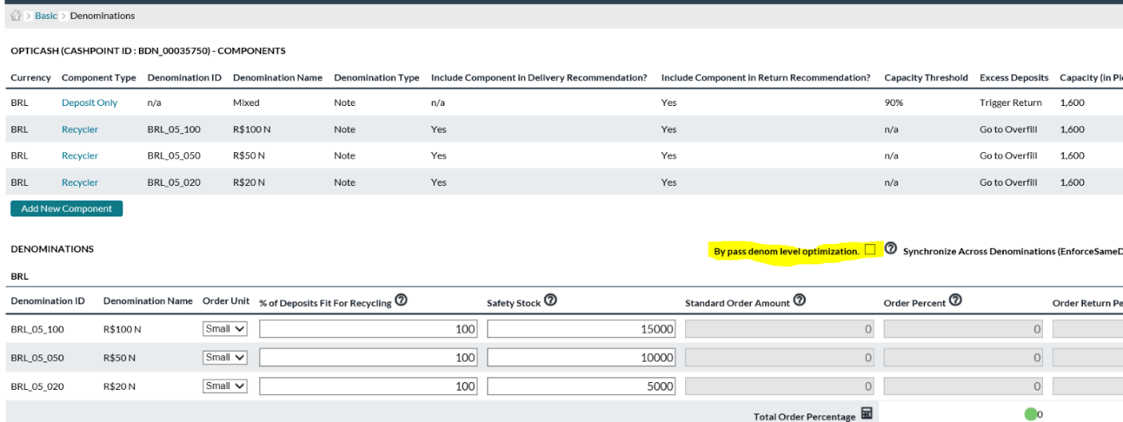

There is a validation added where users will not be able to choose the override checkbox as shown below:

1. Cashpoints should have one mixed deposit component and either
2. All withdrawal components or
3. All recyclers components

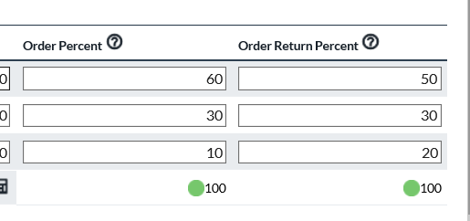

Order return percent has been added to advance devices. The isn’t something that regular ATMs had to be concerned about.

This acts the same way as order percent, returns will be splited across denominations according to the percentage. Much like Order Percent, these values are required for the bypass denomination settings.

Figure 163 CHECKS

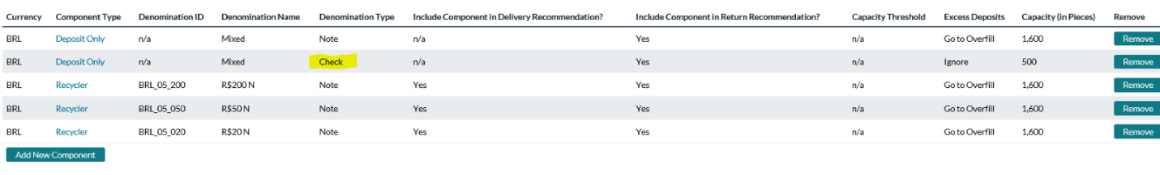

Added check components to the application.

Check is a new denominationon type, however it cannot  be assigned to a denomination normally. It is a special internal denomination that is exclusively to advance device mixed components.

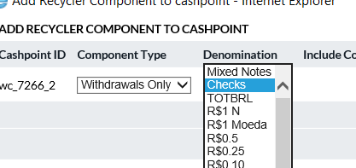

A check component can be deposit only. This validation is now added to mixed note components as well. The unused Mixed coin option was also removed from this selector.

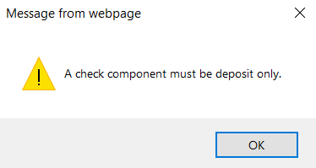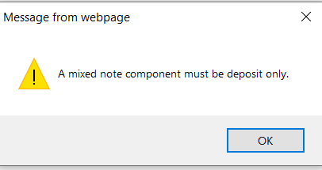

When viewing horizons by values we don’t see any values for checks because we aren’t forecasting for them. We are only forecasting for pieces for checks and therefore have no data to show for checks.

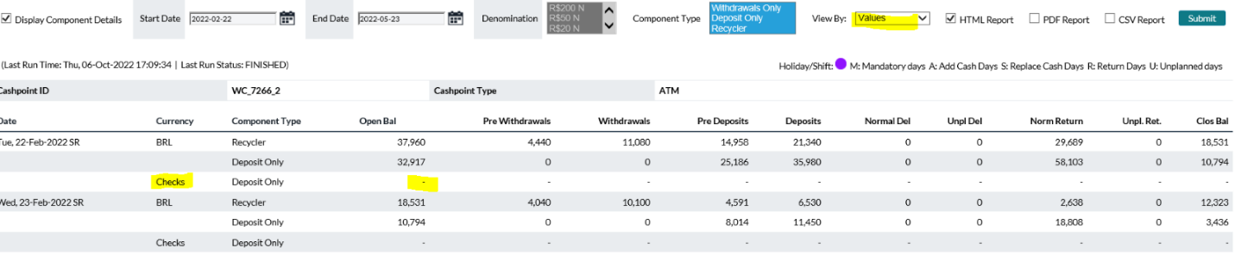

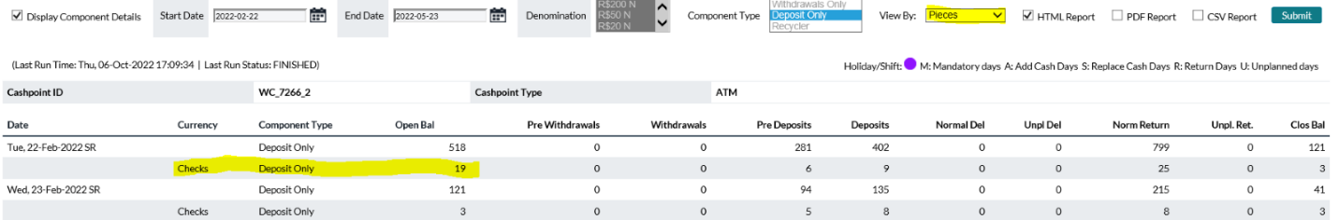

### Cashpoint Service Costs

The Cashpoint Service Costs Report shows a detail of each Cashpoint’s service costs.

Table 146: Cashpoint Service Costs Description

| Field | Description |
| --- | --- |
| **Select Button** | Allows the user to choose Cashpoints to be included in the report. For more information on Cashpoint Selection, see: Cashpoint Selector |
| **Cashpoint ID** | Unique alphanumeric identification of the Cashpoint. |
| **Cashpoint Name** | The name of the Cashpoint as defined at the Cashpoint |
| **Depot** | The Depot to which the Cashpoint is assigned. |
| **Type** | The Type of depot that is being reported  Primary  Secondary |
| **Currency ID** | The Currency ID for which the costs are associated. |
| **Services** | The type of Service that is being reported  Delivery/Add Cash  Return/Replace Cash  Unplanned Service |
| **Costs** | Each of the cost types is explained in the Cashpoint Parameters section of this document. See: Table 15: Service Costs Description |

Return To: System Settings Reports

### Cashpoint Service Days

The Cashpoint Service Days report shows the user information about the service schedule assigned for each Cashpoint. The report is broken down to show all the delivery parameters that are associated with each Cashpoint. Because there are slightly different parameters for ATMs and Branches, it is not possible to show all Cashpoint types in the same report.

Table 147: Cashpoint Service Days Description

| Field | Description |
| --- | --- |
| **Select Button** | Allows the user to choose Cashpoints to be included in the report. For more information on Cashpoint Selection, see: Cashpoint Selector |
| **Sort By** | Allows the user to sort the report.  Delivery Day  Return/Replace Day  Cashpoint ID |
| **Cashpoint ID** | Unique alphanumeric identification of the Cashpoint. |
| **Cashpoint Name** | The name of the Cashpoint as defined at the Cashpoint |
| **Service Days** | The Service days are explained in detail in the Cashpoint Parameters section of the User Guide, see: Table 14: Business and Service Days Description |
| **Transit Time** | Transit Time is used by cost calculation to determine Dead Money Costs. The number of days that money is delivered to or returned by this cashpoint spends in transit. Dead Money Cost is the number of days times the Overnight Earnings Rate. |
| **Currency ID** | A column is displayed in the report for branches to specify special service days for foreign currency. These foreign currency service days are defined at the cashpoint level. For more information see: Cashpoint→Advanced→Foreign Currency Service Days |

Return To: System Settings Reports

### Cashpoint Service Exceptions

The Cashpoint Service Exceptions Report show the changes to the service days for each of the Cashpoints and events that are assigned.

Table 148: Cashpoint Service EXCEPTIONS DESCRIPTION

| Field | Description |
| --- | --- |
| **Select Button** | Allows the user to choose Cashpoints to be included in the report. For more information on Cashpoint Selection, see: Cashpoint Selector |
| **Cashpoint ID** | Unique alphanumeric identification of the Cashpoint. |
| **Cashpoint Name** | The name of the Cashpoint as defined at the Cashpoint |
| **Service Exception ID** | The identifier of the Service Exception that has been defined at *Cashpoint → Basic → Service Days → Service* Exceptions or assigned through the *Network→Defaults→Service* Exceptions page. |
| **Exception Start** | The starting date of the service exception |
| **Exception End** | The ending date of the service exception |
| **Exception Type** | Describes the type of Service Exception that is defined. For a list of the specific Service Exceptions, see: Table 14: Business and Service Days Description |
| **Shift Days** | The number of days the service will be shifted if Shift Before or Shift After. |

Return To: System Settings Reports

### Cashpoint Service Schedules

The Cashpoint Service Schedules Report shows a detailed report of the upcoming service days on the horizon that is generated after the recommendation process is run.

Table 149: Cashpoint Service SCHEDULE DESCRIPTION

| Field | Description |
| --- | --- |
| **Select Button** | Allows the user to choose Cashpoints to be included in the report. For more information on Cashpoint Selection, see: Cashpoint Selector |
| **Cashpoint ID** | Unique alphanumeric identification of the Cashpoint. |
| **Cashpoint Name** | The name of the Cashpoint as defined at the Cashpoint |
| **Cashpoint Type** | Type of Cashpoint based on type and replenishment schedule(Add ATM, Replace ATM, Branch, etc.) |
| **Currency ID** | A column is displayed in the report for branches to specify special service days for foreign currency. These foreign currency service days are defined at the cashpoint level. For more information see: Cashpoint→Advanced→Foreign Currency Service Days |
| **Service Date** | The date of service |
| **Delivery** | Specifies the availability of delivery.  **Blank** – No delivery is possible  **Optional** – Delivery is possible on this day but not required  **Required** - A delivery must be performed on this day |
| **Return** | Specifies the availability of returns.  **Blank** – No return is possible  **Optional** –Return is possible on this day but not required  **Required** - A return must be performed on this day if necessary. If a delivery is needed, the Return day is overridden. |
| **Unplanned Order Day** | Shows if an unplanned delivery is possible for this day.  **Yes** – Unplanned deliveries are possible  **No** – Unplanned deliveries are not possible |
| **Valid Business Day** | Shows if the day is set as a Business Day  **Yes** – The day is set as a Business Day  **No** – The day is not a Business Day |
| **Holiday** | Shows if the day is a Holiday  **Yes** – The day is set as a Holiday based on the calendars and events assigned to the Cashpoint  **No** – The day is not a Holiday |
| **Exception** | Shows if the day is an Exception day meaning the base parameters are overridden to accommodate for special operational circumstances  **Yes** – The day is set as an Exception Day  **No** – The day has no exceptions |
| **Delivery Order Date** | The date that the order must be placed for this service day. This day is determined by the lead time and any service exceptions or non-processing days that may be defined for the Cashpoint |
| **Return Order Date** | The date that the order must be placed for this service day. This day is determined by the lead time and any service exceptions or non-processing days that may be defined for the Cashpoint |
| **Unplanned Order Date** | The date that the order must be placed for this service day. This day is determined by the lead time and any service exceptions or non-processing days that may be defined for the Cashpoint |

Return To: System Settings Reports

### Cashpoint Event Collisions

Event collisions might occur when the pre and post-days of two events fall within the same days. Pre and post-days are the days that impact the demand prior and after the event. The overlapping events can impact the output of recommendations and forecast processes. When event collisions occur, the system must decide which event to associate with the demand.

To ensure the correct and effective process of recommendations and forecasts, the event collisions must be corrected by making sure that the pre and post-effect days do not overlap. First, check event collisions as described below and second, update the pre and post-effect of the events under the Events tab.

When event collisions occur, OptiCash will first take into consideration those events that have a priority against other events. The priorities are determined by the following general rules:

Holiday events are always considered first, then non-holiday events. Events are considered before pre/post effects of events, except for when holiday pre/post effects collide with a non-holiday event.

Table 150: Event Collisions Description

| Field | Description |
| --- | --- |
| **Date** | Date of the event. |
| **Cashpoint ID** | Unique alphanumeric identification of the Cashpoint. |
| **Calendar** | Displays the name of the calendar this event belongs to. |
| **Event ID** | Unique alphanumeric code identifying this event. |
| **From/To** | The time period of the event: start and end dates. |
| **Pre Effect** | The number of days that are impacted before this event. For example, demand may be impacted by Christmas for several days before December 25. |
| **Post Effect** | The number of days impacted after the event. |

Return To: Reports Tab

### Cashpoint Events

Cashpoints can belong to one or to multiple Calendars which may contain one or more Events on them. Cashpoint Events report allows users to report by cashpoint what Events are associated with the cashpoint.

Table 151: Cashpoint Events Description

| Field | Description |
| --- | --- |
| **Select Button** | Allows the user to choose Cashpoints to be included in the report. For more information on Cashpoint Selection, see: Cashpoint Selector |
| **Cashpoint ID** | Unique alphanumeric identification of the Cashpoint. |
| **Cashpoint Name** | Name of the cashpoint as defined by the *Cashpoint>Basic>Cashpoint* Definition page |
| **Calendar ID** | Unique OptiCash ID that defines the calendar whose Events are being listed |
| **Currencies** | Listing by ISO code which currencies are associated with the calendar |
| **Event ID** | Unique OptiCash ID for each event associated with the Calendar |
| **Month** | Calendar Month (Jan, Feb, Mar, et al) in which the defined event occurs |
| **Day or Week** | Events can be defined either for a specific day of the month such as 01 January for every year. Events can also be defined by a particular week and day. For example, an event may always occur on the third Monday in February. This field is numeric and will list the date of the week numerically. If it is the Week being defined the next field “Weekday” will be populated |
| **Weekday** | If an event occurs on a day of a particular week each year such as the third Monday in February, this field will be populated with the Weekday. (e.g., “Monday” in the example). If the Event is for a particular date such as 01 January each year this field will be blank. |
| **Pre-Effect** | Number of Pre-Effect days defined in the Event definition |
| **Post-Effect** | Number of Post-Effect days defined in the Event definition |
| **Holiday** | Yes/No field determining whether the Event is also a Holiday. Holiday setting is used by the Forecasting process in conjunction with Open Holidays flag on the *Cashpoint>Basic>Service Days* screen defining whether the individual cashpoint is open on Holidays. |
| **Weekend Shift** | Lists Forward/Backward/None for events when they occur on Saturdays or Sundays. |
| **Event Dates: From/To** | Beginning and Ending dates for each occurrence of the defined Event. |
| **Event Dates: Pre/Post Effect** | Users can override the Pre/Post effect days for each occurrence of the Event. These fields list the actual settings for each occurrence. |
| **Event Dates: Holiday** | Users can override the Holiday definition for each occurrence of the Event. This field lists how each occurrence is defined. |

Return To: System Settings Reports

### Cashpoint Clusters

This report allows the user to display cluster definitions, including parameters chosen and a list of member cashpoints.

Table 152: Cashpoint CLUSTERS DESCRIPTION

| Field | Description |
| --- | --- |
| **Select Button** | Allows the user to choose Cashpoints to be included in the report. For more information on Cashpoint Selection, see: Cashpoint Selector |
| **Cluster ID** | The identifier of the Cluster is used to uniquely identify it in the system. |
| **Depot ID** | Depot which services this Cluster. |
| **Depot Name** | Name of Depot which services this Cluster. |
| **Region ID** | Region with which this cluster is associated. |
| **Region Name** | Name of Region with which this cluster is associated. |
| **Optimization Profile** | The parameter is chosen for this Cluster: Individual Optimization, Alert, or Cluster Optimization. |
| **Allow Creating Emergency Orders** | Yes/No parameter. |
| **Cashpoint ID** | Cashpoint is a member of this Cluster. |
| **Cashpoint Type** | Indicates the type of Cashpoint listed in the preceding “**Cashpoint ID**” field. |

Return To: System Settings Reports

### Cashpoint Groups

This report allows the user to select a list of Cashpoints which will display the Groups to which those Cashpoints belong. After each group, a summary will be printed in the report showing the total number of ATMs and Branches in the group.

**Note**: If the user does not select all Cashpoints, the report will only show Cashpoints and the number for those Cashpoints selected. Therefore, the summary information at the bottom of each group is reflective of the Cashpoints that were selected for the report.

Table 153: Cashpoint GROUPS DESCRIPTION

| Field | Description |
| --- | --- |
| **Select Button** | Allows the user to choose Cashpoints to be included in the report. For more information on Cashpoint Selection, see: Cashpoint Selector |
| **Group ID** | The identifier of the Group is used to uniquely identify it in the system. |
| **Group Name** | The name of the Group as defined in *Network→Groups* |
| **Cashpoint ID** | Unique alphanumeric identification of the Cashpoint. |
| **Cashpoint Name** | The name of the Cashpoint as defined at the Cashpoint |
| **Cashpoint Type** | Type of Cashpoint based on type and replenishment schedule (Add ATM, Replace ATM, Branch, etc.) |
| **Creation Date** | The date that the Group was created |
| **Last Update Date** | The date that the Group was last updated. |

Return To: System Settings Reports

### Commercial Cashpoint Groups

This report allows the user to select a list of Commercial Cashpoints which will display the Commercial Groups to which those Cashpoints belong.

Table 154: Commercial Cashpoint GROUPS DESCRIPTION

| Field | Description |
| --- | --- |
| **Select Button** | Allows the user to choose Cashpoints to be included in the report. For more information on Cashpoint Selection, see: Cashpoint Selector |
| **Group ID** | The identifier of the Group is used to uniquely identify it in the system. |
| **Group Name** | The name of the Group as defined in *Network→Commercial* Clients |
| **Cashpoint ID** | Unique alphanumeric identification of the Cashpoint. |
| **Cashpoint Type** | Type of Cashpoint based on type. Filled with “**Commercial**” |
| **Creation Date** | The date that the Group was created |
| **Last Update Date** | The date that the Group was last updated. |

Return To: System Settings Reports

### Cashpoint Linkage

This report shows the Cashpoints that are linked to one another based on the settings in the Cashpoints. The report also displays information on the type of linkage that is currently in effect.

Table 155: Cashpoint LINKAGE DESCRIPTION

| Field | Description |
| --- | --- |
| **Select Button** | Allows the user to choose Cashpoints to be included in the report. For more information on Cashpoint Selection, see: Cashpoint Selector |
| **Owner ID** | Unique alphanumeric identification of the Cashpoint that is set up as the Parent Cashpoint |
| **Linked To** | Unique alphanumeric identification of the Cashpoint that is linked to the Parent Cashpoint |
| **Location** | Specifies the Location of the Cashpoint   * Onsite * Offsite * Attached * Side-By-Side |
| **Schedule** | Shows the linkage scenario for the Schedule   * Not Linked * Shared Schedule |
| **Vault** | Shows the linkage scenario for the Vault   * Not Linked * Linked Orders * Linked Balances |

Return To: System Settings Reports

### Institution Details

The Institution Details Report displays information about the institution parameters and licenses currently in force.

Table 156: Institution Details Description

| Field | Description |
| --- | --- |
| **Institution ID** | The ID of this institution to whom the software is licensed |
| **Institution Name** | The name of the institution to whom the software is licensed |
| **Address** | Institution address that is defined in the *System→Institution Page* |
| **Contact Name** | Name of the Contact Person that is defined in the *System→Institution Page* |
| **Business Days** | Institution Business Days as defined in the *System→Institution Page* |
| **Cashpoints Allotted** | Number of Cashpoints for which the institution is licensed |
| **Cashpoints Defined** | The current number of Cashpoints defined in the system |
| **Cashpoints Active** | Number of Cashpoints currently active in the system |
| **Split Denomination for Branches** | The parameter currently defined for denomination splits for branches is defined on the *Processing→Recommendations→Institution* Settings page |

Return To: System Settings Reports

### Network Contacts

The Network Contacts Report allows the user to display the contact details for Regions, Depots, Services, and Centers.

Table 157: Network Contacts Description

| Field | Description |
| --- | --- |
| **Select Button** | Allows the user to choose Cashpoints to be included in the report. For more information on Cashpoint Selection, see: Cashpoint Selector |
| **Cashpoint ID** | Unique alphanumeric identification of the Cashpoint. |
| **Reports Grouped By** | The user can select contact details for the following:   * Center * Servicer * Depot * Region |

Return To: System Settings Reports

### BUSINESS UNITS

The Business Units Report allows users to display Business Units (formerly User Groups) that are assigned specific privileges. This report has filter options to choose which cashpoints, members, and business units will be included in the report.

Table 158: Business Units description

| Field | Description |
| --- | --- |
| **Select Button** | Allows the user to choose Cashpoints to be included in the report. For more information on Cashpoint Selection, see: Cashpoint Selector |
| **Cashpoint ID** | Unique alphanumeric identification of the Cashpoint. |
| **Business Units** | The user can select created Business Units. |
| **Members** | The user can select created Members. (This functionality is moved to EPSS portal) |

1. Historical Reports

The Historical Reports provide users with information on current or history, Orders, and Recommendations.

The following is a summary of the information that will be covered along with hyperlinks to each topic:

* History
* Linked History
* Enhanced ATM History
* History By Denomination
* Intraday History
* Downtime
* Orders
* Ordered Denominations
* Order Custom Fields
* Bag Reference Numbers
* Special Orders
* ATM Residuals
* Linked Orders
* Recommendations
* Special Requirements
* Target vs. Historical Balance
* Target Balance vs. Historical Recommendation
* Order Notification Report
* Cash Levels Report
* Order Blog History Report

Return To: Reports Tab

## History

The History report can be run on both the network and the Cashpoint level. This report allows reviewing all the balance and service details committed in the past. This report is particularly useful to trace unusually high or low demand, which can then be excluded from the forecast to avoid discrepancies associated with such demand

Table 159: History Description

| Field | Description |
| --- | --- |
| **Select Button** | Allows the user to choose Cashpoints to be included in the report. For more information on Cashpoint Selection, see: Cashpoint Selector |
| **Cashpoint ID** | Unique alphanumeric identification of the Cashpoint. |
| **Date** | The date for which the history details are displayed. |
| **Currency** | Currency for which the history details are reported. |
| **Open Bal** | The starting balance represents the closing balance of the last day. |
| **Deliveries** | Planned deliveries for that date. |
| **Returns** | For branches and replacements, ATMs represent the amount of cash returned. |
| **Unplanned Deliveries** | Emergency delivery is triggered when the opening balances are under the required balance. |
| **Unplanned Returns** | Emergency return is triggered when the opening balances are over the maximum holding. |
| **Pre-Withdrawals** | **For ATMs only,** this amount indicates how much cash was withdrawn on a delivery day before the service action. |
| **Deposits** | Represent customer deposits during that date. |
| **Withdrawals** | Represent customer withdrawals during that date. |
| **Closing Balance** | Closing balance at the end of the day. |
| **H/E** | Stoplight-driven field to show whether the historical date was defined as an Event or a Holiday in OptiCash. |
| **Exclude** | Check the box to exclude the balance and delivery records of this date from the Cashpoint history. When checked, this history record will not be used during forecast generation. |
| **Exclusion Reason** | ATMs Only: Displays the Reason an exclusion occurred for a date based on the Automatic Rules on the Network Monitoring page. |

|  |  |
| --- | --- |
| Branches only | |
| **Resvd. Clos.** | Branch Reserve Cash Closing Balance: the total amount of cash that is part of the cash holdings at end of the trading day but is reserved for special customers. Reserved cash is cash that is put aside for special customer collection and is not used to service other customer withdrawals.  **Note:** Reserved cash will not affect the opening and closing balance for the branch. When recommendations run, normal forecasted demand will be taken into consideration. However, recommendations will decide based on available cash to cover forecasted demand. Since reserved cash will affect available cash, the next day’s opening balance will equal the last day’s closing balance less the reserved cash balance. |
| **ATM Ship In** | Total returns received into branch funds from on-site ATMs. |
| **ATM Ship Out** | Total replenishments from branch funds to on-site ATMs. |
| Advanced Devices only | |
| **Note**: At the Cashpoint level report for Advanced Devices, the History report can be run with “**Detailed Information**” which will add Denomination, Component, and other information to provide a truly detailed view of the historical data. | |
| **Dispense** | **Dispense**: the balance of the dispensing cassette that is configured to only dispense notes. |
| **Recycle** | **Recycle** the balance of the recycle cassette that is configured to receive deposits and can dispense as withdrawals. |
| **Cash-In** | **Cash-in**: the balance of the cash-in cassette that is configured to receive deposited notes only and cannot be used by the machine to dispense as withdrawals. |
|  | **Note**: the sum of Dispense, Recycle and Cash-In balances should equal the total closing balance at the ATM. |
| **Status** | Operation or Non-Operation ATM. |

Return To: Historical Reports

## Linked History

The Linked History report can be run on both the network and the Cashpoint level. This report allows reviewing all the balance and service details committed in the past at the Balance Account level. This report is particularly useful to trace unusually high or low demand, which can then be excluded from the forecast to avoid discrepancies associated with such demand

Table 160: Linked History Description

| Field | Description |
| --- | --- |
| **Select Button** | Allows the user to choose Cashpoints to be included in the report. For more information on Cashpoint Selection, see: Cashpoint Selector |
| **Cashpoint ID** | Unique alphanumeric identification of the Cashpoint. |
| **Date** | The date for which the history details are displayed. |
| **Currency** | Currency for which the history details are reported. |
| **Account** | Balance Account for which the history details are reported |
| **Open Bal** | The starting balance represents the closing balance of the last day. |
| **Withdrawals (Outflows)** | Reduction of the account balance through the outflow |
| **Deposits (Inflows)** | Increase of the account balance through the inflow |
| **Net Demand** | Difference between Withdrawals and Deposits |
| **Deliveries (Cash In)** | Planned deliveries for that date. |
| **Returns (Cash Out)** | For branches and replacements, ATMs represent the amount of cash returned. |
| **Unplanned Deliveries (Cash In)** | Emergency delivery is triggered when the opening balances are under the required balance. |
| **Unplanned Returns (Cash Out)** | Emergency return is triggered when the opening balances are over the maximum holding. |
| **Closing Balance** | Closing balance at the end of the day. |
| **Account Delivery** | Delivery total for the full branch reflecting a sum of the individual account deliveries |
| **Account Return** | Return total for the full branch reflecting a sum of the individual account returns |

Return To: Historical Reports

## History By Denomination

The History by Denomination Report provides denomination history reporting. It allows viewing history including the ability to filter by Cash Quality. Please note that care should be used when running this report since the results of the report could be quite large.

Table 161: History by DENOMINATION DESCRIPTION

| Field | Description |
| --- | --- |
| **Select Button** | Allows the user to choose Cashpoints to be included in the report. For more information on Cashpoint Selection, see: Cashpoint Selector |
| **Cashpoint ID** | Unique alphanumeric identification of the Cashpoint. |
| **Date** | The date for which the history details are displayed. |
| **Currency** | Currency for which the history details are reported. |
| **Denomination** | Defines the denomination of each currency included in the historical period selected |
| **Quality** | Designation of Note/Cash Quality by denomination. The History by Denomination report can be filtered by Cash Quality so that only specific qualities are included in the output. |
| **Open Bal** | The starting balance represents the closing balance of the last day. |
| **Deliveries** | Planned deliveries for that date. |
| **Returns** | For branches and replacements, ATMs represent the amount of cash returned. |
| **Unplanned Deliveries** | Emergency delivery is triggered when the opening balances are under the required balance. |
| **Unplanned Returns** | Emergency return is triggered when the opening balances are over the maximum holding. |
| **Pre-Withdrawals** | **For ATMs only,** this amount indicates how much cash was withdrawn on a delivery day before the service action. |
| **Deposits** | Represent customer deposits during that date. |
| **Withdrawals** | Represent customer withdrawals during that date. |
| **Closing Balance** | Closing balance at the end of the day. |
| **Exclude** | Check the box to exclude the balance and delivery records of this date from the Cashpoint history. When checked, this history record will not be used during forecast generation. |
| **Exclusion Reason** | ATMs Only: Displays the Reason an exclusion occurred for a date based on the Automatic Rules on the Network Monitoring page. |
| Branches only | |
| **Resvd. Clos.** | Branch Reserve Cash Closing Balance: the total amount of cash that is part of the cash holdings at the end of the trading day but is reserved for special customers. Reserved cash is cash that is put aside for special customer collection and is not used to service other customer withdrawals.  **Note:** Reserved cash will not affect the opening and closing balance for the branch. When recommendations run, normal forecasted demand will be taken into consideration. However, recommendations will decide based on available cash to cover forecasted demand. Since reserved cash will affect available cash, the next day’s opening balance will equal the last day’s closing balance less the reserved cash balance. |
| **ATM Ship In** | Total returns received into branch funds from on-site ATMs. |
| **ATM Ship Out** | Total replenishments from branch funds to on-site ATMs. |
| Advanced Devices only | |
| **Dispense** | **Dispense**: the balance of the dispensing cassette that is configured to only dispense notes. |
| **Recycle** | **Recycle** the balance of the recycle cassette that is configured to receive deposits and can dispense as withdrawals. |
| **Cash-In** | **Cash-in**: the balance of the cash-in cassette that is configured to receive deposited notes only and cannot be used by the machine to dispense as withdrawals. |
|  | **Note**: the sum of Dispense, Recycle and Cash-In balances should equal the total closing balance at the ATM. |
| **Status** | Operation or Non-Operation ATM. |

## Enhanced ATM History

The Enhanced ATM History report expounds upon the detail found in the History report, but it adds the number of notes for each data type, and it also provides the number of customer transactions for both Deposits and Withdrawals. This report allows reviewing all the balance and service details committed in the past.

**NOTE**: The report has two versions; one in total currency Values and one in total note/coin Pieces.

Table 162: Enhanced ATM History Description

| Field | Description |
| --- | --- |
| **Select Button** | Allows the user to choose Cashpoints to be included in the report. For more information on Cashpoint Selection, see: Cashpoint Selector |
| **Cashpoint ID** | Unique alphanumeric identification of the Cashpoint. |
| **Start Date** | Starting date of the report |
| **End Date** | Ending Date of the report |
| **View by** | Results can be returned in currency Value such as total dollars or in Pieces which would be the total number of notes/coins |
| **Date** | The date for which the history details are displayed. |
| **Currency** | The currency for the displayed history record. (E.g. USD, GBP, MXN, et al) |
| **Component Type** | The total percentage of time the ATM was available for the day. |
| **Cassette** | Returns Cassette ID assigned to the component |
| **Denomination Type** | Note or Coin |
| **Denomination ID** | A unique ID is assigned to the Denomination |
| **Opening Balance** | The starting balance represents the closing balance of the last day. |
| **Deliveries** | Planned deliveries for that date. |
| **Returns** | Planned returns for that date. |
| **Unplanned Deliveries** | Emergency delivery is triggered when the opening balances are under the required balance. |
| **Unplanned Returns** | Emergency return is triggered when the opening balances are over the maximum holding. |
| **Deposits** | Amount of customer deposits for that day |
| **Pre-Withdrawals** | **For ATMs only,** this amount indicates how much cash was withdrawn on a delivery day before the service action. |
| **Withdrawals** | Amount of customer withdrawals for that day |
| **Closing Balance** | Closing balance at the end of the day. |
| **Excluded** | An indicator showing whether that date has been excluded from usage for forecasting purposes |

Return To: Historical Reports

## Intraday History

The Intraday History report details the cashpoint activity and balance activity reported during the intraday period throughout the business day. The report shows records which consist of partial day data. If Users load 4 files each for a different period for a single day, the report would return all 4 records because the users still select data in by full calendar days.

Table 163: Enhanced ATM History Description

| Field | Description |
| --- | --- |
| **Select Button** | Allows the user to choose Cashpoints to be included in the report. For more information on Cashpoint Selection, see: Cashpoint Selector |
| **Cashpoint ID** | Unique alphanumeric identification of the Cashpoint. |
| **Start Date** | Starting Date of the Report |
| **End Date** | Last Date of the Report |
| **View by** | Users select for results to be shown either as whole currency amounts or piece count |
| **Type** | The user selects whether to generate for ATMs or Branches. Users should make this selection before opening the Cashpoint Selector |
| **Currency** | Users select one, more, or all Currencies to generate results |
| **Cycle Start** | Shows the first cycle loaded to OptiCash on the Start Date chosen by the user |
| **Cycle End** | Shows the last cycle loaded to OptiCash on the End Date chosen by the user |
| **Currency** | Currency for which the history details are reported. |
| **Component Type** | Withdrawals Only, Dispense Only, or Recycling |
| **Cassette** | Returns Cassette ID assigned to the component |
| **Denomination ID** | Defines the denomination of each currency included in the historical period selected |
| **Quality** | Designation of Note/Cash Quality by denomination |
| **Open Bal** | The starting balance represents the closing balance of the last day. |
| **Deliveries** | Planned deliveries for that date. |
| **Returns** | For branches and replacements, ATMs represent the amount of cash returned. |
| **Unplanned Deliveries** | Emergency delivery is triggered when the opening balances are under the required balance. |
| **Unplanned Returns** | Emergency return is triggered when the opening balances are over the maximum holding. |
| **Pre Srv** | **For ATMs only,** this amount indicates how much cash was withdrawn on a delivery day before the service action. |
| **Deposits** | Represent customer deposits during that date. |
| **Withdrawals** | Represent customer withdrawals during that date. |
| **Closing Balance** | Closing balance at the end of the day. |

## Downtime

The Downtime Report provides details on the downtimes that have been loaded into OptiCash for ATMs.

* **Caution**: The results of the report could be quite large.

Table 164: Downtime Description

| Field | Description |
| --- | --- |
| **Select Button** | Allows the user to choose Cashpoints to be included in the report. For more information on Cashpoint Selection, see: Cashpoint Selector |
| **Cashpoint ID** | Unique alphanumeric identification of the Cashpoint. |
| **Start Date** | Starting date of the report |
| **End Date** | Ending date of the report |
| **Date** | Date of the reported occurrence of the downtimes |
| **Downtime reasons** | 9 different reasons can be defined and displayed. |
| **Total Uptime** | The total percentage of time the ATM was available for the day. |

Return To: Historical Reports

## Orders

The Orders Report allows the user to print orders that have been committed by the branch and the ATM group. This report allows the user to have information by denomination and currency and also to report orders generated in the past.

Table 165: Orders Description

| Field | Description |
| --- | --- |
| **Select Button** | Allows the user to choose Cashpoints to be included in the report. For more information on Cashpoint Selection, see: Cashpoint Selector |
| **Cashpoint ID** | Unique alphanumeric identification of the Cashpoint. |
| **Cashpoint Type** | Branch or ATM. |
| **Action** | Indicates the type of action: delivery, return or unplanned delivery/return. |
| **Confirmation #** | Confirmation number of the order that has been committed. Upon clicking the hyperlink, the Cashpoint order confirmation screen will be displayed for the order. |
| **Order Date** | The date of when the order was placed. |
| **Order Source** | Indicates the status of the order: auto-committed accepted the recommendation, overridden recommendation, manual order or centrally overridden. |
| **Override Reason** | The override reason indicates why a particular recommendation from OptiCash was not used. The override reasons are created at the **Institution** level under the **System** tab or using OptiNet maintenance functionality. |
| **Currency** | Currency for which the order details are reported. |
| **Amount** | The amount that has been ordered. |

Return To: Historical Reports

## Ordered Denominations

The ordered Denominations report provides users with the ability to view all orders and can be filtered by cashpoint and date range. The reports provide the ability to see not only denomination detail but also the Cash Quality detail.

Table 166: Ordered Denominations Description

| Field | Description |
| --- | --- |
| **Select Button** | Allows the user to choose Cashpoints to be included in the report. For more information on Cashpoint Selection, see: Cashpoint Selector |
| **Cashpoint ID** | Unique alphanumeric identification of the Cashpoint. |
| **Due Date** | Date the order is supposed to be physically delivered to or removed from the cashpoint |
| **Cashpoint Type** | Branch or ATM. |
| **Currency** | Designates the currency each denomination is assigned to |
| **Denomination ID** | Designates the denomination for the line. Each denomination can occur multiple times in the report due to the Cash Quality designations defined below. |
| **Quality** | Designates the Cash Quality for the line. |
| **Action** | Indicates the type of action: delivery, return or unplanned delivery/return. |
| **Confirmation #** | Confirmation number of the order that has been committed. Upon clicking the hyperlink, the Cashpoint order confirmation screen will be displayed for the order. |
| **Order Date** | The date of when the order was placed. |
| **Order Source** | Indicates the status of the order: auto-committed accepted the recommendation, overridden recommendation, manual order or centrally overridden. |
| **Override Reason** | The override reason indicates why a particular recommendation from OptiCash was not used. The override reasons are created at the **Institution** level under the **System** tab or using OptiNet maintenance functionality. |
| **Custom Fields 1-10** | Correspond to the user-defined custom fields that can be set up and tied to orders. |

Return To: Historical Reports

## Commercial Orders

The Commercial Orders Report provides details on the commercial orders that were placed by the Branch in OptiNet.

* **Caution:** The results of the report could be quite large if all Cashpoints and dates are selected.

Table 167: Commercial Orders Description

| Field | Description |
| --- | --- |
| **Select Button** | Allows the user to choose Cashpoints to be included in the report. For more information on Cashpoint Selection, see: Cashpoint Selector |
| **Cashpoint ID** | Unique alphanumeric identification of the Cashpoint. |
| **Start Date** | Starting date of the report |
| **End Date** | Ending date of the report |
| **Search By** | Determines how the starting and ending dates will be used in the search criteria of the report. The available options are:   * **Due Date –** This means the start/end dates of the search will look at the due dates of the deliveries * **Order Date –** This means the start/end dates of the search will look at the order dates of the deliveries |
| **Grouped By** | Determines the information that will be displayed in the report. The available options are:   * **Currency –** A currency order will be displayed as a total for the entire order. No denomination details will be displayed * **Denomination –** The order is broken down by denomination and a summary total record is inserted to show the sum of the order amount. |
| **Due Date** | The date the order is due to be delivered |
| **Client ID** | The identifier of the client to which the order will be delivered |
| **Branch ID** | The branch Cashpoint ID that placed the order for the commercial client |
| **Action** | Specifies the type of service to be performed.  The available actions are:   * Commercial Delivery * Commercial Return |
| **State** | Reports the current Workflow State the order is in at the time the report is run. (Ordered, In Transit, Confirmed, et al) |
| **Conf #** | The confirmation number for the order |
| **Order Date** | The date the order was placed by the Branch |
| **Currency** | The currency ID of the order |
| **Denomination** | The denomination ID of the order |
| **Amount** | Amount of the order |

Return To: Historical Reports

## Order Custom Fields

The Order Custom Field report allows users to view the orders along with the Custom Fields that have been entered for the order.

Table 168 : Order Custom Fields Description

| Field | Description |
| --- | --- |
| **Min Amount** | Allows users to filter the order report to values of a minimum amount |
| **Max Amount** | Allows users to filter the order report to values of a maximum amount |
| **Cashpoint ID** | Unique alphanumeric identification of the Cashpoint. |
| **Cashpoint Type** | Branch or ATM. |
| **Action** | Indicates the type of action: delivery, return or unplanned delivery/return |
| **Order Date** | The date when the order was placed. |
| **Due Date** | The date an order is due for delivery |
| **Currency ID** | Currency for which the order details are reported. |
| **Amount** | The amount that has been ordered. |
| **Tracking ID** | The Tracking ID Associated with the Order |
| **Container** | The number of containers that a particular shipment (those orders with a common tracking ID) will include. |
| **Custom01-Custom10** | The Custom Fields Names defined at the System level |

Return To: Historical Reports

## Bag Reference Numbers

Bag Reference number can be used for tracking purposes for a branch return only.

Table 169: Bag Reference Description

| Field | Description |
| --- | --- |
| **Due date** | If the **Due date** is selected, the report will generate order status by the due dates of the orders.  If the **Order date** is selected, the report will generate the order status by the dates when the orders were placed. |
| **Cashpoint ID** | Unique alphanumeric identification of the Cashpoint. |
| **Cashpoint Type** | Branch or ATM. |
| **Action** | Indicates the type of action: delivery, return or unplanned delivery/return. |
| **Confirmation #** | Confirmation number of the order that has been committed. |
| **Order Date** | The date of when the order was placed. |
| **Order Source** | Indicates the status of the order: auto-committed accepted the recommendation, overridden recommendation, manual order or centrally overridden. |
| **Override Reason** | The override reason indicates why a particular recommendation from OptiCash was not used. The override reasons are created at the **Institution** level under the **System** tab or using OptiNet maintenance functionality. |
| **Bag Reference Number** | Reference number for the returned bag. |
| **Currency** | Currency for which the order details are reported. |
| **Amount** | The amount that has been ordered. |

Return To: Historical Reports

## Special Orders

Special orders are orders placed in OptiNet that do not affect the horizon and optimization of the Cashpoint. For example, an order for a commercial client will not be used in the horizon and will not be accounted for in the recommendation process, because this order was placed to meet a single client’s request under certain circumstances. However, it does not represent a usual customer demand; therefore, it is not accounted for in the recommendation process.

Table 170: Special Orders Description

| Field | Description |
| --- | --- |
| **Select Button** | Allows the user to choose Cashpoints to be included in the report. For more information on Cashpoint Selection, see: Cashpoint Selector |
| **Cashpoint ID** | Unique alphanumeric identification of the Cashpoint. |
| **Cashpoint Type** | Branch or ATM. |
| **Action** | Indicates the type of action: delivery, return or unplanned delivery/return. |
| **Conf. #** | Confirmation number of the order that has been committed. |
| **Order Date** | The date of when the order was placed. |
| **Override Reason** | The override reason indicates why a particular OptiCash recommendation was overridden by the OptiCash analyst or branch user. The override reasons are created at the **Institution** level under the **System** tab or using OptiNet maintenance functionality. |
| **Currency** | Currency for which the order details are reported. |
| **Amount** | The amount that has been ordered. |

Return To: Historical Reports

## ATM Residuals

Displays orders for branches with linked ATMs in a **‘Linked Order’** scenario. The report provides information by denomination on the total amount ordered for the branch and the total sum of orders for the linked ATMs.

Table 171: Linked Orders Description

| Field | Description |
| --- | --- |
| **Select Button** | Allows the user to choose Cashpoints to be included in the report. For more information on Cashpoint Selection, see: Cashpoint Selector |
| **Cashpoint ID** | Unique alphanumeric identification of the Cashpoint. |
| **Cashpoint Type** | Branch or ATM. |
| **Action** | Indicates the type of action: delivery, return or unplanned delivery/return. |
| **Conf. #** | Confirmation number of the order that has been committed. |
| **Order Date** | The date of when the order was placed. |
| **Override Reason** | The override reason indicates why a particular OptiCash recommendation was overridden by the analyst or branch user. The override reasons are created at the **Institution** level under the **System** tab or using OptiNet maintenance functionality. |
| **Currency** | Currency for which the order details are reported. |
| **Denomination** | The denomination for which the order details are reported. |
| **Branch Orders** | The total amount that has been ordered for the branch by currency or denomination. This amount is exclusive of linked ATM orders. |
| **Linked ATM Orders** | The total amount that has been ordered for linked ATMs by currency or denomination. If the branch has several linked ATMs, this will be the sum of all linked ATMs for each currency or denomination. |

Return To: Historical Reports

## Linked Orders

Displays orders for branches with linked ATMs in a **‘Linked Order’** scenario. The report provides information by denomination on the total amount ordered for the branch and the total sum of orders for the linked ATMs.

Table 172: Linked Orders Description

| Field | Description |
| --- | --- |
| **Select Button** | Allows the user to choose Cashpoints to be included in the report. For more information on Cashpoint Selection, see: Cashpoint Selector |
| **Cashpoint ID** | Unique alphanumeric identification of the Cashpoint. |
| **Cashpoint Type** | Branch or ATM. |
| **Action** | Indicates the type of action: delivery, return or unplanned delivery/return. |
| **Conf. #** | Confirmation number of the order that has been committed. |
| **Order Date** | The date of when the order was placed. |
| **Override Reason** | The override reason indicates why a particular OptiCash recommendation was overridden by the analyst or branch user. The override reasons are created at the **Institution** level under the **System** tab or using OptiNet maintenance functionality. |
| **Currency** | Currency for which the order details are reported. |
| **Denomination** | The denomination for which the order details are reported. |
| **Branch Orders** | The total amount that has been ordered for the branch by currency or denomination. This amount is exclusive of linked ATM orders. |
| **Linked ATM Orders** | The total amount that has been ordered for linked ATMs by currency or denomination. If the branch has several linked ATMs, this will be the sum of all linked ATMs for each currency or denomination. |

Return To: Historical Reports

## Recommendations

The recommendation report allows the user to find out detailed information by currency and denomination as recommended by OptiCash. This report could be printed for the past period of time to validate information generated by OptiCash or for future predictions that are important from the treasury point of view.

Table 173: Recommendations Description

| Field | Description |
| --- | --- |
| **Select Button** | Allows the user to choose Cashpoints to be included in the report. For more information on Cashpoint Selection, see: Cashpoint Selector |
| **Cashpoint ID** | Unique alphanumeric identification of the Cashpoint. |
| **Cashpoint Type** | Branch or ATM. |
| **Action** | Indicates the type of action: delivery, return or emergency delivery/return. |
| **Confirmation #** | Confirmation number of the recommendation. |
| **Due Date** | The date of when the recommended action is due. |
| **Status** | Indicates the status of the order: auto-committed accepted the recommendation, overridden recommendation, manual order, centrally overridden or declined recommendation. |
| **Currency** | Currency for which the recommendation details are reported. |
| **Amount** | The amount that has been recommended. |

Return To: Historical Reports

## Special Requirements

The Special Requirements Report allows for reviewing all the messages that have been communicated between the OptiCash user and analyst (or OptiNet branch user) regarding their special requirements for balances or orders. The report displays the recipient and sender IDs and the contents of the message.

Table 174: Special Requirements Description

| Field | Description |
| --- | --- |
| **Select Button** | Allows the user to choose Cashpoints to be included in the report. For more information on Cashpoint Selection, see: Cashpoint Selector |
| **Recipient** | The recipient is an OptiCash user who received the message. |
| **From** | Alphanumeric identification of the user who sent the message. |
| **Send Date** | The date the message was sent. |
| **Subject** | The subject of the message. Click on the hyperlinks and the history of messages regarding this subject will be displayed. |
| **Message Body** | Message contents. |

Return To: Historical Reports

## Target vs. Historical Balance

Target vs. Historical Balance allows the analyst to review stored Horizon Balances that are then compared to Historical (actual) balances. The report provides performance data by both cashpoint and currency levels.

The report can be run at three levels which are Detail, Monthly, and Summary. Detail provides daily data for each date in the range. Monthly provides averages by calendar month by cashpoint for extended date ranges, and Summary provides an average by cashpoint for the entire date range selected.

Table 175: Target vs. Historical Balance Description

| Field | Description |
| --- | --- |
| **Select Button** | Allows the user to choose Cashpoints to be included in the report. For more information on Cashpoint Selection, see: Cashpoint Selector |
| **Cashpoint ID** | Unique alphanumeric identification of the Cashpoint. |
| **Date** | The date for which the history details are displayed. |
| **Currency** | Currency for which the balance details are reported. |
| **Target Balance** | Projected balance from stored Horizons. Provides a Point-in-Time view forward for day-to-day performance tracking throughout the month. |
| **Actual Balance** | Historical balance for the day |
| **% Variance** | Variance by a percentage of Actual to Target Balance |

Return To: Historical Reports

## Target Balance vs. Historical Recommendation

When the Target Balance Function is enabled, the report will display the target balance against the historical recommendation.

Table 176: Target Balance Vs. Historical Recommendation Description

| Field | Description |
| --- | --- |
| **Select Button** | Allows the user to choose Cashpoints to be included in the report. For more information on Cashpoint Selection, see: Cashpoint Selector |
| **Cashpoint ID** | Unique alphanumeric identification of the Cashpoint. |
| **Currency** | Currency for which the balance details are reported. |
| **Recom. Date** | Date of the recommendation. |
| **Due Date** | Due date of the recommendation. |
| **Action** | Delivery or Return. |
| **Recommended Amount** | The amount that was recommended by OptiCash. |
| **Target Closing Balance** | Target Closing Balance if the branch return is set to End of Day (EOD).  Target Closing Balance = Forecasted Closing Balance |
| **Target Opening Balance** | Target Closing Balance if the branch delivery and return are set to Beginning of Day (BOD):  Target Opening Balance = Forecasted Opening Balance + Recommended Delivery Amount – Recommended Return Amount. |
|  | **Note**:  1. The target opening & closing balances are based on the due date of the recommendation.  2. Target balance is rounded to the next 1000.  3. Target Opening Balance does not account for unplanned deliveries and returns |

Return To: Historical Reports

## Order Notification Report

Order Notification Report shows the record of changes in order state. These same actions trigger the Custom Order Notification functions.

Table 177: Order Notification Report Field Descriptions

| Field | Description |
| --- | --- |
| **Select Button** | Allows the user to choose Cashpoints to be included in the report. For more information on Cashpoint Selection, see: Cashpoint Selector |
| **Cashpoint ID** | Unique alphanumeric identification of the Cashpoint. |
| **Workflow** | Order type. There is a different workflow definition for each order type. |
| **Currency** | Currency for which the record applies |
| **Order Date** | Date the order was placed. |
| **Due Date** | Date the service occurs. |
| **Master Ref #** | Also known as Order Reference. |
| **Amount** | Total Amount |
| **Timestamp** | Date and time when an order state change occurred. |
| **User** | The user who initiated the order state change. |
| **Task** | Workflow Task performed to make the order state change. |
| **New State** | The state of the order as a result of this Task. |
| **Blog** | Additional notes or comments regarding the order state change. |

Return To: Historical Reports

## Cash Levels Report

Cash Levels Report shows the most recent intraday balances by denomination and cassette type for selected ATMs

Table 178: Cash Levels Report Field Descriptions

| Field | Description |
| --- | --- |
| **Select Button** | Allows the user to choose Cashpoints to be included in the report. For more information on Cashpoint Selection, see: Cashpoint Selector |
| **Cashpoint ID** | Unique alphanumeric identification of the Cashpoint. |
| **Currency** | Currency for which the balance details are reported. Multiple currencies can be selected |
| **Cassette Type** | Users may select the cassette type(s) to be included in the report. Options include Withdrawals Only, Deposit Only, and Recycler |

Return To: Historical Reports

## Order Blog History Report

The Order Blog History Report allows users to review all Blog entries by Cashpoint Order. Users can now search by Cashpoint ID and date range to select all orders and full Blog History associated with those criteria.

Table 179: Order Blog History Report Field Description

| Field | Description |
| --- | --- |
| **Select Button** | Allows the user to choose Cashpoints to be included in the report. For more information on Cashpoint Selection, see: Cashpoint Selector |
| **Cashpoint ID** | Unique alphanumeric identification of the Cashpoint. |
| **Report Sorted by** | Users can select to filter report results either by Order Date or Due Date |
| **Start Date/End Date** | Users determine the date range for results to be displayed |
| **Cashpoint Type** | ATM or Branch |
| **Action** | Action performed that created the blog entry (e.g., Ordered, Edited, et al) |
| **Order Date** | The date Order was placed into the system |
| **Due Date** | Date the order is scheduled to arrive at the cashpoint |
| **Conf. #** | Unique order ID for the order that contains the blog entry |
| **Status** | Order Status the order became a result of the task/action performed that created the blog entry |
| **Task** | Task performed when the blog entry was made to the system |
| **Username** | The username is for the user who created the blog message manually or if they performed an action that automatically created the blog entry |
| **Blog Time** | Time/Date stamp of when the blog entry was created and saved into the system |
| **Blog Message** | Displays blog messages entered or auto entered via the system |

Return To: Historical Reports

1. Planning Reports

This section of reports deals with reports that help the user to manage Forecasts, Horizons and Recommendations. In addition to providing information about the health and status of this information, several reports have interactive tools to help the user improve Cashpoint performance.

The following is a summary of the information that will be covered along with hyperlinks to each topic:

* Forecast Average Cycle Discrepancy
* Forecast Comparison
* Forecast Details
* Forecast Definition
* Expired Forecasts
* Forecast Health
* Forecast Health (Calculated)
* Horizons
* Linked Horizons
* Downtime Order Impact Analysis
* Downtime Recommendation Impact Analysis
* Linked Recommendations

Return To: Reports Tab

## Forecast Average Cycle Discrepancy

This report shows a list of Forecast Average Discrepancy Levels between the actual and forecasted values for selected Cashpoints by selected weekly cycle. Average discrepancy values ranging from 80% to 120% are usually considered acceptable. As the forecast improves, the range should move closer to 95% - 110%.

Table 180: Forecast Average Cycle Discrepancy Description

| Field | | Description | |
| --- | --- | --- | --- |
| **Select Button** | | Allows the user to choose Cashpoints to be included in the report. For more information on Cashpoint Selection, see: Cashpoint Selector | |
| **Cashpoint ID** | | Unique alphanumeric identification of the Cashpoint. | |
| **Cashpoint Type** | | Cashpoint type: Branch or ATM. | |
| **Currency** | | Currency for which the report is displayed. | |
| **Average Cycle Actuals** | | Average cycle actual values (withdrawals, deposits, or net demand). | |
| **Average Cycle Forecast** | | Average cycle forecast values (withdrawals, deposits, or net demand). | |
| **Average Cycle Difference** | | Average cycle difference = Average cycle forecast values - Average cycle actual values. | |
| **Average Forecast Discrepancy Rate** | | A discrepancy rate showing difference between the forecasted and actual values during the time frame selected. | |
| **Calculated Forecast Adjustment Percentage** | | Calculated forecast adjustment percentage based on the average discrepancy rate above. For Cashpoints that are under-forecasted, this percentage will be calculated 100% subtracted by the average forecast discrepancy rate above. For Cashpoints that are over-forecasted (forecast discrepancy percentage above 100%), the calculated Adjustment percentage cannot be applied, therefore it will display ‘0’. | |
| **Current Forecast Adjustment Percentage** | | Displays an adjustment percentage that is currently applied to this Cashpoint. | |
| **Update Flag** | | Check the box of the Cashpoints for which the adjustment will be applied. | |
|  | **Note**: Make sure that the Cashpoints have both forecasted and actual data for the time frame selected, otherwise, the report will display that there is no data available.  **Date Selection:** It is recommended to use the Forecast Average Discrepancy report for a shorter recent timeframe, for example, 21 days, which will provide the analyst with the most current measurement. Ideally, reports like Forecast Average Discrepancy and Forecast Health (Calculated) Report should be run using 6 weeks, then 3 weeks, and finally 1 week. The analyst must understand the selected date range as selection depends on certain circumstances. For example, when the 2 weeks date range is selected, any anomaly in the data (cash-out, hardware failure, or neighbouring machine down for a day) will make a noticeable difference, thus leading the analyst to believe that an adjustment is necessary. On the other hand, if the analyst uses too much history, forecast variance can look understated. For example, if there is a seasonal change that the forecast is not picking up, and the selected date range was two months, it could take several weeks for the variance to show, indicating the need to adjust. | |

Return To: Planning Reports

## Forecast Comparison

Table 181: Forecast Comparison Description

| Field | Description |
| --- | --- |
| **Select Button** | Allows the user to choose Cashpoints to be included in the report. For more information on Cashpoint Selection, see: Cashpoint Selector |
| **Cashpoint ID** | Unique alphanumeric identification of the Cashpoint. |

Return To: Planning Reports

## Forecast Details

Network forecast allows the user to report the predicted values for branches and ATMs. OptiCash long-term forecast will allow to generate a formal report with all predicted information as long as the forecast has been generated with sufficient dates into the future.

This report also allows the user to compare actual values against forecast values and determine when the forecast must be generated. This report provides good information every week to determine the quality of the prediction based on a variation reported. Positive variation indicates that the forecast is over the actual values. Negative variations tell those actual values are greater than forecasted values. If this is the case, the forecast must be revised to avoid out-of-cash situations.

Table 182: Forecast Details Description

| Field | Description |
| --- | --- |
| **Select Button** | Allows the user to choose Cashpoints to be included in the report. For more information on Cashpoint Selection, see: Cashpoint Selector |
| **Cashpoint ID** | Unique alphanumeric identification of the Cashpoint. |
| **Date** | The date for which the balance details are displayed. |
| **Currency** | Currency for which the balance details are reported. |
| **Actual** | Actual Withdrawals, Deposits or Net Demand – display the actual amounts for that specific day. |
| **Forecast** | Forecasted Withdrawals, Deposits or Net Demand – display the amounts forecasted by OptiCash for that specific day. |
| **Difference** | Difference between the actual and forecasted values. |
| **% Diff** | Difference between the actual and forecasted values in percentages. |

Return To: Planning Reports

## Forecast Definition

Displays forecast dates by Cashpoints, indicating the last forecasted date and the dates of historical data on a basis of which the forecast has been generated.

Table 183: Forcast Definition Description

| Field | Description |
| --- | --- |
| **Select Button** | Allows the user to choose Cashpoints to be included in the report. For more information on Cashpoint Selection, see: Cashpoint Selector |
| **Forecast Definition ID** | Unique alphanumeric identification of the defined forecast parameters (these parameters are defined under the *Processing tab → Forecast*). |
| **Description** | Description of the selected forecast parameter set. |
| **History From/To** | The dates of the historical data are on a basis of which the forecast is generated. |
| **Forecast From/To** | The dates covered by this forecast. |
| **Cashpoint ID** | Unique alphanumeric identification of the Cashpoint. |
| **Cashpoint Name** | Cashpoint name. |
| **Cashpoint Type** | **Type of Cashpoint:** Add Cash ATM, Replace Cash ATM, Add/Replace Cash ATM, Branch, or one of the various Advanced Device types. |

Return To: Planning Reports

## Expired Forecasts

This report displays a list of each Cashpoint and its last forecast date, which means this forecast was generated for a period that finishes on that date. Based on the forecast period, the system builds up a planned horizon for each Cashpoint. Therefore, when forecasts are close to the expiration date, it is important to immediately generate a new forecast period to enable the system to rebuild a new horizon.

It is recommended to run the Expired Forecasts report at least every month and take note of when the forecasts expire so that the forecast could be regenerated before expiration.

|  |  |
| --- | --- |
|  | **Note**: Recommendations will not run for Cashpoints with expired forecasts (less than 45 days for ATMs and less than 60 days for branches). Therefore, it is critical to regenerate the forecast once expired forecasts are identified by this report. |

Table 184: Expired Forecasts Description

| Field | Description |
| --- | --- |
| **Select Button** | Allows the user to choose Cashpoints to be included in the report. For more information on Cashpoint Selection, see: Cashpoint Selector |
| **Cashpoint ID** | Unique alphanumeric identification of the Cashpoint. |
| **Cashpoint Name** | Name of the Cashpoint. |
| **Last Forecasted Date** | The date of the last forecast. |
| **Status** | The status of the forecast is indicated in the green or red legend.  **Red** indicates that Cashpoint has an expired forecast.  **Green** indicates that Cashpoint’s forecast has not expired yet. |

Return To: Planning Reports

## Forecast Health

The network forecast health is determined by a value indicating the quality of the prediction comparing actual versus forecast demand. Forecast health for branches can be run for withdrawals, deposits, and net demand. The network forecast health report uses a combination of:

* All the Cashpoint historical data.
* The historical data is defined in the horizon ID.
* The same time frame as the prior year (if available).

Usually, a Forecast Health value of over 70% is considered acceptable, however, it depends on the internal policies of each institution. As analysts get more experience with their forecast quality, this rate can be set higher. Cashpoints with a correlation under 70% must be analysed to improve the forecast health up to 70% or over. In some cases, achieving high correlations is not under the user's control and this will be related to a lack of stability in demand. In this case, other adjustments must be selected to ensure the Cashpoints are protected from unexpected demand.

Table 185: Forecast Health Description

| Field | Description |
| --- | --- |
| **Select Button** | Allows the user to choose Cashpoints to be included in the report. For more information on Cashpoint Selection, see: Cashpoint Selector |
| **Cashpoint ID** | Unique alphanumeric identification of the Cashpoint. |
| **Type** | Cashpoint type: Branch or ATM. |
| **Cashpoint Name** | Name of the Cashpoint. |
| **Currency** | Currency for which the Forecast Health details are reported. |
| **Withdrawals / Deposits / Net Demand Forecast Health** | A measure of accuracy between forecasted and actual value. |

Return To: Planning Reports

## Forecast Health (Calculated)

The calculated forecast health report provides a calculated percentage of the shared variation between forecasted and actual values for a defined period of time. The difference between the Network Forecast Health report and the Calculated Forecast Health report is that in the Calculated Forecast health report, the user can define a specific period of time to be analysed. This way the user gains more insight into the Forecast Health value variance during a particular period of time and can make appropriate actions.

For ATMs and Branches, forecast health calculates how well the system will predict withdrawals, deposits and net demand of cash for this future forecasted period.

Table 186: Forecast Health (Calculated) Description

| Field | Description |
| --- | --- |
| **Select Button** | Allows the user to choose Cashpoints to be included in the report. For more information on Cashpoint Selection, see: Cashpoint Selector |
| **Cashpoint ID** | Unique alphanumeric identification of the Cashpoint. |
| **Cashpoint Type** | Cashpoint type: Branch or ATM. |
| **Currency** | Currency for which the report is displayed. |
| **Calculated Forecast Health** | A variation between forecasted and actual values for a defined period of time. |
| **Valid Records** | The number of valid records found in the defined time period used for the calculation of forecast health. If there are no missing records for actual or forecasted values, the number of valid records will be the same as the total records. |
| **Total Records** | The total number of records found in the defined time period corresponds with the number of days selected for the report. |

|  |  |
| --- | --- |
|  | **Note**: Make sure that the Cashpoints have both forecasted and actual data for the time frame selected, otherwise, the report will display that there is no data available.  **Date Selection:** it is recommended to use the Forecast Health (Calculated) report for a shorter recent timeframe, for example, 21 days, which will provide the analyst with the most current measurement. Ideally, reports like Forecast Average Discrepancy and Forecast Health Calculated Report should be run using 6 weeks, then 3 weeks, and finally 1 week. The analyst must understand the selected date range as selection depends on certain circumstances. For example, when the 2 weeks date range is selected, any anomaly in the data (cash-out, hardware failure, or neighbouring machine down for a day) will make a noticeable difference, thus leading the analyst to believe that an adjustment is necessary. On the other hand, if the analyst uses too much history, forecast variance can look understated. For example, if there is a seasonal change that the forecast is not picking up, and the selected date range was two months, it could take several weeks for the variance to show, indicating the need to adjust. |

Return To: Planning Reports

## Horizons

The Horizons report can be run on the network and Cashpoint level. This report displays all the future balances and order details as recommended by OptiCash.

Table 187: Horizons Description

| Field | Description |
| --- | --- |
| **Select Button** | Allows the user to choose Cashpoints to be included in the report. For more information on Cashpoint Selection, see: Cashpoint Selector |
| **Cashpoint ID** | Unique alphanumeric identification of the Cashpoint. |
| **Cashpoint Name** | Name of the Cashpoint. |
| **Date** | The date for which the order details are displayed. |
| **Currency** | Currency for which the order details are reported. |
| **Open Bal** | The starting balance represents the closing balance of the last day. |
| **Withdrawals** | Represent forecasted customer withdrawals. |
| **Deposits** | Represent forecasted customer deposits during that date. |
| **Deliveries** | Planned deliveries for that date. |
| **Unplanned Deliveries** | Emergency delivery is triggered when the opening balances are under the required balance. |
| **Returns** | Amount of cash expected to return to the funding source. |
| **Unplanned Returns** | Emergency return is triggered when the opening balances are over the maximum holding. |
| **Total Deliveries** | The sum of normal deliveries and unplanned deliveries. |
| **Closing Balance** | Closing balance at the end of the day. |
| **Required Balance** | Required calculated inventory at the beginning of the day. |
| **Additional fields for ATMs:** |  |
| **Pre-Withdrawals** | The withdrawal amount during the service day, before the delivery, occurs. |
| **Display Component Details (Advanced Devices Only)** | For use with Advanced Devices. When this box is checked, the Cashpoint Horizon Report will display details for each component type and denomination. |

Return To: Planning Reports

## Linked Horizon

The Linked Horizons report can be run on the network and Cashpoint level. This report displays all the future balances and order details by separate branch account as recommended by OptiCash.

Table 188: Linked Horizons Description

| Field | Description |
| --- | --- |
| **Select Button** | Allows the user to choose Cashpoints to be included in the report. For more information on Cashpoint Selection, see: Cashpoint Selector |
| **Cashpoint ID** | Unique alphanumeric identification of the Cashpoint. |
| **Cashpoint Name** | Name of the Cashpoint. |
| **Date** | The date for which the order details are displayed. |
| **Currency** | Currency for which the order details are reported. |
| **Account** | Balance Accounts to be reported |
| **Open Bal** | The starting balance at beginning of the day. |
| **Withdrawals (Outflow)** | Represent forecasted customer withdrawals. |
| **Deposits (Inflow)** | Represent forecasted customer deposits during that date. |
| **Net Demand** | Difference between Withdrawals (Outflow) and Deposits (Inflow) |
| **Deliveries (Cash In)** | Planned deliveries for that date. |
| **Returns (Cash Out)** | Amount of cash to be returned to the funding source. |
| **Unplanned Deliveries (Cash In)** | Emergency delivery is triggered when the opening balances are under the required balance. |
| **Unplanned Returns (Cash Out)** | Emergency return is triggered when the opening balances are over the maximum holding. |
| **Closing Balance** | Closing balance at the end of the day. |
| **Account Delivery** | Delivery total for the full branch reflecting a sum of the individual account deliveries |
| **Account Return** | Return total for the full branch reflecting a sum of the individual account returns |

Return To: Planning Reports

## Advanced Device Horizon

The Advanced Device Horizons report can be at both the Network and the individual Cashpoint level. This report displays all the future balances and order details anticipated by OptiCash. The report can be filtered by both Denomination and Component type. Additionally, the report can be generated by either value or note/piece count.

Table 189: Advanced Device Horizon Field Description

| Field | Description |
| --- | --- |
| **Select Button** | Allows the user to choose Cashpoints to be included in the report. For more information on Cashpoint Selection, see: Cashpoint Selector |
| **Cashpoint ID** | Unique alphanumeric identification of the Cashpoint. |
| **Start Date/End Date** | Users can designate what date range they wish to display in the report results |
| **Denomination** | Users can select one or more denominations to be displayed. |
| **Component Type** | Users select which components they wish to display (e.g., Withdrawal Only, Deposit Only, and Recycler) |
| **View by** | Users designate whether results should be displayed as value (total Pounds, total Dollars, total Euros, et al) or as piece counts |
| **Open Bal** | The starting balance at beginning of the day. |
| **Pre-Withdrawals** | Amount of withdrawals that occur before the service (delivery or return) |
| **Withdrawals (Outflow)** | Represent forecasted customer withdrawals. |
| **Pre-Deposits** | Amount of deposits that occur before the service (delivery or return) |
| **Deposits (Inflow)** | Represent forecasted customer deposits during that date. |
| **Deliveries (Cash In)** | Planned deliveries for that date. |
| **Returns (Cash Out)** | Amount of cash to be returned to the funding source. |
| **Unplanned Deliveries (Cash In)** | Emergency delivery is triggered when the opening balances are under the required balance. |
| **Unplanned Returns (Cash Out)** | Emergency return is triggered when the opening balances are over the maximum holding. |
| **Closing Balance** | Closing balance at the end of the day. |

Return To: Planning Reports

## Emergency Recommendation Analysis

The network emergency report analyses emergencies for the specified Cashpoints with an emergency recommendation date falling within the specified range. The information in the report helps the analyst to interpret the emergency by indicating if the Cashpoint will only run below the minimum required balance or will run out of cash.

Table 190: Emergency Recommendations Analysis Description

| Field | Description |
| --- | --- |
| **Select Button** | Allows the user to choose Cashpoints to be included in the report. For more information on Cashpoint Selection, see: Cashpoint Selector |
| **Cashpoint ID** | Unique alphanumeric identification of the Cashpoint. |
| **Due Date** | Date the delivery will arrive. |
| **Currency** | Currency ID. |
| **Action** | Action and schedule description. |
| **Open** | Opening Balance on the recommendation date. |
| **Accumulated Demand** | Aggregated demand from the emergency recommendation date to the due date of the next normal delivery. |
| **Required Balance** | Minimum required balance of the Cashpoint. |
| **Emergency Delivery** | Amount of the emergency delivery. |
| **Previous Delivery** | Date and amount of last scheduled delivery. |
| **Next Delivery** | Date and amount of next scheduled delivery. |
| **Shortfall** | Amount of the shortfall if the emergency delivery is not made (accumulated demand subtracted by opening balance). |
| **!** | **Out of Cash indicator –** a quick visual indicator for out-of-cash situations.  The **Red** legend indicates that the Cashpoint will run out of cash if the delivery does not occur, as the accumulated demand is greater than the opening balance.  A **Yellow** legend indicates that the Cashpoint just dipped below the minimum required balance but is not likely to run out of cash. The delivery is only needed to maintain the minimum required balance for the Cashpoint.  However, in all cases, the analyst has to analyze each situation and decide based on the information available on whether the delivery is needed or not. |

Return To: Planning Reports

## Downtime Order Impact Analysis

This report shows any impact that might result in current orders that were created before the current date that is due on the current day or in the future.

Table 191: Downtime Order Impact Analysis

| Field | Description |
| --- | --- |
| **Select Button** | Allows the user to choose Cashpoints to be included in the report. For more information on Cashpoint Selection, see: Cashpoint Selector |
| **Cashpoint ID** | Unique alphanumeric identification of the Cashpoint. |
| **Minimum Total Downtime for Any Day During Cycle** | A filter that can be applied to only show data for the days with a minimum downtime percentage. When combined with the ‘**Minimum Downtime for’** option, the filter will apply both filters. |
| **Minimum Downtime For** | Allows the report to be filtered for a specific down reason. When combined with the ‘Minimum Total Downtime’ option, the filter will apply both filters. |
| **Action** | Type of service to be performed |
| **Order Date** | Date the order was placed |
| **Due Date** | Date the order is due to be delivered |
| **Currency** | The currency for the order |
| **Ordered Amount** | Amount of the order |
| **Closing Balance** | The most recent closing balance. |
| **Forecasted Demand** | Accumulated demand from forecast between the date order was placed and yesterday. |
| **Actual Demand** | Accumulated actual demand between the date order was placed and yesterday. |
| **Actual %** | The difference percentage between actual and forecasted amounts. |

Return To: Planning Reports

## Downtime Recommendation Impact Analysis

Table 192: Downtime Recommendation Impact Analysis

| Field | Description |
| --- | --- |
| **Select Button** | Allows the user to choose Cashpoints to be included in the report. For more information on Cashpoint Selection, see: Cashpoint Selector |
| **Cashpoint ID** | Unique alphanumeric identification of the Cashpoint. |
| **Number of Past Days to Analyze** | The number of days from the current date the report will look back to analyze the report |
| **Minimum Total Downtime for Any Day During Cycle** | A filter that can be applied to only show data for the days with a minimum downtime percentage. When combined with the **‘Minimum Downtime for’** option, the filter will apply both filters. |
| **Minimum Downtime For** | Allows the report to be filtered for a specific down reason. When combined with the ‘**Minimum Total Downtime’** option, the filter will apply both filters. |
| **Action** | Type of service to be performed |
| **Due Date** | Date the order is due to be delivered |
| **Currency** | The currency for the order |
| **Recommended Amount** | Amount of the recommended order |
| **Closing Balance** | The most recent closing balance |
| **Forecasted Demand** | Accumulated demand from forecast during the Number of Past Days to Analyze as selected above. |
| **Actual Demand** | Accumulated actual demand during the Number of Past Days to Analyze as selected above. |
| **Actual %** | The difference percentage between the actual and forecasted amounts. |

## Linked Recommendations

The linked recommendation report displays all the recommendations that were generated for the linked Cashpoints in two available scenarios: ATM Cluster or Branches with linked on-site ATMs

Table 193: Linked Recommendations

| Field | Description |
| --- | --- |
| **Select Button** | Allows the user to choose Cashpoints to be included in the report. For more information on Cashpoint Selection, see: Cashpoint Selector |
| **Owner** | Cashpoint ID of the owner Cashpoint, to which other Cashpoints are linked. |
| **Type** | Owner Cashpoint type: Branch or ATM. |
| **Currency** | Currency for which the report is displayed. |
| **Cashpoint ID** | Unique alphanumeric identification of the Cashpoint. |
| **Type** | Cashpoint type of the linked ATM: Branch or ATM. |
| **Location** | Location of the linked Cashpoints: On-site, Side-by-Side, Attached or Off-site. |
| **Action** | Depending on the type of ATM, this field will display either Add or Replace. |
| **Recom. Date** | The date when the recommendation was generated. |
| **Due Date** | The date of when the recommended action is due. |
| **Denomination** | The denomination for which the recommendation details are reported. |
| **Amount** | An amount that has been recommended for each denomination and the total amount. |

Return To: Planning Reports

#### Routes Trips

Route Trips report provides details. It shows the route for each step of the trip from point to point and details the distances by km, currency amount, and service type.

**Note**: OptiTransport – Network Level Inventory Optimization license feature is required to view this report.

Table 194: Routes Trips

| Field | Description |
| --- | --- |
| **Routes** | Choose routes to include in this report |
| **Start Date / End Date** | Date range between which routes will be displayed |
| **Route Name** | The route being displayed. |
| **Date** | The date for this route plan. |
| **Directions** | Link to driving directions for this route plan.  **Note**: Requires OptiTransport – Route Travel Plans Optimization license feature. |
| **Node** | Location of a stop on this route. Also, a cashpoint ID. |
| **Currency ID** | Which currency is being transported |
| **Amount** | Amount of the pickup/delivery at this location. |
| **Service Type** | Regular Orders or Non-cash Orders. |

Return To: Planning Reports

## Transportation Details

The Transportation Details report shows the expected routing of order delivery & pickup for selected dates, including map and driving directions. These routes rely on data typically created by the Network Constraint Optimization process (a form of Recommendations) and a 3rd party mapping service.

**Note**: OptiTransport license features are required to view this report.

Table 195: Transportation Details

| Field | Description |
| --- | --- |
| **Routes** | Choose routes to include in this report |
| **Date** | Date for which routes will be displayed |
| **Route ID** | The route being displayed. |
| **Rank** | Numbering of the stops along the route. |
| **From** | Beginning location for a route trip segment. |
| **To** | Ending location for a route trip segment. Also, the cashpoint where delivery or pickup is expected. |
| **Distance** | The estimated distance for this route trip segment is in kilometres. |
| **Status** | Current status of this order, if applicable. |
| **Last Updated** | Date/time when this order was most recently updated, if applicable. |
| **Map panel** | Displays visual representation of the route, along with turn-by-turn driving directions. |

Return To: Planning Reports

## Driving Directions

The Driving Directions report shows the turn-by-turn directions for following the route plan. These routes rely on data typically created by the Network Constraint Optimization process (a form of Recommendations) and a 3rd party mapping service.

**Note**: OptiTransport license features are required to view this report.

Table 196: Driving Directions

| Field | Description |
| --- | --- |
| **Route Name** | Choose a route to include in this report |
| **Date** | Date for which directions will be displayed |
| **Directions** | Turn-by-turn directions for driving this route. Includes printable version. |

Return To: Planning Reports

1. Metrics & MI Reports

Metrics and Management Information (MI) reports allow the user to evaluate network performance in terms of orders committed, balances and deliveries, cash utilization, and cost analysis. The main goal of these reports is to provide management with information, on a basis of which management can identify the weakest links in the network and make the appropriate decisions to achieve better optimization and higher savings.

Cost and performance reports compare actual and projected costs, showing potential savings in holding costs, fixed costs, carrier utilization and Dead Money costs.

The following is a summary of the information that will be covered along with hyperlinks to each topic:

* Cash Position
* Cash Utilization
* Costs (Actual)
* Costs (Charted Actual)
* Costs (Actual vs. Projected)
* Order Override Reasons
* Target Balance Lost Opportunity
* Target Balance Lost Opportunity with Linked ATMs
* Target Balance Branch Cash Lost Opportunity Summary
* Horizon Comparison

Return To: Reports Tab

## Cash Position

The Cash Position Report covers all information indicating the position of cash in the Cashpoints: average and maximum opening balances, number of deliveries, amounts delivered and number of cashouts.

Table 197: Cash Position Description

| Field | Description |
| --- | --- |
| **Select Button** | Allows the user to choose Cashpoints to be included in the report. For more information on Cashpoint Selection, see: Cashpoint Selector |
| **Cashpoint ID** | Unique alphanumeric identification of the Cashpoint. |
| **Currency** | Currency for which the details are displayed. |
| **Average Opening Balance** | Average opening balance of this Cashpoint. |
| **Maximum Opening Balance** | Maximum opening balance of this Cashpoint. |
| **Average Planned Delivery** | The average amount of planned deliveries. |
| **Average Unplanned Delivery** | The average amount of unplanned deliveries. |
| **Number of Planned Deliveries** | The number of planned deliveries. |
| **Number of Unplanned Deliveries** | The number of unplanned deliveries. |
| **Total Delivery** | The total amount delivered to this Cashpoint during the period of time selected. |
| **Average Planned Returns** | The average amount of planned returns. |
| **Average Unplanned Returns** | The average amount of unplanned returns. |
| **Number of Planned Returns** | The number of planned returns. |
| **Number of Unplanned Returns** | The number of unplanned returns. |
| **Total Returns** | The total amount of returns during the period of time selected. |
| **Number of Run Out Cash** | The number of Cashouts. |

Return To: Metrics & MI Reports

## Cash Utilization

The network cash utilization report is a report that allows the user to determine how successfully the funds have been utilized for each Cashpoint in the network. The effectiveness is expressed by the cash utilization percentage per delivery cycle and indicates the rate at which cash is utilized against the total cash available at the Cashpoint during the selected delivery cycle.

When reading the Cash Utilization report, the information displayed relates to the delivery that occurred on a specific day. Therefore, the delivery dates are displayed, along with the Opening Balance, Pre-Withdrawal, and Delivery amounts. The other calculations are shown to help explain the Utilized Percentage. The table below will explain the calculations.

Table 198: Cash Utilization Options

| Field | Description |
| --- | --- |
| **Select Button** | Allows the user to choose Cashpoints to be included in the report. For more information on Cashpoint Selection, see: Cashpoint Selector |
| **Start/End Date** | The starting and ending dates of the report. |
| **Details** | The level of detail that the report will display. The options are:  **Daily** – Shows the Deliveries for each Cashpoint and each delivery date during the period selected for the report  **Monthly** – Shows a Summary for each Cashpoint and each month during the period selected for the report  **Summary** – This shows a Summary of all Cashpoints and dates during the period selected for the report |
| **Pre-Withdrawals** | Determines how **Pre-Withdrawal** amounts will be used in the report. The pre-withdrawal amount is used to determine how much cash was taken from the machine before the delivery. This amount is important as it allows the report to show the actual amount that was utilized between deliveries.  **Use Pre-Withdrawals** – This option is used when the history has the correct Pre-Withdrawal amount that was loaded along with the history. This is usually part of the nightly data load.  **Use Replenishment Percent** – This option is used when there are no pre-withdrawal amounts reported in the daily history file. This option will calculate the pre-withdrawal amount based on a percentage that is stored at each Cashpoint in the parameters. |

Table 199: Cash Utilization Report Description

| Field | Description |
| --- | --- |
| **Cashpoint ID** | **Daily and Monthly only –** Unique alphanumeric identification of the Cashpoint |
| **Delivery Date** | **Daily –** The date the delivery occurred  **Monthly –** The month and year that is being summarized |
| **Currency** | Currency delivered |
| **Open. Bal.** | **Daily only –** Opening balance of the Cashpoint on the delivery date. |
| **Pre-Withdrawals** | **Daily only –** The pre-withdrawal amount reported in the history of the Cashpoint |
| **Deliveries** | **Daily –**The delivery amounts reported in the history of the Cashpoint  **Monthly –** Summary of the deliveries that occurred for Cashpoint during the month  **Summary –** Average Delivery amount based on the total amount of deliveries / the total number of deliveries |
| **Deliveries/Available** | **Summary only –** The total amount of deliveries for all Cashpoints and dates selected. |
| **Residual Amount** | **Daily –** This number is the calculated amount of cash that was left in the ATM after the delivery is made on the Next Delivery Day (NDD). This amount is not used in the calculation of the Utilized Percentage but is displayed for informational purposes. This number may be different than expected due to rounding.  **Monthly –** A monthly summary of the daily residual amounts. |
| **Average Residual Amount** | **Summary only –** The average residual amount for the Cashpoints and dates selected. |
| **Highest Residual Amount** | **Summary only –** The highest residual amount for all the Cashpoints and dates selected |
| **Lowest Residual Amount** | **Summary only –** The lowest residual amount for all the Cashpoints and dates selected |
| **Cash Available** | **Daily –** The Cash that is available for withdrawal after the current day’s Delivery. This amount can be thought of as the amount of cash at the beginning of the cycle and the Utilized Percentage will be a percentage of this amount.  **Monthly –** A summary of the daily Cash Available summarized by month and Cashpoint for the period and Cashpoints selected for the report |
| **Utilized Amount** | **Daily –** This is the amount of cash that was used from the CDD to the NDD. Think of this number as the amount of cash that was withdrawn between deliveries. Therefore, the amount should be the remainder of the withdrawals on the CDD plus the withdrawals up until the next delivery occurs.  **Monthly –** A summary of the daily Utilized amount summarized by month and Cashpoint for the period and Cashpoints selected for the report  **Summary –** A summary of the daily Utilized amount summarized for all Cashpoint sand dates selected for the report |
| **Utilized %** | The percentage of utilization indicates the difference between the delivered/ Available Amount and the Utilized Amount. |
|  | **Note**: If the **‘Use Pre-replenishment Percent’** option is used in this report; the Utilized % is likely to be different than with the **“Use Pre-Withdrawals”** option. With the option ‘Use Pre-Withdrawals’, the above calculation is applied using amounts displayed in the **‘Utilized Amount’** and **‘Deliveries/Available’** columns. With the ‘Use Pre-replenishment Percent’ option, OptiCash will calculate the Utilized % based on the Pre-Replenishment setting at the Cashpoint level. Therefore, the **‘Deliveries/Available’** column will not reflect calculation of the pre-withdrawal amount based on this Cashpoint setting. However, the internal calculation of the Utilized % takes the pre-replenishment percentage into account. |
| **Action** | Depending on the type of replenishment, this field will display either Add or Replace. If the historic data shows 0 returns, it is considered an Add action, if returns are greater than 0, it is considered a Replace action |

The following are the details on how the utilization rate is calculated; the abbreviations NDD = Next Delivery Day, CDD = Current Delivery Day:

Table 200: Cash Utilization calculations

|  |  |
| --- | --- |
| Daily | |
| **Residual Amount** | This number is the calculated amount of cash that was left in the ATM after the delivery is made on the Next Delivery Day (NDD). This amount is not used in the calculation of the Utilized Percentage but is displayed for informational purposes. This number may be different than expected due to rounding.  Residual Amount = NDD Opening Balance – NDD Pre-Withdrawal Amount |
| **Cash Available** | The Cash that is available for withdrawal after the current day’s Delivery. This amount can be thought of as the amount of cash at the beginning of the cycle and the Utilized Percentage will be a percentage of this amount.  **For Replace action:**  Cash Available = CDD Delivery Amount  For Add action (Use Pre Withdrawals option):  Cash Available = CDD Opening Balance -CDD Pre Withdrawals + CDD Delivery Amount  For Add action (Use Pre Replenishment % option):  Cash Available = CDD Opening Balance – (CDD Withdrawals * Cashpoint Pre-Replenishment Percentage ) +  CDD Delivery Amount |
| **Utilized Amount** | This is the amount of cash that was used from the CDD to the NDD. Think of this number as the amount of cash that was withdrawn between deliveries. Therefore, the amount should be the remainder of the withdrawals on the CDD plus the withdrawals up until the next delivery occurs.  **Use the Pre-Withdrawals option:**  Utilized Amount = (Sum of Withdrawals from CDD to NDD-1 day) +NDD Pre-Withdrawal Amount – CDD Pre-Withdrawal Amount  **Use the Pre-Replenishment Percentage option:**  Utilized Amount = (Sum of Withdrawals from CDD to NDD-1 day) +(NDD Withdrawals * Cashpoint Pre-Replenishment Percentage) –  (CDD Withdrawals * Cashpoint Pre-Replenishment Percentage ) |
| **Utilized %** | The percentage of the previous delivery (and remaining balance) that was used during the cycle.  Utilized % = Utilized Amount / Cash Available |
|  | **Note:** The last delivery in a Cashpoint’s history cannot be calculated for Utilized Amount because it is missing an endpoint (no next delivery). Therefore, the last delivery in history will be omitted from all Cash Utilization reports. |

To achieve an accurate utilization rate of the delivery / total available cash at the beginning of the cycle, there must be an associated utilized amount at the end of the delivery cycle.

Given there may be some Cashpoints that only have a once-a-month delivery, the utilization rate can only be provided after 1 month for that delivery cycle. For example, an ATM has a delivery on May 15th, 2006, and the next delivery is on June 15th, 2006. The utilization for the delivery cycle from May 15th to June 15th can only be calculated once the data is available by June 15th.

Therefore, data range selection criteria will select the closure date for the delivery cycle rather than the delivery date of the delivery cycle. OptiCash is looking at each service not as a delivery, but as a closure of the prior delivery and utilization results are reported that way. That means the first closure would go back in time (in some cases outside the date range selected) to find the total amount utilized. So, if users run the utilization report from May 1st to May 31st, the utilization rate will be reported for May 15th against the utilized amount calculated going back to April 15th (using the above example of monthly deliveries on the 15th of each month).

Return To: Metrics & MI Reports

## Costs (Actual)

The main purpose of the cost report is to reflect the actual costs and the cost structure of the currency management, including holding, handling, fixed, variable, insurance, transit, or out-of-cash costs. The report indicates the total percentage of orders by type of costs.

Actual Costs must be up-to-date and calculated to run this report. See the Processing→Cost Calculation for more information on calculating costs.

|  |  |
| --- | --- |
|  | **Note**: If the network has cluster ATMs or branches with linked onsite ATMs, it is important to note that when running cost and performance reports, the user should not select child ATMs and onsite ATMs as the costs are assumed by the parent ATM or branch. Therefore, delivery costs for the on-site ATMs should be excluded. |

Table 201: Costs (Actual) Description

| Field | Description |
| --- | --- |
| **Select Button** | Allows the user to choose Cashpoints to be included in the report. For more information on Cashpoint Selection, see: Cashpoint Selector |
| **Cashpoint ID** | Unique alphanumeric identification of the Cashpoint. |
| **Balance Cost** | Balance cost details will give an overview of costs associated with cash being held in a Cashpoint. Balance Costs are the sum of the following costs:  Balance Cost = Holding Cost + Insurance Cost + Out-of-Cash Cost  **Holding Costs** – costs associated with holding too much cash (for instance, lost potential savings from interest rates).  Holding Costs = (Closing Balance x Interest Rate %) / Number of Days in a Year* x Days Cash is Held in Cashpoint  * user-defined under *Maintenance → OptiCash Settings* screen.  **Insurance Costs** are based on the currency insurance rate that is charged to insure funds kept in Cashpoints.  Insurance Costs = (Closing Balance x Insurance Rate %) / Number of Days in a Year*  * user-defined *under Maintenance → OptiCash Settings* screen.  **Out-of-Cash Costs**: any costs associated with out-of-cash indicated by the cost set by the institution such as penalty, admin fee, etc.  Out-of-Cash Costs = Cost per Outage Amount x Number of Outages*,  *where Outage is when Closing Balance is less than the threshold amount defined in *Processing tab → Cost Calculation → Cost Options.* |
| **Carrier Cost** | Carrier costs will display the costs associated with a delivery or return service, including handling, fixed and variable costs. These costs are defined at a Cashpoint level under the *Advanced tab → Costs*.  **Handling Costs**: Total internal costs associated with the processing/handling of cash delivery. This may include the value of employees’ time required during the delivery, and any other overhead or administrative costs (defined as Delivery and Return Handling Costs for branches, Replenishment Costs for ATMs).  **Fixed Costs**: Cost per delivery regardless of the amount of cash being transported.  **Variable Costs**: Costs based on the amount of cash being transported. In some cases, variable costs may be on a sliding scale or range (defined by the Range button).  Carrier Costs = (Handling Costs + Fixed Costs + Variable Costs) x Number of Deliveries |
| **Dead Money Cost** | Dead money costs associated with transit costs, i.e., costs of ‘dead cash’ while being in transit.  Dead Money Costs = (Delivery Amount x Interest Rate %) / Number of Days in a Year** x Delivery Time* + (Return Amount x Interest Rate %) / Number of Days in a Year** x Return Time*  *number of days for Return and Delivery Time defined in *Processing tab → Cost Calculation → Cost Options*.  ** user-defined *under Maintenance → OptiCash Settings* screen. |
| **Total Cost** | Total costs will be the sum of all the costs in the above categories. |

Return To: Metrics & MI Reports

## Costs (Charted Actual)

The main purpose of the network cost report is to reflect the cost structure of the currency management, including holding, handling, fixed, variable, insurance, transit, or out-of-cash costs. The report indicates the total percentages by type of costs in a pie chart.

Actual Costs must be up-to-date and calculated to run this report. See the Processing→Cost Calculation for more information on calculating costs.

## Costs (Actual vs. Projected)

The main purpose of this report is to analyze Cashpoint performance by comparing actual costs with the costs projected by OptiCash. The report displays the cost details in the actual orders scenario against what the costs would have been if the user had followed the recommendations of OptiCash.

Projected and Actual Costs must be up-to-date and calculated to run this report. See the Processing→Cost Calculation for more information on calculating costs.

Table 202: Costs (Actual VS. Projected) Description

| Field | Description |
| --- | --- |
| **Select Button** | Allows the user to choose Cashpoints to be included in the report. For more information on Cashpoint Selection, see: Cashpoint Selector |
| **Cashpoint ID** | Unique alphanumeric identification of the Cashpoint. |
| **Costs** | The costs of this report are covered in the Cost (Actual) report, see: Costs (Actual) |

Return To: Metrics & MI Reports

## Order Override Reasons

The Network Order Override Reason Report allows reviewing all override actions committed when placing an order. This report displays the override reason, number of orders, and amount ordered and recommended.

**Note**: This report is only available for HTML and PDF. There is no option for CSV for this report

Table 203: Order Override Reasons Description

| Field | Description |
| --- | --- |
| Select Button | Allows the user to choose Cashpoints to be included in the report. For more information on Cashpoint Selection, see: Cashpoint Selector |
| Cashpoint ID | Unique alphanumeric identification of the Cashpoint. |
| Title | Short title of the override reason. |
| Override Reason | Full description of the override reason. |
| **Number of Orders** | The number of orders that have been overridden due to this reason. |
| **Ordered Amount** | The actual amount ordered. |
| **Percentage** | Indicates a percentage of each override reason against total orders placed during the time selected in the report. The sum of all percentages provided will total 100%. |
| **Recommended Amount** | The amount that has been recommended by OptiCash. |
|  | **Note**: Recommendations that are auto committed or accepted (without edit) will appear in the report with no reason or title.  **Note** The accepted/auto-committed orders can be displayed as ‘C’, ‘D’ or ‘E’, etc. depending on the number of the override reasons displayed in the graph. Similarly, each override reason will be displayed in the next available color depending on the number of override reasons displayed. |

Return To: Metrics & MI Reports

## Order Status

The main purpose of the network order status is to reflect how orders are being committed by the branch and the ATM network. The report indicates the total number, amount, and percentage of orders by order status.

Table 204: Order Status Description

| Field | Description |
| --- | --- |
| **Select Button** | Allows the user to choose Cashpoints to be included in the report. For more information on Cashpoint Selection, see: Cashpoint Selector |
| **Order Origin** | Indicates the status of the order: auto-committed accepted the recommendation, overridden recommendation, manual order or centrally overridden. |
| **Number of Orders** | The number of orders for a particular order origin category. |
| **Total Amount** | The total amount that has been ordered. |
| **Percentage** | Percentage of a particular order origin in total orders. |

Return To: Metrics & MI Reports

## Order Disputes

Order Disputes report is available in two forms: Summary report shows the status of order disputes. Detail report shows the disputed history at each step since the dispute was opened.

Table 205: Order Disputes Description

| Field | Description |
| --- | --- |
| **Select Button** | Allows the user to choose Cashpoints to be included in the report. For more information on Cashpoint Selection, see: Cashpoint Selector |
| **Start Date** | First Date in the desired range |
| **End Date** | Last Date in the desired range |
| **Report Type** | Summary or Detail |
| **Dispute State** | Resolved or Unresolved. One or both may be included. |

Return To: Metrics & MI Reports

## Orders Compliance

Orders Compliance provides performance data comparing recommended deliveries and/or returns to actual ordered amounts at the percent variance.

Orders Compliance can be filtered by Date, Currency, and Planned and Emergency, Emergency only, or Planned Only. Additionally, the user can generate the report showing Delivery orders only, Return orders only, or Net Orders which provides a comparative analysis of the Net amount delivered to/returned from the cashpoint.

By running the report for Detail, the user will generate the metrics in the table by order date and by cashpoint. The summary provides a cashpoint average for the entire date range whereas the Monthly level provides a beginning-to-end of calendar month average by cashpoint throughout the entire date range selected by the analyst.

Table 206: Orders Compliance Description

| Field | Description |
| --- | --- |
| **Select Button** | Allows the user to choose Cashpoints to be included in the report. For more information on Cashpoint Selection, see: Cashpoint Selector |
| **Start Date** | First Date in the desired range |
| **End Date** | Last Date in the desired range |
| **Currency** | Currency to show in the output. Will default to all available currencies |
| **Summary** | Users can select level report data to be shown at:   * **Detail –** Cashpoint-level data by Order Date * **Summary –** Cashpoint-level averages for the entire date range * **Monthly –** Cashpoint-level averages by calendar month for the entire date range |
| **Action** | User selects action type to be shown in Report:   * Net Orders (Delivered Cash – Return Cash) * Deliveries (cash-in only) * Returns (cash-out only) |
| **Schedule** | The user designates whether to report Planned deliveries/returns, Emergencies, or both Planned and Emergencies |
| **Compare To** | This selects whether the recommendations will be compared to History or Orders. Useful if one or the other source is believed to be an unreliable record. |
| **Cashpoint ID** | Identifies the cashpoint being reported |
| **Date** | Order Date reported (if applicable per Summary level) |
| **Currency** | Designates currency value for each line item in the report |
| **Recommended Amount** | OptiCash-recommended amount |
| **Ordered Amount** | The actual amount ordered by OC/ON user |
| **% Variance** | Percentage comparison of Ordered vs. Recommended amounts |

Return To: Metrics & MI Reports

## Recommendation Compliance

The recommendation compliance report is a daily report that allows the user to control discrepancies on a weekly and monthly basis between what has been recommended and ordered by the Branch and ATM group.

This report also provides a comparison between forecasted and actual values used to generate the recommendations.

|  |  |
| --- | --- |
|  | **Note**: Recommendation Compliance Detail Report will generate records by each Cashpoint and each day selected in the report, therefore, the larger the Cashpoint network, the larger the data sets are being analysed and generated by OptiCash. Some customers may have limitations of system memory resources, which may cause this report to run slower. In such cases, it is recommended to either break down the number of Cashpoints selected for this report or run the report for a shorter period of time. Alternatively, the report can be run for the **.CSV** version only to avoid browser limitations for HTML display using a lot of system memory for larger data sets. |

Table 207: Recommendation Compliance

| Field | Description |
| --- | --- |
| **Select Button** | Allows the user to choose Cashpoints to be included in the report. For more information on Cashpoint Selection, see: Cashpoint Selector |
| **Cashpoint ID** | Unique alphanumeric identification of the Cashpoint. |
| **Cashpoint Type** | Branch or ATM. |
| **Due Date** | Date indicating when recommendations were due as generated by OptiCash. |
| **Currency** | Currency for which the recommendation details are reported. |
| **Recommended** | The amount that was recommended (from the recommendation table). |
| **Ordered** | The amount that was ordered (from the orders table). |
| **History** | The amount that was delivered/returned (based on historical deliveries/returns from the history table). |
| **Difference** | Difference between the recommended and ordered amount. |
| **% Diff** | Difference between the recommended and ordered amount in percentage. |
| **Forecasted Demand** | Forecasted Net Demand displays the amount forecasted by OptiCash for that specific day. |
| **Actual Demand** | Actual Net Demand displays the actual amount for that specific day. |
| **Difference** | Difference between the actual and forecasted demand. |
| **% Diff** | Difference between the actual and forecasted demand in percentages. |

Return To: Metrics & MI Reports

## Target Balance Lost Opportunity

When the Target Balance Functionality is enabled, the report will calculate lost opportunity cost based on the overnight earnings rate and the difference between the historical actual balance and the target balance.

Table 208: Target Balance Lost Opportunity Description

| Field | Description |
| --- | --- |
| **Select Button** | Allows the user to choose Cashpoints to be included in the report. For more information on Cashpoint Selection, see: Cashpoint Selector |
| **Cashpoint ID** | Unique alphanumeric identification of the Cashpoint. |
| **Date** | The date for which the history details are displayed. The dates in this report are displayed by the due date of the target balance. |
| **Cashpoint Name** | Name of the Cashpoint for which the balance details are reported. |
| **Currency** | Currency for which the balance details are reported. |
| **Time of Day** | Beginning of Day (BOD) or End of Day (EOD). |
| **Open Bal** | Actual opening balance.  Displayed only with the BOD option. |
| **Normal Del.** | Planned deliveries for that date.  Displayed only with the BOD option. |
| **Normal Ret.** | Represents the amount of cash to be returned.  Displayed only with the BOD option. |
| **Cash On Hand** | Represents total cash available after the service:  Cash On Hand = Open Bal + Normal Del. – Normal Ret.  Displayed only with the BOD option. |
| **Closing Balance** | Actual closing balance at the end of the day. Displayed only with the EOD option. |
| **Target Bal.** | When BOD, this will represent Target Opening Balance.  Target Opening Balance = Forecasted Opening Balance + Recommended Delivery Amount – Recommended Return Amount.  When EOD, this will represent Target Closing Balance.  Target Closing Balance = Forecasted Closing Balance |
|  | **Note**:  1. The target opening & closing balances are based on the due date of the recommendation.  2. Target balance is rounded to the next 1000.  3. Target Opening Balance does not account for unplanned deliveries and returns |
| **Variance** | When BOD, this will represent:  Variance = Cash On Hand – Target Balance  When EOD, this will represent:  Variance = Closing Balance – Target Balance |

Return To: Metrics & MI Reports

## Target Balance Lost Opportunity with Linked ATMs

When the Target Balance Functionality is enabled, the report will calculate lost opportunity costs for branches with linked ATMs in a **‘Linked Order’** scenario.

Table 209: Target Balance Lost Opportunity With Linked ATMs Description

| Field | Description |
| --- | --- |
| **Select Button** | Allows the user to choose Cashpoints to be included in the report. For more information on Cashpoint Selection, see: Cashpoint Selector |
| **Cashpoint ID** | Unique alphanumeric identification of the Cashpoint. |
| **Date** | The date for which the history details are displayed. The dates in this report are displayed by the due date of the target balance. |
| **Currency** | Currency for which the balance details are reported. |
| **Time of Day** | Beginning of Day (BOD) or End of Day (EOD). |
| **Open Bal** | The starting balance represents the closing balance of the last day.  Displayed only with the BOD option. |
| **Normal Del.** | Planned deliveries for that date.  Displayed only with the BOD option. |
| **Normal Ret.** | Represents the amount of cash to be returned.  Displayed only with the BOD option. |
| **Cash On Hand** | Represents total cash available after the service:  Cash On Hand = Open Bal + Normal Del. – Normal Ret.  Displayed only with the BOD option. |
| **Closing Balance** | Closing balance at the end of the day. Displayed only with the EOD option. |
| **ATM Open. Bal.** | Total starting balance for the linked ATMs. |
| **ATM Recom.** | Total recommendations for the linked ATMs. |
| **ATM Norm. Del.** | Total normal deliveries for the linked ATMs. |
| **ATM Clos Bal.** | Total closing balance for the linked ATMs. |
| **Total Cash** | Represents total cash with the linked ATMs available after the service:  **When BOD:**  Total Cash = Cash on Hand + Linked ATMs Opening Balance  **When EOD:**  Total Cash = Branch Closing Balance + Linked ATMs Closing Balance |
| **Target Bal.** | When BOD, this will represent Target Opening Balance.  Target Opening Balance = Forecasted Opening Balance + Recommended Delivery Amount – Recommended Return Amount.  When EOD, this will represent Target Closing Balance.  Target Closing Balance = Forecasted Closing Balance |
|  | **Note**:  1. The target opening & closing balances are based on the due date of the recommendation.  2. Target balance is rounded to the next 1000.  3. Target Opening Balance does not account for unplanned deliveries and returns |
| **Variance** | For both EOD and BOD, this will represent:  Variance = Total Cash – Target Balance |
| **Lost Opportunity** | Variance x Overnights Earnings Rate / Number of Days in a Year |

Return To: Metrics & MI Reports

## Target Balance Branch Cash Lost Opportunity Summary

When Target Balance Functionality is enabled, this report will calculate lost opportunity costs and display results in a month-by-month summary.

Table 210: Target Balance Branch Cash Lost Opportunity Summary Description

| Field | Description |
| --- | --- |
| **Select Button** | Allows the user to choose Cashpoints to be included in the report. For more information on Cashpoint Selection, see: Cashpoint Selector |
| **Region ID** | Unique alphanumeric identification of the region. |
| **Region Name** | Name of the region the Cashpoint belongs to. |
| **Cashpoint ID** | Unique alphanumeric identification of the Cashpoint. |
| **Month and Year** | The month and year for which the details are displayed. |
| **Currency** | Currency for which the balance details are reported. |
| **Avg. Branch Cash On Hand** | Represents average cash available (based on actual history) for the branch after the service during the month.  Displayed only with the BOD option. |
| **Avg. Branch Closing Balance** | Average branch closing balance during the month based on actual history. Displayed only with the EOD option. |
| **Branch Scheduled Service Days Count** | Number of deliveries and returns during the month selected. |
| **Target Bal.** | When BOD, this will represent the Total Target Opening Balance.  Target Opening Balance = Forecasted Opening Balance + Recommended Delivery Amount – Recommended Return Amount.  When EOD, this will represent the Total Target Closing Balance.  Target Closing Balance = Forecasted Closing Balance |
|  | **Note**:  1. The target opening & closing balances are based on the due date of the recommendation.  2. Target balance is rounded to the next 1000.  3. Target Opening Balance does not account for unplanned deliveries and returns |
| **Variance** | When BOD, this will represent:  Variance = Total Branch Cash On Hand – Target Balance  When EOD, this will represent:  Variance = Total Branch Closing Balance – Target Balance |
| **Lost Opportunity** | Variance x Overnights Earnings Rate / 12 (months) |

Return To: Metrics & MI Reports

## Horizon Comparison

The horizon comparison report is only used for the branches. The primary objective of the horizon comparison report is to compare Cashpoint’s actual (historical) closing balance to what the closing balance would have been if the branch complied with the OptiCash recommendation. This report may be used to monitor order compliance and the effectiveness of the OptiCash recommendation.

It should be noted that this report can only be applied in a fixed schedule scenario with the required days defined at the Cashpoint level.

Table 211: Horizon Comparison Summary Description

| Field | Description |
| --- | --- |
| **Select Button** | Allows the user to choose Cashpoints to be included in the report. For more information on Cashpoint Selection, see: Cashpoint Selector |
| **Cashpoint ID** | Unique alphanumeric identification of the Cashpoint. |
| **Cashpoint Name** | Name of the Cashpoint displayed in this report. |
| **Currency** | Currency for which the balance details are reported. |
| **Actual Balance** | An average value of the Adjusted Closing Balance within the selected period of time. |
| **Simulated Balance** | An average value of the calculated Closing Balance within the selected period of time. |
| **Difference** | Difference between the simulated and actual balance:  Difference = Actual Balance – Simulated Balance |
| **Saving** | Monthly savings are produced when the simulated balance is lower than the actual balance. Savings are calculated based on the overnight earning rate:  Savings = Difference * Overnight Earning Rate / 12 |
| **Overnight Earning Rate** | The rate of return available funds will earn or the opportunity cost of maintaining excess cash in the branch. This is an annualized rate. |
| **Holding** | Correlation between the actual and simulated balance.  Holding = Actual Balance / Simulated Balance |
| **Cashpoint State** | Indicates the state (location) of the Cashpoint. |
| **Region ID** | The ID of the region this Cashpoint belongs to. |
| **Center ID** | The ID of the center this Cashpoint belongs to. |

Table 212: Horizon Comparison Detail Description

| Field | Description |
| --- | --- |
| **Cashpoint ID** | Unique alphanumeric identification of the Cashpoint. |
| **Currency** | Currency for which the balance details are reported. |
| **Date** | The date for which the balance details are displayed. |
| **Opening Balance** | Displays an opening balance from history on delivery days and calculated closing balance from previous days when there are neither deliveries nor returns. |
| **ATM Residuals** | Total returns from ATMs linked to the branch (On-site ATMs). |
| **Actual Delivery** | Actual Delivery order from the orders table. |
| **Adjusted Actual Returns** | Normal Actual Return from history.  **Note** that the actual returns may be shifted in such cases when there are no returns on the required return days but there are returns on the following business day. In this case, the returns will be shifted to the previous business day to reflect the real situation. |
| **Simulated Returns** | OptiCash recommended returns from the recommendations table. |
| **Total Demand** | Total net demand from branch history. |
| **Closing Balance** | Calculated closing balance:  Closing Balance = Opening Balance + Total Demand – Simulated Returns + Actual Delivery + ATM Residuals; |
| **Actual Closing Balance** | Actual closing balance from branch history. |
| **Adjusted Actual Closing Balance** | Adjusted closing balance based on the adjusted actual returns. If the return is shifted to the previous business day, the adjusted returns will be deducted from the closing balance of this previous business day and that number will be the adjusted actual closing balance, the numbers will stay the same on the none adjusted days. |

Return To: Metrics & MI Reports

## Carriers SLA Compliance Report

Carrier SLA Compliance Report reflects by date range whether or not a delivered order matches the OptiSuite ordered amount and also if the delivery time complied with the established SLA Profile for the individual cashpoint.

Table 213: Horizon Comparison Detail Description

| Field | Description |
| --- | --- |
| **Cashpoint ID** | Unique alphanumeric identification of the Cashpoint. |
| **Date** | The date for which the balance details are displayed. |
| **Depot ID** | Unique identifier for the Depot servicing the ATM being reported on |
| **Currency** | Three-character ISO code for the delivered currency |
| **Denomination** | The denomination code for each denomination delivered |
| **Cassette Type** | Dispense, Deposit, or Recycler |
| **Cassette ID** | Unique alphanumeric identification of the cassette |
| **Order Amount** | OptiSuite ordered amount |
| **Order Transmit Time** | Date and Timestamp of transmission of the order |
| **Service Type** | Replace ATM or Add ATM |
| **Agent Service Start Date** | Date and Timestamp of when SLA tracking of the order began |
| **Delivered Time** | Date and Timestamp of when the order was physically delivered to the ATM |
| **Pre-Service Balance** | Balance before service |
| **Post Service Balance** | Balance immediately following service |
| **Delivered Amount** | Amount of cash delivered by the Carrier |
| **Time Compliance** | Shows whether the difference between Agent Service Start Date and Delivered Time complies with the applicable SLA. And, if not, by how much time the carrier was over the allowable time. |
| **Amount Compliance** | Shows whether the delivered amount of currency matches the OptiSuite ordered amount. |

Return To: Metrics & MI Reports

1. Models Tab

Models allow the OptiCash User to test scenarios to discover the cost impact of changing system parameters in a safe environment that is separate from the production environment. In this way, users can run simulations and see the net impact of changing settings or discover potential areas where improvement can be made.

The following will be covered in this section:

* Model Overview
* Modelling Requirements
* Model Types
* General Modeling Rules
* Getting Started
* Creating a New Model
* Models→Overview
* Models→Results
* Models→Simulations
* Model Cost Calculations
* Models→Network Settings
* Reports

Return To: Introduction to the Interface

## Model Overview

The modelling simulation module in OptiCash is a sophisticated tool that allows you to determine the potential cost savings that exist in your network based on your historical data. Using historical data and network parameters, OptiCash creates a forecasting algorithm for each Cashpoint being analysed. This information allows the users to understand better the scenarios applied in the production phase and the correct expectation in terms of balances, deliveries, returns and potential savings for all types of Cashpoints.

Using historical data such as daily withdrawals, replenishments, and opening/closing balances, it is possible to take a period in the past and determine how much OptiCash would have saved for selected Cashpoints on a pre-established period of time. Other benefits of the modelling simulation include:

* **Moving Cash Volume Analysis –** understand how much excess cash you may currently have in your Cashpoint network. OptiCash analysis provides details on cash replenishments, returns and the average cash held in your network.
* **Operational Costs Analysis –** gain valuable insight into your operating costs, including holding costs, dead money (cash-in-transit) costs and transportation costs. Our simulation results will show you where additional savings can be achieved in your network.
* **Costs of Funds Analysis –** easily understand the real impact of interest rate changes. Should you hold more cash in your network, or should you increase the frequency of deliveries. OptiCash takes all the **“guess-work”** out of these types of decisions.
* Evaluating how OptiCash has been performing during a given period. In this case, OptiCash modelling offers the opportunity to establish a comparison between projected cost vs. simulated cost allowing the user to benchmark the performance of the ATM and Branch network.
* Evaluating how well the institution executes recommendations and how user overrides of the recommendation process affect costs.
* Determining which scenario will return the best benefits.
* Learning how to alter the various parameters, requirements, and costs in a non-production environment to perform sensitivity analysis on the impact of these changes.
* When flexible delivery schedules are available and cost-effective, modelling can be used to determine the average ideal delivery schedule for the Cashpoints.
* During contract negotiations, modelling can effectively be used to evaluate the pricing schemes of competing service providers by applying them to realistic modelling scenarios using actual historical data captured by the system.

Return To: Models Tab

## Modelling Requirements

The pre-requisites for performing modelling include the following:

* When a model is created, OptiCash copies Cashpoint settings to the model database. Therefore, when the user desires to apply different ‘What if’ scenarios, a basic set of parameters must be available.
* All Cashpoints used for simulations must be valid. This means that they have been forecasted for the period the simulation will be run for, historical data has been properly loaded and, finally, the Cashpoints are valid in terms of settings. If you are currently running Cashpoints in a production environment, then they can be simulated.
* The historical period being analysed must be consistent. To establish an accurate comparison between simulated values and actual values the historical data must include at least the following information: consistent opening and closing balances, deliveries, and returns (for both branches and ATMs), withdrawal and deposit information for branches and just withdrawals for ATMs. The comparison establishes a benchmark against actual values in terms of the number of deliveries, number of returns, cash utilization for ATMs and cost reduction from the deliveries/returns and the holdings maintained for each one of the Cashpoints. In some cases, the analysis will be performed with the forecast information. In this case, the balance information is not required for the period of simulation since the intention with this type of analysis is to understand what OptiCash will generate in terms of future predictions or a simple comparison between two different scenarios in the future.
* The modelling period must be within the historical forecast period in case of comparison between the actual and forecast. Last load and forecast information are only required in case simulations are run in the future.
* The beginning and end dates for the modelling must exclude weekends. It is highly recommended to start and end the recommendation period on Cashpoint operational days. This means the recommendation process is produced daily during operational days. In case your institution produces recommendations daily including weekends, then the weekend selection will be valid.

Return To: Models Tab

## Model Types

The following table describes the types of models available in OptiCash with a focus on model differences, its benefits and impact on the simulated results:

Table 214: Model Types

|  |  |
| --- | --- |
| Benchmark Actual Model | |
| **Simulation Date Requirements** | When the selected model type is **“Benchmark Actual”** users must ensure simulation From and To dates contain historical actual data. Simulation results reflect what would have been if the users followed OptiCash recommendations based on the actual first-day balance. |
| **Information Used** | This model will use actual values from the historical data, i.e., OptiCash will simulate using actual withdrawals for ATMs and actual withdrawals, deposits, and net demand for branches. |
| **Model Horizon** | The simulation uses the opening balance of the first day of the selected simulation period to generate a simulated recommendation.  Day 1 Model Opening Balance = Day 1 Actual Opening Balance  Day 2 Model Opening Balance ≠ Day 2 Actual Opening Balance (same with Day 3, 4, 5, etc.)  Model Delivery (Model Recommendation) ≠ Actual Delivery  Model Return (Model Recommendation) ≠ Actual Return (Advanced Devices & Branches)  Model Withdrawals = Actual Withdrawals  Model Deposits = Actual Deposits (Advanced Devices & Branches)  Model Net Demand = Actual Net Demand (Advanced Devices & Branches)  Model Closing Balance ≠ Actual Closing Balance  Model Opening Balance = Model Closing Balance of the previous day |
| Benchmark Forecast Model | |
| **Simulation Date Requirements** | This type of model allows the user to select any date from the forecast From and To date. The model type and the selected periods must be taken into consideration to ensure that a fair comparison is done between the model results and the historical values.  The forecast model type is usually run for the future period of time and OptiCash will calculate costs based on the horizon from forecasted data. In this case, the Model Overview screen will not display Actual information since simulations were run into the future. However, if the simulation is run for the past period of time, costs will be calculated based on the horizon from actual historical data and displayed in the Model Overview screen. |
| **Information Used** | FORECAST model type uses forecasted values from the forecast data. For this model type, users MUST select the Model From date as the last load date for the Cashpoints in the model. This is because the model requires having the last closing balance which can be carried over into the future while generating future horizon. |
| **Model Horizon** | Actual Horizon will only exist if the selected simulation period covers historical data. Model Horizon will be identical to Cashpoint’s regular horizon at the Cashpoint level if recommendations are run successfully for this Cashpoint. The only difference is that the Cashpoint’s horizon is generated 45 days into the future with each recommendation process, whereas the model horizon can be generated for a longer time depending on the simulation To Date.  Day 1 Model Opening Balance = Day 1 Horizon Opening Balance  Model Delivery (Model Recommendation) = Horizon Delivery  Model Return (Model Recommendation) = Horizon Return (Advanced Devices & Branches)  Model Withdrawals = Forecasted Withdrawals  Model Deposits = Forecasted Deposits (Advanced Devices & Branches)  Model Net Demand = Forecasted Net Demand (Advanced Devices & Branches)  Model Opening Balance = Model Closing Balance of the previous day |
| Validation Model | |
| **Simulation Date Requirements** | When the selected model type is **“Validation”** users must ensure that From and To dates contain historical data. Simulation commits recommendations to orders considering 100% compliance with recommendations. Recommendations are generated based on forecasted withdrawal/deposit information and committed recommendations/orders. The recommendation process is re-run each day after the opening balance gets adjusted based on the difference between forecasted and actual withdrawal/deposit information. This simulated environment best represents the real production environment as recommendation performance is based on forecasted demand, while the opening balance gets an adjustment based on actual demand – and this is exactly what is happening in the real production environment. This model accounts for forecast quality and possible discrepancies which will occur on a day-to-day basis.  **Important to note** that this model type will take more processing time due to the recommendation process being run for each day in the selected simulation period. |
| **Information Used** | This model will use forecasted customer demand values but will readjust the next day’s opening balance by the difference between the forecasted customer demand and actual customer demand. |
| **Model Horizon** | Day 1 Model Opening Balance = Day 1 Actual Opening Balance  Day 2 Model Opening Balance ≠ Day 2 Actual Opening Balance (same with Day 3, 4, 5, etc.)  Model Delivery (Model Recommendation) ≠ Actual Delivery  Model Return (Model Recommendation) ≠ Actual Return (Advanced Devices & Branches)  Model Withdrawals = Forecasted Withdrawals  Model Deposits = Forecasted Deposits (Advanced Devices & Branches)  Model Net Demand = Forecasted Net Demand (Advanced Devices & Branches)  Model Closing Balance ≠ Actual Closing Balance  Model Opening Balance≠ Model Closing Balance of the previous day  Model Opening Balance = Model Closing Balance of the previous day +/- Difference Amount between the Forecasted and Actual Demand. |

Return To: Models Tab

## General Modelling Rules

### Why it is necessary to have all cashpoints forecasted prior to Simulations

Forecast and actual values are used from forecast tables. With the OptiCash modelling function, the user will be able to run simulations using actual or forecasted withdrawals and deposits. OptiCash forecast acts over excluded days, smoothing the values and these are used for the simulations as actual to produce a fair comparison. Forecast values will be used in case of a benchmark analysis comparing the impact of the forecast in the final results for each of the Cashpoints.

Return To: Models Tab

### Would the Model be created with the current cashpoint settings

Once the user decides to create a new model, the model will copy the original settings defined in the OptiCash production environment. OptiCash modelling function will then allow the user to change settings within a model and alter the cost and non-cost parameters for any Cashpoints that belong to the newly created model. This functionality can be used to test different scenarios and compare these scenarios with the actual results. Different models can also be compared to understand the effect these changes will have on the costs of the network or performance indicators such as cost per currency dispensed and Cashpoint utilization.

Return To: Models Tab

### Emergencies in the beginning of generated horizons

If a Cashpoint has been defined with emergencies, the simulated horizon will produce emergencies in the beginning of the horizon when the lead-time of the Cashpoint is greater than 0. Modelling will not take into consideration committed orders. Therefore, when the simulations process is initiated, the balance of the Cashpoint may not be sufficient to cover the demand until the next delivery is allowed by the lead-time or simply because the next defined delivery day is a further day in the selected model time frame.

In the case of simulations for on-demand schedules, the comparison between the actual and simulated periods must be performed using the From date + Normal delivery lead-time + 1 day. This will ensure that no emergencies are included in the analysis. Some other considerations may apply when the simulations are being run with fixed delivery schedules. In this case, the recommended period to consider must be the From date + 7 days.

Return To: Models Tab

## Getting Started

To access the Modelling tool, click on the Models tab in the main menu.

Figure 164: Model Page

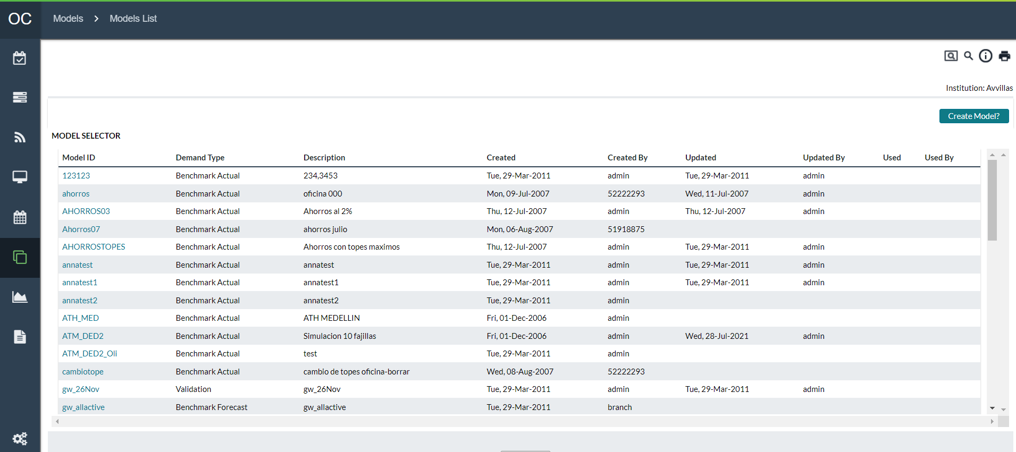

The model list will display all models that have been previously used for simulations. Models List provides information on each model, described in the following table:

Table 215: Model Selector Fields

| In this field: | Enter or specify the following: |
| --- | --- |
| **Demand Type** | Three model types are available to choose from:  Benchmark Actual  Benchmark Forecast  Validation  For more information on these model types, see: Model Types |
| **Model ID** | A unique name to identify this model. |
| **Description** | A short description of this model. |
| **Created** | Date when the model was created. |
| **Created By** | The user name of the person who created the model. |
| **Updated** | Date when the model settings were edited and/or assigned to Cashpoints. |
| **Updated By** | The user name of the person who edited the model settings and/or assigned to Cashpoints. |
| **Used** | Date when the simulations were run. |
| **Used By** | The user name of the person who ran the simulations. |

To use the existing model or update existing model settings, click on one of the hyperlinks for models previously defined, and a new window will be launched for the model selected.

Return To: Models Tab

## Creating a New Model

Initially, a new model must be created, which will copy historical data and model settings to the model database. The user then will be able to create an environment for benchmark analysis.

To define new model settings, click the  hyperlink under the Models tab from the main menu.

In the *Create Model* window, select the demand type from the drop-down list: Benchmark Actual, Benchmark Forecast or Validation.

Figure 165: Model Creation Page

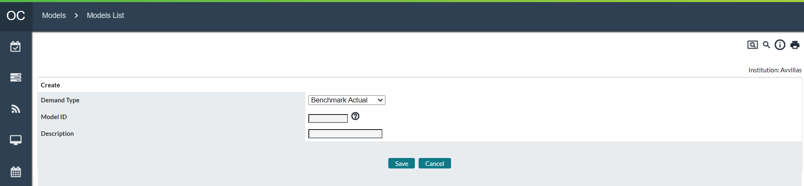

Enter a unique identifier for this model.

**Note:** Model ID must not contain any spaces between the characters.

In the Description field, enter a short description for this model.

When clicked on the **Save** button, the software will copy data of all the Cashpoints in the network into a separate set of tables for this particular model.

Return To: Models Tab

## Models→Overview

Previously created models can be selected from the Model Selector window under the Models tab. When clicking on the hyperlink of a model, a new window is launched, where the user can create an environment for which a simulation will be run. In the following, each of the tabs in the Model screen is explained in detailed as the main components of the modelling function.

Model Overview provides summarized information for the model that has been created. The results and summary information in the tables will only be displayed if the actual cost calculation and model have been run.

Figure 166: Model Overview Page

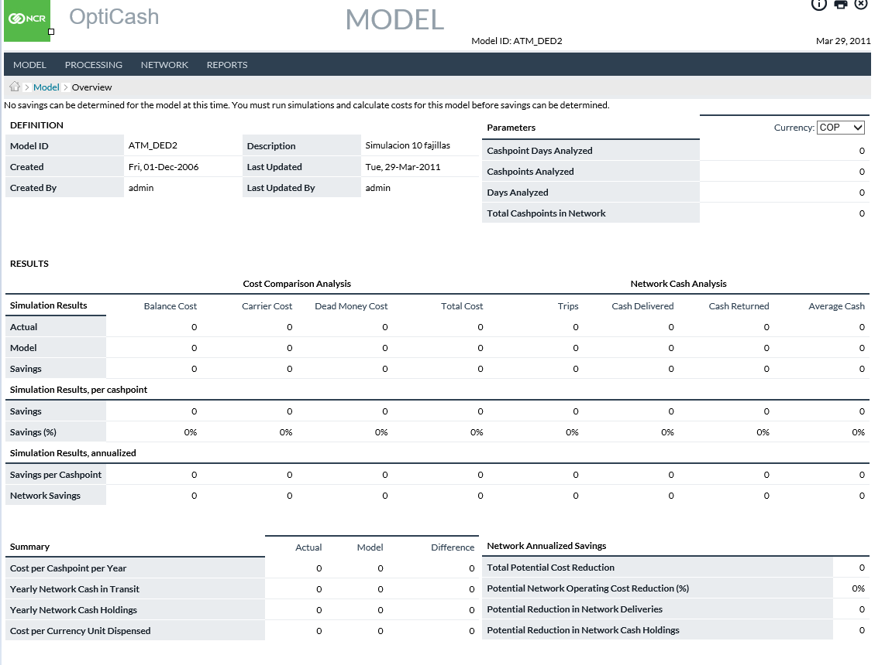

Table 216: Model Definition Panel

| Field | Description |
| --- | --- |
| **Model Id** | Unique identifier of the model created. |
| **Description** | Short description of the model created. |
| **Created** | Date when the model was created. |
| **Last Updated** | Date when the model was updated. |
| **Created By** | OptiCash user that has created the model settings. |
| **Last Updated By** | OptiCash user that has updated the model settings. |

Table 217: Model Parameters Panel

| Field | Description |
| --- | --- |
| **Currency** | The drop-down list allows the user to select the currency if there are any multi-currency Cashpoints available. |
| **Cashpoint days analysed** | The number of days used to establish the comparison. It is the number of days between the From and To Date. |
| **Cashpoints Analysed** | Number of Cashpoints used to establish the comparison. |
| **Total Cashpoints in Network** | Total number of Cashpoints created in OptiCash. This value will be used to project potential savings based on the number of Cashpoints analysed. |

Table 218: Model Results Panel

| Cost Comparison Analysis | |
| --- | --- |
| **Balance Cost, Carrier Cost, Dead Money Cost and Total Cost** | The costs are calculated based on actual costs and model costs. The calculation of cost categories is described in Cashpoint Service Costs. |
| Network Cash Analysis | |
| **Trips** | The number of physical trips made to replenish cash for the specified period of time in this model. |
| **Cash Delivered** | Sum of all cash replenishments made during the specified period of time in this model. |
| **Cash Returned** | Sum of all Cash returned made during the specified period of time in this model. |
| Simulation Results | |
| **Actual** | Actual results summary based on the actual information driven by the parameters defined in the actual production environment. |
| **Model** | Model results summary based on the model information driven by the parameters defined in the model. |
| **Savings** | Indicates savings produced by the model when compared to actual results:  Savings = Model – Actual |
| **Average Cash** | Average Closing Balance during the selected time frame for simulation. |
| Simulation Results, per Cashpoint | |
| **Savings** | Amount of savings per one Cashpoint in simulation. This amount is calculated as follows:  Savings = Savings (from the above fields in the Simulation Results) / Number of Cashpoints Analysed in Simulation. |
| **Savings (%)** | Percentage of savings per one Cashpoint in simulation. This percentage is calculated as follows:  Savings (%) = Model (from the above fields in the Simulation Results) x 100% / Actual (from the above fields in the Simulation Results) – 100%. |
| Simulation Results, annualized | |
| **Savings per Cashpoint** | Annualized amount of savings per one Cashpoint in simulation. This amount is calculated as follows:  Savings per Cashpoint = Savings (from the above fields in the Simulation Results per Cashpoint) / Cashpoint Days Analysed x 365 days. |
| **Network Savings** | Network Savings = Savings per Cashpoint (from the above fields in the Simulation Results annualized) x Number of Cashpoints in the Network. |

The Summary panel is described in the following table indicating the calculation methods used in the analysis:

Table 219: Model Summary Panel

|  |  |
| --- | --- |
| Summary | |
| **Actual** | Actual results summary based on the actual information driven by the parameters defined in the actual production environment. |
| **Model** | Model results summary based on the model information driven by the parameters defined in the model. |
| **Difference** | Difference = Model – Actual. |
| Parameter | Calculation |
| **Utilization** | (Cash Delivered – Cash Returned) / (Cash Delivered) x 100% |
| **Cost per Cashpoint per Year** | Cost per Cashpoint per Year = Total Cost / Number of Cashpoints Analysed / Days Analysed x 365 days. |
| **Yearly Network Cash in Transit** | Yearly Network Cash in Transit = Cash Delivered / Number of Cashpoints Analysed / Days Analysed x 365 days x Total Cashpoints in Network. |
| **Yearly Network Cash Holdings** | Yearly Network Cash Holdings = Total Sum of the Network Balance Cost per Year for all network Cashpoints |
| **Cost per Currency Unit Dispensed** | Cost per Currency Unit Dispensed = Total Cost per One Currency in withdrawals for ATMs or net demand for branches.  **ATMs**: Total cost for all network ATMs / Total Withdrawals for all network ATMs. **BRANCHES**: Total cost for all network Branches / Total Net Demand. |

Table 220: Model Network Annualized Savings Panel

|  |  |
| --- | --- |
| Parameter | Calculation |
| **Total Potential Cost Reduction** | Potential Cost Reduction = Total Network Savings on Total Costs (the Results table). |
| **Potential Network Operating Cost Reduction (%)** | Potential Network Operating Cost Reduction (%) = Savings % (the Results table). |
| **Potential Reduction in Network Deliveries** | Potential Reduction in Network Deliveries = Network Savings for Cash Deliveries (the Results table). |
| **Potential Reduction in Network Cash Holdings** | Potential Reduction in Network Cash Holdings = Network Savings for Average Cash (the Results table). |

Return To: Models Tab

## Models→PROCESSING

The Processing Tab in the model shows any processes that are running specific to the models. This page is similar to the Process Status Page from the main OptiCash Menu. For more information, see: Processing→Process Status

Figure 167: Model Process Status Page

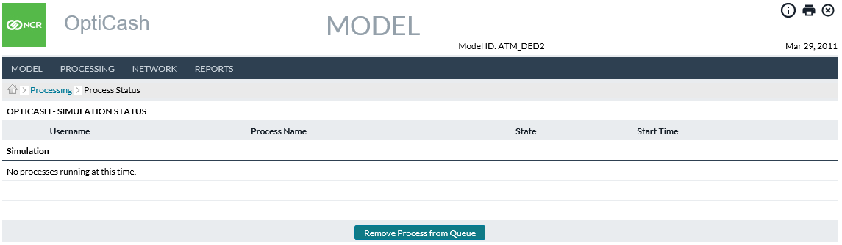

Return To: Models Tab

## Models→Results

The Results screen provides a simulation snapshot by status and by date.

Figure 168: Model Results Page

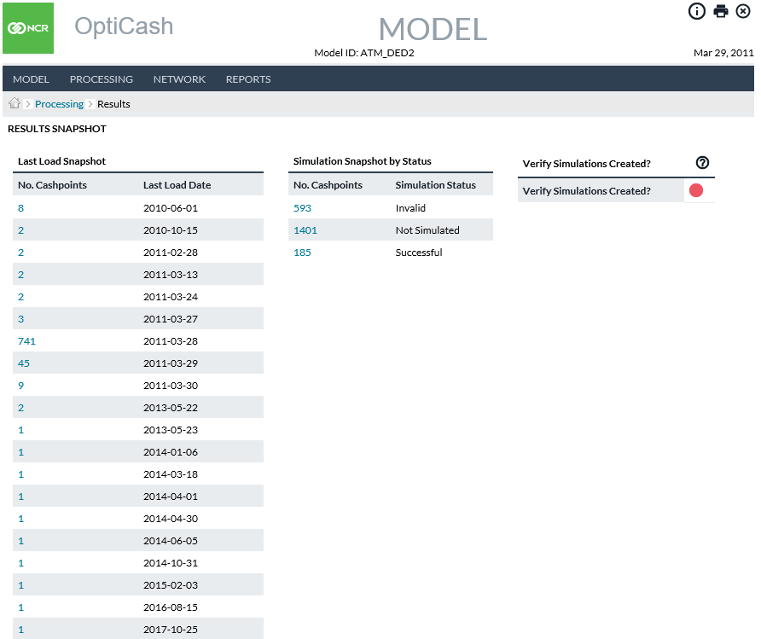

Return To: Models Tab

## Models→Simulations

On the Simulations tab, the user can Validate the simulation parameters and execute the Simulation process. To run a Simulation, the simulation profile must first be defined. If there is nothing specified in the Settings Dropdown box, then there are no settings defined. Clicking on the ‘**Settings’** Tab will allow the user to create a Settings ID.

The Validation Button is used to Validate the settings to make sure the parameters defined for the simulation are correct. This works in the same way as the Validation process for Recommendations. For more information on Validations, see:

Run Recommendations→Recommendation Validation Report

Figure 169: Simulations Page

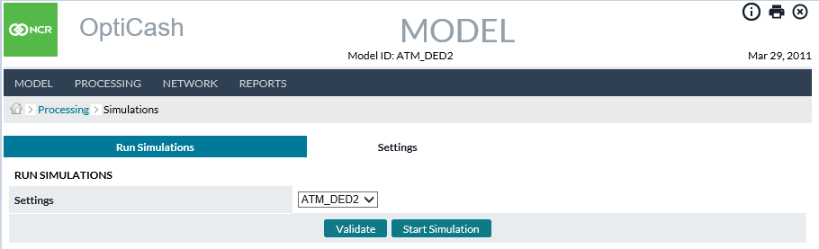

Return To: Models Tab

### Models→Simulations→Settings

The Settings Tab allows the user to create a simulation profile that will be used by the Simulation Process. The profile is used to define the period of time and Cashpoints that will be included in the simulation

Figure 170 : Simulation Settings Page

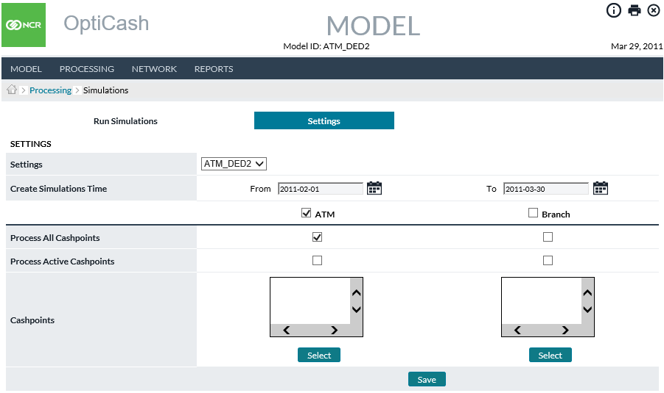

Table 221: Simulation Settings Description

| Fields | Description |
| --- | --- |
| **Settings** | For the first time, new settings ID must be created in the Settings field.  Once the settings have been defined, select them from the drop-down list. |
| **Create Simulations Time: From** | Use the Calendar button to indicate the beginning date of the simulations.  **NOTE**: If you are using a monthly cost structure, the simulation will not count orders outside of the simulation period toward the monthly allotment. For this reason, it is advised to begin the simulation on the 1st of a calendar month, if you are using monthly costs. See table 189 previously for further considerations on choosing a simulation start/end. |
| **Create Simulations Time: To** | Use the Calendar button to indicate the end date of the simulation. |
| **Check ATM or Branch** | Check the check box of the ATM or Branch for which simulations will be run. |
| **Process All Cashpoints** | Check-in order to process all Cashpoints or leave it unmarked to select specific Cashpoints only. |
| **Process Active Cashpoints** | Check-in order to process active Cashpoints only or leave unmarked and select specific Cashpoints. |
| **Cashpoints** | Select specific Cashpoints (using the Select button). |

Return To: Models Tab

## Model Cost Calculations

Model cost calculation is the basis of Model Savings and Model Utilization Comparison analysis, indicating what savings/utilization would have been produced if the user had operated in the environment set up for this model. Therefore, before running Model Savings and Model Utilization Comparison reports, it is important to process cost calculations.

The actual Costs tab in the Cost Calculation screen displays the actual cost last-run information. The actual costs should be run under the Processing tab in the main OptiCash screen, not in the Modeling module. Actual cost calculation must be generated before model cost calculation so that the benchmark data for comparison of the actual costs against model costs is established.

In the Modeling module, only model cost calculation should be run, during which costs will be calculated based on the model settings. In the following, it is explained how to run model cost calculation.

For more information on Actual Costs, see: Processing→Cost Calculation

Figure 171: Model Cost Calculations

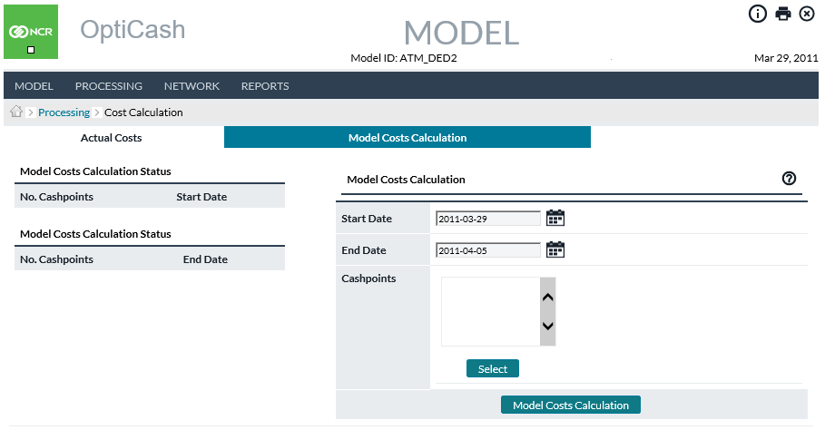

Return To: Models Tab

## Models→Network Settings

Under the Network tab, users will set up the environment for the model, including Cashpoint parameters and costs, assign service costs and service days from the depot level and change overnight earnings rate for the currencies available.

Network settings are where the users will have the ability to change parameter and cost settings, and advanced parameters for the Cashpoints in this model. The parameters that can be set are the same as those that are available in the Cashpoint.

The user must select the Cashpoint type and Currency and click the Select button to access the parameters. All the available parameters are similar to those used in production with OptiCash. For more information on these parameters, see the following sections:

* Table 11: General Cashpoint Parameters
* Table 12: ATM-Specific Parameters
* Table 13: Branch-Specific Parameters

Return To: Models Tab

Figure 172: Model Network Settings Page

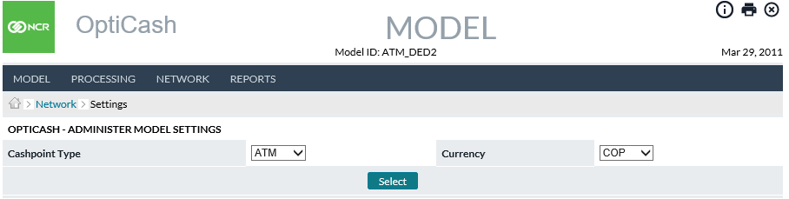

Figure 173: Model ATM Settings Page

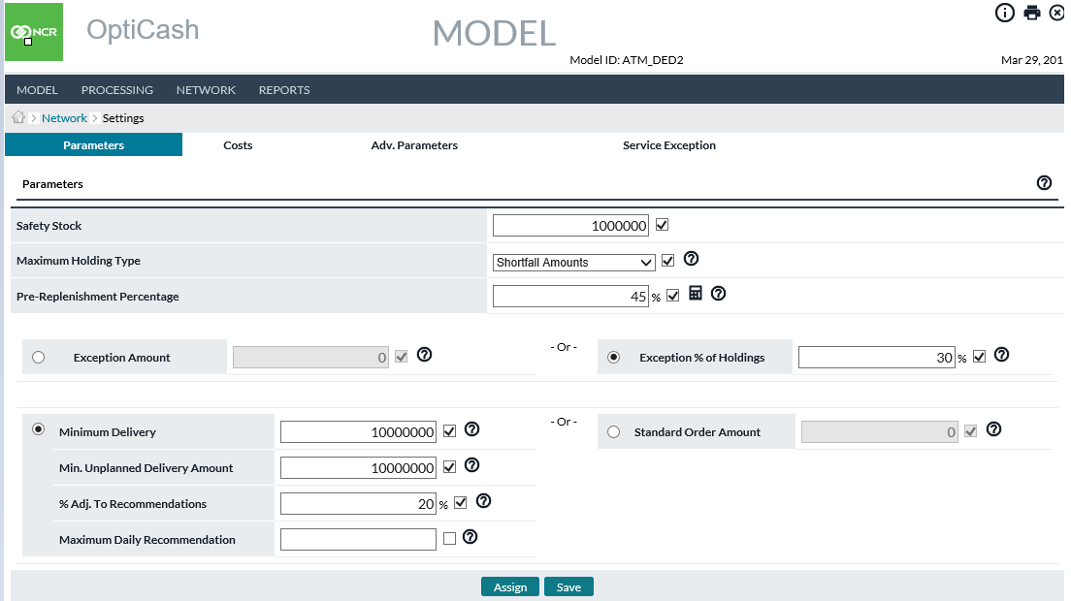

Figure 174: Model Branch Settings Page

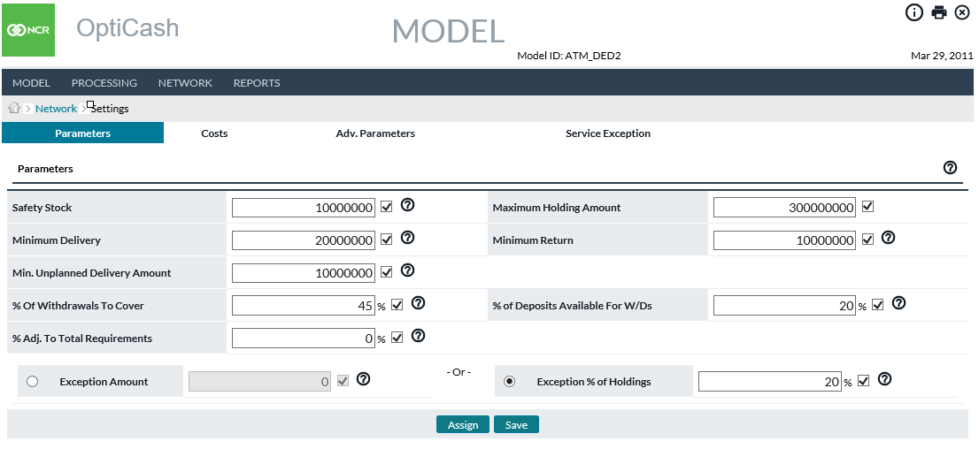

|  |  |
| --- | --- |
|  | **Note**: whenever settings are assigned /edited, the model list in the Model Selector window will indicate the date when the model settings were assigned/edited and the user name of the person who assigned/edited the settings. |

### Costs

In the Costs screen, the user can change the currency insurance rate, delivery and return handling costs and mass-assign these costs to the Cashpoints selected. These costs are explained in more detail in the following table, and they apply to all types of Cashpoints: Dispensing ATMs, Advanced Devices, and Branches.

For more information on these parameters, see: Table 15: Service Costs Description

Figure 175: Model Cost Assignment Page

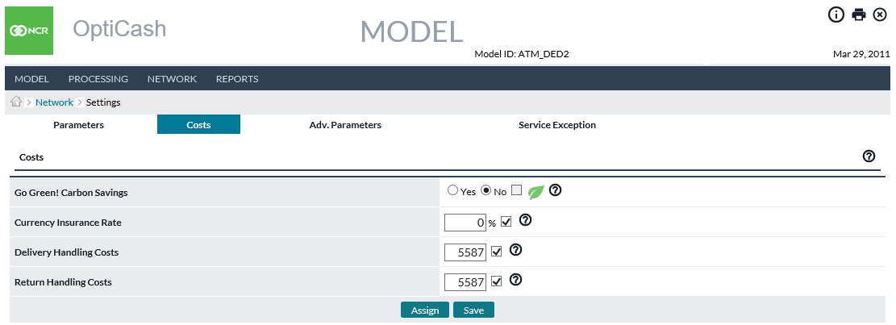

|  |  |
| --- | --- |
|  | **Note**: whenever settings are assigned /edited, the model list in the Model Selector window will indicate the date when the model settings were assigned/edited and the user name of the person who assigned/edited the settings. |

Return To: Models Tab

### Advanced Parameters

Advanced parameters for a Cashpoint are the same parameters that were defined under the Parameters tab. However, under advanced parameters, the system allows setting different parameters for a different day of the week or a specific day during the year.

Figure 176: Model Advanced Settings Assignment Page

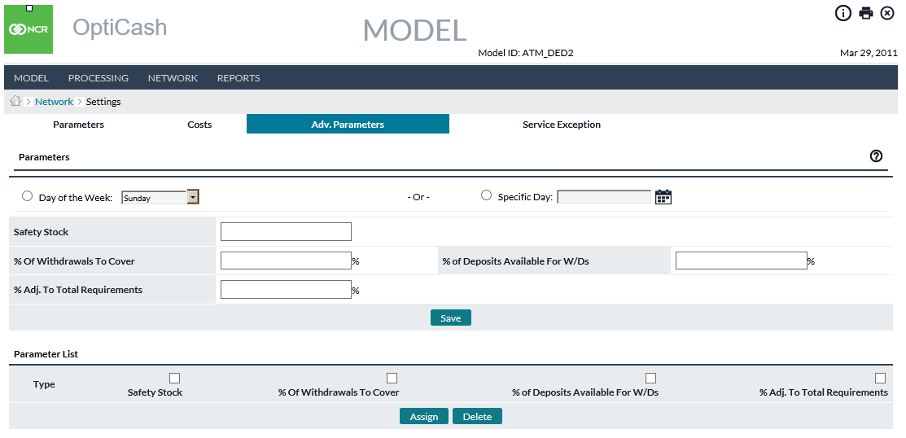

|  |  |
| --- | --- |
|  | **Note**: whenever settings are assigned /edited, the model list in the Model Selector window will indicate the date when the model settings were assigned/edited and the user name of the person who assigned/edited the settings. |

Return To: Models Tab

### Carriers

Under the Carriers tab, the user will have the ability to mass-assign service costs and service days from the depot level. For more information on Assigning Costs, See: Depots→Assign Service Costs

Figure 177: Model Assign Service Costs Page

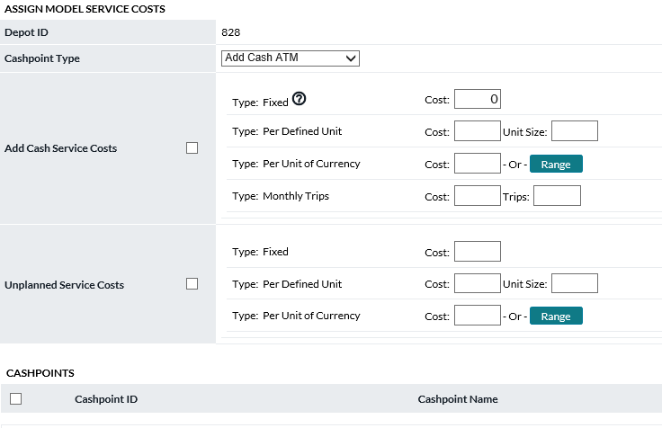

Return To: Models Tab

### Currencies

Under Currencies, the user will have the ability to change the Overnight Earnings Rate for this model. The overnight Earnings Rate is an annualized rate of return available funds will earn or the opportunity cost of maintaining excess cash in the branch.

Figure 178: Model Currencies Assignment Page

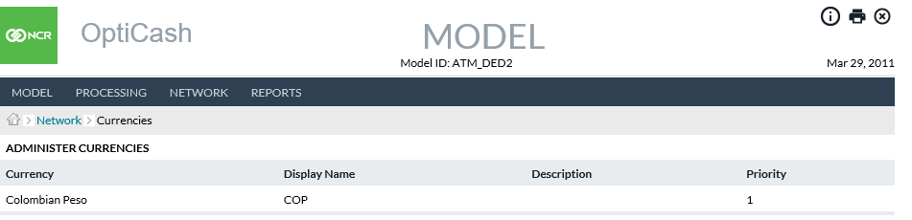

Return To: Models Tab

1. Reports

The reports available in the Model are similar to those used in production with OptiCash. For specific information on these reports, refer to the following sections of this document:

* Charted Model Costs
* Savings (Cost Comparison)
* Cash Utilization Comparison
* Delivery Day Utilization
* Horizon Comparison
* Parameters
* Service Costs
* Service Days
* Cashpoint Service Schedule

Return To: Models Tab

Figure 179: Model Reports Page

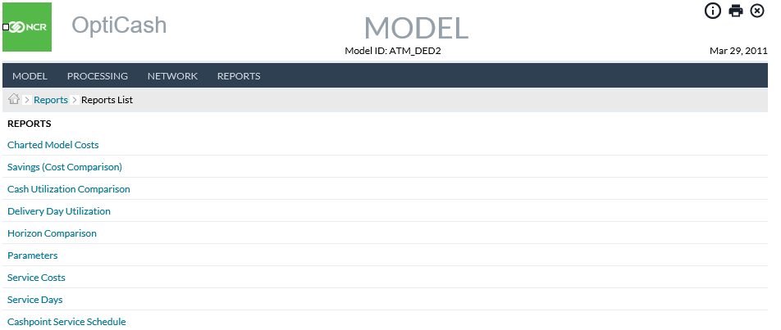

## Charted Model Costs

Charted Model Costs Reports provide both a graphical and a data summary of the Costs resulting from the Modeled Simulations.

Figure 180: Charted Model Costs Report

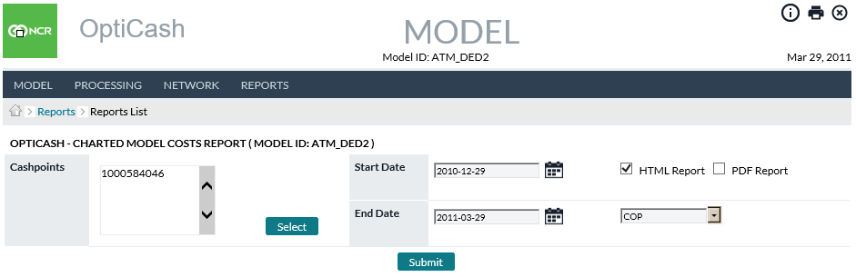

Table 222: Charted Model Costs Field Descriptions

| Field | Description |
| --- | --- |
| **Select Button** | Allows the user to choose Cashpoints to be included in the report. For more information on Cashpoint Selection, see: Cashpoint Selector |
| **Start/End Date** | Users can select the date range to generate the report. The date range must be within the confines of the Model Simulation period defined by the Model itself. |
| **Select Currency** | The user will determine which currency the report is to be generated for |
| **Holding Costs** | Costs associated with holding too much cash (for instance, lost potential savings from interest rates).  Holding Costs = (Closing Balance x Interest Rate %) / Number of Days in a Year* x Days Cash is Held in Cashpoint  * user-defined under *Maintenance → OptiCash Settings* screen. |
| **Insurance Costs** | Insurance Costsare based on the currency insurance rate that is charged to insure funds kept in Cashpoints.  Insurance Costs = (Closing Balance x Insurance Rate %) / Number of Days in a Year*  * user-defined under *Maintenance → OptiCash Settings* screen. |
| **Out-of-Cash Costs** | Costs associated with out-of-cash are indicated by the cost set by the institution such as penalty, admin fee, etc.  Out-of-Cash Costs = Cost per Outage Amount x Number of Outages*,  *where Outage is when Closing Balance is less than the threshold amount defined in the *Processing tab → Cost Calculation → Cost Options.* |
| **Dead Money Costs** | Dead money costs associated with transit costs, i.e., costs of ‘dead cash’ while being in transit.  Dead Money Costs = (Delivery Amount x Interest Rate %) / Number of Days in a Year** x Delivery Time* + (Return Amount x Interest Rate %) / Number of Days in a Year** x Return Time*  *number of days for Return and Delivery Time defined in *Processing tab → Cost Calculation → Cost Options*.  ** user-defined under *Maintenance → OptiCash Settings screen.* |
| **Handling Costs** | Total internal costs associated with the processing/handling of cash delivery. This may include the value of employees’ time required during the delivery, and any other overhead or administrative costs (defined as Delivery and Return Handling Costs for branches, Replenishment Costs for ATMs). |
| **Fixed Costs** | Cost per delivery regardless of the amount of cash being transported. |
| **Variable Costs** | Cost is based on the amount of cash being transported. In some cases, variable costs may be on a sliding scale or range (defined by the Range button). |
| **Total Costs** | Total costs will be the sum of all the costs in the above categories. |

## Savings (Cost Comparison) Report

The Savings and the Cost Comparison Report are two versions of a report that detail Actual and Modeled Costs including Holding Costs, Insurance Costs, Out of Cash Costs, Carrier (Fixed and Variable) Costs, Handling Costs, and Dead Money Costs. Definitions of these costs can be found in Table 207: Charted Model Costs Field Descriptions.

Table 223: Savings (Cost Comparison) Report Field Descriptions

| Field | Description |
| --- | --- |
| **Select Button** | Allows the user to choose Cashpoints to be included in the report. For more information on Cashpoint Selection, see: Cashpoint Selector |
| **Start/End Date** | Users can select the date range to generate the report. The date range must be within the confines of the Model Simulation period defined by the Model itself. |
| **Time Period** | Users can select   * **Daily** to show the detail of every date in the Date range or * **Monthly** to show by-Month summary detail of the selected date range |
| **Detail Level** | Users have the option of selecting   * **Detail –** Returns results for single cashpoints for each date * **Cashpoint Summary –** Return results by cashpoint for the selected date range * **Depot Summary –** Returns results for all cashpoints linked to the same Depots * **Network Summary –** Returns results for all cashpoint selected |
| **Report Type** | Users can select   * Savings Report which will return the savings achieved in Actual vs. Simulation * Cost Comparison returns for Actual vs Model for each Cost type |

## Cash Utilization Comparison

The Cash Utilization Comparison Report is a report that allows the user to determine how successfully the funds could be utilized for each Cashpoint in the network given the defined simulation definitions. The effectiveness is expressed by the cash utilization percentage per delivery cycle and indicates the rate at which cash is utilized against the total cash available at the Cashpoint during the selected delivery cycle.

When reading the report, the information displayed relates to the delivery that occurred on a specific day both in the Actual period and in the Simulated period. Therefore, the delivery dates are displayed along with the Opening Balance, Pre-Withdrawal, and Delivery amounts. The other calculations are shown to help explain the Utilized Percentage. The table below will explain the calculations.

Table 224: Cash Utilization Comparison Options

| Field | Description |
| --- | --- |
| **Select Button** | Allows the user to choose Cashpoints to be included in the report. For more information on Cashpoint Selection, see: Cashpoint Selector |
| **Start/End Date** | The starting and ending dates of the report. |
| **Currency** | Users select the currency report to be generated |
| **Details** | The level of detail that the report will display. The options are:  **Daily** – Shows the Deliveries for each Cashpoint and each delivery date during the period selected for the report  **Monthly** – Shows a Summary for each Cashpoint and each month during the period selected for the report |
| **Pre-Withdrawals** | Determines how Pre-Withdrawal amounts will be used in the report. The pre-withdrawal amount is used to determine how much cash was taken from the machine before the delivery. This amount is important as it allows the report to show the actual amount that was utilized between deliveries.  **Use Pre-Withdrawals** – This option is used when the history has the correct Pre-Withdrawal amount that was loaded along with the history. This is usually part of the nightly data load.  **Use Replenishment Percent** – This option is used when there are no pre-withdrawal amounts reported in the daily history file. This option will calculate the pre-withdrawal amount based on a percentage that is stored at each Cashpoint in the parameters. |

Table 225: Cash Utilization Comparison Report Description

| Field | Description |
| --- | --- |
| **Delivery Comparison** | Details Actual vs. Model with Variance % for three main data points:   * Opening Balance * Pre-Withdrawals * Deliveries/Available |
| **Used Amount Comparison** | “**Utilized**” means cash dispensed or used. This variation of the report compares the Actual vs. Model with Variance % for two data points:   * Utilized Amount * Utilized % |
| **Total Utilization Comparison** | This report variation compares Actual vs. Model with Variance % for three data points:   * Deliveries/Available * Utilized Amount * Utilized % |
| **Cashpoint ID** | **Daily and Monthly only** –Unique alphanumeric identification of the Cashpoint |
| **Delivery Date** | **Daily** – The date the delivery occurred  **Monthly** – The month and year that is being summarized |
| **Currency** | Currency delivered |

Additional Field Definitions and Calculations can be found in Cash Utilization Report Description table.

## Delivery Day Utilization

The Delivery Day Utilization Report counts the number of trips on each weekday in the simulation and shows the distribution of deliveries by weekday.

## Horizon Comparison

The Horizon Comparison provides a view of simulated activity by cashpoint and includes Opening Balance, Deliveries, Returns, Withdrawals, Deposits, Closing Balance, and other related fields for the simulated period and the actual period if the model is either a Benchmark Actual or Validation. Benchmark Forecast models will only produce for the simulated period. The Simulated and Actual Horizons are set side-by-side by cashpoint and by date so that actual production activity can easily be compared to simulated production activity.

Additionally, the Horizon Comparison provides alerts for both Simulated and Actual activity to alert for cash shortfalls, out-of-cash, too-high balances, and others as described below.

The report is produced in either a Detail version or a Cashpoint Summary version. The fields are the same in either version the difference being the Summary version returns averages for each field by cashpoint for the date range selected by the user.

Table 226: Models Horizon Comparison Field Descriptions

| Field | Description |
| --- | --- |
| **Select Button** | Allows the user to choose Cashpoints to be included in the report. For more information on Cashpoint Selection, see: Cashpoint Selector |
| **Start/End Date** | Users define the period to be included in report results.  **NOTE**: The dates are ultimately limited by the date range included in the simulations and by the cashpoints simulated. |
| **Group** | The user selects either Detail or Cashpoint Summary. Detail version returns results by cashpoint and by each date in the range. Cashpoint Summary version returns averages by cashpoint for the full date range. |
| **Cashpoint Type** | ATM or Branch |
| **Cashpoint ID** | Unique alphanumeric identification of the Cashpoint. |
| **Currency** | Currency for which the balance details are reported. |
| **Date** | Reflects the date of the activity |
| **Note**: Unless noted, the below fields are produced for both the “**Actual**” portion of the report as well as the “**Model**” portion. “**Actual**” refers to the actual historical activity as reported to OptiCash for each cashpoint. This is the actual activity that occurred. “**Model**” refers to activity simulated by OptiCash based upon the then-current settings in the Model section of the application. | |
| **Opening Balance** | Reflects the Actual Closing balance for each day for the Actual portion of the report. The Model portion Opening Balance will be taken from the prior day’s Closing Balance and will be calculated from the simulated activity of that day. |
| **Normal Deliveries** | Cash is delivered to a cashpoint on a regular delivery day in the case of fixed scheduling. In the case of on-demand scheduling, it is cash delivered to a cashpoint and ordered within normal lead time requirements |
| **Linked Normal Deliveries** | Normal deliveries as defined above but for Linked Cashpoints as defined in Cashpoint Linkage such as a Branch with linked child ATMs |
| **Unplanned Deliveries** | Cash is delivered to a cashpoint based upon an Emergency Recommendation or manually ordered for a date that is not within the normal lead time requirements. Unplanned Deliveries will normally result in an incremental cost increase. |
| **Returns** | Cash is shipped out of a cashpoint and back to the vault or cash center. |
| **Withdrawals** | Cash is distributed from a cashpoint as a result of customer demand. |
| **Deposits** | Cash taken into a cashpoint from a customer |
| **Net Demand** | Cash demand is reflected as the difference between Withdrawals and Deposits. |
| **Required Balance** | The amount is calculated as the minimum amount of cash that must be in the Opening balance at the start of the day. If the Required balance is higher than the Opening Balance on a given day, an Emergency Delivery may be generated to protect the Cashpoint (unless an exception amount or percentage waives the requirement. See: Table 11: General Cashpoint Parameters for more information)  The Required Balance is always zero for Historical data. For Gap and Horizon days, the calculation varies for ATMs and Branches.  **Branches** – The Required Balance = Safety Stock + Other Requirements + Amount of Withdrawals to Cover – Amount of Deposits Available for Withdrawal.  **Example**:  Safety Stock = 148,700  Other Requirements = 100,000  Withdrawals To Cover = 80%  Deposits Available for W/D = 20%  Forecasted Withdrawals = 467,380  Forecasted Deposits = 121,520  Therefore, the Required Balance =  ( 148,700 + 100,000 + (.80 * 467,380) – (.20 *121,520)) = **598,300**  **ATMs** – The Required Balance depends on whether or not a delivery is scheduled for the day.  **Delivery Days** – Required Balance = Safety Stock + Calculated Pre-Withdrawals  **Non-Delivery Days** – Required Balance = Safety Stock + Forecasted Withdrawals  **Example :** (Delivery Day)  Safety Stock = 10,000  Pre-Replenishment Percentage = 50%  Forecasted Withdrawals = 50,000  Therefore, the Required Balance =  (10,000 + (.50 * 50,000)) = **35,000**  **Example:** (Non-Delivery Day)  Safety Stock = 10,000  Pre-Replenishment Percentage = 50%  Forecasted Withdrawals = 50,000  Therefore, the Required Balance =  (10,000 + 50,000) = **60,000** |
| **Closing Balance** | Opening Balance + All Deliveries – All Returns + All Deposits – All Withdrawals = Closing Balance. |
| **Alerts** | Six separate alerts can be generated based on the activity of that day.  **SF -** Opening Balance Shortfall from Minimum Required Balance  **EM -** Emergency **OOC -** Out Of Cash **AD -** Delivery on non-service day **HOB -** High Opening Balance on Delivery Day (Balance > 50% of Delivered Amt) **IOB -** Inconsistent Balance |

#### Parameters

The Model Parameters report is identical to the Cashpoint Parameters report found on the main Reports tab of OptiCash, and field descriptions can be found here in this guide.

**Note**: The Parameters reported by this report are those in place in the Model tables of OptiCash at the last simulation run or the creation of the Model.

## Service Costs

The Model Service Costs report is identical to the Cashpoint Service Costs report found on the main Reports tab of OptiCash, and field descriptions can be found here in this guide.

**Note**: The Service Costs reported by this report are those in place in the Model tables of OptiCash at the last simulation run or the creation of the Model.

## Service Days

The Model Service Days report is identical to the Cashpoint Service Days report found on the main Reports tab of OptiCash, and field descriptions can be found here in this guide.

**Note**: The Service Days reported by this report are those in place in the Model tables of OptiCash at the last simulation run or the creation of the Model.

## Cashpoint Service Schedule

The Cashpoint Service Schedule report details service (delivery and/or return) days for each cashpoint in addition to their associated order days, whether there was a Service Shift, whether it was a Holiday, and other influencing factors.

Table 227: Models Cashpoint Service Schedule Field Description

| Field | Description |
| --- | --- |
| **Select Button** | Allows the user to choose Cashpoints to be included in the report. For more information on Cashpoint Selection, see: Cashpoint Selector |
| **Start/End Date** | Users define the period to be included in report results.  **NOTE**: The dates are ultimately limited by the date range included in the simulations and by the cashpoints simulated. |
| **Cashpoint ID** | Unique alphanumeric identification of the Cashpoint. |
| **Cashpoint Name** | Name associated with the Cashpoint ID |
| **Cashpoint Type** | ATM or Branch |
| **Service Date** | Date of Service (Delivery or Return) |
| **Delivery** | Indicates if the date is a valid delivery date and what type of date it is such as Required Replace, Required Add, Optional Replace, or Optional Add |
| **Return** | Indicates if the date is a valid return date and what type of date it is such as Required Return or Optional Return |
| **Unplanned Order Date** | Yes or No field showing whether the date in question is available for Unplanned Services |
| **Valid Business Day** | Yes or No field reflecting whether or not based upon Model settings the day is a day where the cashpoint is expected to be available to dispense or receive cash |
| **Holiday** | Yes or No field reflecting whether the day is set as a Holiday in OptiCash |
| **Exception** | Yes or No field reflecting whether the day has a Service Exception set for it |
| **Delivery Order Date** | Reflects the date when the Normal Delivery was ordered. Should be equal to the Service Date minus Normal Delivery Lead Time. |
| **Return Order Date** | Reflects the date when the Normal Return was ordered. Should be equal to the Service Date minus Normal Return Lead Time. |
| **Unplanned Order Date** | Reflects the date when the Unplanned Delivery was ordered. Should be equal to the Service Date minus Unplanned Delivery Lead Time. |

1. Glossary

The following table summarizes the most widely used definitions in this help document.

| Term | Description |
| --- | --- |
| **Accepted Recommendation Status** | Accepted Recommendation status appears on an order when the Branch/ATM staff accepts a recommendation generated by OptiCash. In this case, the total recommended amount is equal to the total ordered amount. |
| **Add Cash ATMs** | In this type of ATM, the cash is added without withdrawing the amount of cash left in the cassette. |
| **Add/Delivery** | This refers to a grouping of delivery types. When an item is referred to as Add/Delivery it means that it includes Add Cash Replenishment for ATMs as well as Branch Cash Deliveries. |
| **Add Cash Service Costs** | The costs associated with each add cash service to the Cashpoint or cost per trip. |
| **Administrator** | The OptiCash user has administrative rights to the system, which means full control over the settings and actions such as assigning the rights to the users, editing settings, etc. |
| **Advanced Device** | A group of ATM types including Recycling ATM, Deposit Machine, Teller Cash Machine, Self Checkout Machine, Smart Safe, and Other Recycle Capable Devices. Generally, those ATMs which accept deposits (may or may not include some form of withdrawal also). |
| **ATM** | ATM stands for Automatic Teller Machine. It is an entity often defined by the way it is serviced: Add Cash ATM, Replace Cash ATM. And by the type of business in which it deals: Dispensing ATM, Recycling ATM, Deposit Machine, Teller Cash Machine, Self Checkout Machine, Smart Safe, or Other Recycle Capable Device. |
| **Auto Committed Status** | Auto Committed status appears on an order when the OptiCash recommendations process is run with the “Commit Created Recommendations” option turned on. This status means that the order will be included in the order output along with user-committed orders (those having any status other than Auto Committed). However, unlike user-committed orders, the recommendations process may alter these orders up until the actual order date. |
| **BOD** | Beginning of the day. |
| **Browser** | A computer application used to access the internet or in this case to access the OptiSuite applications |
| **Carrier** | The organization carrying the cash. |
| **Carrier Cost** | The charges that are to be paid to the Carrier. Carrier costs consist of two components: fixed costs (minimum charge for a trip) and variable costs (value per delivered/cleared amount). |
| **Cash** | Notes and coins. |
| **Cash Management** | Cash management involves the management of competing costs involved in handling cash, which includes cash holding, transportation, and other handling costs. |
| **Cashpoint** | A Cashpoint is defined as a branch or an ATM. In this application, a Cashpoint can mean either or both. |
| **Cassette** | A device holding cash, which is used in ATM machines. |
| **Centrally Overridden** | Centrally overridden order means that the order has been edited by the OptiCash analyst, who has the right to change orders previously placed by other Branch/ ATM staff or place new orders. |
| **Currency Insurance Rate** | The rate charged to insure funds are kept in Cashpoints. This is an annual rate and is typically generated by the governing/central bank, e.g., the European Central Bank rate, or FDIC rate in the U.S. market. |
| **Cycle** | The frequency of when the Cashpoint is serviced. The options could be weekly, bi-weekly, tri-weekly and every fourth week. |
| **Data Health Indicator** | The data health indicator is a rolling average denoting the general health of the daily balance loads. A higher percentage denotes consistent balances, ordering, etc., while a lower percentage is indicative of balance problems, order discrepancies, etc. |
| **Delivery** | Cash is delivered by a carrier. |
| **Demand** | Cash demand is reflected by the total actual withdrawals during the day. |
| **Denomination** | Value of a note or a coin. |
| **Depot** | Depot is a servicer’s equivalent of a money center. |
| **Drop-down List** | The drop-down list provides a list of alternatives, any of which can be selected. The selected item will be inserted into the field. |
| **EOD Delivery/Return Time** | EOD stands for End Of Day and indicates that the branch generally receives its deliveries (or returns cash) at the end of the business day. Therefore, the demand on the day of delivery must be included in the calculation of the delivery/return recommendation. |
| **Event** | Certain day(s) during which there is going to be an unusually high or low demand. Instances of an event in the past are used to forecast cash demand for instances of that event in the future. Also, by defining historical day(s) with high or low demand as an event, that high or low demand will not sway the prediction of cash demand for normal days in the future. |
| **Exception Amount** | Exception amount is a setting used to define the level that the Cashpoint can be below the required balance without triggering an emergency recommendation. If 10,000 is input, the Cashpoint must be forecast to fall short of its cash requirements by at least 10,000 to satisfy one of the conditions to trigger an unplanned delivery recommendation. Only one of the Exception Amounts or Exception Percentage of Holdings can be defined for a Cashpoint at the same time. |
| **Exception Percentage of Holdings** | Exception percentage of holdings is a setting used to define the level that the Cashpoint can be below the required balance without triggering an emergency recommendation. If 15% is input, the Cashpoint must be forecast to fall short of its cash requirements by at least 15% of the required cash balance to trigger an unplanned delivery recommendation. Only one Exception Amount or Exception Percentage of Holdings can be defined for a Cashpoint at the same time. |
| **Fixed Schedule** | The Cashpoint service days are set on fixed days during the week when the service is available. In this scenario, the service days are defined as Required Service Days. |
| **Forecast** | A process in OptiCash that uses historical data and events to predict cash demands for different Cashpoints in the network. |
| **History** | A time series of historical data, which is used as a basis for forecasting. |
| **Holding** | The cash held in a Cashpoint. |
| **Horizon** | Horizon reflects particular details for a Cashpoint with forecasted values such as balance details, withdrawals, deposits, deliveries, returns, etc. |
| **Large Order Unit Size** | A large order unit size is typically the larger of the two potential ordering increments for a denomination. It will usually be bundle size for notes and box size for coins.  **Note:** This should be defined in OptiCash by value, not by note/coin count. |
| **Lead-time** | The number of days required to service a Cashpoint (counted from the day an order is placed until it arrives). |
| **Manual Order** | Manual order allows the user to enter/place an order manually rather than loading orders from the recommendation process. |
| **Maximum Capacity** | The maximum amount of cash that a Cashpoint may hold. For ATMs, this is often measured in terms of the maximum capacity of the cassettes servicing the denominations. For branches, this amount may be due to physical limitations, security, or corporate policy. |
| **Maximum Holding Type** | The maximum holding type determines the maximum holding optimization method to be used by OptiCash in emergencies. |
| **Minimum Delivery** | The minimum amount of cash, as set by the bank will be delivered to a Cashpoint. |
| **Mix Cassette** | Mix cassette contains notes of different denominations and/or different currencies. |
| **On Demand Schedule** | The on-demand schedule refers to the situation where deliveries are made on the days recommended by OptiCash, considering customer demand and cost optimization. In this scenario, the service days are set as optional. |
| **Order Percent** | The default percentage for each denomination represents the percent (e.g., 20, 30, etc) of a total order that is typically made up of a given denomination. |
| **Order Unit** | Denomination package size: Large, Small or Any.  Order Unit defines the increments of a particular denomination which can be used in deliveries and returns. For example, if a Large Order Unit for $10 notes is defined as 5,000 and the Cashpoint is set to use only Large order units, then deliveries/returns for $10 notes will only be allowed in multiples of 5,000, i.e., 5,000, 10,000, 15,000, etc. This applies both to recommended orders and manual orders entered into OptiCash.  **Note:** Any Order Unit option, the recommendation process and order entry screens will use the denomination value as the increment unit. |
| **Overridden Recommendation** | An overridden recommendation occurs when the branch/ATM staff considers the recommendation not viable for a given circumstance. OptiCash considers a recommendation overridden when the total amount recommended differs from the total amount ordered even when most of the denominations stay intact. |
| **Percent Adjustment to Recommendations** | This is a percentage used to increase the recommendation amount. This can be a buffer in the event of running too low on cash for some unexpected reason. Any % entered will affect savings opportunities. The purpose of the software is to provide accurate recommendations for the cash needs of all Cashpoints, based on history, and it should not need this adjustment. Therefore, it is recommended to avoid, minimize the amount of, or use only temporarily . |
| **Percentage of Deposits Available for Withdrawal** | The percentage of daily cash deposits used or recycled to cover cash withdrawals. |
| **Pick up/Return** | Pickup of cash by a carrier from a Cashpoint. |
| **Post-effects** | Deviation from the typical demand after an event (e.g., holiday). |
| **Pre-effects** | Deviation from the typical demand before an event (e.g., holiday). |
| **Pre-Emptive Alerts** | Pre-Emptive alerts are alerts generated by the system to make the user aware of any potential discrepancies with Cashpoint(s). These alerts are generated using the history, activity, and demand of Cashpoint(s). The system will generate a pre-emptive alert because it detects a possible out-of-cash situation. These alerts may require action in the next 24 hours or it could allow 7 days, depending on the cash situation of the Cashpoint. |
| **Pre-Replenishment Percentage** | Funds withdrawn from Cashpoint before delivery are expressed as a percentage of total daily demand. |
| **Pre-Withdrawals** | The withdrawal amount during the service day, before the delivery, occurs. |
| **Forecast Health Indicator** | A measure of accuracy between forecasted and actual value. |
| **Recommendation** | The value and timing of a cash order or clearance that is recommended by OptiCash. A recommendation is calculated by considering the Cashpoint definition(s), last load balance, forecasted cash demand and the service days and costs. The OptiCash application optimizes the costs based on the variables provided. |
| **Recycle ATM** | In this type of ATM, the deposited cash is also used for withdrawals. |
| **Region** | Regions are defined by nationwide geographic boundaries, administrative zones, or another regional structure defined internally. |
| **Replace ATM** | Cassettes in the ATM are replaced by new cassettes of cash without opening them. |
| **Replace/Return** | This refers to a grouping of delivery types. When an item is referred to as Replace/Return it means that it includes Replace Cash Replenishment for ATMs, as well as Branch Cash, Returns. |
| **Replacement Handling Costs** | These costs are the total internal costs associated with the processing/handling of a cassette replacement delivery for an ATM. This may include the value of employees’ time required during the replacement, and any other overhead or administrative costs. This is not the cost associated with the service depot. |
| **Replenishment Handling Costs** | The total internal costs associated with the processing/handling of cash add delivery for an ATM. They may include the value of employees’ time required during the delivery, and any other overhead or administrative costs. This is not the cost associated with the service depot. |
| **Reporting** | Reporting function in OptiCash gives predictions for future balances, displays all the details on operational tasks performed by the users, analyze costs and reviews the settings of the system. |
| **Required Balance** | Calculated cash inventory required at the beginning of the day. |
| **Required Service Days** | The days of the week when a Cashpoint should be serviced. |
| **Requirements** | Settings for calculation of required balances. |
| **Return** | Pickup of cash by a carrier. |
| **Safety Stock** | This amount represents the minimum level of cash held at a given Cashpoint, below which a system alert would be generated to inform that a given Cashpoint is running too low on cash. |
| **Season** | A period of time when the cash demand is higher/lower than the average. |
| **Shortfall** | The amount below the minimum required amount. |
| **Small Order Unit Size** | Small order unit sizes are typically the smaller of the two potential ordering increments for a denomination. It will usually be strap size for notes and roll size for coins.  **Note** that this should be defined in OptiCash by value, not by note/coin count. |
| **Standard Order Amount** | Fixed order amount overriding any system-generated recommendation. Not recommended, except in special circumstances such as extremely low volume or extremely high-volume Cashpoints that are difficult to forecast because of inconsistent customer demand. |
| **URL** | **Universal Resource Locator** – the address used to access a website or the OptiSuite Applications. |
| **Unplanned Delivery (Emergency Order)** | An emergency order may be generated by OptiCash due to unusually high cash demand or other unusual circumstances. |
| **Variance** | The difference between actual and forecast data. |

1. Table of Figures

Figure 1: OptiCash Login Screen 13

Figure 3: Navigation Tabs 16

Figure 4: Date Selector 19

Figure 5: Cashpoint Search Page 20

Figure 6: Cashpoint Selector Window 22

Figure 7: Language selector 25

Figure 8: Cashpoint Elements 27

Figure 9: Cost Range Page 49

Figure 10: Cashpoint Overview Page 51

Figure 11: Currency Balance Entry Page 59

Figure 12: Denomination Balance Entry Page 59

Figure 13: ATM Current Cash Levels Page 62

Figure 14: Branch Current Cash Levels Page 63

Figure 15: Cashpoint Definition Page 63

Figure 16: Branch Parameters Page 64

Figure 17: ATM Parameters Page 65

Figure 18: Advanced Device Parameters Page 65

Figure 19: Branch Service Days Page 66

Figure 20: ATM Service Days Page 67

Figure 21: Advanced Device Service Days Page 68

Figure 22: Service Exceptions 68

Figure 23: View Service Days 69

Figure 24: ATM Denomination Page 69

Figure 25: Branch Denomination Page 70

Figure 26: Advanced Device Denomination Page 70

Figure 27: Advanced Device CompoNent Definition Page 73

Figure 28: Non-Cash Media Page 73

Figure 29: Cashpoint Linkage Page 75

Figure 30: ATM Costs Page 78

Figure 31: Recycler ATM Costs Page 78

Figure 32: Branch Costs Page 79

Figure 33: ATM Advanced Parameters Page 80

Figure 34: Branch Advanced Parameters Page 80

Figure 35: Advanced Device Advanced Parameters Page 81

Figure 36: Foreign Currency Service Days Page 82

Figure 37: Custom Linkage Add New Screen 84

Figure 38: Funding Partner Linkage Screen 84

Figure 39: Order Overview Page 85

Figure 40: Order Detail Page 87

Figure 41: Create A New Order Page 90

Figure 42: Manual Order Page 91

Figure 43: Advanced Device Manual Order Page 93

Figure 44: Branch Return Create A New Order Page 95

Figure 45: Branch Return Recommendation Review Page 95

Figure 46: Order Confirmation Page 96

Figure 47: Create A New Transfer Page 98

Figure 48: Create A New Foreign Currency order Page 100

Figure 49: Order Foreign Currency Page 101

Figure 50: Order Custom Fields on THE Orders Overview Page 103

Figure 51: Order Page with Workflow 104

Figure 52: Order Page with Workflow and Blog HIstory 107

Figure 53: Edit Tracking ID Page 108

Figure 54: View Forecast Page 110

Figure 55: Forecast Generation Page 114

Figure 56: Forecast Analysis Page 114

Figure 57: Today -> Dashboard Page 117

Figure 58: Current Balance Levels Dashboard Page 120

Figure 59: Last Load Snapshot Page 122

Figure 60: To-Do List 123

Figure 61: Data Alerts Page 127

Figure 62: Forecast Health Summary Report 128

Figure 63: Dynamic Forecast Results Report Page 129

Figure 64: Today --> Orders Page 131

Figure 65: Today --> Orders workflow Page 135

Figure 66: Pre-Emptive Alerts Overview Page 137

Figure 67: Pre-Emptive Alert Report Page 138

Figure 68: Data Health Summary Page 141

Figure 69: Run Data Health Check Page 143

Figure 70: Data Health Indicator Status Report 144

Figure 71: Process Status Page 146

Figure 72: Results Page 148

Figure 73: Forecast Snapshot Report 150

Figure 74: Recommendation Snapshot Report 151

Figure 75: Load Balances Page 152

Figure 76: Load Orders Page 155

Figure 77: Load Downtime Page 157

Figure 78: Validation Settings Page 158

Figure 79:Run Recommendation Page 162

Figure 80: Recommendation Validation Report 164

Figure 81: Recommendation Settings Page 169

Figure 82: Institution Settings Page 173

Figure 83: Recommendation Output Page 174

Figure 84: Network Optimization page 176

Figure 85: Forecast Page 177

Figure 86: Forecast Institutional Settings Page 179

Figure 87: Output Orders Page 181

Figure 88: Orders Output Settings Page 182

Figure 89: Actual Cost Calculation Page 186

Figure 90: Projected Cost Calculation Page 186

Figure 91: Model Cost Calculation Page 187

Figure 92: Cost Option Page 188

Figure 93: Cost Calculation Details Report 190

Figure 94: Network Cashpoints Page 193

Figure 95: Administer Default Settings 196

Figure 96: Parameters 197

Figure 97: Costs 197

Figure 98: Denominations 198

Figure 99: Advanced Parameters 199

Figure 100: Service Exceptions 200

Figure 101: Forecast Adjustments 201

Figure 102: Assign Foreign Currency Settings Page 202

Figure 103: Centers Page 206

Figure 104: Servicers Page 207

Figure 105: Depots Page 209

Figure 106: Depot Add/Edit Page 210

Figure 107: Assign Costs Page 212

Figure 108: Assign Service Days Page 213

Figure 109: Assign Cashpoints Page 215

Figure 110: Assign Secondary Depot Page 216

Figure 111: SLA Profile Page 217

Figure 112: Regions Page 220

Figure 113: Groups Page 222

Figure 114: Clusters List Page 223

Figure 115: Cluster Add/Edit Page 224

Figure 116: Corporate Page 227

Figure 117: CLient Page 229

Figure 118: CLient Definition Page 230

Figure 119: CLient Parameters Page 233

Figure 120: Assign Clients To THE Branch Page 234

Figure 121: Network Monitoring Page 236

Figure 122: New/Edit Rule Page 237

Figure 123: Calendar Page 241

Figure 124: Calendar Cashpoints Page 242

Figure 125: Events Page 244

Figure 126: Add/Edit Event Page 245

Figure 127: Year-Type Page 247

Figure 128: Institution Page 249

Figure 129: Privileges Page 251

Figure 130: User Information Page 251

Figure 131: user Information Page (OptiNet Branch Users) 252

Figure 132: Business Unit Editing Page 259

Figure 133: Edit OptiNet Workflow Profiles Page 260

Figure 134: Currencies Page 262

Figure 135: Denominations Page 264

Figure 136: Cash Quality Page 266

Figure 137: Cash Quality Add/Edit Page 267

Figure 138: Foreign Currency Description 268

Figure 139: Non-Cash Media Page 270

Figure 140: Exchange Rate Page 271

Figure 141: Interest Rate Page 272

Figure 142: Inner Wallet Type Page 273

Figure 143: Instituion Page 276

Figure 144: Example of an Order Workflow 277

Figure 145: Order Workflow Page 278

Figure 146: Order Workflow Editing Page 279

Figure 147: Order Custom Field Definitions Page 283

Figure 148: Custom Field to Order Linkage Page 284

Figure 149: Cashpoint Copy Page 287

Figure 150: Rename Cashpoint Page 288

Figure 151: Delete Cashpoint Page 288

Figure 152: Activate/Deactivate THE Cashpoint Page 289

Figure 153: Copy THE History Page 290

Figure 154: Purge Data Page 292

Figure 155: Include/Exclude THE History Page 296

Figure 156: View Logs Page 298

Figure 157: Audit Log Browser Search Page 300

Figure 158: Audit Log Browser Search Results Page 301

Figure 159: Audit Log Browser Transaction Detail Page 302

Figure 160: Virtual Analyst Page 304

Figure 161: History Selection Page 307

Figure 162: Report Generation Page 314

Figure 163 CHECKS 322

Figure 164: Model Page 402

Figure 165: Model Creation Page 403

Figure 166: Model Overview Page 404

Figure 167: Model Process Status Page 408

Figure 168: Model Results Page 409

Figure 169: Simulations Page 410

Figure 170 : Simulation Settings Page 410

Figure 171: Model Cost Calculations 412

Figure 172: Model Network Settings Page 413

Figure 173: Model ATM Settings Page 413

Figure 174: Model Branch Settings Page 414

Figure 175: Model Cost Assignment Page 414

Figure 176: Model Advanced Settings Assignment Page 415

Figure 177: Model Assign Service Costs Page 416

Figure 178: Model Currencies Assignment Page 416

Figure 179: Model Reports Page 417

Figure 180: Charted Model Costs Report 418

1. Table of Descriptions

Table 2: Main Menu Tabs 17

Table 3: OptiCash Icons 17

Table 4: OptiCash Buttons 18

Table 5: Date Selector Description 19

Table 6: Cashpoint Search Description 21

Table 7: Cashpoint Selector Description 22

Table 8: Cashpoint General Definitions 28

Table 9: Branch and Dispensing ATM Denomination Fields 32

Table 10: Advanced Device Components 34

Table 11: General Cashpoint Parameters 35

Table 12: ATM-Specific Parameters 37

Table 13: Branch-Specific Parameters 39

Table 14: Business and Service Days Description 42

Table 15: Service Costs Description 47

Table 16: Cashpoint Overview Description 51

Table 17: Balance Entry Description 60

Table 18: Advanced Device Components and Denominations Fields 71

Table 19: Non-Cash Media Description 74

Table 20: Cashpoint Linkage Description 75

Table 21: Foreign Currency Service Days Description 82

Table 22: Advanced LInkage Field Descriptions 83

Table 23: Advanced Linkage Field Descriptions 84

Table 24: Order Overview Description 86

Table 25: Order Detail Description 88

Table 26: Create A New Order Description 90

Table 27: Create New Order (Manual Entry) Description 91

Table 28: Create A New Order Description (Advanced Device Return) 94

Table 29: Order Confirmation Description 96

Table 30: Create A New Order Description 99

Table 31: Foreign Currency Order Description 100

Table 32: Foreign Currency Order Amount Entry Description 101

Table 33: Order Custom FieLD Description 103

Table 34: Order Page with Workflow 104

Table 35: Blog HIstory Field Descriptions 107

Table 36: Edit Tracking ID Description 108

Table 37: View Forecast Description 110

Table 38: Dashboard Page Descriptions 117

Table 39: Current Balance Level Dashboard Types 119

Table 40: Current Balance Level Dashboard Graph Field Descriptions 120

Table 41: Last Load Snapshot Descriptions 122

Table 42: To-Do List Description 123

Table 43: Data Alerts Fields 127

Table 44: Forecast Health Summary Description 128

Table 45: Dynamic Forecast Results Description 130

Table 46: Order Page Descriptions 131

Table 47: Order Status Description 133

Table 48: Orders workflow Page Descriptions 135

Table 49: Pre-Emptive Alerts Overview Description 137

Table 50: Pre-Emptive Alert Report Description 138

Table 51: Data Health Summary Description 141

Table 52: Run Data health Check Description 143

Table 53: Data Health Indicator Status Description 144

Table 54: Process Status Description 146

Table 55: Results Description 148

Table 56: Forecast Snapshot Description 150

Table 57: Recommendation Snapshot Description 152

Table 58: Load Balances Description 153

Table 59: Load Orders Description 155

Table 60: Load Downtime Description 157

Table 61: Validation Settings Description 158

Table 62: Run Recommendation Description 163

Table 63: Recommendation Validation Description 164

Table 64: Recommendation Validation Messages 165

Table 65: Recommendation Settings Description 169

Table 66: Institution Settings Description 173

Table 67: Recommendation Output Description 175

Table 68: Network Contraints Optimization Field Definitions 176

Table 69: Forecast Description 178

Table 70: Forecast Institutional Settings Description 180

Table 71: Output Orders Description 181

Table 72: Orders Output Settings Description 183

Table 73: Cost Calculation Description 187

Table 74: Cost Option Description 188

Table 75: Cost Calculation Details Description 190

Table 76: Network Cashpoints Description 193

Table 77: Assign Foreign Currency Settings Description 201

Table 78: Centers Description 204

Table 79: Servicers Description 206

Table 80: Depots Description 208

Table 81: Depot Add/Edit Description 209

Table 82: Assign Costs Description 211

Table 83: Assign Service Days Description 213

Table 84: Assign Cashpoints Description 214

Table 85: Assign Secondary Depot Description 215

Table 86: SLA Profile Description 216

Table 87: OptiTransport Route Definitions Page 217

Table 88: Route Definitions 217

Table 89: Add Route Definitions Page 218

Table 90: route Definition Fields Description 218

Table 91: Regions Description 220

Table 92: Group Type Selection 221

Table 93: Groups Description 221

Table 94: Cluster Definition Fields 223

Table 95: Corporate Description 227

Table 96: CLient Description 228

Table 97: Client General Definitions 229

Table 98: Client Parameter Definitions 232

Table 99: Assign Clients to Branch Description 234

Table 100: Network Monitoring Description 235

Table 101: New/Edit Rule Description 236

Table 102: Calendar Description 240

Table 103: Calendar Cashpoints Page 241

Table 104: Events Page Description 243

Table 105: Add/Edit Event Description 244

Table 106: Year-Type Description 247

Table 107: Institution Description 249

Table 108: User Description 251

Table 109: Group Details Window 254

Table 110: Button Functions 254

Table 111: Business Unit Rights 255

Table 112: Business Units Field Descriptions 258

Table 113: Currencies Description 261

Table 114: Denominations Description 263

Table 115: Cash Quality Definitions Field Descriptions 265

Table 116: Foreign Currency Description 267

Table 117: Non-Cash Media Description 269

Table 118: Exchange Rate Description 270

Table 119: Interest Rate Description 272

Table 120: Inner Wallet Description 273

Table 121: Institution Description 275

Table 122: Order Workflow Description 277

Table 123: Order Workflow Editing Description 278

Table 124: Order Custom Field Definitions Description 282

Table 125: Custom Field To Order Description 284

Table 126: Cashpoint Copy Description 286

Table 127: Rename Cashpoint Description 287

Table 128: Delete Cashpoint Description 288

Table 129: Activate/Deactivate Cashpoint Description 289

Table 130: Copy History Description 290

Table 131: Purge Data Description 291

Table 132: Include/Exclude History Description 295

Table 133: Log Viewer Description 298

Table 134: Audit Log Browser Search Description 299

Table 135: Audit Log Browser Search Results Description 300

Table 136: Audit Log Browser Transaction Detail Description 302

Table 137: Virtual Analyst Description 303

Table 138: History Selection Description 306

Table 139: Report Summary 308

Table 140: Report Description 313

Table 141: Cashpoint Contacts Description 316

Table 142: Cashpoint Details Description 316

Table 143: Cashpoint Parameters Description 317

Table 144: Cashpoint Denominations Description 318

Table 145: Advanced Device Components Description 319

Table 146: Cashpoint Service Costs Description 323

Table 147: Cashpoint Service Days Description 324

Table 148: Cashpoint Service EXCEPTIONS DESCRIPTION 325

Table 149: Cashpoint Service SCHEDULE DESCRIPTION 325

Table 150: Event Collisions Description 327

Table 151: Cashpoint Events Description 328

Table 152: Cashpoint CLUSTERS DESCRIPTION 329

Table 153: Cashpoint GROUPS DESCRIPTION 330

Table 154: Commercial Cashpoint GROUPS DESCRIPTION 331

Table 155: Cashpoint LINKAGE DESCRIPTION 331

Table 156: Institution Details Description 332

Table 157: Network Contacts Description 333

Table 158: Business Units description 333

Table 159: History Description 335

Table 160: Linked History Description 337

Table 161: History by DENOMINATION DESCRIPTION 338

Table 162: Enhanced ATM History Description 340

Table 163: Enhanced ATM History Description 341

Table 164: Downtime Description 342

Table 165: Orders Description 343

Table 166: Ordered Denominations Description 344

Table 167: Commercial Orders Description 345

Table 168 : Order Custom Fields Description 346

Table 169: Bag Reference Description 347

Table 170: Special Orders Description 348

Table 171: Linked Orders Description 349

Table 172: Linked Orders Description 350

Table 173: Recommendations Description 351

Table 174: Special Requirements Description 351

Table 175: Target vs. Historical Balance Description 352

Table 176: Target Balance Vs. Historical Recommendation Description 353

Table 177: Order Notification Report Field Descriptions 353

Table 178: Cash Levels Report Field Descriptions 354

Table 179: Order Blog History Report Field Description 355

Table 180: Forecast Average Cycle Discrepancy Description 357

Table 181: Forecast Comparison Description 358

Table 182: Forecast Details Description 359

Table 183: Forcast Definition Description 359

Table 184: Expired Forecasts Description 360

Table 185: Forecast Health Description 361

Table 186: Forecast Health (Calculated) Description 362

Table 187: Horizons Description 363

Table 188: Linked Horizons Description 364

Table 189: Advanced Device Horizon Field Description 365

Table 190: Emergency Recommendations Analysis Description 366

Table 191: Downtime Order Impact Analysis 368

Table 192: Downtime Recommendation Impact Analysis 368

Table 193: Linked Recommendations 369

Table 194: Routes Trips 370

Table 195: Transportation Details 371

Table 196: Driving Directions 371

Table 197: Cash Position Description 373

Table 198: Cash Utilization Options 375

Table 199: Cash Utilization Report Description 375

Table 200: Cash Utilization calculations 378

Table 201: Costs (Actual) Description 380

Table 202: Costs (Actual VS. Projected) Description 382

Table 203: Order Override Reasons Description 383

Table 204: Order Status Description 384

Table 205: Order Disputes Description 384

Table 206: Orders Compliance Description 385

Table 207: Recommendation Compliance 386

Table 208: Target Balance Lost Opportunity Description 387

Table 209: Target Balance Lost Opportunity With Linked ATMs Description 389

Table 210: Target Balance Branch Cash Lost Opportunity Summary Description 390

Table 211: Horizon Comparison Summary Description 392

Table 212: Horizon Comparison Detail Description 392

Table 213: Horizon Comparison Detail Description 394

Table 214: Model Types 397

Table 215: Model Selector Fields 401

Table 216: Model Definition Panel 404

Table 217: Model Parameters Panel 404

Table 218: Model Results Panel 404

Table 219: Model Summary Panel 406

Table 220: Model Network Annualized Savings Panel 407

Table 221: Simulation Settings Description 410

Table 222: Charted Model Costs Field Descriptions 417

Table 223: Savings (Cost Comparison) Report Field Descriptions 419

Table 224: Cash Utilization Comparison Options 420

Table 225: Cash Utilization Comparison Report Description 421

Table 226: Models Horizon Comparison Field Descriptions 422

Table 227: Models Cashpoint Service Schedule Field Description 425

CXBanking, OptiCash, User Reference Guide

March 2023

www.ncr.com